

Pedagogical Sequence – This War of Mine
A3.4 January 2025
UDC

Title: This war of mine
This War of Mine (11 Bit Studios, 2014) offers a unique take on war by shifting the focus from battlefield action to the struggles of civilians caught in conflict. Inspired by events like the Siege of Sarajevo (1992-1996), the game challenges players to navigate moral dilemmas and survive the perils of everyday life in a war-torn environment. Outcomes for each character depend on the choices made throughout the game, leading to multiple possible endings. In This War of Mine, you won't play as an elite soldier, but as a group of civilians trying to survive in a city besieged by war: you won't have enough food or medicine, and you'll be under constant threat from soldiers and other hostile civilians.
In 2020, Poland included the video game This War of Mine in the official list of recommended school readings. The government has acquired licenses so that students in all Polish high schools can play for free and assist their teachers in teaching sociology, ethics, philosophy, and history (Ollie Bray & Anesa Hosein, Games in Schools, 2023).

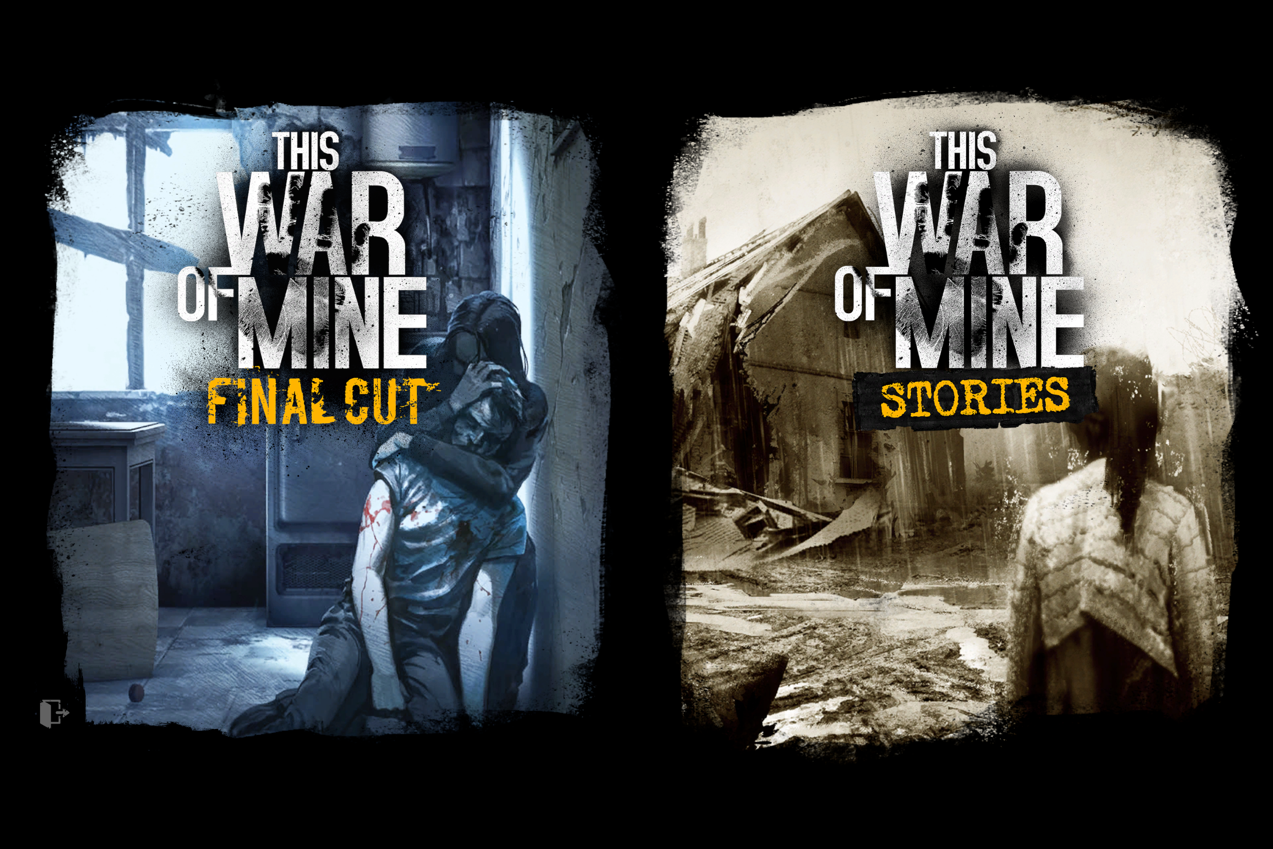

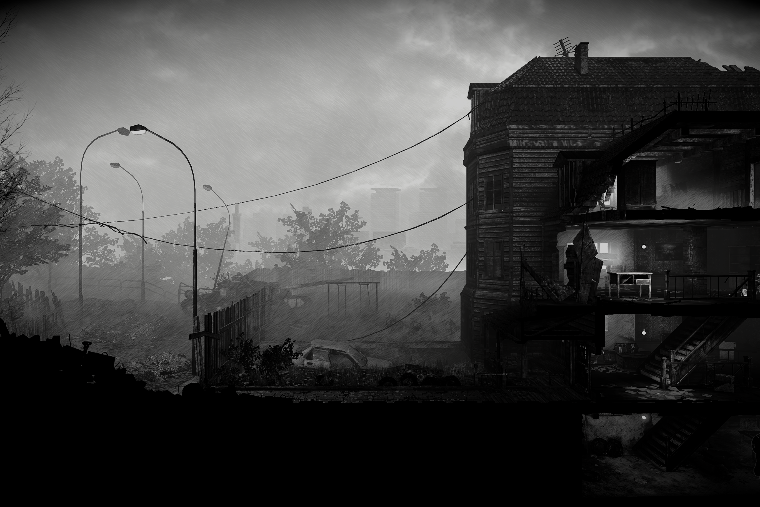
[This War of Mine ©11 Bit Studios]

Duration: 2 sessions, 50’ each
Subject/s: English, Technology, History
Topics: Civilian experience in war; survival and scarcity; moral ambiguity; trauma; community; innocence; war. Exposition of the ethical grey areas that arise in contexts of conflict.
SDGs: Peace, Justice, and Strong Institutions; Reduced Inequalities; Gender Equality; No Poverty.
Dimensions of conflict through the game:
☒ social impact
☒ environmental impact
☒ economic impact
☒ technological impact
Learning objectives: Students will be exposed to ethical debates in which they will need to develop their problem-solving skills, social and environmental awareness, and ethical decision-making from a critical thinking perspective. The students will develop strategies for social and personal awareness and will generate internal debates about the effects of warfare on the individual and the community. They will acquire the ability to deconstruct their identity through exposure to human rights violations.
Interpersonal skills: Intersectionality, community management, enhancement of empathy, critical thinking, questioning.
Technical requirements & material required: screen, computer with Internet connection (the game requires a purchase on Steam; therefore, it would be replaced in class or at home with the viewing of gameplay videos on streaming platforms).
Year: 4º ESO (15 yo)

Further reading/material:
Bjørkelo, Kristian A. "“It Feels Real to Me”: Transgressive Realism in This War of Mine", in Transgression in Games and Play, edited by Kristine Jørgensen and Faltin Karlsen, MIT Press, 2019.
Bray, Ollie and Anesa Hosein. Games in Schools, European Schoolnet, 2023.
Gieba, Kamila. “Territory of Agon. Civilian Perspective in a Besieged City in the Computer Game This War of Mine”. Future Human Image, Vol. 12, 2019, pp. 22-27.
House, Ryan. "Reframing the domestic experience of war in This War of Mine: Life on the battlefield." In Feminist War Games? Mechanisms of War, Feminist Values, and Interventional Games, edited by Jon Saklofske, Alyssa Arbuckle, and Jon Bath. Routledge, 2019, pp. 53-63.
Kampe, Christopher. “Seven dimensions of a feminist war game. What we can learn from This War of Mine”. In Feminist War Games? Mechanisms of War, Feminist Values, and Interventional Games, edited by Jon Saklofske, Alyssa Arbuckle, and Jon Bath. Routledge, 2019, pp. 132-149.
Kwiatkowski, Kacper. "Civilian Casualties: Shifting Perspective in This War of Mine", In Zones of Control: Perspectives on Wargaming, edited by Pat Harrigan, Matthew G. Kirschenbaum, MIT Press, 2016.
Pergerson, Cole. "How This War of Mine Creates Empathy for Virtual Characters" ART 108: Introduction to Games Studies, 2021.
Smale, S. de, Kors, M. J. L., & Sandovar, A. M. “The Case of This War of Mine: A Production Studies Perspective on Moral Game Design”. Games and Culture, Vol. 14, No. 4, 2019, pp. 387-409.

Preparation Phase
The implementation of video games in the classroom is a relatively recent development (Moreno-Cantano and Venegas-Ramos 43). However, despite the short lifespan of this discipline, it is not devoid of significant and innovative teaching strategies and methodologies that have fostered its exponential growth across various educational contexts and levels. In this regard, the video game proposed in this didactic sequence, This War of Mine, holds a privileged position as it inherently encompasses social, cultural, and ethical debates that are interdisciplinary in their application across multiple subjects in the educational curriculum. Topics such as the effects of our decisions and actions on the community and individuals become evident in the dynamics presented by the game’s narrative. This narrative addresses issues related to resource management during times of conflict, the impact of war on spatial, environmental, and personal routines, and how technological development allows us to recognize the ethical and social dilemmas that emerge in contexts of crisis or social emergency.
To efficiently implement these issues in the classroom, it would be essential to provide students with the opportunity to experience the video game firsthand. However, we face a currently insurmountable challenge: the game is not free (as of January 8, 2025: Steam – €1.89; PlayStation Store – $26.99; Nintendo – $1.99). To address this, we will adapt the pedagogical sequence to the use of gameplay videos available on free platforms, enabling students to observe the types of decisions the game presents and to participate in the scheduled activities based on those observations.
The difficulty level of this title is significant, so an initial introduction through gameplay that sparks interest in delving deeper into the game’s dilemmas later on may even be advantageous. Additionally, since gameplay videos can be paused, fast-forwarded, or rewound according to the needs of the moment, they offer the added benefit of emphasizing specific aspects as needed.
In this regard, it is advisable for teachers to familiarize themselves with the dynamics presented by the video game before introducing it in the classroom, as the various elements useful for its application in the sessions should be identified in advance.
Therefore, for the optimal use of the game in classes, the following is recommended:
- Appropriate technological equipment (computer, headphones, projector, and speakers).
- Internet connection.
- Teachers should engage in prior preparation, including reviewing documentation, previewing gameplay, testing the functionality of materials and resources, assessing the level of difficulty, and identifying specific elements of the video game that could be more directly applicable depending on the focus. For example, one could play with a character who is an expert in mathematics or another with advanced commercial skills. It would also be useful to determine which aspects to emphasize in the proposed activities, as the game allows for discussions around the spaces it generates, the strategies required, the logic of its scenarios, critical thinking, conflict resolution, leadership, rhetoric, and, of course, ethical dilemmas.
- The game is inspired by the Siege of Sarajevo (among other conflicts), making it essential to research the historical events that gave rise to this wartime scenario in Europe and other contexts. This knowledge would help make these dilemmas relatable and translatable to any situation, encouraging students to view these scenarios as potentially applicable, to some extent, to their own daily lives.
- Gameplay in English: https://www.youtube.com/watch?v=foroh4lCeAg (19’)
- Gameplay in Spanish: https://www.youtube.com/watch?v=fzfB0slMNhM (23’)
- Full game walkthrough (English): https://www.youtube.com/watch?v=VOtlLiHJRW8 (5h 46’)

Game Phase
Lesson No. | Description in Steps | Social form | Material/technical requirements
1 | Step 1: Introduction  - Students are informed about the dynamics of the class with the use of videogames, as well as its advantages.  - Initial information to students includes the presentation of moral dilemmas, such as, would you intervene if you witnessed abuse of any kind? What if your own safety were at risk? (See Annex 1).  - Students are asked about their identifications and the degree of importance they give to certain aspects of their lives (see Annex 2) | Whole class | IT equipment and materials in Annexes
1 | Step 2: Introduce the game with a short video (LINK: https://www.youtube.com/watch?v=VcmBJZcT1zE) (5 first minutes). Show images of other well-known warfare videogames (see Annex 3). The teacher explains that this game differs from most war games in that your mission here is not to eliminate enemies but to survive. The game is experienced from the perspective of citizens enduring the hardships of war. | Whole class | IT equipment and materials in Annexes
1 | Step 3: Encourage a critical discussion among students about the main social problems they see in their daily lives, both through their own experiences and through the media they use. To support this, elements of conflict such as gender, ethnicity, social class, geopolitics, environment, sexuality, immigration, and so on can be suggested later. Teacher will also focus on critical thinking about the media used by students and their possible ideological leanings. | Group work of 5 students.  Whole class. | Materials in Annex 4.

Reflection Phase
Lesson No. | Description in Steps | Social form | Material/technical requirements
2 | Step 4: Refreshing concepts. Very briefly, students refer to main conclusions from Lesson No 1. | Whole class | No needs
2 | Step 5: Gameplay. Students watch the first 5 minutes of the walkthrough video:  (https://www.youtube.com/watch?v=VOtlLiHJRW8)  Students should take notes on the key elements in the video that are related to conflicts. Meanwhile, the teacher moves around the classroom, ensuring that the students are paying attention, taking notes, and actively engaging in understanding the game. The teacher may decide to pause the video if they perceive that the group needs more time to identify potential conflict themes. | Whole class | IT equipment described in p.4
2 | Step 6: Students share with the class their findings of conflict signals in the video. | Whole class | No needs
2 | Step 7: Gameplay review. The teacher pauses the video at minute 1:18 so that the students can closely observe the general layout of the building's interior, its elements, and the characters who inhabit it. Students are required to pay special attention to the game aesthetics and comment on its effect on their emotions: does the image produce happiness, sadness, fear, anger, disgust, hope, despair, frustration, guilt, empathy, confusion? | Groups 4-5 | IT equipment described in p.4
2 | Step 8: Show the gameplay in Spanish from minute 17:30 to 20:30, where a scene is shown in which the player must decide whether to intervene in an act of aggression, knowing it will cost their character's life, or let it happen and survive.  Invite the students to put themselves in the character's shoes and decide whether to help the woman or not. After their responses, introduce the nuance of how they would act if that woman were a loved one.  Introduce a new debate about another scene from the game (it is not necessary to view it, but if desired, it can be shown here: https://www.youtube.com/shorts/KzhbPHJSXVE), in which the character must decide whether to loot an elderly couple, leaving them in an extremely vulnerable situation, in order to avoid that his own family members starve to death. Once again, the teacher will encourage a debate among the students about how they would act in that situation.  Furthermore, the teacher will also ask the students to extrapolate that dilemma to a situation in their everyday lives in order to uncover the true significance of such moral dilemmas. | Groups 4-5 | IT equipment described in p.4
2 | Step 9: Inform the students that there is a DLC for the game featuring a playable character who is a child, and depending on our decisions, this child may fall into depression. How do students perceive the role of children in a war scenario? In what sense can they compare the situation of these children to situations belonging to our daily lives? | Groups 4-5 | If needed, IT equipment described in p.4
2 | Final Reflection: Reflect in groups about the findings of conflict signals in the gameplay. This final activity will focus on retrieving feedback from students about the game, the lessons, and the topics. If there is time left, the teacher can introduce some of the questions, but there will be an online questionnaire for students to complete (QR Code or  https://forms.office.com/e/PPxiKwm8Gr):  - Did you enjoy the game?  - Would you play it in full and recommend it to your friends?  - What did you learn from the game?  - How do you think the game made you reflect upon your own values?  - Do you think that being in a state of conflict affects your ability to make reasoned decisions and that the various pressures imposed by the conflict justify morally questionable decisions?  - How would you improve the use of this (or other) videogame in the classroom?  - Do you think videogames are a useful tool in the learning process for students your age?  - After these lessons, do you see conflict in a different way? How?  - Do you think the conflicts presented in the video game can be truly applied to the school environment, for example?  - Do you have any other opinions, suggestions, or recommendations about these lessons? | Whole class | Annex 5 (QR Code)

Annex 1: Conflict situations

Bullying (AI-generated image, https://www.artguru.ai/es/)


Situations of safety risk (AI-generated image, https://www.artguru.ai/es/)

Annex 2: Questions about students’ identities.
- How would you define yourself in terms of social awareness? Compassionate? Empathetic? Individualistic? An ally? Any other?
- How would you rank the following elements in order of importance in your life?
  - Sustenance
  - Freedom
  - Rights
  - Love and friendship
  - Community
  - Peace
  - Ecology
  - Respect
  - Solidarity
  - Resources and money
- Would you give up any of your privileges to protect the rights of others?

Annex 3: Other examples of war video games.
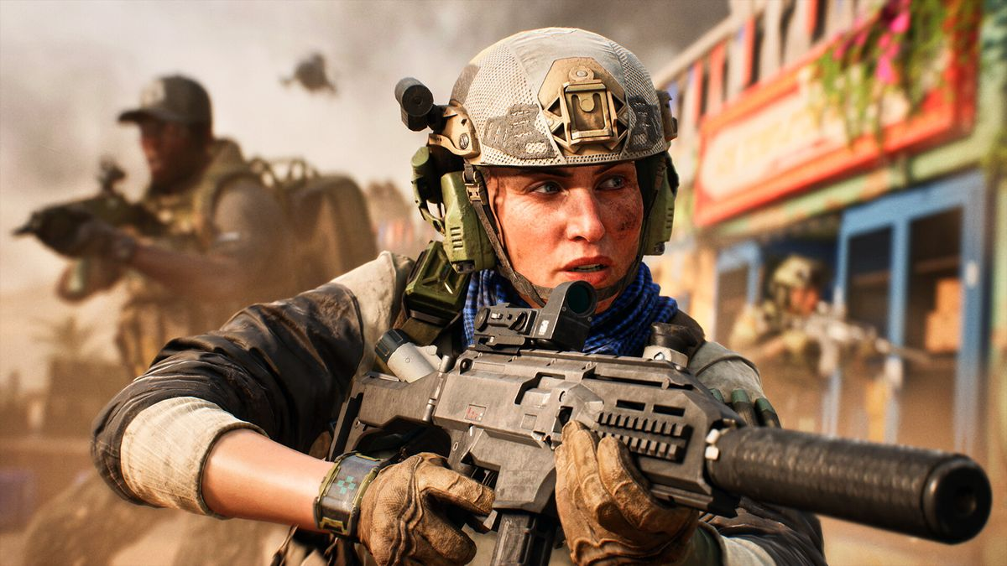
Battlefield
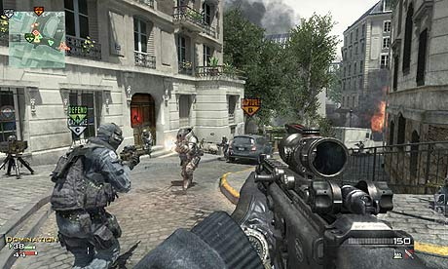
Call of Duty

Annex 4: Images of inequality based on gender, ethnicity, social class, geopolitics, sexuality, immigration
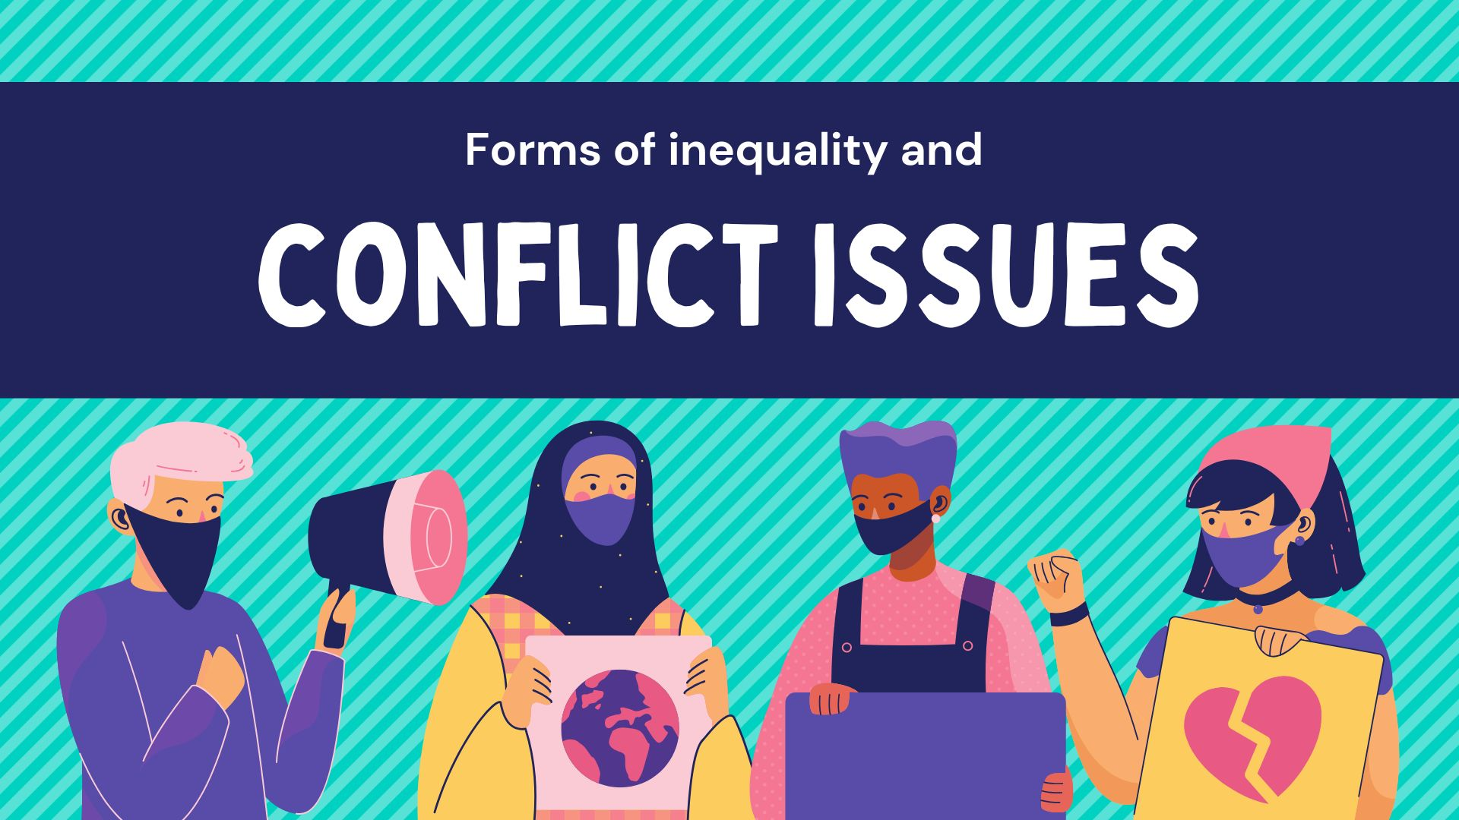
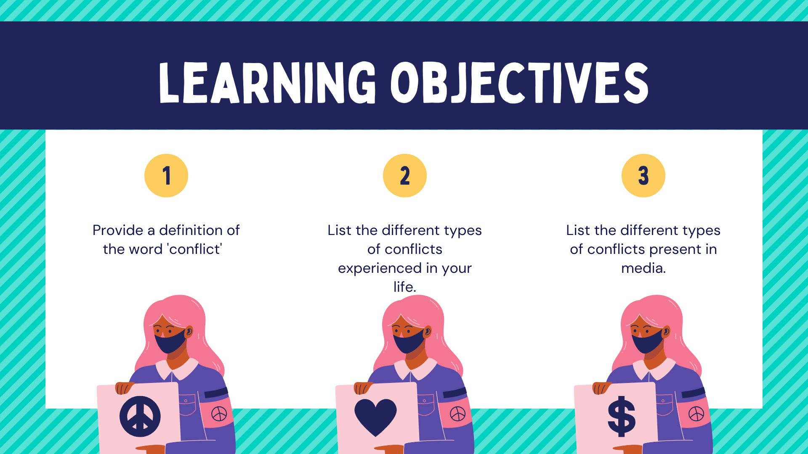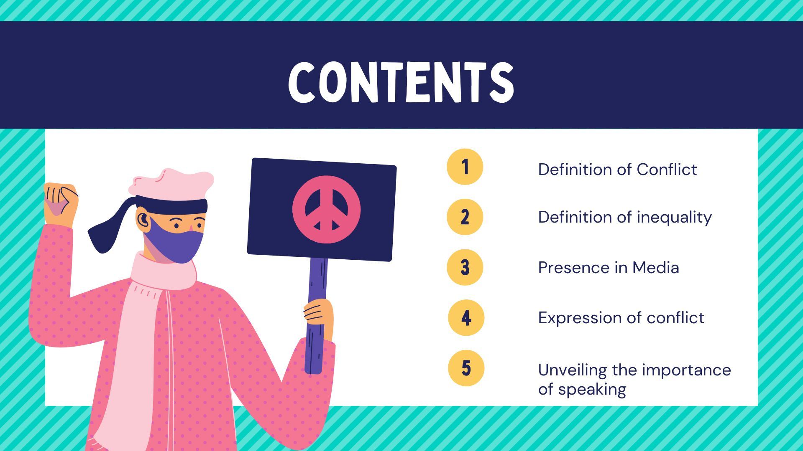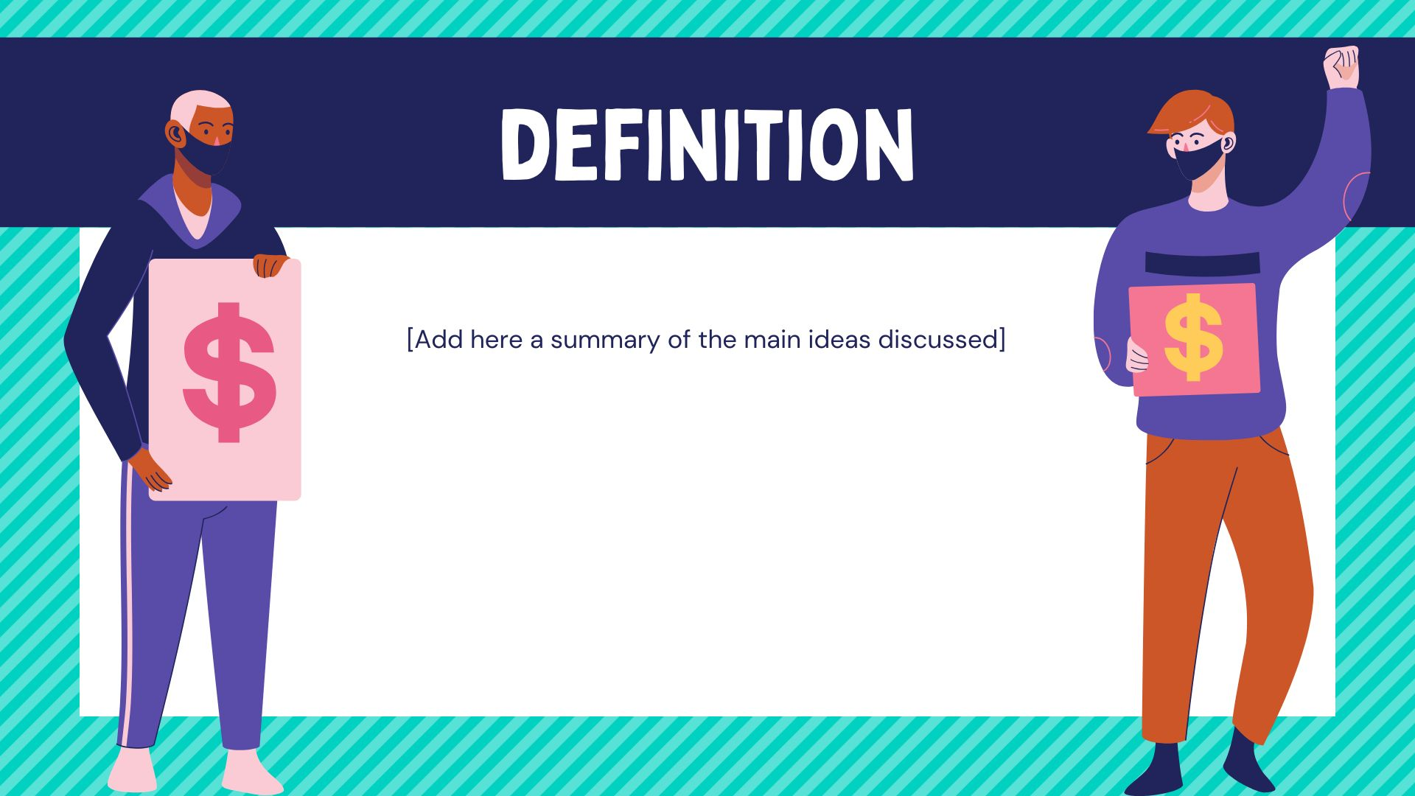
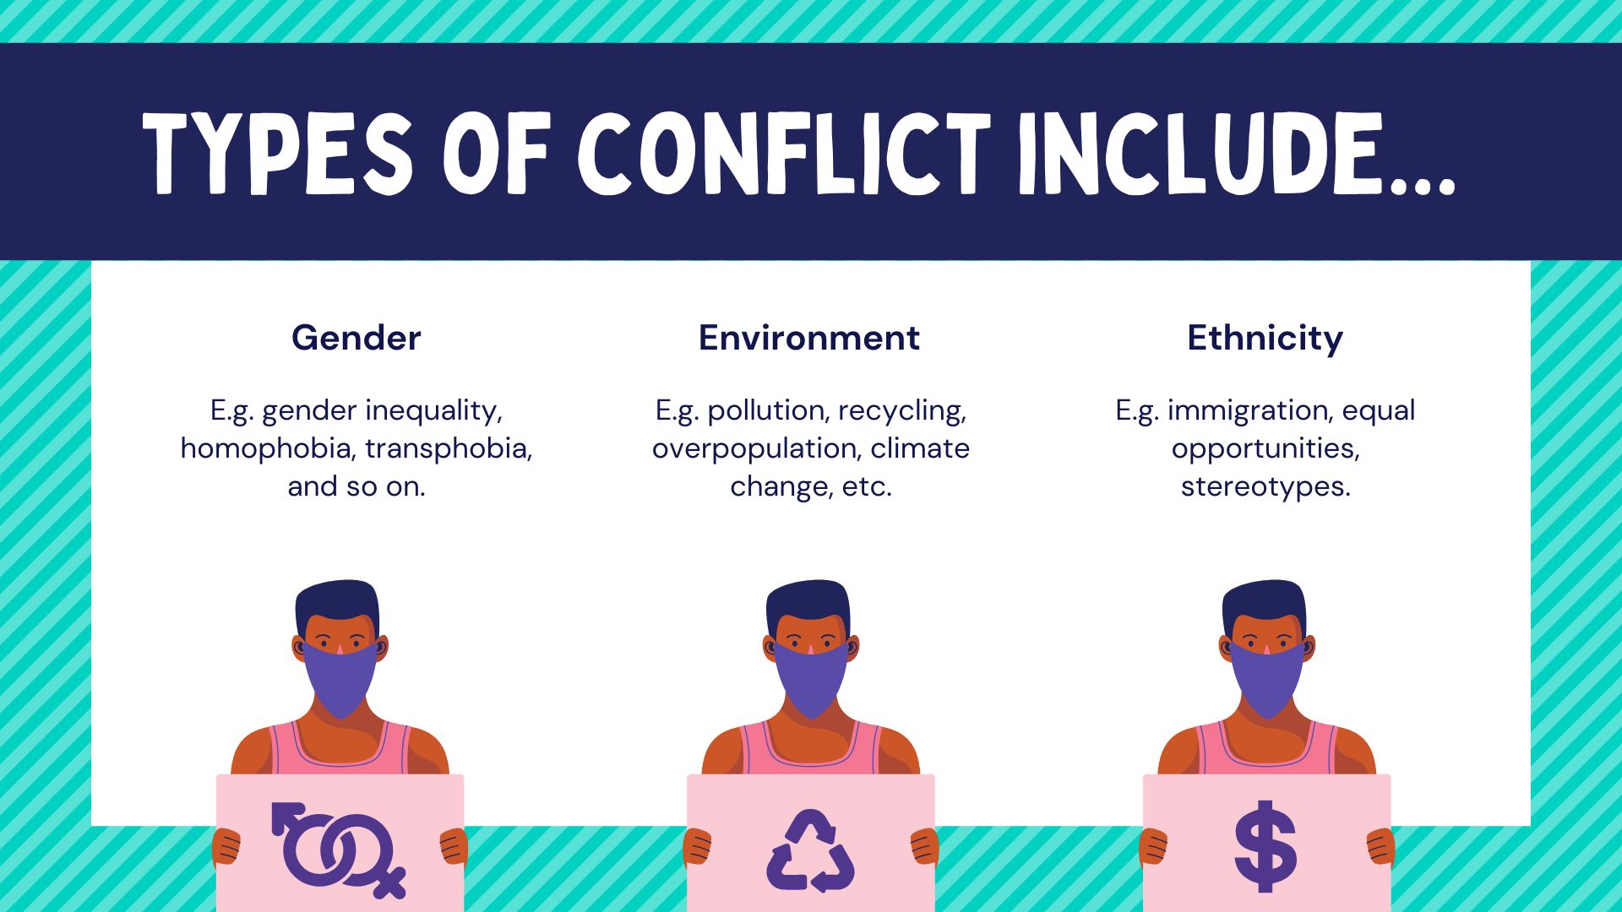

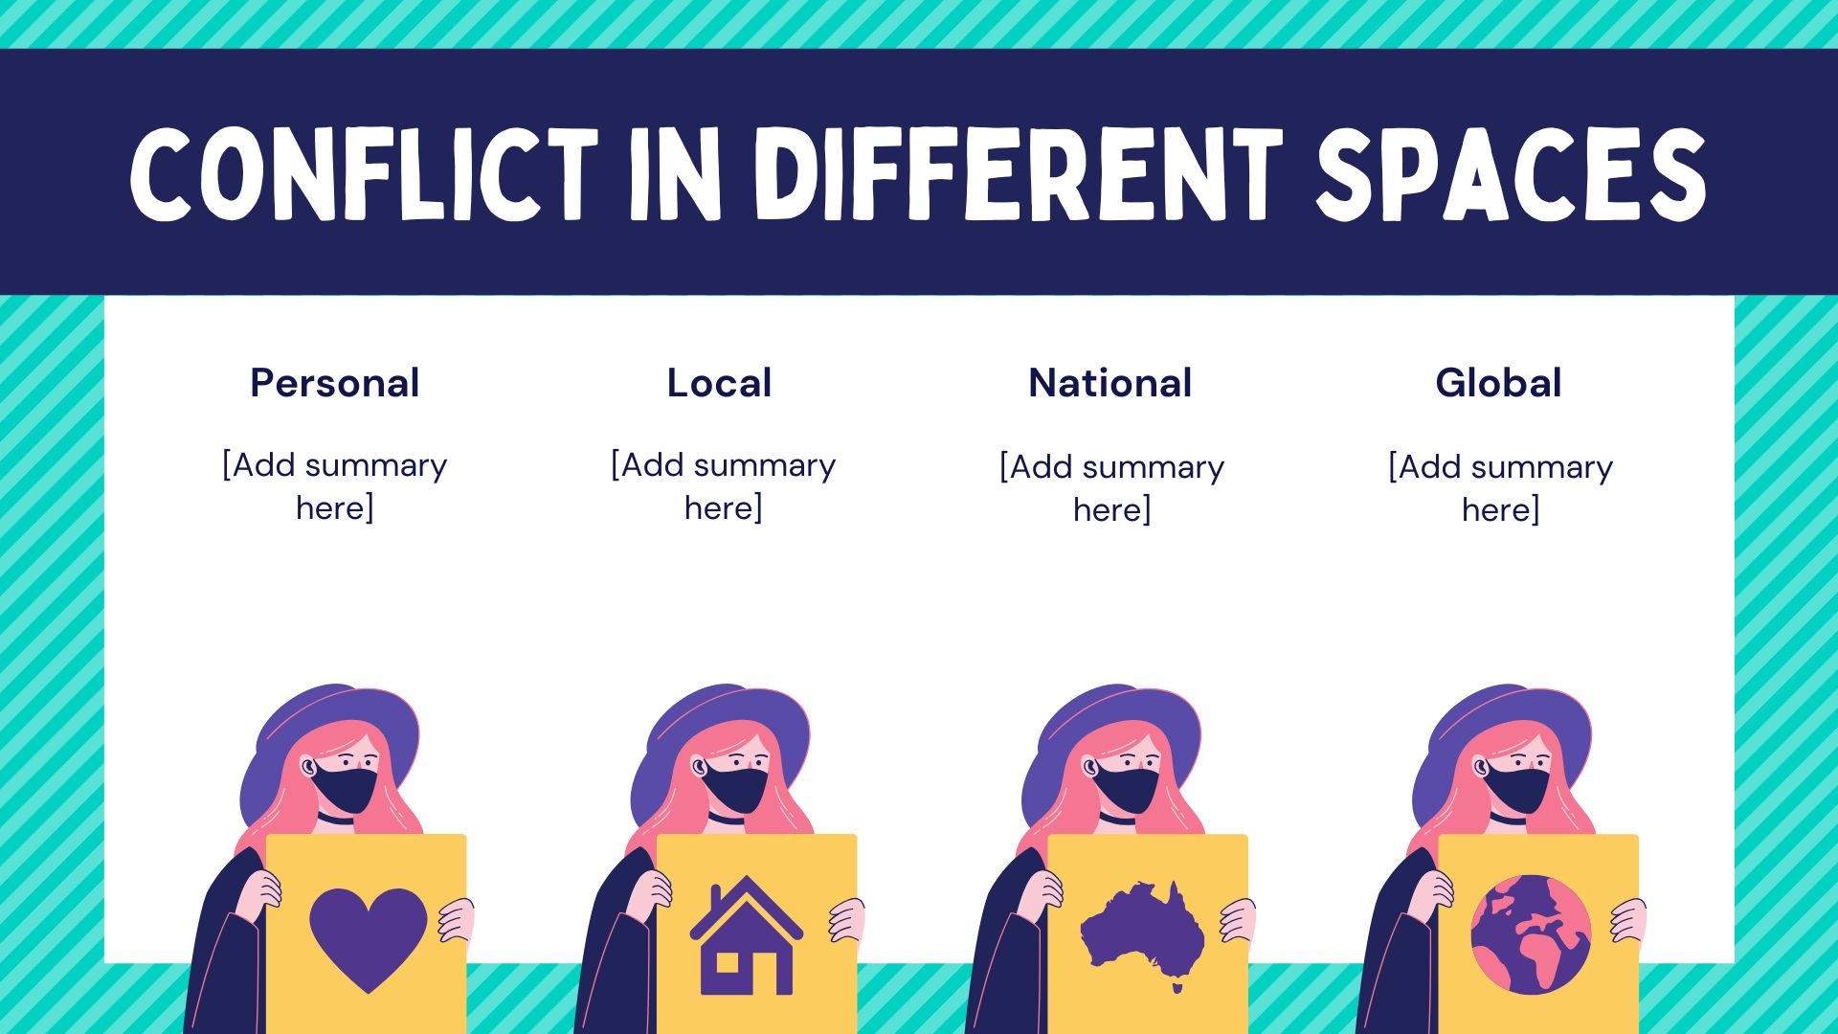

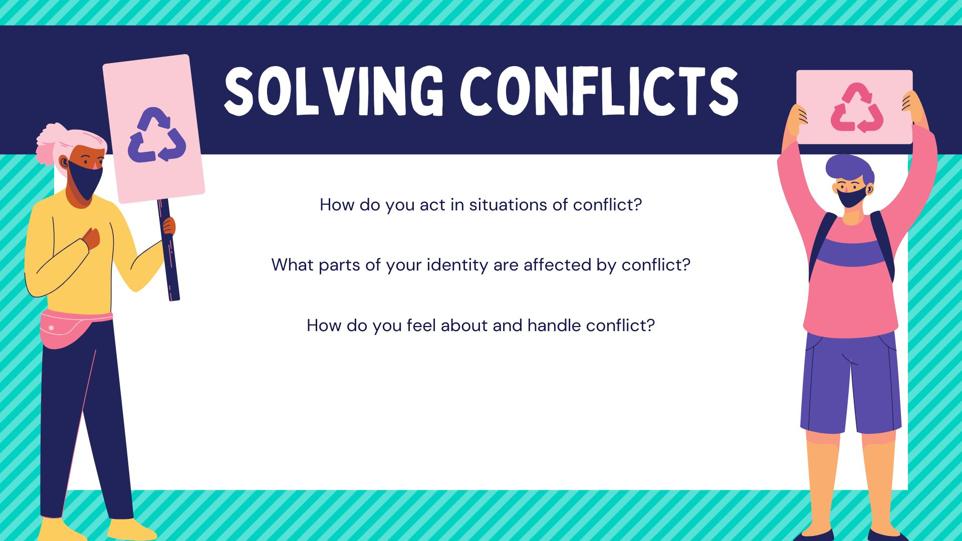

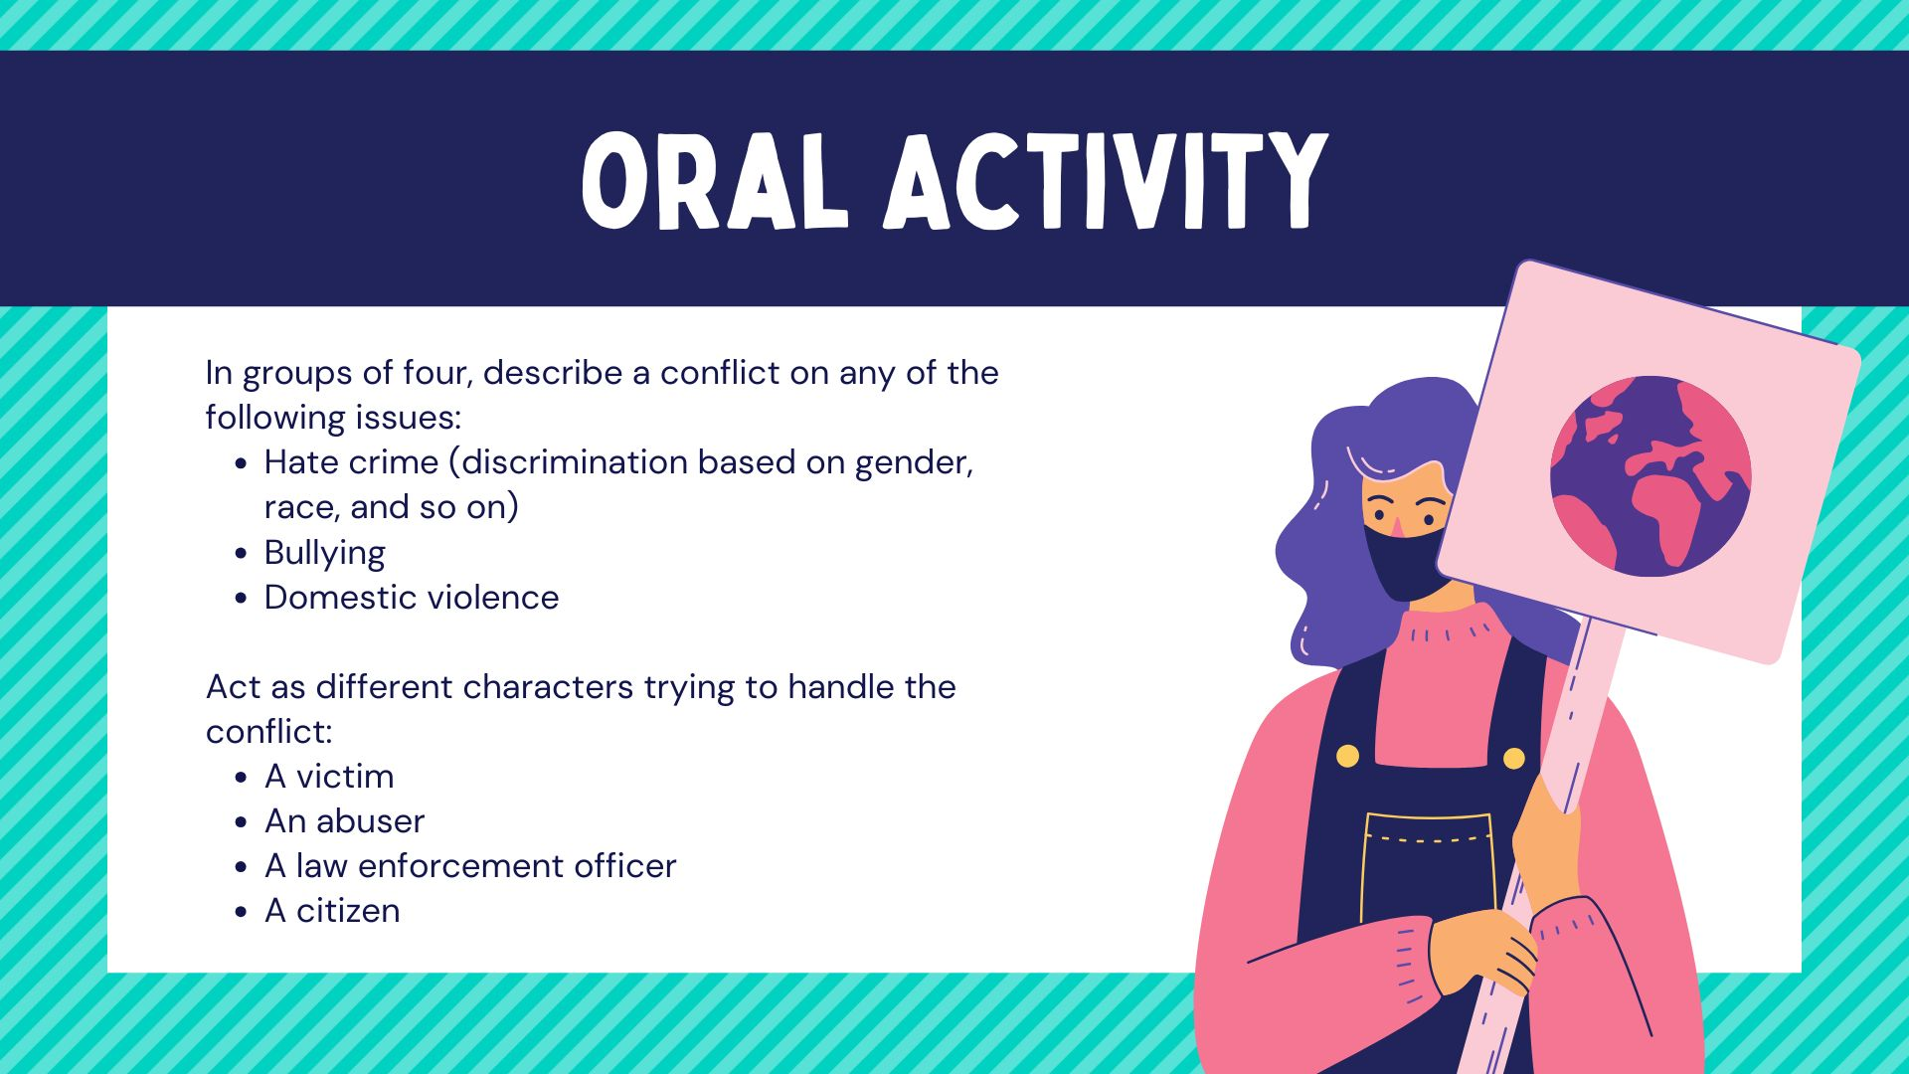

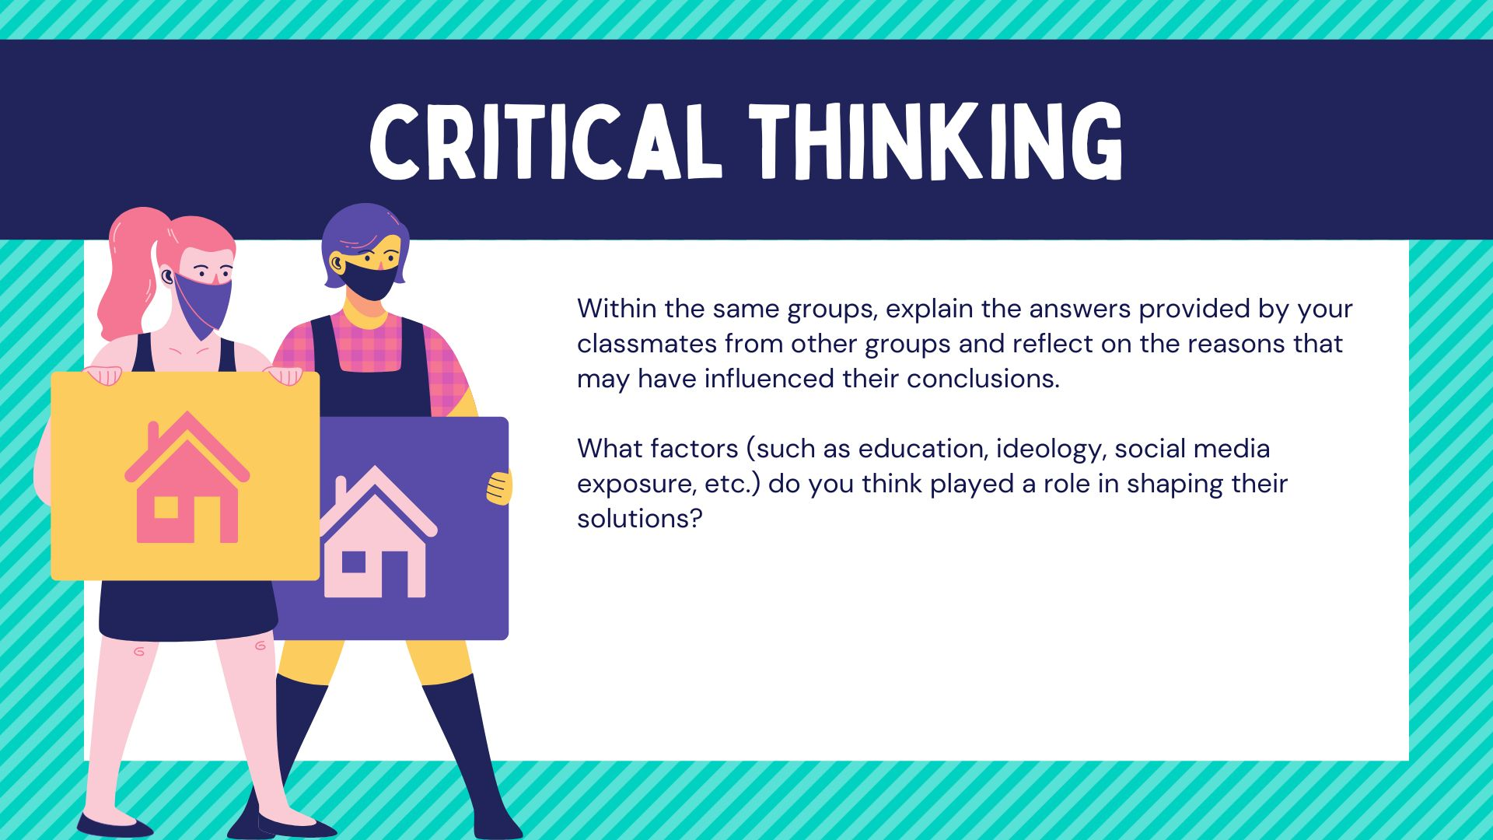

Annex 5: QR Code for final questionnaire and cell phone/ PC captures
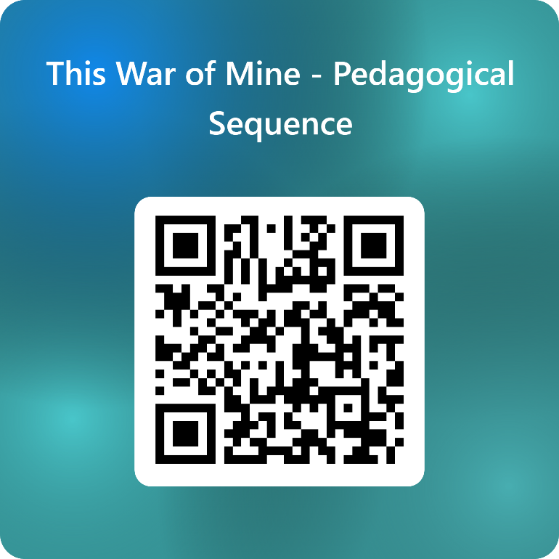

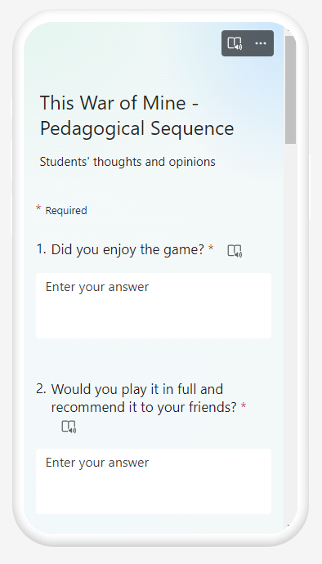
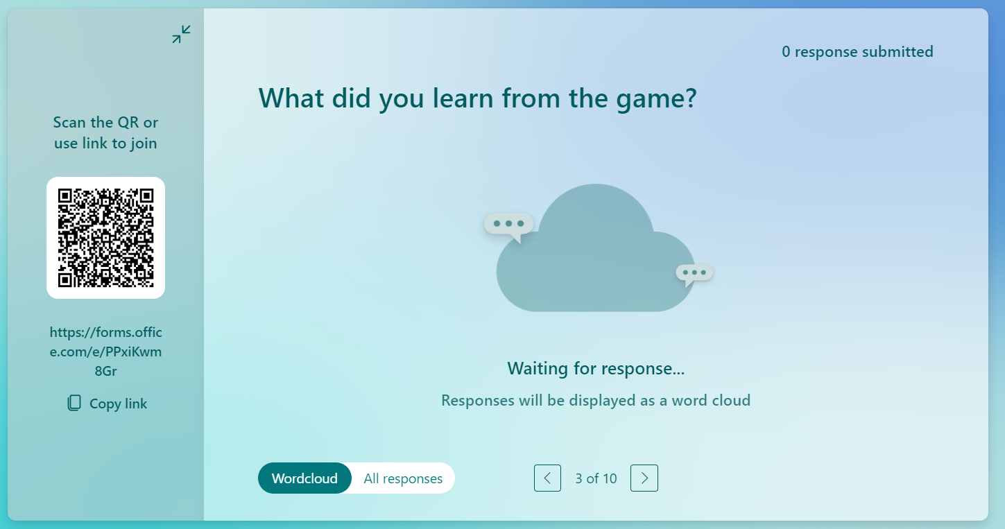

Annex 6: Game Analysis

This War Of Mine
The video game This War of Mine is a fascinating example of how video games can be interpreted as communication tools that convey messages through user interaction. Each video game is a construct of meaning that acquires different interpretations depending on the player's experience. In this context, This War of Mine presents itself as an interactive narrative where the game's content and objectives are intertwined with the gameplay process, offering a rich and educational gaming experience.
The two main hypotheses in video game studies are perfectly applicable to This War of Mine:
- Video games can be seen as means of communication: This video game not only entertains but also communicates a profound message through its narrative and game mechanics.
- Video games contain values: In This War of Mine, both implicit and explicit values are present in its plot, mechanics, and objectives, influencing the player's perception of the game's content.
The fundamental characteristic of This War of Mine is its interactivity, which enhances its use as an educational and training tool. Through constant interaction with the game, players not only advance in the story but also face challenges that foster problem-solving and decision-making skills.
Key Features of the Game:
1. Playability:
- Actions and Mechanics: This War of Mine offers a variety of mechanics ranging from resource management to strategic decision-making. The player's ability to handle these mechanics directly impacts the development of the game and the user's experience.
- Story and Characters: The narrative of This War of Mine is carefully crafted to keep the player engaged, with deep characters adding layers of meaning to the plot. The story not only entertains but also presents moral and social dilemmas that invite reflection.
This War Of Mine
The video game This War of Mine is a fascinating example of how video games can be interpreted as communication tools that convey messages through user interaction. Each video game is a construct of meaning that acquires different interpretations depending on the player's experience. In this context, This War of Mine presents itself as an interactive narrative where the game's content and objectives are intertwined with the gameplay process, offering a rich and educational gaming experience.
The two main hypotheses in video game studies are perfectly applicable to This War of Mine:
- Video games can be seen as means of communication: This video game not only entertains but also communicates a profound message through its narrative and game mechanics.
- Video games contain values: In This War of Mine, both implicit and explicit values are present in its plot, mechanics, and objectives, influencing the player's perception of the game's content.
The fundamental characteristic of This War of Mine is its interactivity, which enhances its use as an educational and training tool. Through constant interaction with the game, players not only advance in the story but also face challenges that foster problem-solving and decision-making skills.
Key Features of the Game:
1. Playability:
- Actions and Mechanics: This War of Mine offers a variety of mechanics ranging from resource management to strategic decision-making. The player's ability to handle these mechanics directly impacts the development of the game and the user's experience.
- Story and Characters: The narrative of This War of Mine is carefully crafted to keep the player engaged, with deep characters adding layers of meaning to the plot. The story not only entertains but also presents moral and social dilemmas that invite reflection.
2. Usability:
- Clarity of Objectives and Messages: The game is designed to be intuitive, allowing players to understand objectives without needing to read extensive manuals. The interface and in-game messages are clear, contributing to a smooth experience.
- Accessibility Features: This War of Mine includes options to adapt the game to different needs, ensuring it is accessible to a broad audience.
3. Educational Content:
- Theme and Skills Developed: The content of This War of Mine addresses relevant themes and fosters important skills such as critical thinking and strategy. The game is designed to develop competencies valuable in educational and professional contexts.
- Connection to 21st Century Skills: The video game links to 21st-century skills such as problem-solving, decision-making, and collaboration, providing a formative experience that extends beyond entertainment.
4. Analysis as an Educational Resource:
- Linkage with Educational Resources: In the context of educational analysis, This War of Mine is examined in relation to the resources and educational dimensions of the InterGames program. The game serves as a resource that can be integrated into educational settings to promote active learning and critical reflection.
To facilitate the analysis of This War of Mine, a reference table has been prepared, breaking down the key characteristics in each of these four categories, allowing for a comprehensive evaluation of the video game as an educational and entertainment tool.

Title
Platform | PC (Steam), Xbox and PlayStation 5
Language | Turkish, spanish, english, german, french, italian, portuguese (brazilian), russian, chinese (simplified), japanese and korean
N. º of sessions played | 3
Total time played | 4h30 (30 minutes, 2 hours and 2 hours)
Brief Description | This War of Mine is a video game that centers around an intense and strategic narrative where players take on the role of a character in a tense and conflicted environment. In the game, players must make crucial decisions that affect the course of the story, managing resources, forming alliances, and facing moral dilemmas. The game’s plot unfolds in a challenging context, requiring players to think critically and act strategically to achieve their objectives. Player interaction and decisions play a fundamental role in the overall experience, with each choice potentially leading to different outcomes and endings.

Dimension | Evaluation Criteria
Usability  (analysis of technical correctness and ease of use) | - Is the game easy to learn and play?  The game is designed to be accessible to both new and experienced players. It typically features a tutorial or introductory segment that helps players understand the basic mechanics and objectives. The learning curve is generally smooth, allowing players to grasp the core gameplay elements without too much difficulty.  - Is the user interface (controls and navigation) clear and tailored to the target audience?  The user interface is usually intuitive and tailored to the game's target audience. Controls and navigation are designed to be straightforward, with clear visual and textual cues that help players understand how to interact with the game. Menus and options are organized in a user-friendly manner, enhancing the overall experience.  - Are accessibility options implemented?  The game often includes accessibility features to accommodate players with different needs. These may include options for text size adjustments, colorblind modes, and customizable control schemes. The presence and effectiveness of these features can vary, so it’s important to check the specific accessibility settings available in the game.  - Is the game response accurate and fast?  The responsiveness of the game is generally quick and accurate, with minimal lag or delay between player input and game response. This ensures a smooth and engaging experience, critical for maintaining immersion and effective gameplay.  - Are in-game messages accurate?  In-game messages are typically clear and accurate, providing players with relevant information about objectives, gameplay mechanics, and other important aspects. Accurate messaging helps prevent confusion and aids in smooth gameplay progression.  - Are there instructions?  The game usually includes instructions, either through an initial tutorial, in-game prompts, or a help menu. These instructions guide players on how to play and utilize various game features, ensuring they can effectively engage with the game.  - Is it possible to save the game?  Players can generally save their progress at designated points or through an autosave feature. The ability to save is crucial for allowing players to resume their game without losing progress and to manage their gaming sessions flexibly.  - Are there any bugs?  While most games strive for stability, bugs can occur. Common issues might include graphical glitches, occasional crashes, or minor gameplay bugs. The frequency and impact of these bugs can vary, and developers usually address them through patches and updates.  Other relevant usability comments:  - Performance and Optimization: The game’s performance on various hardware configurations should be smooth, with minimal impact on gameplay. Optimization for different platforms and systems can enhance the overall experience.  - User Feedback: Player feedback can be valuable in identifying usability issues and areas for improvement. Monitoring community forums and reviews can provide insights into common usability concerns and how they are being addressed.
Gameplay (analysis of the game's play and narrative structures, and how game design produces meaning) | - Were you able to finish the game (yes/no: why)?  Yes. The game is designed to be completable with a mix of strategy and decision-making. Difficulty can vary based on player approach and choices, but the game offers a complete experience that allows players to reach the end.  - Duration (per level/mission or over the whole game)  Each level or mission in This War of Mine typically lasts between 30 to 60 minutes, depending on the complexity of the objectives and the player’s skill. The total game duration is usually around 10 to 12 hours for a complete playthrough, though this can vary with exploration and decision-making.  - Degree of interactivity (do the player's decisions play a crucial role in the outcome of the game)?  High. In This War of Mine, player decisions have a significant impact on the development of the story and the available endings. Choices made throughout the game can alter the course of the narrative and affect character relationships.  - Is the pace of the game satisfying?  Generally, the pace of the game is satisfying, balancing high-intensity moments with slower sections that allow players to reflect on their decisions and strategies. However, some players may find the pace slow during extended exploration phases.  - Narrative weight (high/medium/low)  High. Narrative is a central component of This War of Mine. The story is well-developed, with deep characters and significant conflicts that drive the game and keep players engaged with the plot.  - Presence of a narrator: yes/no  Yes. The game uses narration in the form of dialogues and monologues that enrich the story and provide additional context about the world and characters.  - Presentation and role of the main character (characteristics and qualities of the character/avatar)  The main character is complex and well-developed, with distinct personality traits and motivations. Their role in the story is central, and their decisions and actions directly influence the game’s progress and resolution.  - Depiction and role of the antagonist (characteristics and qualities)  The antagonist in This War of Mine is depicted as a powerful and multifaceted figure, with their own motives and goals that create conflict and challenges for the protagonist. Their presence and actions are crucial to the plot and the game’s dynamics.  - Presentation of the setting (world in which the character develops)  The game presents a detailed and well-designed world that reflects the tone and atmosphere of the story. The environment is rich in detail and contributes to the player’s immersion, with different areas explored by the protagonist throughout the narrative.  - Dimension/temporality: time period covered by the story and its characteristics (fictional/real, global/local, etc.)  The story of This War of Mine takes place in a fictional setting with elements of realism and fantasy. The time period and scale are designed to support the narrative, ranging from local to global depending on the story’s development.  - Mission (what are the essential actions to win/complete the game)  Essential actions include completing main missions, solving puzzles, making key decisions, and managing resources effectively. Each mission advances the plot and contributes to achieving the game’s final objectives.  - What are the implicit/ultimate goals of the game?  Implicit goals include uncovering the truth behind the central conflict, developing the protagonist’s story, and achieving a satisfying resolution to the main conflict. The ultimate goal is typically related to overcoming the antagonist and resolving major quests.  - What are the main challenges/obstacles faced by the protagonist?  The protagonist faces various challenges, including combat encounters, strategic dilemmas, resource management, and moral decisions. These obstacles are designed to test the player’s skills and decision-making abilities, impacting the game’s progression and outcome.  - Are the game mechanics appropriate to the content and implicit goals?  The game mechanics are well-suited to the content and implicit goals. Mechanics such as combat, exploration, and decision-making are integrated to support the narrative and overall objectives, providing a cohesive and engaging experience.  - Do you agree with the reward system (incentives for action)?  The reward system is well-implemented, offering incentives such as unlocking additional content, achievements, and narrative progression. These elements motivate players to continue and explore different aspects of the game.  - How is the feedback system (text, audio or audiovisual comments given to the player for certain actions)?  The feedback system in This War of Mine is effective, providing clear responses through text, audio cues, or audiovisual elements. This helps players understand the impact of their actions and guides them through the game.  - Overall story (description of the story of the game as a whole)  The overall story of This War of Mine focuses on an intense and multifaceted narrative where the protagonist navigates a world filled with conflict and challenges. Through critical decisions and strategic actions, players uncover the truth behind the main events and confront the antagonist to resolve the central conflict. The plot is rich with dramatic twists and character development, offering a meaningful and immersive experience.
Content  (analysis of the content of the game and the messages conveyed in relation to the objective) | - What are the themes of the game?  This War of Mine explores themes such as conflict and resolution, personal sacrifice, and moral ambiguity. The game delves into the consequences of choices and the complexities of power dynamics and personal responsibility. Themes of identity and agency are also central, as players navigate the protagonist's journey and face ethical dilemmas that shape their understanding of right and wrong.  - What kind of reflection, knowledge, skills, competences, awareness are developed?  The game encourages critical thinking and ethical reflection as players confront moral decisions and their implications. It fosters strategic planning and problem-solving skills through its challenges and puzzles. Additionally, players gain empathy and self-awareness by experiencing the protagonist’s struggles and understanding different perspectives. The game also enhances decision-making skills by highlighting the impact of choices on the narrative and character development.  - Is there an explicit use of sources of information?  The game may reference various sources of information, such as historical or cultural elements, to build its world and narrative. However, these references are typically integrated into the game’s story and environment rather than presented as explicit, separate sources. Players might encounter background details or lore that reflect broader concepts but are woven into the gameplay rather than cited explicitly.  - Do you think the player can get the intended message without external help?  Players can generally understand the intended message of the game through gameplay and narrative alone. The game’s design, including its story, dialogues, and decision-making processes, is crafted to convey its themes and messages. While external analysis or discussion might deepen understanding, the core messages are accessible through the game’s content and player experience.  - Did you change your beliefs/opinions or learn something new after playing the game?  This varies by individual. Players might find their beliefs or opinions challenged or refined as they engage with the game’s themes and moral dilemmas. The game’s exploration of complex issues and ethical choices can lead to new insights or perspectives, encouraging players to reflect on their own values and decision-making processes.  Other relevant comments about the content  - Complexity of Moral Choices: The game stands out for its nuanced depiction of moral choices, often placing players in situations where there is no clear right or wrong answer. This complexity encourages players to think deeply about their decisions and their consequences, reflecting real-world ethical dilemmas.  - Character Development: The game features well-developed characters whose backstories and motivations are intricately woven into the narrative. This depth adds layers to the story and makes the characters' struggles and growth more impactful.  - World-Building: The game excels in creating a rich and immersive world. The setting is not only visually captivating but also integral to the narrative, providing context and enhancing the story’s themes. The world’s design supports the storyline and helps players feel fully engaged.  - Emotional Engagement: The game is designed to evoke a range of emotions, from empathy and frustration to satisfaction and reflection. This emotional engagement helps players connect with the story and characters on a deeper level.  - Interactivity and Narrative Integration: The gameplay mechanics are seamlessly integrated with the narrative, ensuring that player choices directly affect the story. This alignment between gameplay and story enhances the overall experience and makes the player’s role in the narrative feel meaningful.  - Cultural and Historical References: The game may include subtle references to real-world cultures or historical events, enriching the narrative and providing context. These references are often used to deepen the story’s themes and provide a more immersive experience.  - Replay Value: Given its branching storylines and multiple endings, the game offers significant replay value. Players are likely to return to explore different choices and outcomes, which adds to the game's overall longevity and appeal.  - Impact on Players: The game’s ability to provoke thought and discussion about its themes can lead to meaningful reflections and conversations among players. It challenges them to consider their own beliefs and perspectives, making the experience not just entertaining but also intellectually stimulating.  - Educational Value: For those interested in game design or narrative studies, This War of Mine serves as an example of how interactive storytelling can be used to explore complex themes and moral questions. It provides insights into how games can be crafted to convey deeper messages and engage players on multiple levels.  - Accessibility and Inclusion: Consideration of accessibility features in the game is important. While this is specific to each player's experience, effective implementation of such features ensures that a wider audience can engage with the content, making the game more inclusive.
Didactic resource  (analysing the game as a didactic resource) | - 21st century skills included:  - ☒Critical thinking  - ☐ Creativity  - ☐ Collaboration  - ☒ Communication  - ☐ Information literacy  - ☐ Media literacy  - ☐ Technology literacy  - ☒ Flexibility  - ☐ Leadership  - ☒ Initiative  - ☒ Productivity  - ☒ Social skills  - Dimensions covered:  - ☒ Social  - ☐ Environmental  - ☐ Technological  - ☒ Economic  - Link with InterGames subjects:  - ☐ Environmental Sciences  - ☒ Civic Education  - ☐ Arts  - ☒ History  - ☒ Economics  - Competences (knowledge achieved by the learner)  Ethical Reasoning: Players develop a deeper understanding of ethical reasoning and decision-making through the game’s complex moral choices.  Strategic Thinking: The game enhances strategic thinking by requiring players to plan and anticipate the outcomes of their decisions.  Narrative Analysis: Players learn to analyze and interpret narrative elements, understanding how story and gameplay are intertwined.  Empathy and Perspective-Taking: Through character interactions and dilemmas, players gain insights into different perspectives and the impact of choices on various characters.  - Problem solving conditions (way of thinking to solve problems: reproductive-memory, productive-creativity)  The game requires a blend of reproductive-memory (recall of facts and past decisions) and productive-creativity (innovative problem-solving and strategy development).  - Need for prior knowledge (no/yes: detail)  No. Some prior knowledge may be helpful, especially regarding general problem-solving strategies or the game’s thematic elements. However, the game is designed to be accessible to players without extensive background knowledge.  - Learning curve (learning difficulty: low, medium, high)  Medium. The learning difficulty is generally medium. While the game is approachable, it challenges players to engage deeply with its mechanics and narrative.  - Possibility of group work (no/yes: detail)  Although the game is designed for individual play, it can be used in group settings to discuss strategies, outcomes, and themes, facilitating collaborative learning and analysis.  - Does it include a teaching guide (information for teachers with tips and examples for implementation in the classroom)?  There is no official teaching guide included with the game. However, educators can create supplemental materials based on the game's content to aid in classroom implementation.  - Possibility of teacher evaluation (no/yes: please specify)  Yes. The game does not include built-in teacher evaluation tools, but educators can develop their own methods for assessing student engagement and learning outcomes based on gameplay experiences.  Other relevant comments concerning its use as a teaching resource and Interdisciplinary possibilities  - Interdisciplinary Integration: This War of Mine can serve as a versatile teaching tool across various subjects. Its narrative and gameplay elements can be integrated into lessons on ethics, technology, and creative writing. The game's immersive environment provides a rich context for interdisciplinary projects and discussions.  - Student Engagement: The game’s engaging story and decision-making elements can capture students' interest and encourage active participation. It can be particularly effective in stimulating discussions on complex themes and fostering critical thinking.  - Adaptability: The game’s content can be adapted for different educational levels, with more advanced analysis and discussion suitable for older students and simpler tasks for younger learners.  - Supplemental Resources: Educators might benefit from creating or finding additional resources to enhance the use of the game in the classroom, such as discussion questions, project ideas, and relevant articles or case studies.

