

Climate
Trail
–

Pedagogical

Sequence

By C.I.P.

December

2024

CLIMATE TRAIL
Short description of the game: Climate Trail is a narrative-driven survival game set in a dystopian future shaped by extreme climate change. Players take on the role of a climate refugee attempting to navigate a difficult journey from the southern United States to Canada in search of habitable conditions. With limited resources and escalating environmental challenges, the game emphasizes strategic decision-making, critical thinking, and resilience. Through its compelling storyline, Climate Trail raises awareness about the urgent need for climate action and the realities of forced migration caused by environmental degradation.
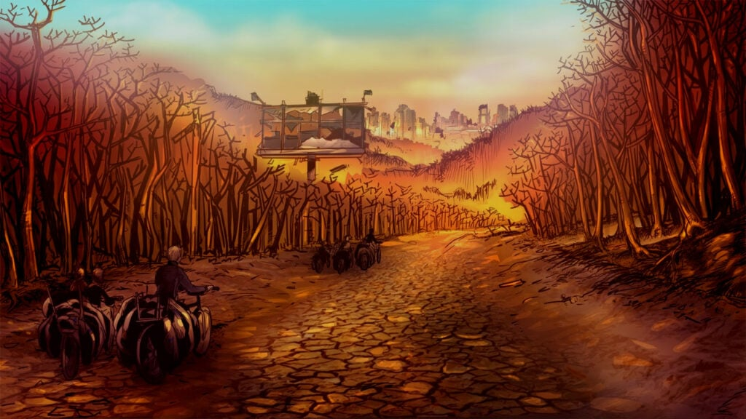

Duration: 3-4 lessons
Subject/s: Environmental science, Civic Education, Geography, Economics
Topics: Climate mitigation, global citizenship, financial management, climate change. Resilience, sustainability
SDGs: 13, 12, 11
Dimensions of conflict through the game:
☐ social impact
☐ environmental impact
☐ economic impact
☐ technological impact

Learning objectives: The pedagogical sequence using “Climate Trail” game aims to develop students' understanding of climate change and its multifaceted impacts, particularly on climate migration and resource scarcity. Through gameplay and guided reflection, students will enhance critical thinking, decision-making, and resource management skills while exploring ethical dilemmas tied to survival and global inequalities. The sequence fosters empathy, awareness of the social, economic, and environmental dimensions of climate crises, and a sense of urgency to act on climate issues. Students will also strengthen collaboration and communication skills, preparing them to engage with real-world sustainability challenges.
Interpersonal skills: Collaboration, communication, empathy, conflict resolution and decision-making
Technical requirements & material required: PC/smartphone/tablet + Headphones + mouse for each student; WIFI; QR-Code to game URL
Further reading/material:
Climate Change, Inequality, and Human Migration | Journal of the European Economic Association | Oxford Academic
Climate change is already forcing millions of people to migrate – and it will only get worse

Preparation Phase
In the Preparation Phase for using Climate Trail in the classroom, it is crucial to ensure that all students have access to a device (PC, tablet, or smartphone) with the game installed and running smoothly. A reliable internet connection is essential to ensure seamless gameplay, as the game requires real-time feedback and updates based on players' decisions. Additionally, students should have access to headphones to fully immerse themselves in the game’s sound design and audio cues without disturbing others in the classroom.
Before the class begins, the teacher should play through Climate Trail to understand its mechanics, gameplay loop, and educational themes. It is a game which needs enough and long play time therefore consider this beforehand to have enough time for multiple play times in order to fully capture its essence. This will allow the teacher to anticipate any potential issues students may face and to guide them effectively during their gameplay. The teachers should familiarize themselves with the game's key features, such as resource management, policy decision-making, and the balance between financial and environmental concerns, to better support students in their decision-making processes.
To introduce the game, the teacher should provide a context overview without spoiling the gameplay. The focus should be on the environmental challenges the game presents, such as managing the planet’s climate and resources in the face of climate change. The teacher can discuss how the game simulates real-world environmental issues but should avoid revealing key outcomes or choices that would weaken the spontaneous experience for students.
Given the nature of Climate Trail, it is also important to prepare students for the game's complex and sometimes challenging scenarios. Students will need to make decisions that balance ecological, social, and financial factors, which may prompt them to reflect on their values and understand the broader consequences of those choices. The teacher should be prepared to guide students through discussions around sustainability, climate change, and the impact of policy decisions on both local and global scales. It is essential to create a safe space for students to express any frustrations or ethical dilemmas that arise from their choices in the game.
Additionally, the teacher may provide students with introductory materials on environmental issues, climate change, and sustainable practices to ensure they have the context they need to engage meaningfully with the game’s themes. If there are students with a deep interest or background in environmental science, the teacher should encourage them to contribute to discussions, helping to enrich the learning experience for the whole class.
Finally, as the game might elicit strong emotional reactions, especially regarding the real-world consequences of climate change and the future of humanity and our planet, the teacher should prepare to address any emotional or ethical concerns raised by students. This may involve a brief discussion on the real-world implications of sustainability practices, including issues such as resource depletion, poverty, and inequality, which may come up during gameplay. If needed, the teacher should be sensitive to students' backgrounds and personal experiences related to environmental concerns, ensuring that all discussions are respectful and constructive.

Game Phase
Lesson No. | Description in Steps | Social form | Material/technical requirements
1 | Step 1: Introduction to the Game and gameplay mechanics  Begin the lesson by introducing the game Climate Trail, explaining that it is a strategy-based game focused on climate change, resource management, and decision-making. Explain that students will be responsible for managing the world’s resources to ensure sustainable development while tackling environmental and financial challenges.  The teacher should highlight that the game is designed to simulate real-world consequences of climate-related decisions, such as managing energy, agriculture, and emissions. The objective is to achieve a balance between economic growth, social stability, and environmental sustainability.  Emphasize that the game involves making both short-term and long-term decisions, which will affect the course of the game.  Encourage students to think critically about the ethical and social implications of their decisions while playing and take notes on thoughts and concerns during their gameplay experience.  Note: The teacher should provide a brief overview of how the game works, but avoid spoiling any key strategies or outcomes. | Plenum | Laptop and projector for demonstrating gameplay overview
1 | Step 2: Demonstrate game mechanics  Before students start playing, the teacher should demonstrate the gameplay mechanics on a projector. This includes:  - Navigating the main game interface  - Making decisions related to resource allocation (e.g., choosing between investing in renewable energy or maintaining fossil fuel reliance)  - Interpreting the game’s feedback on decisions (e.g., social or environmental impacts of each choice)  The teacher will walk students through an introductory scenario to ensure that everyone understands how to interact with the game, how to read and interpret the text-based feedback, and how to make informed decisions that will affect the game’s outcome.  If students face language barriers (as the game is in English), it’s essential to ensure access to translation tools or provide basic vocabulary for key concepts beforehand. | Plenum | Laptop and projector
1 | Step 3: Actual gameplay  Once students understand the game mechanics, they will start playing the game individually or in groups (playing it in groups even though the game is singleplayr can enhance and add to their group work skills however it will extend the game play since for every decision the students will need to consult each other before making a decision). Each student/group will open Climate Trail on their device (smartphone, tablet, or PC).  The students will play through the early stages of the game, making decisions that will impact resource distribution, environmental protection, and overall development. The teachers should monitor the students' gameplay, ensuring that they understand the importance of balancing environmental, financial, and social factors.  Encourage students to explore different decision-making paths and consider the long-term consequences of their choices. The teachers may provide guidance as needed, particularly if students encounter difficulty in understanding the consequences of their decisions.  Note: The game is designed for multiple playthroughs, and students may be encouraged to play beyond the class to explore alternative choices and strategies. | Individual/Single Player or group work/multiplayer | 1 PC/tablet/smartphone per student/group, headphones, and paper/pen for notes
1-2 | Step 4: Active gameplay (continued engagement)  Students will continue playing Climate Trail at home, continuing to make decisions that impact the game world. It’s important to remind them that the game’s decisions are snowballing, and their choices will have both immediate and long-term effects on the game’s progression and final outcome.  The game may take several hours to complete, so it’s expected that students will finish playing outside of class time. In the next lesson, students will share their experiences and reflect on the choices they made.  The teacher should remind students to think about their strategies and the broader implications of their decisions, such as how climate policies affect different social groups, economies, and the environment. | Individual/Single Player or group play | 1 PC/tablet/smartphone per student/group, headphones, and notes for reflecting on decisions
2 | Step 5: Reflection on gameplay and class discussion  Once the students have completed their game-play, the teacher for the remaining time of this lesson will lead a reflection session to discuss the experiences and outcomes. Questions for initial reflection might include:  - What was the hardest decision you faced in the game? Why?  - How did your decisions affect the environment in the game?  - What strategies did you use to balance economic growth with environmental sustainability?  - How did the game make you think about real-world climate change issues?  - Were there moments when you felt conflicted about the choices you made? How did you resolve these conflicts?  This is the phase where it will deepen students’ understanding of the environmental, social, and ethical dimensions of the game. Students should share their experiences and discuss how their gameplay strategies can be connected to real-world issues. | Plenum | Whiteboard for recording key points and student reflections

Reflection Phase

Lesson No. | Description in Steps | Social form | Material/technical requirements
3 | Step 7: Bridging the gap – comparing game choices with real-life impact  Begin this reflection phase by engaging students in a guided debate about the decisions they made in Climate Charger. Ask students to consider:  - What were the most challenging decisions you had to make in the game, and how did you handle them?  - Which decisions had the most immediate impact on the environment or economy?  - How do you think the consequences in the game would compare to real-world actions?  Instead of simply discussing answers, use interactive polling or voting systems to allow students to anonymously vote on different decisions they made during gameplay. After each poll, ask students to discuss the majority decision and compare it to what might happen in reality. Were the consequences more severe or less severe than expected?  This exercise connects students’ virtual decisions to real-world consequences and helps them better understand the complexity of the climate crisis. For this, the teacher can share real-world statistics regarding the consequences of unsustainable policies, like rising carbon emissions, biodiversity loss, etc. (Material 1) | Group work | Material 1: Climate Change Fact Sheet or Real-World Data  Whiteboard for visualizing and comparing decisions
3 | Step 8: Personal Reflection “What would you do”?  Have students reflect personally by placing themselves in the shoes of the protagonist in Climate Trail. To facilitate this, split students into groups and tell them to write a brief response to the prompt:  - If you were the leader making these decisions in real life, how would you approach balancing the environment with economic and social needs?  For this part, invite students to engage in paired group sharing: after writing their responses, let them exchange their writings with those of another group, read them carefully and each group reflect critically on the decisions of the other group. After they can share their feedback and reflection with the rest of the class. Students can then discuss these common emotional responses, such as fear, frustration, or hope. | Group work | Paper and pens for writing
3-4 | Step 9: Engaging in scenario-based discussions  As thy are in small groups, present them with climate challenge based scenarios (Material 2). Give each group a set of criteria to evaluate decisions based on environmental, social, and economic impacts. The goal is for each group to critically discuss their proposed solution and its consequences.  After 15 minutes of group work, bring the class back together and have each group present their decision, including reasoning and expected outcomes. The teacher can then ask the class to vote on which proposed solution seems most sustainable and realistic, encouraging a deeper reflection on the feasibility of real-world solutions. The group with the most votes can present their solution to the school and be encouraged to think about ways their idea can be implemented in the real world and/or promote it further to policy-makers. | Group work (small groups | Material 2: Climate change scenarios (printed or projected)  Whiteboard for summarizing ideas
4 | Step 11: Call to Action - “From Reflection to Change”  End the reflection phase with a forward-looking action plan. After the students have reflected on the game and the discussion, guide them in creating a personal or group “Climate Action Pledge”. Each student should identify one real-life action they can take to help address climate change, whether it's reducing waste, supporting sustainable brands, or spreading awareness through social media. They can write down their pledges and either share them aloud or keep them as a personal goal.  The class will also participate in a brainstorming session about how to raise awareness and engage others in addressing climate change. Students can think of creative campaigns, like creating posters or short videos about climate action, or organizing small events to raise awareness in their school.  The key idea here is to transition from the game’s virtual reflection to tangible actions in real life. Encourage students to set both short-term and long-term goals to integrate sustainable practices into their daily lives | Plenum (group brainstorm and individual work) | Material 3: Climate Action Pledge Template  Whiteboard for class brainstorm

Material 1 – Climate Change Factsheet
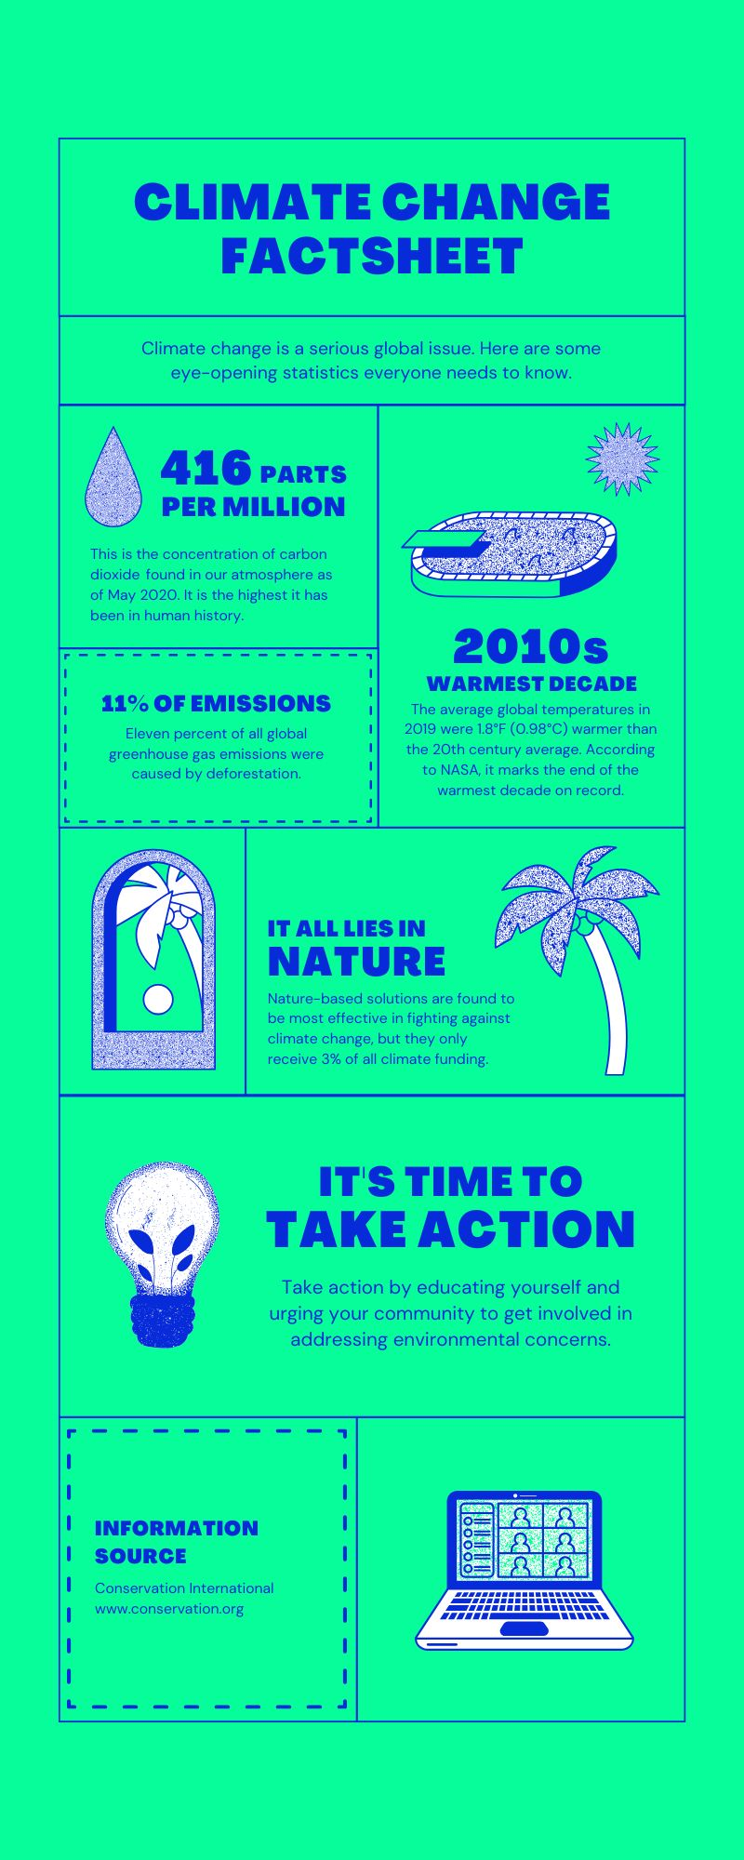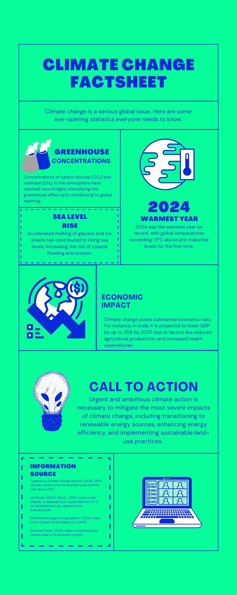

Material 2 – climate Change Scenarios

https://www.canva.com/design/DAGawbssOQM/sCbf9w0sFi46FXCSafImYA/edit?utm_content=DAGawbssOQM&utm_campaign=designshare&utm_medium=link2&utm_source=sharebutton

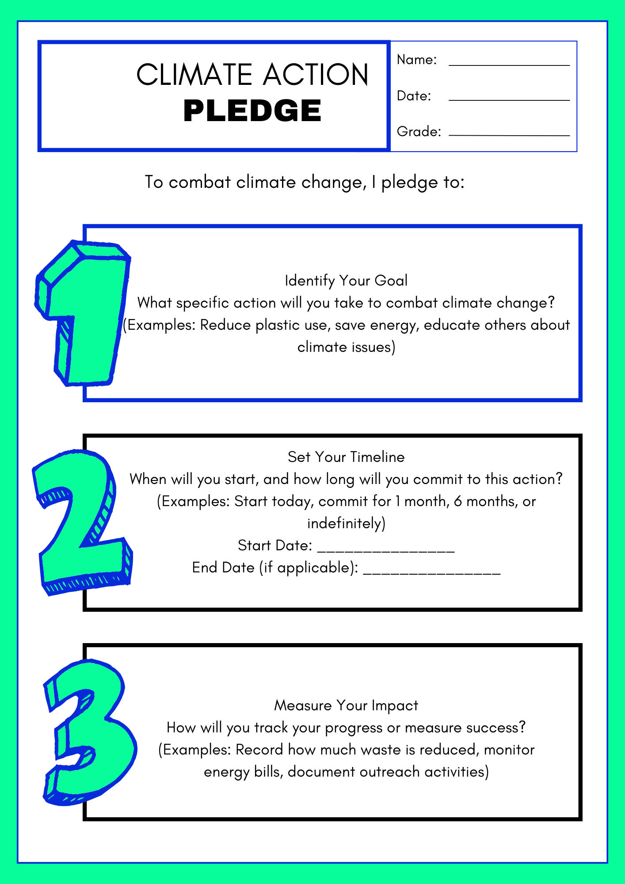
Material 3: Climate Action Pledge Template

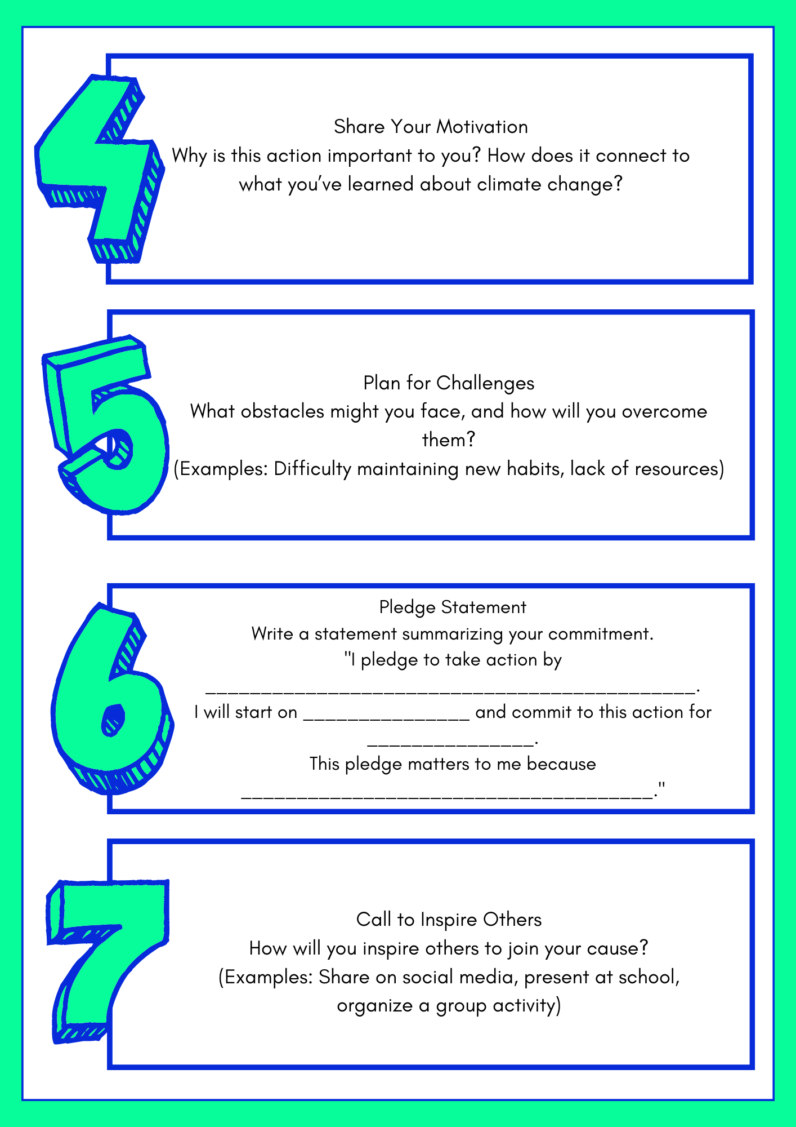

Annex – Game analysis:

