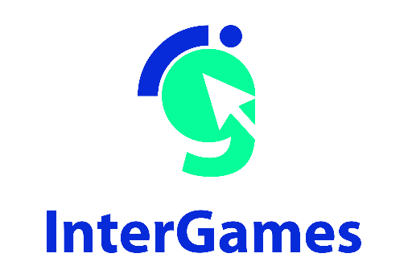

Pedagogical
Sequence

Plasticity

By Progettomondo

January

2025

Plasticity
Plasticity is an interactive video game that immerses players in a world dominated by plastic pollution. The game explores the environmental consequences of plastic waste on wildlife, ecosystems and communities. Through the eyes of a character affected by this problem, players must face challenges, make decisions and reflect on their role in the global environmental crisis.

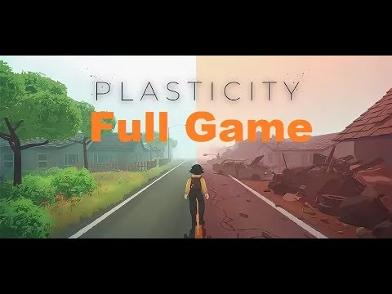

Duration: 2 lessons
Subject/s: civic education, technology, English, sciences, geohistory
Topics: environmental sustainability, consequences of plastic waste, health and human rights, global environmental awareness and responsability
SDGs: 3, 10, 12, 14, 15
Dimensions of conflict through the game:
X social impact
X environmental impact
X economic impact
☐ technological impact
Learning objectives: - Understand the environmental and social effects of plastic pollution.
- Reflect on the importance of individual actions for global environmental change.
- Promote critical thinking, cultural sensitivity and global citizenship through the topic of plastic pollution.
- Develop empathy and awareness about the impact of human actions on the planet.
Interpersonal skills: Empathy, social skills, environmental sustainability, critical thinking, teamwork, active listening
Technical requirements & material required:
Windows PC, Android, or iOS devices
• Speakers and projector or Interactive Board
• YouTube
• Printed sheets (Material 1, 2, 3)
• Physical stuff: colours, papers, posters…
Further reading/material: https://www.unep.org/resources/turning-off-tap-end-plastic-pollution-create-circular-economy
https://www.unep.org/resources/turning-off-tap-end-plastic-pollution-create-circular-economy
https://www.unep.org/resources/perspective-series/issue-no-44-opportunity-end-plastic-pollution-global-international
https://app.mapx.org/static.html?views=MX-AL9TL-ZX8GH-HT5JM&zoomToViews=true&language=en&theme=color_light
https://www.unep.org/resources/perspective-series/issue-no-44-opportunity-end-plastic-pollution-global-international
https://app.mapx.org/static.html?views=MX-AL9TL-ZX8GH-HT5JM&zoomToViews=true&language=en&theme=color_light

Preparation Phase
Ensure that there is a stable Internet connection in the classroom and that all devices are ready to access the game on the platform. Students should download the Steam platform to their PCs before the class. Prepare introductory material on the topic to be distributed and explained to the class.
Trigger warning: The game deals with issues of environmental collapse and animal suffering. It is important to warn students in advance and give them the option of express eventual too emotionally engaging. Spend some time in the preparation phase to collect from the students how they feel toward the environmental issues, eco-anxiety etc…
Optional: In the preparatory phase you can give students a homework assignment. It can be done in groups and is aimed at gathering background information with respect to the type of material that will be the focus of the learning unit. Ask them to prepare a presentation that can be shared in class: the research could be devoted to different aspects, each assigned to a specific group: plastics and their characteristics; plastic production steps; plastic disposal steps. This work, of course, is not necessary if within the curriculum these topics have already been addressed. In this case it is enough to devote a brief summary!

Game Phase
Lesson No. | Description in Steps | Social form | Material/technical requirements
1 | Step 1: Introduction (10’)  Before starting the game introduce the theme through a brief icebreaker Ask the students to “Raise your hand if...  -you have a small bottle of water in your backpack.  -if you are hosting a party provide plastic cups and plates.  -at home you use disposable items  -if you always throw your water bottle in the container provided at school.  -see around you or on you an object created by recycling plastic”  Invite the student to observe the behavior in the class and introduce the game explaining that they are going to play a videogame called Plasticity.  Warns that the video game could definitely be different than the ones they are used to but the aim of the activity is to reflect together on the issue proposed thorough the videogame. Therefore, they will have to approach it by putting themselves in the shoes of the protagonist trying to reflect in each step on what is happening, the information they gather so that they can then discuss it together. The goal is not to win but to think critically! | Plenum | PC with the videogame installed.
1 | Step 2: Play the game!  Invite the students to download the game in each PC:  https://store.steampowered.com/app/1069360/Plasticity/  As soon as all the students are ready invite them to play the game (20-30’). Give them enough time to play and complete the game. | Individual | Windows PC,  Android, iOS  devices, or  YouTube  gameplay video
1 | Step 3: Game discussion (30’)  The goal of this activity is to stimulate a deep reflection on emotions and choices made during the game, promoting a collective discussion that encourages students to share their experiences and better understand the consequences of plastic pollution.  Before starting the discussion, each student will be asked by the teacher to take a moment to reflect on the following questions and respond with key words that will then be discussed in the circle:  “How did you feel during the game?”  “What were the main difficulties you encountered in trying to reduce plastic pollution in play?”  “How did dealing with the consequences of your actions in the game make you feel?”  “What do you think we can do in real life to avoid the mistakes we saw in the game?”  Before closing the PC, ask the students to choose an evocative image that reflect his/her emotions after the game experience.  After 5 minutes of reflection, invite students to share the image with the class explaining why he/she has chosen that image and what does it represent. If you have the possibility collect all the images in an app as Padlet (http://padlet.com )  While the students express their contribution, the teacher collects the answers and puts them together in a final summary to highlight key concepts, such as individual responsibility, environmental challenges, and the importance of informed choices. | Individual, Plenum | Windows PC, padlet.com, board
1 | Step 4: Breaking news (40’)  Divide the class into groups of 5-6 students and assign each group the task of looking for a plastic-related news story: group 1: global statistics; 2. types of plastic use; 3. consequences of plastic consumption; 4. plastic and link to SDGs; 5. a good news.  After searching for information, each group completes the Material 1 sheet to then display to the class in the next meeting. You can also print and give to the groups the Material 2 to have a general overview about the problem.  You can suggest to the group some relevant links but remember that they can discover other data resources:  Group 1: https://ourworldindata.org/faq-on-plastics#how-much-plastic-and-waste-do-we-produce;  Group 2: https://ourworldindata.org/faq-on-plastics#which-sectors-use-the-most-plastic  Group 3: https://www.un.org/africarenewal/magazine/may-2023/understanding-plastic-pollution-and-its-impact-lives  Group 4: https://www.bpf.co.uk/sdgs/home.aspx  Group 5: https://www.goodnewsnetwork.org/tag/plastic/ (but we recommend to choose some news related to their country or territory of intervention) | Group work | Material 1, Material 2  Link as described, PC or tablet or smartphone

Reflection Phase

Lesson No. | Description in Steps | Social form | Material/technical requirements
2 | Step 6: Breaking news presentation (30’)  Make a recap of the previous meeting and then give the students 10 minutes to take back their presentations and fine-tune them before their presentation and decide who will be the spokesperson.  Each group will then have 5 minutes to present their work to the class.  In the last part bring the students together in a circle and initiate a shared reflection. prepare a poster board to note down their responses with respect to the questions you will ask and on which they can contribute:  - What did I learn from the research done in groups or by listening to others?  - Did I know the impacts of plastics on the environment and people?  - What was the thing that angered or affected me the most?  In closing, take up the message from the videogame “It’s never too late to make a difference” and go from there for the next step. | Work group Plenum | Videoprojector, PC, Board
2 | Step 7: It’s time to action (30’)  The data we have seen may discourage us, but change is possible, and examples of realities and organizations struggling to solve the problem are many indeed (if possible suggest to the students some nearby realities with which they could get in touch).  Introduce the UNEP video that gives an overview on possible solutions linked to reuse, reduce, transform, circular economy: https://youtu.be/kET-l4DbohQ  Introduce the experience born in Bali thanks to the activism of two sisters who founded the NGO “Bye Bye Plastic Bags”: https://youtu.be/P8GCjrDWWUM  After having watched the videos, the teacher using an app like mentimeter.com or similar, asks the students what words resonate most after listening to these experiences of activism.  Students write 3 words each and the teacher read the summary in plenary. | Plenum | Youtube links, mentimeter (or similar)
2 | Step 8: Our actions (50’)  Divide the students into groups of 4/5 and let them know that it is time to devise their own outreach action within the school. To do this they must use the material 3. Each group must identify:  1. With respect to plastic consumption or waste what problem do we observe at school?  2. which stakeholders are directly related to the problem (students, teachers, headteacher…)?  3. choose one of these stakeholders to address the campaign: what behavior should they change?  4. what is our claim to intrigue and convince them to act differently?  5. choose the image associated with your claim.  6. identify the channels to spread the message.  Now it’s time to take action! | Group work of 4-5 students | Material 3

Material 1
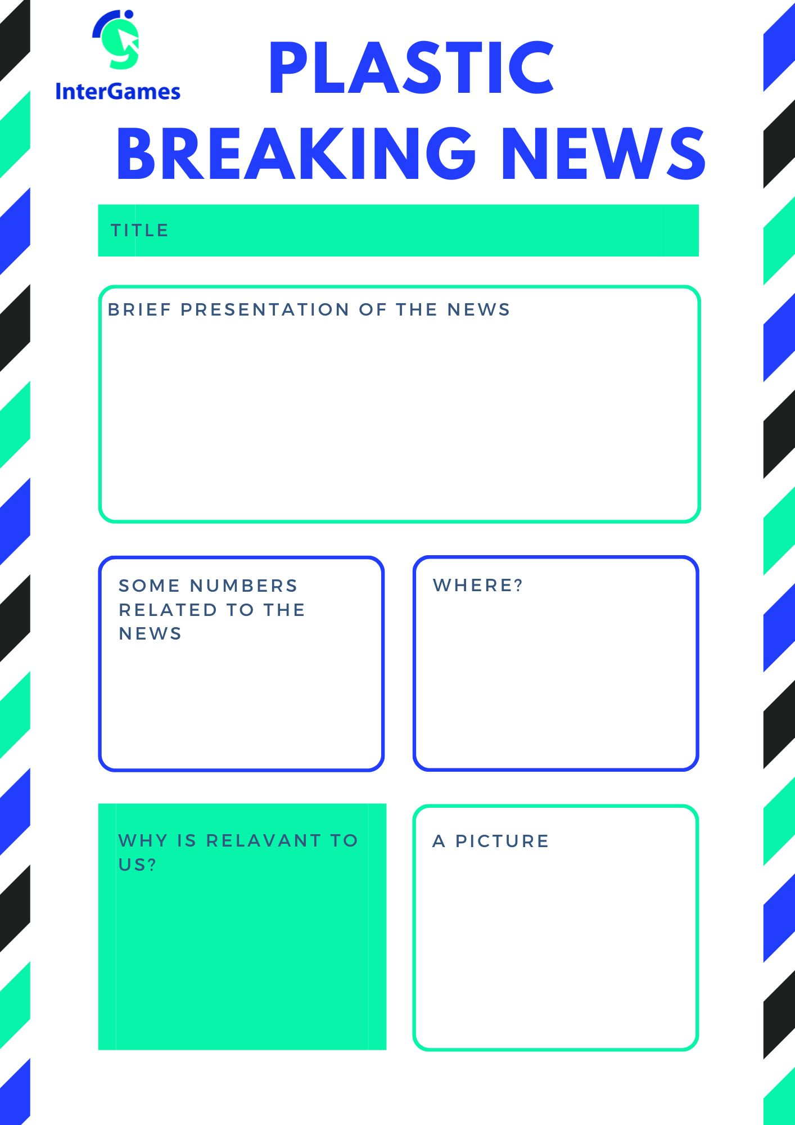

Material 2

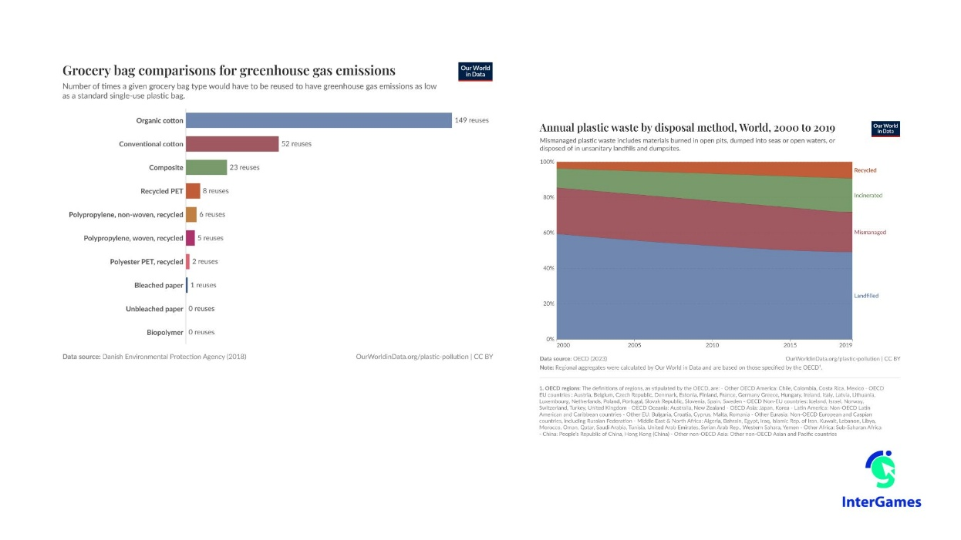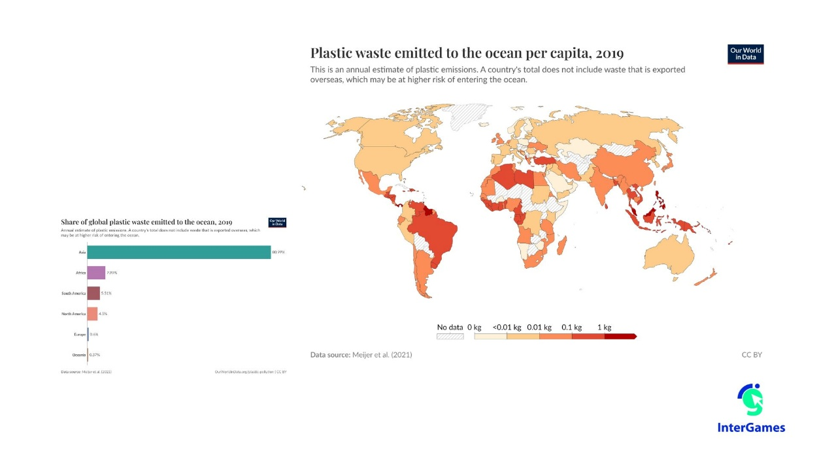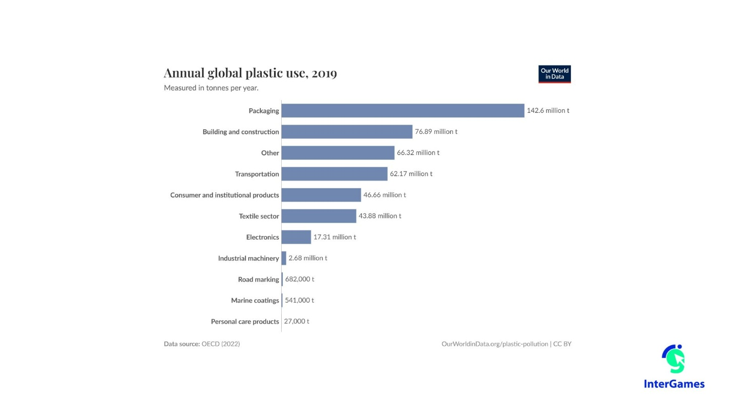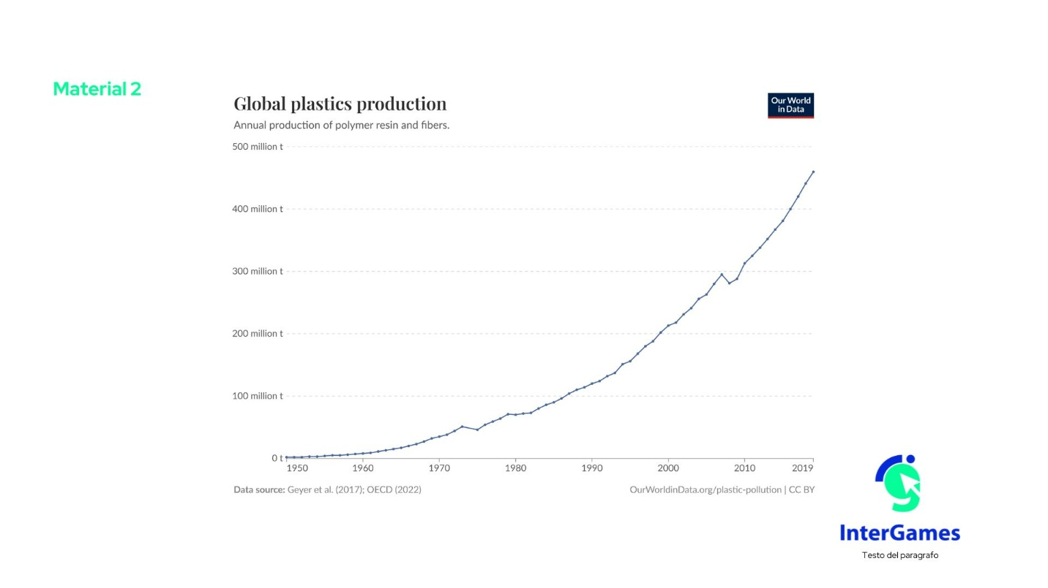

Material 3
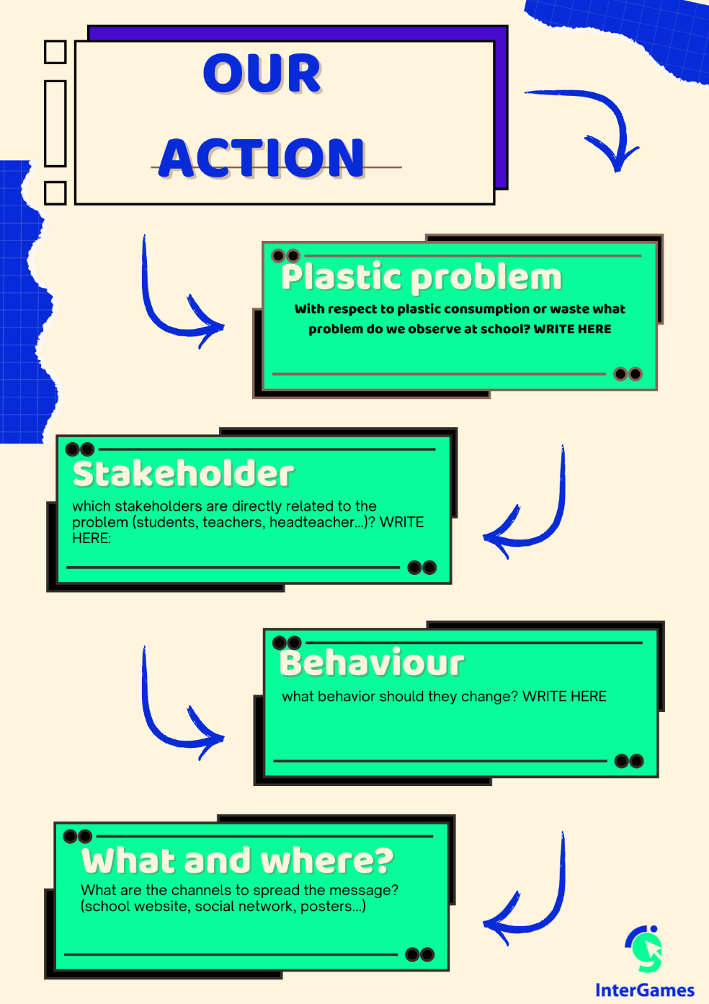



Annex – Game analysis:

