

Pedagogical Sequences – September 12th

A3.4.

January 2024
Helixconnect Europe

Contents
1. Pedagogical sequences –September 12tH 3
2. Annex – Game analysis 8

1. Pedagogical sequences –September 12tH
Title: September 12th

September 12th is a political simulation game designed to critique the cycle of violence inherent in counterterrorism strategies. The game presents a simple yet profound message: the more the player attempts to eliminate "terrorists," the more civilians are caught in the crossfire, ultimately leading to the radicalization of more individuals. The game serves as an interactive commentary on military interventions, unintended consequences, and ethical dilemmas in global conflict.

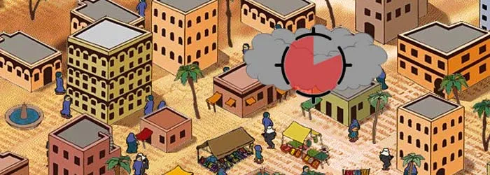
© OnSeriousGames https://www.onseriousgames.com/september-12th-a-toy-world-newsgame/

Duration: 1 lesson
Subject/s: Civics, Political Science, History
Topics: Counterterrorism, unintended consequences, ethics in military interventions, radicalization
SDGs: 16: Peace, Justice, and Strong Institutions; 10: Reduced Inequalities;
Dimensions of conflict through the game:
☒ social impact
☒ environmental impact
☒ economic impact
☐ technological impact
Learning objectives:
This sequence aims to help students analyze the consequences of military interventions on civilian populations while exploring the ethical dilemmas involved in counterterrorism strategies. Through discussions and media analysis, students will critically assess how terrorism and counterterrorism policies are represented in different narratives. Additionally, they will develop perspective-taking skills by evaluating arguments from multiple stakeholders and reflecting on the unintended consequences of violence and retaliation.
Interpersonal skills:
- Critical thinking and problem-solving
- Perspective-taking
- Critical thinking
- Media literacy
Technical requirements & material required:
- Computer with internet access
- Speakers and projector (if available)
- YouTube gameplay videos if the game is unavailable
- Printed diagrams
Further reading/material:
- Book: "The War on Terror: From 9/11 to ISIS" by Andrew Hoskins and Ben O’Loughlin
- Book: "Terrorism and Counterterrorism" by Brigitte L. Nacos
- Documentary: "The Fog of War" by Errol Morris: https://www.imdb.com/title/tt0317910/
- "The Costs of War" – A project by Brown University documenting the human and economic impact of counterterrorism operations. https://www.youtube.com/watch?v=3Rzfso9nWqA&list=PLBrPYoChOfODeNt25fzNx7i3rl1_fQQl4&index=12

Preparation Phase

To begin the lesson, introduce the game September 12th and explain its mechanics. Show a brief gameplay segment and ask students to analyze what they observe: How do the mechanics encourage or discourage violence? Lead a discussion on their initial impressions of the game’s message and how it differs from traditional war-themed games.

Next, provide students with historical case studies on counterterrorism operations, such as post-9/11 policies and drone strikes. Ask students to compare the game’s mechanics with real-world military actions and discuss the ethical dilemmas that arise. Encourage them to reflect on the long-term consequences of violence and how public opinion is shaped by different narratives.

Game Phase

Lesson No. | Description in Steps | Social form | Material/technical requirements
1 | Step 1: If devices are available, allow students to play the game in pairs for 10 minutes. If not, show a recorded gameplay session. | Plenum | Projector, PCs, YouTube video, speakers, Internet connection
1 | Step 2: Facilitate a guided discussion: What emotions did they experience while playing? (one word answers, use Kahoot to make them more interactive) How does the game illustrate the concept of unintended consequences? | Plenum | Whiteboard, markers, Kahoot
1 | Step 3: Visual Mapping Exercise: Have students create a cause-and-effect diagram that traces the chain reaction of decisions in the game to help them visually understand unintended consequences. (The templates are provided under Copy templates section). | Individual
  Diagrams
  (Copy templates 1)

Reflection Phase

Lesson No. | Description in Steps | Social form | Material/technical requirements
1 | Step 4: Discuss the role of media narratives in counterterrorism efforts by showing different news reports on military interventions. Encourage pupils to assess bias, framing, and missing perspectives. What are the ethical implications of counterterrorism? How does the media influence the public opinion? | Plenum | Projector, whiteboard,  Selected news articles
1 | Step 5: Conclude the lesson with a final discussion. Example:  Does the game challenge or reinforce existing beliefs about terrorism and military intervention? How might policymakers use this perspective to approach global security differently? | Plenum | No material required

Encourage students to think critically about both sides of the argument without reinforcing stereotypes.

Copy templates:

- Visual Mapping Diagrams:

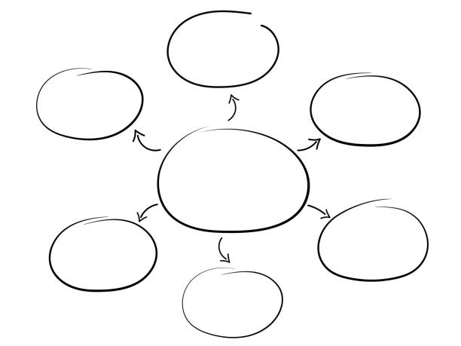
iStockphoto.com

- News articles

Additional resources:
Rothenberger, L., & Hase, V. (2024). Biased Social Media Debates About Terrorism? A Content Analysis of Journalistic Coverage of and Audience Reactions to Terrorist Attacks on YouTube. Social Media + Society, 10(4). https://doi.org/10.1177/20563051241290113
Kaskeleviciute, R., Knupfer, H., & Matthes, J. (2024). Inconspicuous Terrorists?: Effects of Terrorism News on Attitudes and Stereotypes About Muslims. Journalism & Mass Communication Quarterly, 0(0). https://doi.org/10.1177/10776990241271111
‘The international legal system has collapsed, and journalism is collapsing with it’: why 2024 was the deadliest year on record for reporters’ https://theconversation.com/the-international-legal-system-has-collapsed-and-journalism-is-collapsing-with-it-why-2024-was-the-deadliest-year-on-record-for-reporters-245228
‘Global media tell only part of Africa’s story – new report shows which outlets perform best and worst’ https://theconversation.com/global-media-tell-only-part-of-africas-story-new-report-shows-which-outlets-perform-best-and-worst-237150
‘The chilling effects of trying to report on the Israel-Gaza war’ https://theconversation.com/the-chilling-effects-of-trying-to-report-on-the-israel-gaza-war-227978

2. Annex – Game analysis
September 12th
In order to facilitate the analysis of the selected video games, a reference table has been prepared, which breaks down the main characteristics to be considered in each of these four categories.
Title
Platform | Windows PC, Web
Language | English
N. º of sessions played | 3
Total time played | 30 minutes
Brief Description | Trying to shoot the running terrorists among the civilians.

 | Dimension |  |  |  | Evaluation Criteria
 | Usability (analysis technical correctness and ease use) |  |  | of of | - Is the game easy to learn and play?  - Yes.  - Is the user interface (controls and navigation) clear and tailored to the target audience?  - Yes.  - Are accessibility options implemented?  - No.  - Is the game response accurate and fast?  - Yes.  - Are in-game messages accurate?  - Yes.  - Are there instructions?  - Yes, at the beginning.  - Is it possible to save the game?  - No, because this game has no end.  - Are there any bugs?  - Yes, the web version doesn’t work and it’s only available for PC to download.
Gameplay (analysis of the game's play and  narrative structures, and how game design produces meaning) |  |  |  |  |  | - Were you able to finish the game (yes/no: why)?  - Not really since this game has no ending.  - Duration (per level/mission or over the whole game)  - Depends on the player.  - Degree of interactivity (do the player's decisions play a crucial role in the outcome of the game)?  - Yes, to some degree. However, nothing major.  - Is the pace of the game satisfying?  - Yes.  - Narrative weight (high/medium/low)  - Low.  - Presence of a narrator: yes/no  - No.  - Presentation and role of the main character (characteristics and qualities of the character/avatar)  - The main character is the player, deciding on how and when to shoot.  - Depiction and role of the antagonist (characteristics and qualities)  - There is no description, it’s more visual (terrorists depicted wearing a rifle and under cover).  - Presentation of the setting (world in which the character develops)  - It’s pretty straightforward, it depicts a real picture of chaos of war.  - Dimension/temporality: time period covered by the story and its characteristics (fictional/real, global/local, etc.)  - No time period, it’s semi-real.  - Mission (what are the essential actions to win/complete the game)  - You cannot complete the game. The more terrorists you shoot,  the more civilians caught in the cross-fire decide to become terrorists.  - What are the implicit/ultimate goals of the game?  - To showcase how hard it is to stay morally gray or good when it comes to killing, and how ultimately that can create a vicious cycle.  - What are the main challenges/obstacles faced by the protagonist?
- You can never win. There is no right choice.
- Are the game mechanics appropriate to the content and implicit goals?
- Yes.
- Do you agree with the reward system (incentives for action)?
- There is no reward system. On the contrary, the more you kill
the more the game punishes you. However, you can also not not kill - that’s the point.
- How is the feedback system (text, audio or audiovisual comments given to the player for certain actions)?
- There is no feedback system after the game starts.
- Overall story (description of the story of the game as a whole)
- There’s not much to tell, since the game doesn’t have any complex story. The narrative itself is more visual and open to personal interpretation.
Content (analysis of the content of the game and the messages conveyed in relation to the objective) |  |  |  |  |  | - What are the themes of the game?  - War, impossibilities of war, moral dilemmas.  - What kind of reflection, knowledge, skills, competences, awareness are developed?  - The game can trigger deeply moral and ethical questions of killing as a means to achieve peace.  - Is there an explicit use of sources of information?  - No.  - Do you think the player can get the intended message without external help?  - Yes, absolutely.  - Did you change your beliefs/opinions or learn something new after playing the game?  - Yes, the game can present you with the impossibilities of making a ‘right decision’ when in war.
Didactic resource (analysing game didactic resource) |  | as | the a |  |  | - 21st century skills included:
 |  | as |  |  |  | - Critical thinking  - Creativity  - Collaboration  - Communication  - Information literacy  - Media literacy  - Technology literacy  - Flexibility  - Leadership  - Initiative  - Productivity  - Social skills
 |  | as |  |  |  | - Dimensions covered:
 |  | as |  |  |  | - Social  - Environmental  - Technological  - Economic
 |  | as |  |  |  | - Link with Intergames subjects:
 |  | as |  |  |  | - Environmental Sciences  - Civic Education  - Arts  - History  - Economics
 |  | as |  |  |  | - Competences (knowledge achieved by the learner)  - Decision-making, critical thinking.  - Problem solving conditions (way of thinking to solve problems: reproductive-memory, productive-creativity)  - Impossibility of the right choice.  - Need for prior knowledge (no/yes: detail)  - No. The game is quite straightforward.  - Learning curve (learning difficulty: low, medium, high)  - Low  - Possibility of group work (no/yes: detail)  - No, this is a single player game. However, it can be played in the group by each player and then trigger discussions.  - Does it include a teaching guide (information for teachers with tips and examples for implementation in the classroom)?
- No.
- Possibility of teacher evaluation (no/yes: please specify)
- No, since there are no winning and no right decisions here. It can only trigger conversation, but it cannot be graded in any way.

