

Pedagogical
Sequence

Aguamod

By Progettomondo

February

2025

Aguamod
Aguamod is a serious play. It encourages us to adopt a holistic approach to solve complex dynamics. We are in a future society in another planet and we have to solve some conflicts regarding the environmental, social and economic spheres, such as about wild animal eating sheep, accessibility to clean water, uniform to wear during formal meeting in the community and the last about cyberbullism against one person in the community. Our role is to understand facts, opinions and to find a solution good for everyone. To achieve the different goals, it is fundamental to recognize the interdependence among the three dimensions cited in the game, and how our actions in one field will affect the others, such as planting trees will increase the living conditions of the population in that area.

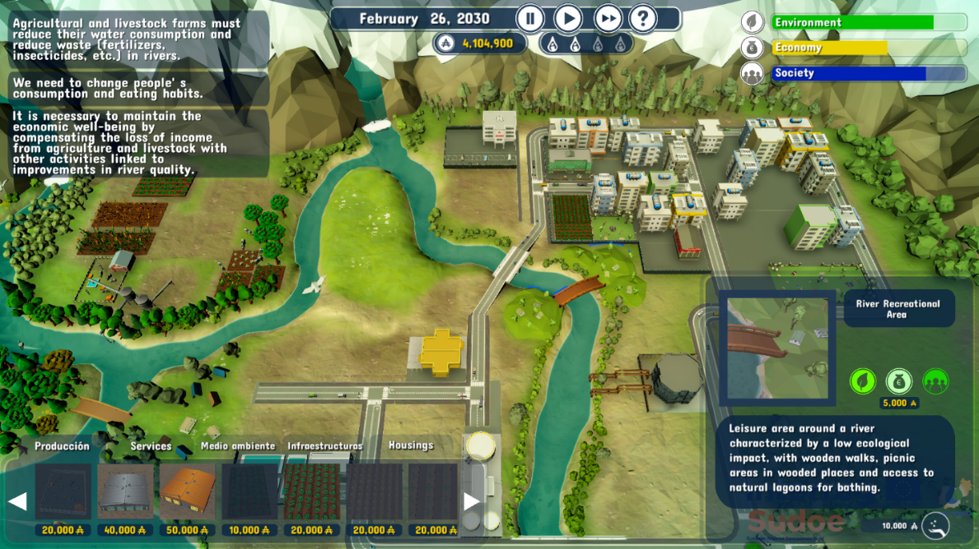

Duration: 2 lessons (5 hours in total)
Subject/s: civic education, history, social sciences, English, geography, economics, natural sciences.
Topics: mediation, decision making, water, sustainable economy, climate change, future, management of resources
SDGs:6, 7, 10, 11, 13, 16.
Dimensions of conflict through the game:
X social impact
X environmental impact
X economic impact
X technological impact
Learning objectives: Test the process of decision making and its effect, understand the difference between facts and opinion, understand the power of mediation to take a decision, understand global
issues i.e. water supply, war…Promote critical and system thinking and cultural sensitivity, interactive learning, holistic approach, raising awareness, self-reflection
Interpersonal skills: Empathy, critical thinking, system and future thinking, ability to collaborate, decision- making, prosocial identities, understanding, communication, take effective actions, planning for action, active listening
Technical requirements & material required:
Windows PC, Android, or iOS
Devices, chairs, tables
• Speakers and projector or Interactive Board
• YouTube
• Printed Material 1, 2
• Physical stuff: colours, papers, posters, images
Further reading/material: https://sdgs.un.org/2030agenda
https://www.un.org/sustainabledevelopment/news/communications-material/.
https://social.desa.un.org/2030agenda-sdgs
https://www.nasa.gov/
http://climate.copernicus.eu/

https://www.unep.org/
https://www.eea.europa.eu/data-and-maps/data-providers-and-partners/carbon-dioxide-information-and-analysis

Preparation Phase
The videogame needs to be installed on the PC (Android or Mac) through this link: http://www.aguamod-sudoe.eu/videojuego/. Ensure that all students have access to a suitable device, such as a PC, tablet or smartphone. So if the students use their laptop ask them to download the game, otherwise install the them in the PC of the informatic classroom. The game should be installed and running smoothly. A stable internet connection is important for uninterrupted gameplay, as the game relies on real-time feedback and updates based on player decisions. If available, providing students with headphones.
Trigger alarm: create a supportive environment where students feel comfortable expressing any frustrations or ethical dilemmas that may arise as they grapple with the challenges presented by the game.
The pedagogical sequence consists of two modules, structured, however, with different timetables. The first module has a duration of 2 school hours, while the second module involves conducting a Climate Action Simulation that must not be interrupted in the course. this module lasts about 3 hours.

Game Phase
Lesson No. | Description in Steps | Social form | Material/technical requirements
1 | Step 1: Web of sustainability (30’)  1.Ask participants to stand in a circle.  2. Explain that they are to build a model for sustainability.  3. You start. Hold the ball of string in your hand and name a environmental fact, for instance “a flood has happened”.  4. Hold onto the end of the string and throw the ball to someone across the circle. They catch it! There is now a straight line of string between the two of you.  5. This person has to name a consequence of the flood. It can be related to environment, people or economy. They then hold onto the string and throw the ball to a third person across the circle.  6. This third person has to think of another consequence related to the last one. He/she then throw the ball to a fourth person.  7. Continue the game so that the ball of string passes back and forth across the circle until you have created a criss-cross mesh that represents the "web of sustainability".  remaining in a circle explains to the children that they can look at the network as a set of factors that are related to different aspects: some to the economy, some to society, and some to the environment.  Introduce the 2030 Agenda, which I am sure they will already be familiar with, and explain to them how it introduces a new concept of sustainability that encompasses several dimensions. You can help by showing the SDGs and the diagram of the three dimensions of sustainability (Material 1).  Explain to them that the video game they are about to make deals precisely with the theme of sustainability by showing the relationships between the different dimensions that have been addressed. Suggest watching the video to introduce the game  https://www.youtube.com/watch?v=ACP3Sd-yChY&t=27s | Plenum | Ball of yarn or similar, Material 1
1 | Step 2: Gameplay (40’)  Invite the student to play the game accordingly to the rules explained in the preparation phase. | Individual | Windows PC,  Android, iOS  devices
1 | Step 3: Debriefing (40’)  Invite the students to sit in a circle to facilitate the exchange among students and promote active listening. Ask the students something about the experience during the game. You can choose questions among these:  - How did you feel during the game?  - What made you choose the solution you chose?  - Did you find it hard to choose? If so, why?  - Are you satisfied about your decision? How would you measure success?  - What did you think is a sustainable choice considering the experience in the game?  - Is it difficult to take sustainable decisions? Why?  As a summary, ask students to agree on find a definition of sustainability after the game experience. “Sustainability is….”Write the definition on a board or on a poster and help them to take in consideration all the references related to Agenda 2030 (https://sdgs.un.org/2030agenda) | Plenum | Board or poster

Reflection Phase
Lesson No. | Description in Steps | Social form | Material/technical requirements
2 | Step 4: Climate Action Simulation preparation  The Climate Action Simulation is a group roleplaying game to explore possible solutions to mitigate climate change and to look into its root causes. This simulation is grounded on real data, allowing participants to assess the impacts of their decisions in real time. The game is based on a mock United Nation summit, organized by the Secretary General of the UN, where different actors are called to play their role. You are the Secretary General. First of all, you have to split the class into groups which represent different stakeholders: Clean Tech; Climate Justice Hawks; Conventional Energy; Industry and Commerce; Land, Agriculture, and Forestry; Developed Nations; Developing Nations; Emerging Nations. There should be 6 groups or more, but it varies on the number of participants. Each group must be composed by 4 to maximum 6 persons, to favour discussion during the simulation. You must pre-assign students to a specific group, making sure competences are balanced within each group, such as being careful not to gather shy students all together. Be careful not to place students with a migratory background into the Developing Nations group, in order not to trigger sensitive reactions and issues. The common objective of all stakeholders is to comply with the Climate Paris Agreement (2015), by developing a plan which limit the global warming well below 2 C°, aiming at 1.5 C°. The room where the game takes place should be set up with: a projector and a computer that has access to the EN-ROADS simulator and to the PowerPoint slides of the game; chairs and tables; phone or stopwatch to keep track of time. This simulation highlights how to deal with a complex and multi-facet matter. It is necessary to adopt a holist approach and to act in different areas, which are interdependent, as already experienced in the videogame. This simulation is related to “En-roads”, developed by Climate Interactive (https://www.climateinteractive.org/). In order to adequately prepare yourself and to get knowledge on how to move the simulator’s levers and its functioning, have a look at the materials present in the platform (you can find materials that will help you in your role as facilitator here https://www.climateinteractive.org/en-roads-game-facilitator-guide; En-ROADS Workshop facilitator guide v32; and some supplemental slides here https://www.climateinteractive.org/en-roads-supplemental-slides ). | Plenum | Projector, Computer,  Internet
2 | Step 5: Introduction (5’)  By referring to the previous experience, highlight how students will now switch from a virtual simulation, related to the videogame, to a team game related to a real event: the climate change topic. While putting forward the “climate action simulation” proposal, you point out how the decisions of each group into play will affect different spheres, such as the economic, social and environmental one. To introduce the simulator platform, you can show the video Overview of the En-ROADS Climate Solutions Simulator - YouTube. | Plenum | Projector, Computer, Internet, Chairs, Tables
2 | Step 6: Climate Action Simulation experience  Begin by welcoming participants. Briefly introduce the motivation behind the event, why is important to talk about climate change (to see more materials about climate change, have a look at these slides: https://www.canva.com/design/DAGe_WxxH9o/t4KcUTuR75xL6LbaMxGqDw/view?utm_content=DAGe_WxxH9o&utm_campaign=designshare&utm_medium=link2&utm_source=uniquelinks&utlId=h72377265ad). Then, present the En-roads platform to students, where you can explore the simulator, and explain them how the simulation works (you can find the PowerPoint slides here https://www.climateinteractive.org/en-roads-game-slides ). Once groups are formed, you give participants the briefing statement related to their group and a bit of time to read it (you can find the materials here https://img.climateinteractive.org/2024/05/CAS-8-team-quick-download-May2024.zip). Members of each group can brainstorm over their goals and identity, meanwhile you can engage in conversation with the groups individually. Before starting the game, show them how the simulator works, throughout the link given in the introduction part. Then, you launch at least 3 rounds of more or less 20 minutes each, during which you should check on each group in order to coach them on their strategy and goals. Afterwards, you open the Plenary Presentations in which each group will send their representative to deliver a 1-2 minute presentation about their proposal. They can choose to add a new solution or to reverse one that was previously proposed by another party. Every time a group present their plan of action, you will input it into the simulator and, eventually, evaluate the results together, highlighting whether the temperature has decreased or increased. Each round ends when the goal is achieved or when the time is over. From the second round onwards, the different parties can communicate among each other to find common solutions. | Role Play | Projector,  Computer,  Internet, Chairs, Tables,  Phone or Stopwatch, Print briefing materials
2 | Step 7: Climate Action Simulation Debriefing  Finally, take a minute of silence to reflect on this experience. Afterwards you ask participants to step out from their roles in order for you to start a discussion, by putting forward some questions, such as: what surprised you? To what extent did your proposal taken together produce the result you expected? What will you take away from today, and how can you apply what you learned to the real world? Let them talk about their feelings and focus the conversation on building hope and channel their emotions into constructive actions, by explaining why you are hopeful, by telling a positive story, by highlighting new positive trends. Remember that the purpose of this workshop is to motivate effective actions, so give them time to talk and express themselves. | Plenum | Chairs

Material 1

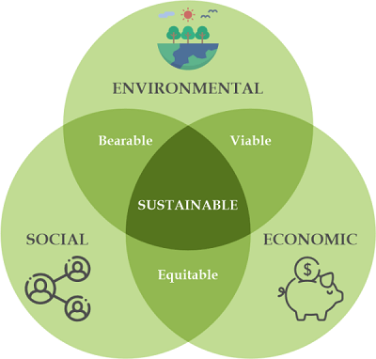

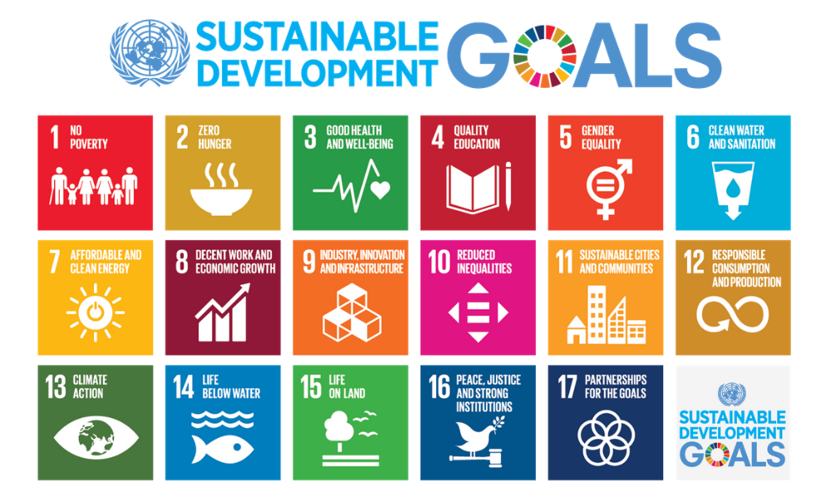

Annex 1- To know more about Climate Change

Annex – Game analysis:

© 2025 Climate Interactive. All the materials inserted are under These support materials are licensed under a Creative Commons Attribution 4.0 International License. This license lets you remix, adapt, and build upon Climate Interactive’s work, even commercially, as long as you give Climate Interactive credit for the original creation of the materials.

