

Pedagogical Sequences – PHONE STORY
A 3.5.

March 2025
Südwind

PHONE-STORY
Short description of the game: Phone Story is a mobile or browser game that provides a reflective and critical examination of the global impact of the technology industry, specifically focussing on the smartphone supply and production chain. It aims to raise awareness about the social and environmental issues associated with smartphone production. Players are invited to play 4 mini-games (alongside the scenes of mining/resources, production, consumption and recycling) and reflect on the hidden costs of their technology. The game uses its narrative and gameplay to foster critical thinking about ethical issues in the tech industry.
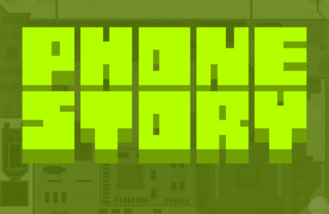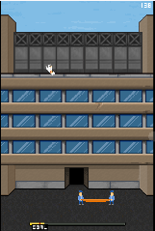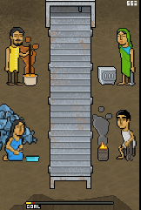
Pic No. 1-5 – Screenshot

Duration: 2 lessons
Subject/s: Economics, Civic and Environmental Education
Topics: Supply Chain, Labour Rights, Environmental Impact of Electronics, Consumer Responsibility + CSR, Overconsumption, Capitalistic Structures
SDGs: 8, 12, 13
Dimensions of conflict through the game:
☒ social impact
☒ environmental impact
☒ economic impact
☒ technological impact
Learning objectives: Pupils will know more about the four stages of the production and supply chain of modern electronics, the hidden costs and the social and environmental impact;
Pupils will understand…
…the context of globalized production chains of power and politics; …the ethical issues related to smartphone production (incl. labour conditions and environmental impact) and will be able to reflect on them;
Interpersonal skills: Critical thinking, information literacy, social skills, productive-creativity (generating personal reflections and ethical considerations) for the future decisions;
Technical requirements & material required: PC + Headphones + mouse for each student; WIFI; QR-Code to URL
Further reading/material: https://www.phonestory.org https://electronicswatch.org/en

Preparation Phase
In the preparation phase, it must be ensured that there is a strong WLAN in the room and that Internet is available for each PC. In addition, each student needs 1 PC, 1 mouse and 1 headset. To introduce the game without having the story mode played in plenum the teacher can either play the story mode beforehand and then immediately is in the obsolescence mode or he/she can turn off the speakers on the beamer/PC that presents the game to the class.
Don't work with a raised index finger on this topic. Smartphones contribute a lot to the ‘I’ - especially at this age. It's more about awareness and small steps.

Game Phase
Lesson No. | Description in Steps | Social form | Material technical requirements
1 | Step 1: Introduction  Introduction to the topic of “Production and Supply Chain of Phones” as well as the social and environmental problems that occur with it.  Questions could be asked such as “Do you know which stages are necessary to produce a smartphone?”. The four cards can be prepared beforehand (material 1) or the white-board can be used to write down the four stages.  Step 2: “Before we look into those stages a bit more into detail, you going to play a short browser game on the topic.” | Plenum | Material 1 (with tape or pins)  or  White-board + markers
1 | Step 3: Practice the mechanics  The teacher projects his/her browser and plays the (silent!) story mode or the obsolescence mode (see preparation phase) to make the pupils familiar with the mechanics. Especially the first and the third mini-game might need an explanation on how it works as the mechanics is not entirely intuitive.  As all pupils will eventually go through the “story mode” it is not necessary to showcase it while demonstrating the mechanics. Nevertheless, in case the English skills of pupils are not sufficient the teacher might as well showcase the entire story mode one time and translates afterwards the most necessary words.  “All fit for the game? So, let’s play!” | Plenum | Beamer  Teachers PC with game opened in browser;  In some cases: speakers;
1 | Step 4: Actual Gameplay  Each pupil opens a browser and enters the URL (phonestory.org) and klick on the button “Play Online” as well as on the big “play” sign that appears;  After the game has finished the page with the score appears à pupils shall stop at that point to compare in classroom, if wanted.  Each game might need around 10 min (depending on the skills of the player) – each player should have the possibility to replay at least one time (especially if he/she dropped out quickly). | Individual work (single-player) | 1 PC per pupil  1 mouse per pupil  1 headphone per pupil
1 | Step 5: Leader-Board  Even though it is not necessary, it is sometimes the intrinsic wish and very important for students to compare their scores with each other. Material 2 can be used for this purpose, or a simple class list in Excel can be projected on the wall.  It shall not be the core of this lesson plan and this step might also be skipped. | Plenum | Material 2
1 | Step 6: Reflection on gameplay  A brief reflection on the gameplay (mechanics, experience) can be done by the following questions:  “What did you enjoy most about the game? Why?”  “Were there any parts of the game that frustrated you? How did you handle them?”  “What real-life applications can you draw from the game’s experiences?”  This last question could be the transition to the next lesson and can make curious before going into a short break. | Plenum

Reflection Phase
Lesson No. | Description in Steps | Social form | Material technical requirements
2 | Step 7: Reality-Check  Go back to Material 1 – the four stages of production and supply chain of a typical Smartphone.  Now we will take a closer look on all stages and make a connection to the real world. Are the scenarios that we have been presented in the game really the case in real-life or an exaggerated parody?  Each of the four stages can be dealt in more depth – there is extensive material on all of them. In this lesson plan we suggest to keep the following goals in mind:  1 Raw material extraction à awareness raising  2 Production à awareness raising, comparison  3 Use à reflection of own behaviour  4 Recycling à take action | Plenum | Material 1
2 | Step 8: Raw-material extraction  a) Distribute Material 3 – Minerals & Substances in mobile phones worksheet so that pupils have an idea how many different substances are inside their beloved Smartphone. After this short exercise the “solution sheet” of material 3 can either be distributed or shown via beamer/pptx. | Individ. work | Material 3 (incl. solution sheet)
2 | Step 9: Conflict materials  A lot of the raw-material extraction is done under very bad working conditions and from areas that are under civic war for a long time – like the Democratic Republic of Kongo (DRC).  That is why those materials are referred to as “conflict materials”.  Project this video “Conflict Minerals 101” from “Enough Project” (2018), 2:36min long (until 1:54’) and put subtitles in your language if necessary:  https://www.youtube.com/watch?v=6aJxfEkSiPg  In Material 4 – Conflict Minerals – Video Transcript you can find a full transcript for your convenience; We recommend to show it until 1:54min if you don’t want to raise the topic of taking action and writing a letter to a brand. If you want to write a letter, you can find a template of a letter here:  https://enoughproject.org/demandthesupply  After watching this short video, you might ask some questions to summarize again the main gist of the video:  “What is the connection between the raw materials in Congo and the ‘deadliest war since the Second World War’, as the video says?”  “The video talked about the ‘Dodd-Frank 1502 law’, which forces companies to disclose their mineral resources. Do you know of a law here in Europe that holds companies accountable?” [EU Supply Chain Law see https://commission.europa.eu/business-economy-euro/doing-business-eu/sustainability-due-diligence-responsible-business/corporate-sustainability-due-diligence_en]  “What actions can you as a consumer take to reduce the demand for conflict minerals and support ethical sourcing practices?” [write a letter, see above // sign petitions from NGOs // inform about good-practices // buy less]  More Resources:  If you want to stay a bit longer on this topic there are more short videos that write about the topic of “conflict materials”:  https://www.youtube.com/watch?v=japfUdlcNvY  The Disturbing Connection Between Your Phone And Violence In The Congo by CNBC  https://www.youtube.com/watch?v=3OWj1ZGn4uM  In Focus: Congo's Bloody Coltan - a short by the Pulitzer Center  https://www.youtube.com/watch?v=aF-sJgcoY20  Conflict Minerals 101 by Enough Project | Plenum | Youtube-Link, Laptop, Beamer, Speakers, Internet
2 | Step 10: Production – Workers rights  In the second mini-game players had to catch jumping workers with safety nets. Now it’s time to tell pupils that this was not exaggerated, but that was bitter reality.  In Material 5 you will find a newspaper article on the suicides happened in Foxconn, the world’s largest contract electronics manufacturer. Present the most important points of this tragedy and then let seven pupils read the coloured paragraphs – one by one. After each paragraph write down the example of bad working condition (e.g., feeling like an invisible number, not a human; lack of help; being alone; working 12h shift; not getting paid; unpaid meetings; …) – either on moderation cards or on the board. Read or summarize the “solutions” to the suicides – one of them was to “hang safety nets”, like in the game.  In Material 6 you will find the opposite task – now it’s about decent and fair workers’ rights and laws that protect us in Europe from the stated workers conditions.  In case you have more time on that:  Make quick groups of 4-5 pupils. Half of the classroom will be distributed Material 5 – Newspaper article and half classroom will get Material 6 – What are decent working conditions? Give them 15 minutes to complete the tasks – writing on the one hand negative and on the other hand positive working conditions down; one word on one moderation card. Group and select them on a pin board and go further with the analysation.  More Resources:  Video from the Financial Times (4:59’) on Suicides in Foxconn (2010) https://www.ft.com/video/9e2886a5-fac5-3081-9b19-45d2423f0510 | Plenum  or  Working groups 4-5 ppl | Material 5  Material 6
2 | Step 11: Use & Fair Alternatives  In this step pupils shall reflect their own part in the supply chain of cell phones as well as learn more fair alternatives in the industry.  There are several variants how you can proceed.  You can take Material 7 – 5 Rs for the people and planet present it via beamer or distribute copies of it. You can also distribute the explanation with the examples or you let the pupils come up with the ideas what the step could be in practical terms when it comes to cell phones.  Another variant is that you use Material 8 – Worksheet: Cut the pyramid as well as the five Rs. Let pupils place the Rs on the position in the pyramid and then provide them with the solution. Even older pupils and adults might think of “recycling” as the first and best step – that is completely normal, as this is a concept that is the most familiar for people. So, let’s talk more about the not known steps – that are by far more effective to save resources.  More ideas on “repairing”:  https://www.ifixit.com/de-de/Store “I fix it” à for interdisciplinary work it might be nice to repair an old phone with the pupils in craft classes  Pupils could research of “repairing cafés” or other places where they can take their broken cell phone to let it be fixed.  More ideas on “fair products on the market”:  There is not yet a fully fair phone on the market – but the “Fair Phone” is working very hard to be the pioneer. You might let the pupils search on the company’s website where they dive deeper in their “impact” https://www.fairphone.com/en/impact/ and let groups present one impact in their own words. | Plenum  or group work  also, work in pairs possible | Material 7  Material 8
2 | Step 12: Recycling  Finally, the last step in the supply chain of a cell phone is reached. Pupils might be aware of the necessity of the backing-up of their data, the factory resent as well as removing SIM and memory card in their phone. But what comes after?  How is a phone properly recycled? Can someone just throw the phone in a trash bin?  Give pupils the homework to find out how a phone is properly recycled. They must find at least two ways where exactly they can recycle phones in their own neighbourhood/community. [manufacturer programs of retailers; recycling centers for e-waste; projects;]  Tipp: Think also of the accessories (chargers, cables) that came with the phone – they can be recycled as well! | Individ. work home-work
2 | Step 13: Wrap up  Wrap up the last two lessons on the phone by asking “What new things have you learnt in the last two lessons?”.  Close with a motivating sentence f.e., “Remember, even small actions can create big changes! By making informed choices and advocating for ethical practices, you have the power to shape a more just and sustainable world!” | Plenum

Copy templates:
Material 1 – Four Stages of the production and supply chain of a phone

raw material extraction

production

use

recycling

Material 2 – Leader Board

Name | Score | Level | Sessions played

Material 3 – Minerals & Substances in mobile phones
There are more than 40 different materials in a smartphone, each with its own complex supply chain, this is a significant undertaking. Here you can find a selection of eight core materials to better understand the “job” of each material within the phone. Please connect the left side - the raw material - with the right side - the intended use! Attention – it can be more then one use for one material!

Cobalt | 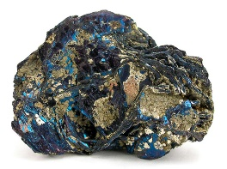 |  | Wires & connectors
Copper | 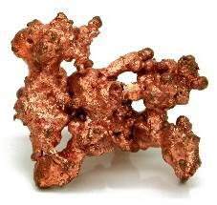 |  | Housing of the modules and the external of the phone
Gold |  |  | Battery
Lithium | 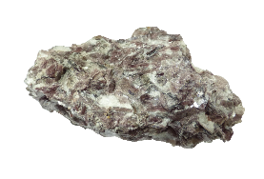 |  | Vibration motor in bottom module
Neodymium | 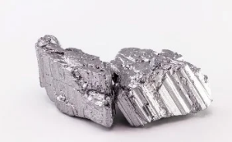 |  | Magnets in speaker module and bottom module
Plastic | 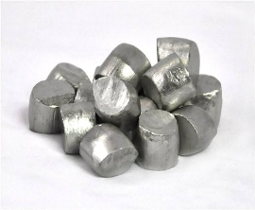   |  | Circuit boards
Tin | 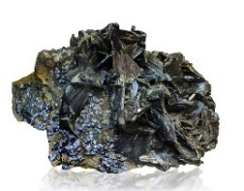
Tungsten
Material 3 – Minerals & Substances in mobile phones – Solutions Sheet

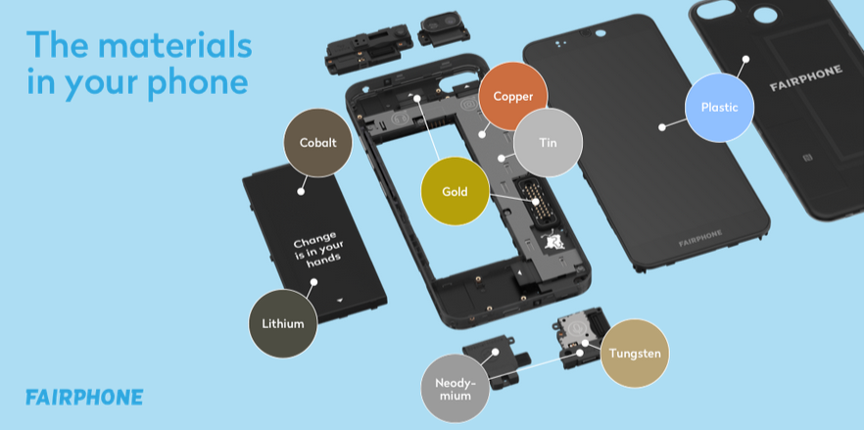

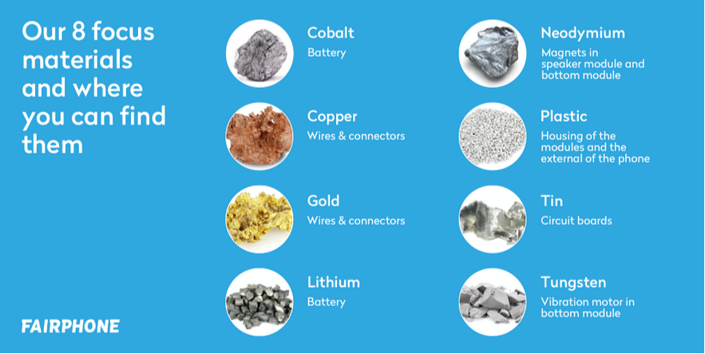
Pic Nr. 6+7 – Screenshot
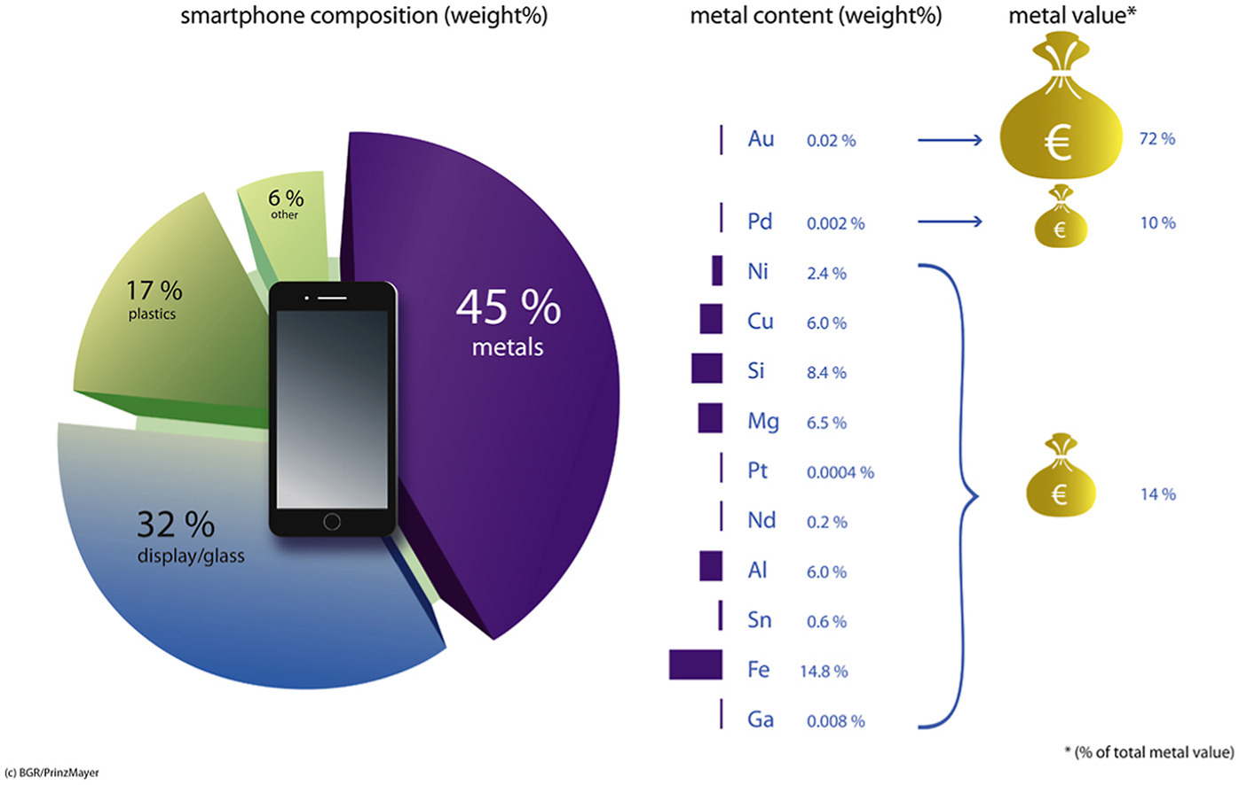

Pic 8 – Material Composition in Mobile Phones (11/2020)

Material 4 – Conflict Minerals – Video Transcript
Transcript from: Conflict Minerals 101
https://www.youtube.com/watch?v=6aJxfEkSiPg

Without Congo, you might not be watching this video.
Why?
There are four minerals used to power all our devices, laptops, cellphones, cameras.
• Tungsten makes your phone vibrate.
• Tantalum stores electricity for its battery.
• Gold coats its wires.
• Tin solders the circuit board to hold everything together.
But it's not just gadgets. These minerals are in everything, from jewellery and eyeglasses to cars, planes, and medical equipment.
They've also helped fuel the deadliest war since World War II. We call them conflict minerals.
Their theft and sale has provided key funds to armed groups committing mass violence in Congo, looting and destroying communities, abducting children as soldiers and slaves, and using rape as a weapon of war. For decades, militias and the Congolese army have profited from these conflict minerals.
But scrutiny from activists, investors, students, celebrities, and Congolese civil society has begun to turn the tide. A decade ago, activists began pressuring consumer electronics companies to examine their supply chains.
In 2010, the United States passed Dodd-Frank 1502, a law requiring companies to publicly report on their mineral sources. Before it went into effect, UN experts had reported that almost every mining deposit in eastern Congo was controlled by a military group.
Six years later, nearly 80% of tin, tungsten and tantalum miners surveyed in eastern Congo did not face the threat of armed groups. And some of the same companies that had once said it was impossible are now sourcing verified conflict-free minerals from Congo.
But it's not over.
Monitoring and reporting on supply chains must continue, as must pressure on companies that can't yet verify the conflict-free origin of their minerals. We must support projects to create and improve livelihoods in Congolese mining communities and put an end to conflict gold-smuggling, which continues to fund armed groups.
(Min 1:54) - Hi, this is John Prendergast from the Enough Project. Companies won't take these steps until they hear from you, their consumers. Demand their attention. Demand that they be part of the solution. It'll take 20 seconds of your time to send a note to 20 of the largest companies in the world to tell them to source conflict-free minerals from the Congo in their products. And if you want to do more, we have lots of options. Please go to enoughproject.org/demandthesupply.

Material 5 – Newspaper article

What happened after the Foxconn suicides?
By Margaret Heffernan (CEO, speaker and writer),
August 7, 2013 / MoneyWatch

MoneyWatch) In 2010, 18 employees making iPhones and iPads at the Foxconn factory in China attempted suicide. Much was made of this in the media at the time - although few people paid attention to the fact that Taiwanese-based Foxconn, the largest private sector company in China, also works for Microsoft, IBM, Samsung, Amazon, HP, Dell and Sony. Nevertheless, with the focus on Apple, Steve Jobs gamely insisted that the factory, with swimming pools and cinemas, was far better than required. The Foxconn communications director Liu Kun, argued that with more than a million employees in China alone, the rate of "self-killing" wasn't far from China's relatively high average. Everyone pledged to do better and the story went away.
Well, not quite away. A team of courageous researchers, Students and Scholars against Corporate Misbehavior (SACOM), pursued the story. Working as a team to protect themselves and their interviewees, Jenny Chan and her colleagues interviewed Tian Yu, a 17-year-old-girl who had attempted suicide after her first month at Foxconn. She survived but suffered multiple spinal and hip fractures and was left paralyzed from the waist down. Her story, now published in the academic journal New Technology, Work and Employment, sheds an extraordinary light on the process that feeds us new gadgets every day.
Yu stood in line an entire morning to apply for the job, filling out the job application, taking a blood test and having her fingerprints scanned. She got a staff number and an employee handbook full of motivational encouragement: "'Hurry toward your finest dreams, pursue a magnificent life. At Foxconn, you can expand your knowledge and accumulate experience. Your dreams extend from here until tomorrow." At orientation, she and her fellow new hires were told stories of entrepreneurs Bill Gates and Steve Jobs as inspiration for their new careers.
She was late for work the first day because the site is so vast and confusing that she got lost. "The factory directory shows that there are ten zones listed from A to H, J, and L, and they are further subdivided into A1, A2, A3, L6, L7, J20, and so on. It takes almost an hour to walk from the south main gate to the north main gate, and a.m.another hour to walk from the west to the east gate. I did not know what each building was, nor did I know the meaning of the English acronyms that could be seen written everywhere, such as FIH [Foxconn International Holdings] and the JIT [just-in-time] Hub."
Yu's job was inspecting screens to ensure they weren't scratched. She woke at 6:30 a.m., attended an unpaid meeting at 7:20 a.m. and started work 20 minutes later. Lunch was at 11 a.m. and she usually skipped dinner to work until 7:40 p.m. -- a 12 hour day. Technicians from the engineering department time every task and, if workers can meet the quotas, the targets are increased. Anyone unable to meet their hourly quota is not allowed to rest. Conversation in the workshop was forbidden.
Quotations from Foxconn's CEO, Terry Gou, adorn the walls: "Growth, thy name is suffering," and "Execution is the integration of speed, accuracy and precision." Then there was, "Achieve goals or the sun will no longer shine."
To achieve targets, Yu had to adopt a particular posture, her stool had to stay within yellow and black lines; every movement was studied, rationalized and standardized for maximum efficiency. Although Yu made no mistakes, she saw others punished by being made to stand at attention for hours or endure a public humiliation of reading statements of self-criticism.
Sleeping in a company dormitory, Yu made no friends because her shifts were always being changed, making it hard to develop personal relationships. Her roommates also were from different parts of China, so there were significant linguistic barriers. Those might have been overcome with time -- except there was no time. The factory was, she said, "a massive place of strangers."
At the end of her first month, Yu received no wages because of an administrative error that no one helped her to resolve. She had to take a bus to another factory of 130,000 people where she had to try to find someone to locate her wage card. No one would help her. The second-hand cell phone her father had given her when she had left home broke and she had no money left. With no friends, no communication and no money, she jumped from her dormitory window.
Because of her injuries, Yu can no longer be a migrant worker. Although she eventually went back to her family in the country, she can't be a farm worker either. She has managed to learn to brush her teeth, dress herself and sit up and has started to weave slippers to earn a little income.
Foxconn's response has been, fundamentally, to blame the workers. CEO Gou insists that if he were running the factory in his homeland Taiwan, he would not be held responsible for the suicides; only in China is he forced to bear this burden. Now, new hires must sign an anti-suicide pledge, promising that if they kill themselves, the company won't be blamed or pursued for compensation "so that the company's reputation would not be ruined and its operation remains stable." Only after an outcry did the company retract the document.
It put up safety nets instead.
Labor unions have operated within Foxconn since 2006, but they are more symbolic than real. The chief union liaison is the CEO's special personal assistant, who is on record as saying, "Suicide is foolish, irresponsible and meaningless." Wages have been increased by 9 percent, but quotas have risen by 25 percent. A worker making 5,120 phone casings per day now has to make 6,400 per day. A company phone helpline isn't trusted. The young workers who had hoped they might be able to work hard, save up and leave to start their own businesses mostly fail. Their dreams of professional advancement give way to exhaustion.
Chinese sociologists have warned that the suicides should be seen as loud cries for help from the population of migrant workers. Taiwanese scholars have called for an end to military discipline in factories. Foxconn has replied with a commitment to increase productivity and replace some jobs with robots.
The problem here is not shortage of funds. Apple is the second-most profitable company in the Global Fortune 500. Samsung ranks 12th, Microsoft 17th. Trading as Hon Hai Precision Industry, Foxconn ranks No. 40 in the Global Fortune 500, with profits of $3.2 billion in 2013. It's clear who gets the lion's share of this relationship.
According to other Research by Chan, "Foxconn's operating margins have declined steadily over the past six years, from 3.7 percent in the first quarter of 2007 to a mere 1.5 percent in the third quarter of 2012, even as total revenues rose in the same period with the expansion of orders. By contrast, Apple's operating margins peaked at 39.3 percent in early 2012 from initial levels of 18.7 percent in 2007."
You don't have to be an economist to appreciate that this is fundamentally a redistribution of wealth, from the productivity of Foxconn workers to the shareholders. What that means is that the employees of Foxconn don't just make our phones; they also fund our portfolios.
Source: https://www.cbsnews.com/news/what-happened-after-the-foxconn-suicides/ © 2013 CBS Interactive Inc. All Rights Reserved.

Material 6 – Decent working conditions
Task: Please find at least five rights you have at work in Europe and write it in the screens below.

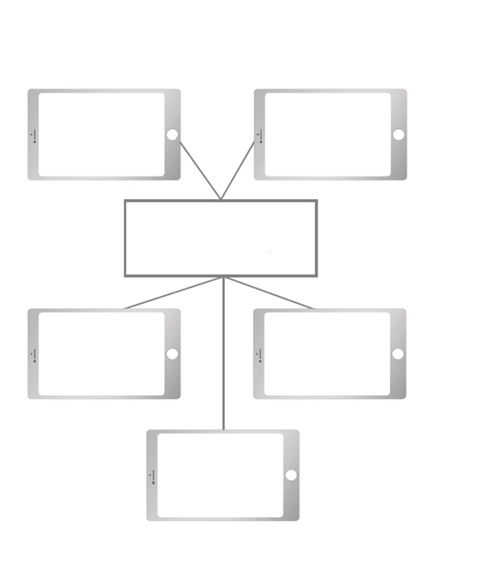
WORKERS RIGHTS
Material 7 – 5 Rs for the people and planet

Step 1: Refuse – Politely say no to items (e.g., plastic bags). It can take some practice, but this is the most effective way to minimize waste. Refuse to fall for the marketing of big phone companies that want to sell you basically the old phone with little new features for a high price. Ask yourself if you really need this one next phone even though yours is still very new and has all functions that you need. Refuse to compare yourself with others based on material things.
Step 2: Reduce – Reduce what you buy (especially items wrapped in lots of packaging). With electronics it means, use your phone less by turning it off when you are not using it but also avoid unnecessary apps and updates. Everything needs resources!
- With those two steps you help the planet and the workers the most: It means there is simply no new extraction needed.
Step 3: Reuse – Give your old phone to someone else who can use it, like a family member or a friend. Instead of throwing away a broken phone, try to fix it. You can replace a cracked screen, a dead battery, or other faulty parts (at least in some phones!). Many companies provide spare parts and guides to help you repair your phone yourself or through a professional.
- By repairing, you're not only saving money but also reducing the demand for new resources and minimizing electronic waste. It's an important step that contributes to a more sustainable use of our technology.
Step 4: Repurpose – It is also known as “upcycling”. You might be surprised to learn how many products serve more than one purpose. Turn your old phone into a music player, a security camera, or a remote control for other devices.
Step 5 – Recycle – When your phone stops working, take it to a recycling center where it can be broken down and used to make new phones or other products. Just never throw it in the normal trash bin and also do not put it in a “hidden drawer” where it stays for many years. There are very precious materials inside as you now know!

Material 8 – 5 Rs for the people and planet – Worksheet

Recycle

Repurpose

Reuse

Reduce

Refuse

Annex – Game analysis:

[in the end there should be all analysis – from the Game Analysis Report by UDC – included there with 10pt]

from: https://www.molleindustria.org/flash/index.html?file=/swf/phone_story_web.swf. Last opening on 12.11.24
In Austria we have a so called “Ö3-goodie bag” – a project of a popular radio station with the post offices – collecting old phones from each household by a paper bag that you can place in any post-box and will be delivered free of charge to a certified recycling station.
from https://www.fairphone.com/en/2021/01/17/fair-materials/. Last opening 11.12.24
Source: https://ars.els-cdn.com/content/image/1-s2.0-S0301420720301392-fx1_lrg.jpg, 11.11.2024

