

Pedagogical Sequences – PLASTICITY
A 3.5.

April 2025
Südwind

Plasticity
Short description of the game: Plasticity is a puzzle-platformer game set in a plastic-ridden future where players take on the role of Noa, a young girl navigating through a world affected by pollution. The game features dynamic gameplay that responds to player actions, offering an emotional and environmental message. Developed by 30 students, it aims to raise awareness about pollution and climate change.

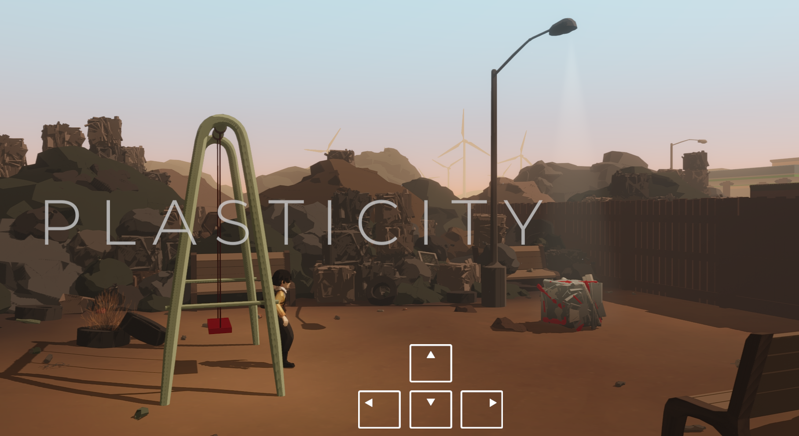
Pic No. 1 – Screenshot

Duration: 3 lessons (+1)
Subject/s: Economics, Civic and Environmental Education, Arts
Topics: Environmental Awareness, Pollution, Sustainability, Plastic Waste, Overconsumption, SDGs, Climate Change, Health, Life on land and Sea
SDGs: 9, 10, 11, 12, 13, 14, 15
Dimensions of conflict through the game:
☒ social impact
☒ environmental impact
☒ economic impact
☒ technological impact
Learning objectives: Pupils will learn about environmental consequences of garbage use and waste, environmental and ethical awareness about sustainability and production circles, pollution, and sustainability, focusing on the consequences of plastic waste
Pupils will understand…
the context of globalized consumption and disposal of plastic waste and its consequences
the environmental impact of plastic use on biodiverse life and will be able to reflect on
Interpersonal skills: Critical thinking, information literacy, productive-creativity (generating personal reflections and ethical considerations) for the future decisions; Technology Literacy, Initiative; Empathy
Technical requirements & material required: PC + Headphones + mouse for each student; Keyboard, WIFI; QR-Code to URL
Further reading/material:
Sungai Watch.2023. Project Report 2023. https://www.canva.com/design/DAF6GTqlzhs/RwjfzonUGjswQ2dlU5RV2g/view?utm_content=DAF6GTqlzhs&utm_campaign=designshare&utm_medium=link&utm_source=editor#25 [19.12.2024; 12:47]

OECD.2022. Plastic pollution is growing relentlessly as waste management and recycling fall short, says OECD. (https://www.oecd.org/en/about/news/press-releases/2022/02/plastic-pollution-is-growing-relentlessly-as-waste-management-and-recycling-fall-short.html)

Preparation Phase
In the preparation phase, it must be ensured that there is a strong WLAN in the room and that Internet is available for each PC. In addition, each student needs 1 PC, 1 mouse and 1 headset and keyboard. The game is available at the platform ‘Steam’. In preparation for the lessons, it should be downloaded. Teachers should calculate some time for that process.
Note & Learning from specific School-testings: The most challenging aspect of playing ‘Plasticity’ at school is the preparation. If the group is using school PCs or school-owned laptops, the administrator must be contacted in advance to either install Steam and the game before the lesson or grant students the necessary permissions to install the game themselves. Also, headsets are quite necessary to dive into the game-play and get immersed. In addition, it is essential that the teacher has played the game a few times themselves. As the controls are sometimes a little tricky and players may need help with how to move the fugue, the teacher needs this ‘mechanical’ knowledge.
Tipp: The frustration that could arise because the controls are sometimes a bit buggy could be framed in such a way that you also need staying power and resilience for environmental protection and giving up is not an option!

Game Phase
Lesson No. | Description in Steps | Social form | Material technical requirements
1 | Step 1: Introduction  Plastic is a material which has a fixed place in of our lives. 30 seconds to think about (if you want, use a countdown):  Find 5 items in your daily life, made out of plastic (followed by a short discussion). You can also collect the answers on the (white)board.  - Key aspect: plastic is in our daily life in most of the goods we consume. But where does it come from and where does it end up? I t needs to be produced (extraction); transformed (production) and disposed (recycled, discarded).  Look together at the graphic of the plastic life cycle (Material 1):  - How is plastic produced? (Extraction, Production)  - How and where is it discarded? (Recycling, Disposal) | Plenum | White-board + markers, chalk; Info-graphic (Material 1)
 | Step 2: “Before we look into those stages a bit more into detail, you are going to play a short browser game on the topic.” | Plenum
1 | Step 3: Practice the mechanics  The teacher projects his/her browser and shows the pupils the outline of the video game “Plasticity”.  There are only 4 buttons to use (CTRL, directional buttons) to run and jump. A game takes approximately 20-30 Minutes, there will be breaks during the game to read and get into the story.  “All fit for the game? So, let’s play!” | Plenum | Beamer  Teachers PC with game opened in browser;  In some cases: speakers;
1 | Step 4: Actual Gameplay  Each pupil opens a browser and enters the URL https://store.steampowered.com/app/1069360/Plasticity/ installs the game and click “Play now”. After starting the game, pupils we see the title and can start right away.  Option 1: Every player does a playthrough of the game and decides themselves the outcome of the game.  Option 2: The class is divided into two groups. One group is instructed to always choose to help, the other group is instructed to ignore beings in need. (If you have enough time, and can do a second playthrough, you can also let the pupils do the opposite, of what they did first to have a direct comparison). | Individual work (single-player) | 1 PC per pupil  1 mouse per pupil  1 headphone per pupil  1 Keyboard
1 | Step 5: Reflection on gameplay  Go back to Material 1 – the graphic of the plastic life circle, keep it in mind, when we discuss the following questions about the game “Plasticity”.  Option 1:  Reflexive questions after the playthrough  - How was it?  - What was your outcome of the game?  - Why did you decide to help/not to help?  - Would you change your decisions after knowing the ending?  - Do you see any relation to our planetary situation?  Option 2:  Reflexive questions after the playthrough  - What were the differences in your gameplay?  - How did you feel about your decisions during the game?  - Would you change your decisions after knowing the ending?  - Do you see any relation to our planetary situation?  - “What real-life applications can you draw from the game’s experiences?”  This last question could be the transition to the next lesson and can make curious before going into a short break. | Plenum | Material 1
Though the game itself displays a virtual world, it bears lots of similarities to ours. Pictures and Emotion should be talked through thoroughly (especially during the reflexion phase).

Reflection Phase
Lesson No. | Description in Steps | Social form | Material technical requirements
2 | Step 6: Extraction, Production:  Video: “How is plastic made?”  https://www.youtube.com/watch?v=Y7e2yHxZl3A  Tipp: Ask the physics teacher to discuss the topic “plastic” with the students or show them an experiment during their next class. Invite him/her to the lesson.  Watch the video and ask afterwards, if everything was understandable. Work with the working sheet (Material 2a + b) and compare it in the end with the whole class. | Plenum | Youtube-Link, PC, Speakers, Internet,Material 2a+b
2 | Step 7: Consumption  Talk in pairs – Sustainability: Plastic and the SDGs  The sustainable development goals are 17 goals for a better life for all. 193 states agreed to work towards fulfilling the goals until 2030. The goals are connected, applicable on all levels (individuals, schools, institutions, municipalities, countries). They are called sustainable, because they focus on social, ecological and economic aspects and they promise to “leave no one behind”, so they take especially vulnerable groups into account.  Read more about the goals here:  https://www.unicef.org/sustainable-development-goals  Or watch this short video  “Sustainable Development Goals - EXPLAINED in 5 minutes! (SDG’s)🌎🍀”  (https://www.youtube.com/watch?v=RmCH_--xHT8)  Discuss the following three questions with your partner:  - What do you remember about the game “Plasticity”?  - How sustainable is plastic?  - Work together on the task on your working sheet (Material 3) | Plenum,  small groups of 2-3 | Material 3, Youtube-Links, Laptop, Beamer, Speakers, Internet

2 | Step 8: Consumption and Waste  Read the peculiar story of the 28 000 rubber ducks lost at sea in 1992 and how they can still be found today.  Discuss the questions below. (Material 4). |  | Material 4
2 | Step 9: Reality Check (Homework)  Let the pupils follow the instructions on Material 5 (Homeworksheet).  On Instagram: Search for influencers on Instagram in Bali. What is shown? What pictures appear. Take a view screenshot or write down links to videos.  Look at the Instagram post of Sungaiwatch or makeachange.world and see their work in Bali.  Click through the 2023 report and have a look at the top polluting brands. Which brands do you know? Which are available in your country?*  https://www.canva.com/design/DAF6GTqlzhs/RwjfzonUGjswQ2dlU5RV2g/view?utm_content=DAF6GTqlzhs&utm_campaign=designshare&utm_medium=link&utm_source=editor#25  Read the article about the “great pacific garbage patch.” https://www.bbc.com/future/article/20240115-visualising-the-great-pacific-garbage-patch  The true size of …. https:/www.thetruesize.com  “A 2018 study predicted at least 79,000 tonnes of ocean plastic are floating inside an area of 1.6 million sq km (618,000 sq miles) – a figure that is four to 16 times higher than previously reported. This is twice the size of Texas, or three times the size of France.”  Key aspect: Self-determined exploration of the topic of environmental conditions and the effects of plastic using a regional example | Indiv. work | Material 5; Internet on phone or Computer,
3 | Step 10: Comparison on homework  - Let the students show their results of their search about plastic pollution in rivers in Bali, Indonesia.  - What did surprise you? How did you personally feel about the pictures you found online?  - What happens with the garbage collected in Bali?  The last question can be used as a transition question to work on the solutions. | Plenum  or in pairs
3 | Step 11: Recycling and Disposal of Plastic  Introduction: We have played “Plasticity”, we saw how a world littered by plastic could look like. In your homework you have made a reality check and read about plastic in the oceans. We see that we are not that far off the virtual world, if plastic is not correctly recycled or disposed of.  What can we do?  Step 11 can take be done within a lesson, or if possible, on a bigger scale as a school project within a week or over a longer period.  Collect ideas on your whiteboard or flipchart.  (Collect and dispose correctly, recycle, alternative resources, reusable materials, buy les plastic, refillable bottles for drinks and hygiene products etc., raise awareness)  Go back to the Info-graphic (Material 1): only 9% of worldwide plastic is recycled (https://www.oecd.org/en/about/news/press-releases/2022/02/plastic-pollution-is-growing-relentlessly-as-waste-management-and-recycling-fall-short.html)  - We have BIN there (Worksheet)  Separate into small groups and sections and inspect your school. How is plastic discarded? Are their recycling containers? Use the worksheet to collect data (Material 6) and compare it at the end.  - What can we change in our school. Keep in mind the 17 sustainable goals, when you think about practical solutions.  - You can write them down in the working sheet (Material 7) | Working groups 4-5 ppl | (White)-board, Flipchart, Pens, Material 6, Material 7, Material 3 (on the beamer), Beamer
3 | Step 12: Take the Quiz!  Answer the questions about plastic and repeat and wrap up what you have read and learnt. The quiz was created by Columbia Climate School.  https://news.climate.columbia.edu/2024/04/11/quiz-plastics-101/ | Plenum, individual | Smartphone, PC, Beamer, QR-Code with Link (Material 8)
4 | Step 13: Spread the news (optional lesson)  Here are some more ideas to continue in a interdisciplinary way and to raise awareness  - Use the collected ideas and data to make a change. Let the students write an action plan with measurements to change plastic use in your school. Present it to the head of school and other teachers or boards.  - Start an art project. Collect all plastic items which are used within a week during school hours and sculpture a statue or display it in your school (arts).  - Let students use the information collected in these lessons to write a short exhibit (language lessons, arts)  - Show the degree of degradability of plastic and plastic alternatives (e.g., compost it).  - Visit local landfills or recycling companies  - Let students do research about local solutions and ideas and garbage laws in your country.  - Whole school approach: think also about the people at your school who have a direct impact on garbage: janitor, cleaning personnel, include them in your findings | Plenum,small groups

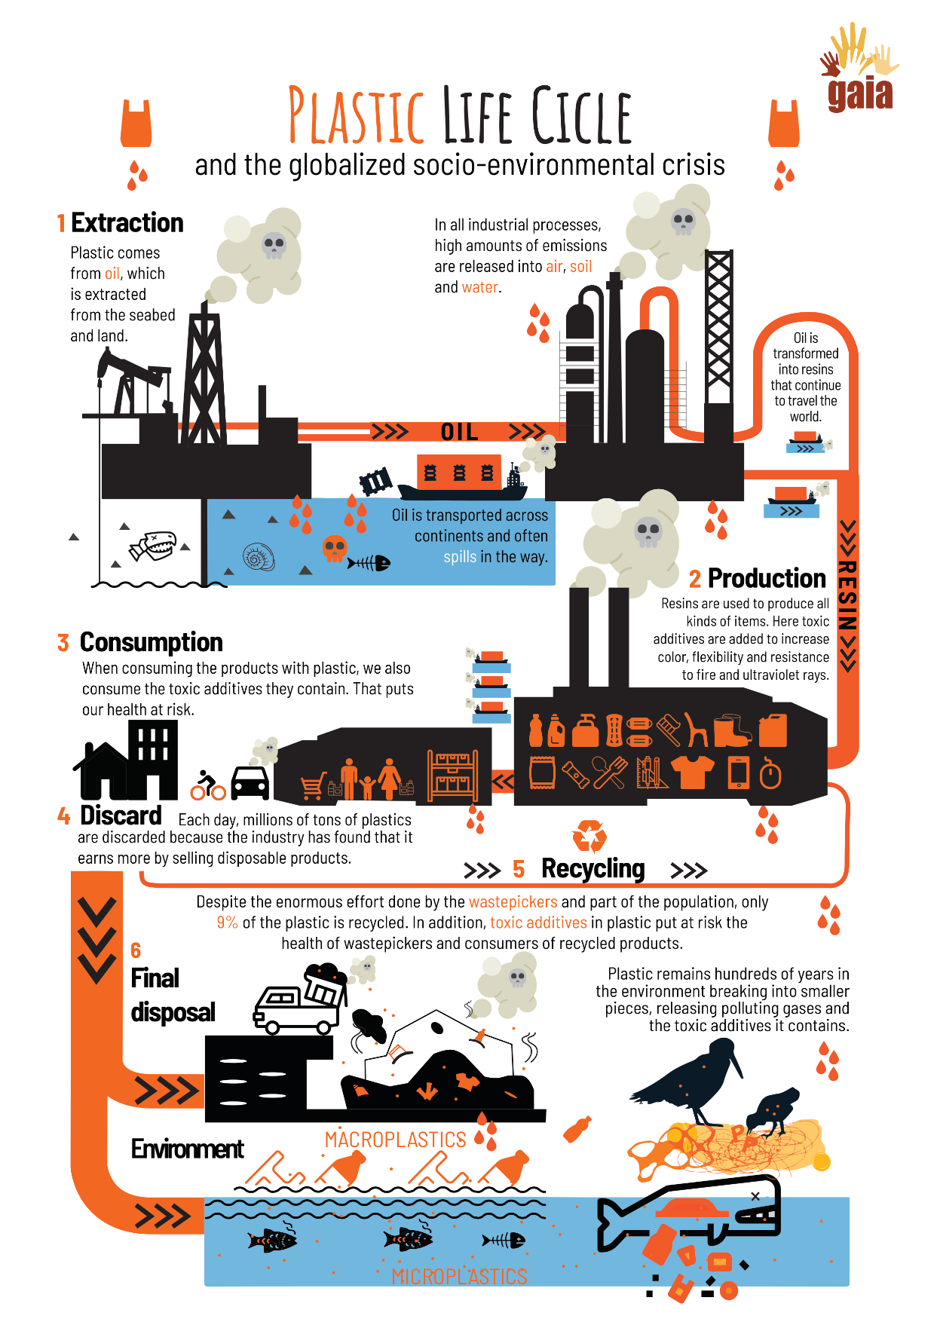
Copy templates:
Material 1 – Graphic Plastic Life Circle

from: Plastics crisis: challenges, advances and relationship with wastepickers. 2022.https://www.no-burn.org/wp-content/uploads/2022/11/Plastics-Crisis-ENG.pdf [19.12.2024; 15:09]
Material 2a – Correction Sheet

1 A nonrenewable energy source and a type of fossil fuel. Similar to coal and natural gas, it was created from the remains of ancient marine organisms, including plants, algae, and bacteria. Over millions of years, the combined effects of intense heat and pressure transformed these organic materials into carbon-rich substances that serve as the basis for fuel and numerous other products we use today.

1 Petrolium (Crude Oils)

2 Drilling
2 Oil is drilled on land using rigs and offshore from platforms. Most modern wells use air rotary drilling rigs, where engines power a drill bit to create a borehole. As the bit cuts through rock, air is pumped through the drill to carry rock fragments to the surface for geological analysis. When oil is struck, it may initially gush out. Pumps are then used to extract the oil, utilizing an up-and-down motion to bring it to the surface.

3 Process of Purification of crude oil before it can be converted into fuel or other products.
3 Refining

4 Process which breaks heavy hydrocarbons into lighter molecules using heat, pressure, and sometimes catalysts. It is crucial for producing gasoline and diesel fuel.

4 Cracking

5 Process where small molecules, called monomers, join together to form large molecules called “polymers”. These polymers can be made from one type of monomer or several, and usually need at least 100 monomers to have special properties like elasticity, strength, or the ability to form fibers. Some polymers are made of thousands of monomers.
5 Polymerization

6 Standardized plastic pellets (cut plustic strands).
6 Nurdles

Material 2b – Working Sheet

Watch the video “How is plastic made” on Youtube. Write the number of the term to its correct definition.

Process of Purification of crude oil before it can be converted into fuel or other products.

Process where small molecules, called monomers, join together to form large molecules called “polymers”. These polymers can be made from one type of monomer or several, and usually need at least 100 monomers to have special properties like elasticity, strength, or the ability to form fibers. Some polymers are made of thousands of monomers.
1 Petrolium (Crude Oil)

2 Drilling

A nonrenewable energy source and a type of fossil fuel. Similar to coal and natural gas, it was created from the remains of ancient marine organisms, including plants, algae, and bacteria. Over millions of years, the combined effects of intense heat and pressure transformed these organic materials into carbon-rich substances that serve as the basis for fuel and numerous other products we use today.

3 Refining

4 Cracking

Process which breaks heavy hydrocarbons into lighter molecules using heat, pressure, and sometimes catalysts. It is crucial for producing gasoline and diesel fuel.

5 Polymerization

6 Nurdles
Oil is drilled on land using rigs and offshore from platforms. Most modern wells use air rotary drilling rigs, where engines power a drill bit to create a borehole. As the bit cuts through rock, air is pumped through the drill to carry rock fragments to the surface for geological analysis. When oil is struck, it may initially gush out. Pumps are then used to extract the oil, utilizing an up-and-down motion to bring it to the surface.

Standardized plastic pellets (cut plastic strands).

Material 3 –Environmental and social Impacts of plastic

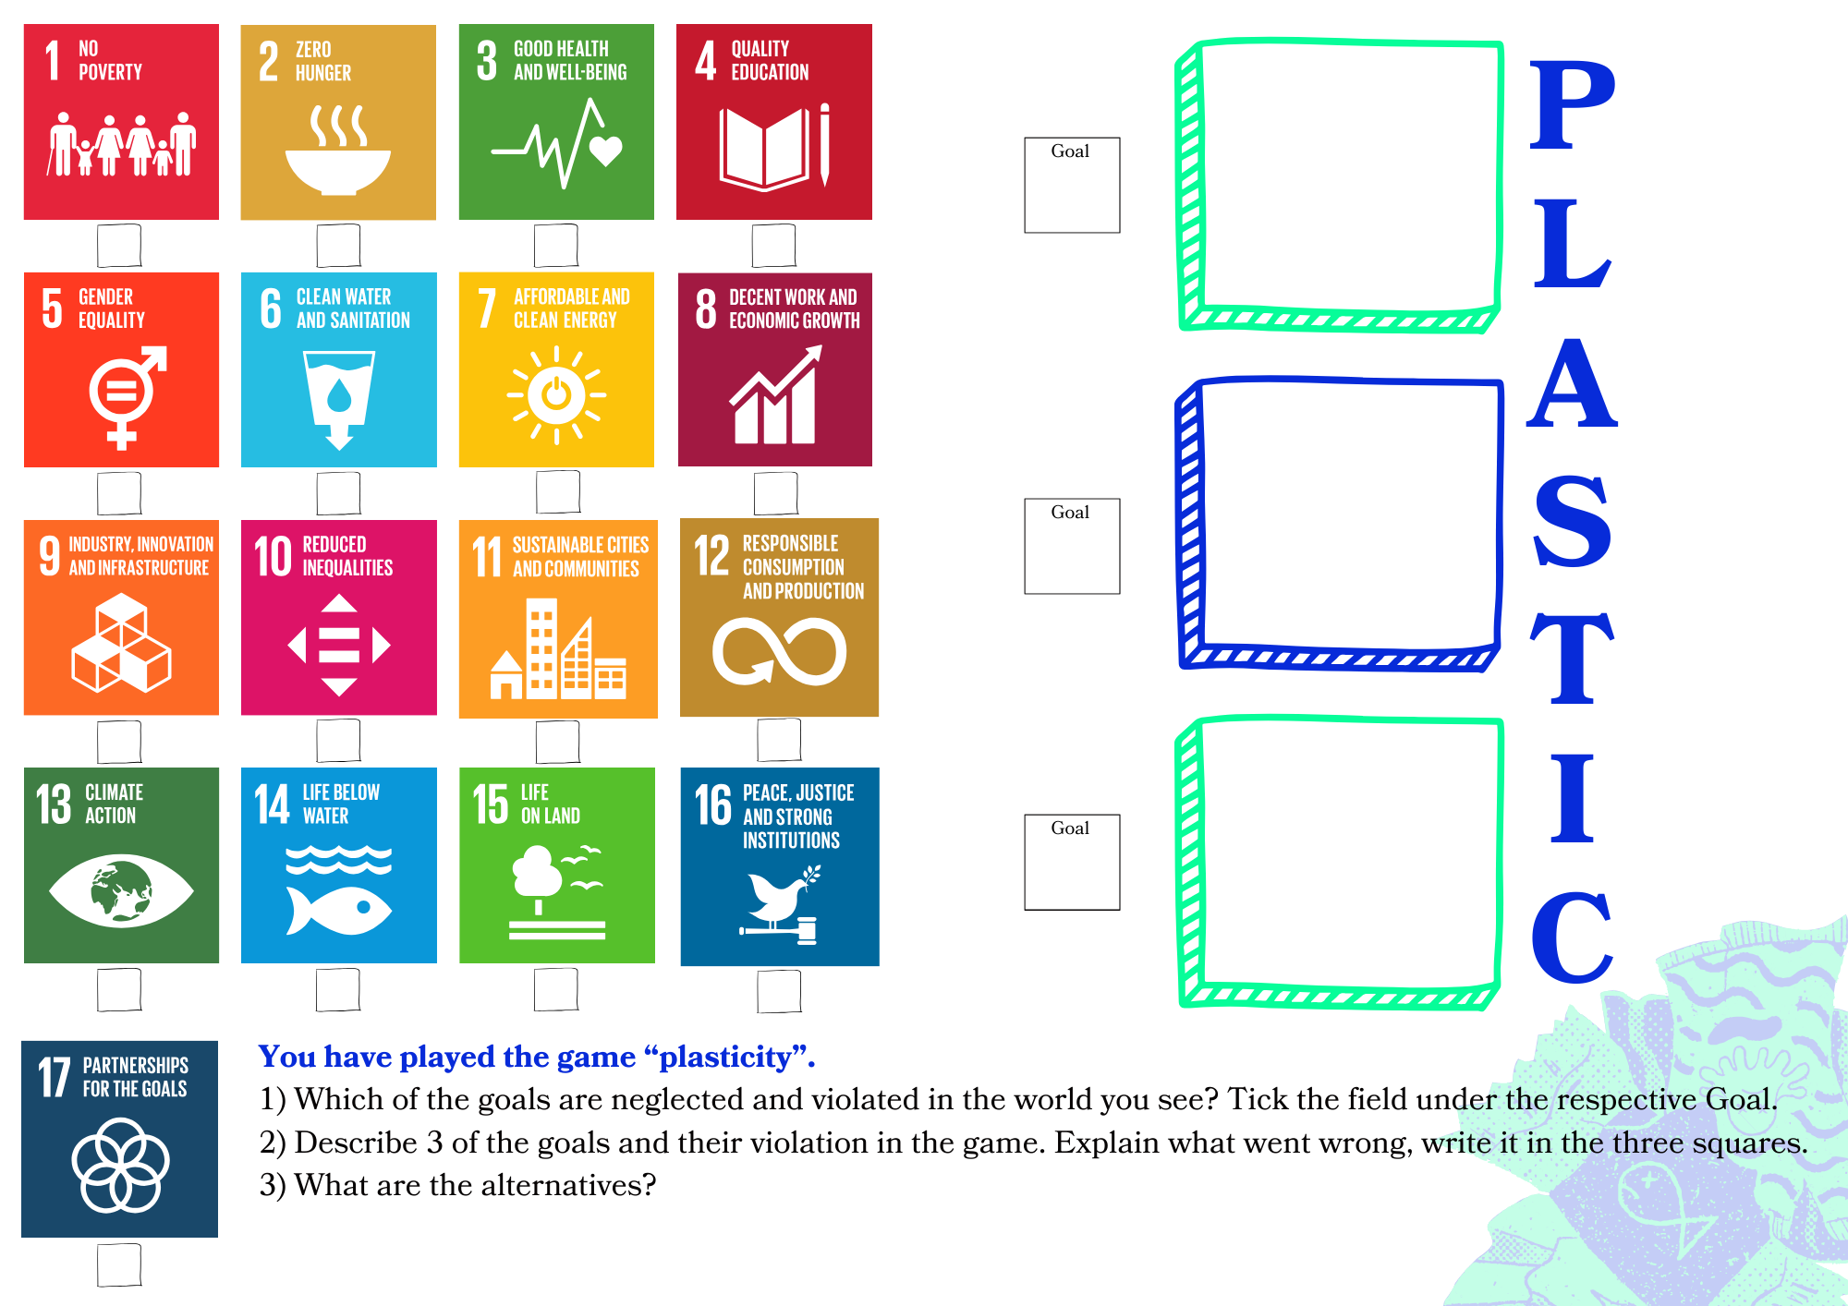

Material 4 – Rubber Ducks at sea
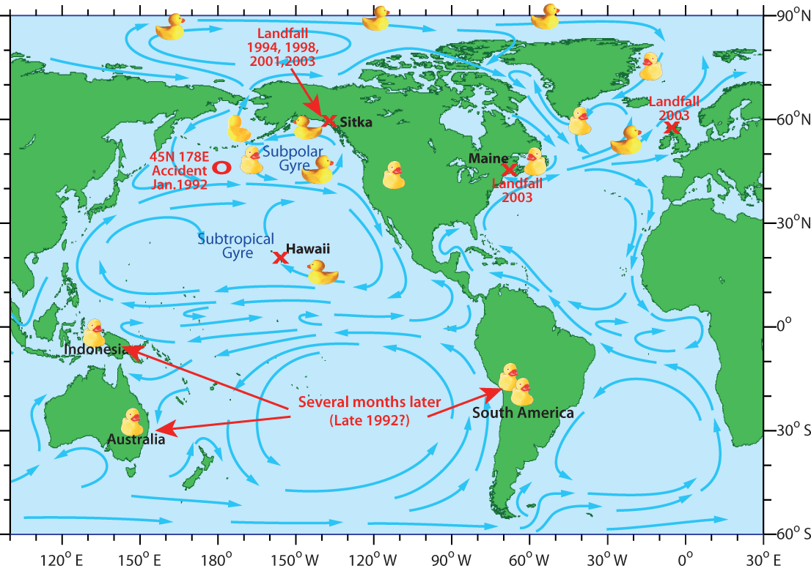
In January 1992, a shipping container carrying approximately 28,800 plastic bath toys—including yellow rubber ducks, blue turtles, red beavers, and green frogs—was lost overboard during a storm in the North Pacific Ocean. These toys, known as "Friendly Floatees," were en route from Hong Kong to the United States when they were inadvertently released into the sea. Unlike typical bath toys, the Friendly Floatees lacked holes, enabling them to remain buoyant without taking on water. This unique characteristic allowed them to travel vast distances, propelled by ocean currents. Seattle-based oceanographers Curtis Ebbesmeyer and James Ingraham recognized the scientific value of tracking these toys to study ocean surface currents. Their research provided insights into the movement of flotsam and the dynamics of ocean currents. Approximately ten months after the spill, the first of these toys began washing ashore near Sitka, Alaska, about 2,000 miles from their point of origin. Over the years, the Floatees continued their journey, with some becoming trapped in Arctic ice and eventually reaching the North Atlantic. By 2003, sightings were reported in New England, Canada, and Iceland. The extensive travels of these toys have been documented in various studies and publications, highlighting their role in understanding oceanic processes. This incident not only captivated public interest but also underscored the significance of ocean currents in distributing debris across the globe, contributing to a deeper understanding of marine science and environmental awareness.

Map of possible journeys taken by the bath-tub toys. Tale of the bathtube toy – fact or fiction. 2008. https://seos-project.eu/oceancurrents/oceancurrents-c02-ws01-s.html [19.12.2024; 15:13]
Questions about the text:
Why should plastic (in form of rubber ducks or other waste) in the oceans concern us?
The story shows that plastic doesn’t naturally degrades, what are the consequences?
Think of the game “Plasticity”. Have you heard or seen stories about plastic littering in your country?

References:
https://www.bbc.co.uk/programmes/articles/5r4gpxYrCv2KknmvP1Zcrn3/filming-rubber-ducks-in-the-big-blue
https://edition.cnn.com/2013/10/09/business/goods-lost-at-sea/index.html
https://www.npr.org/2011/03/29/134923863/moby-duck-when-28-800-bath-toys-are-lost-at-sea

Material 5 – Reality Check (Homework)
- Search for influencers on Instagram in Bali. What is shown? What pictures appear. Take a view screenshots or write down links to videos.
- Look at the Instagram post of Sungaiwatch or makeachange.world and see their work in Bali.
- Click through the 2023 report and have a look at the top polluting brands. Which brands do you know? Which are available in your country?*
https://www.canva.com/design/DAF6GTqlzhs/RwjfzonUGjswQ2dlU5RV2g/view?utm_content=DAF6GTqlzhs&utm_campaign=designshare&utm_medium=link&utm_source=editor#25

Read the BBC article (2024) about the “great pacific garbage patch.”
https://www.bbc.com/future/article/20240115-visualising-the-great-pacific-garbage-patch
- Find the comparison of the countries and the great pacific garbage patch and look up the size on the page “The true Size of” (https://www.thetruesize.com/)
- How big is the Garbage patch comapared to your country (e.g. 3x size of ..)
Answer: _____________________________________________
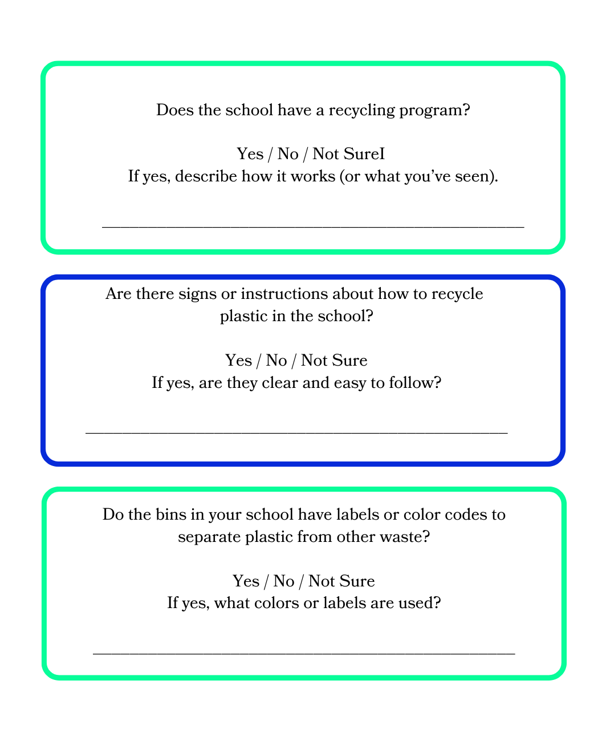
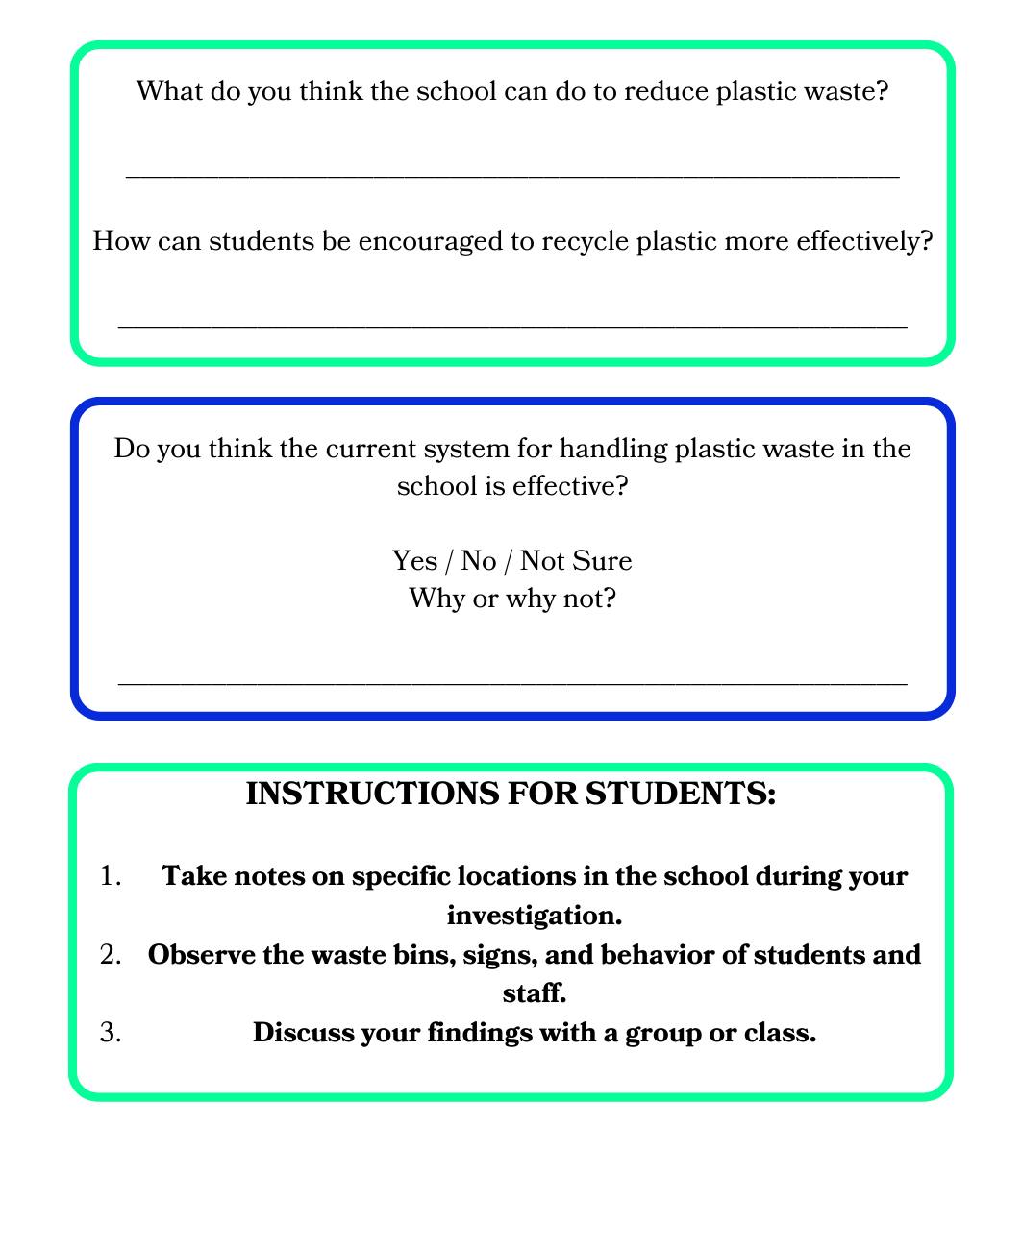
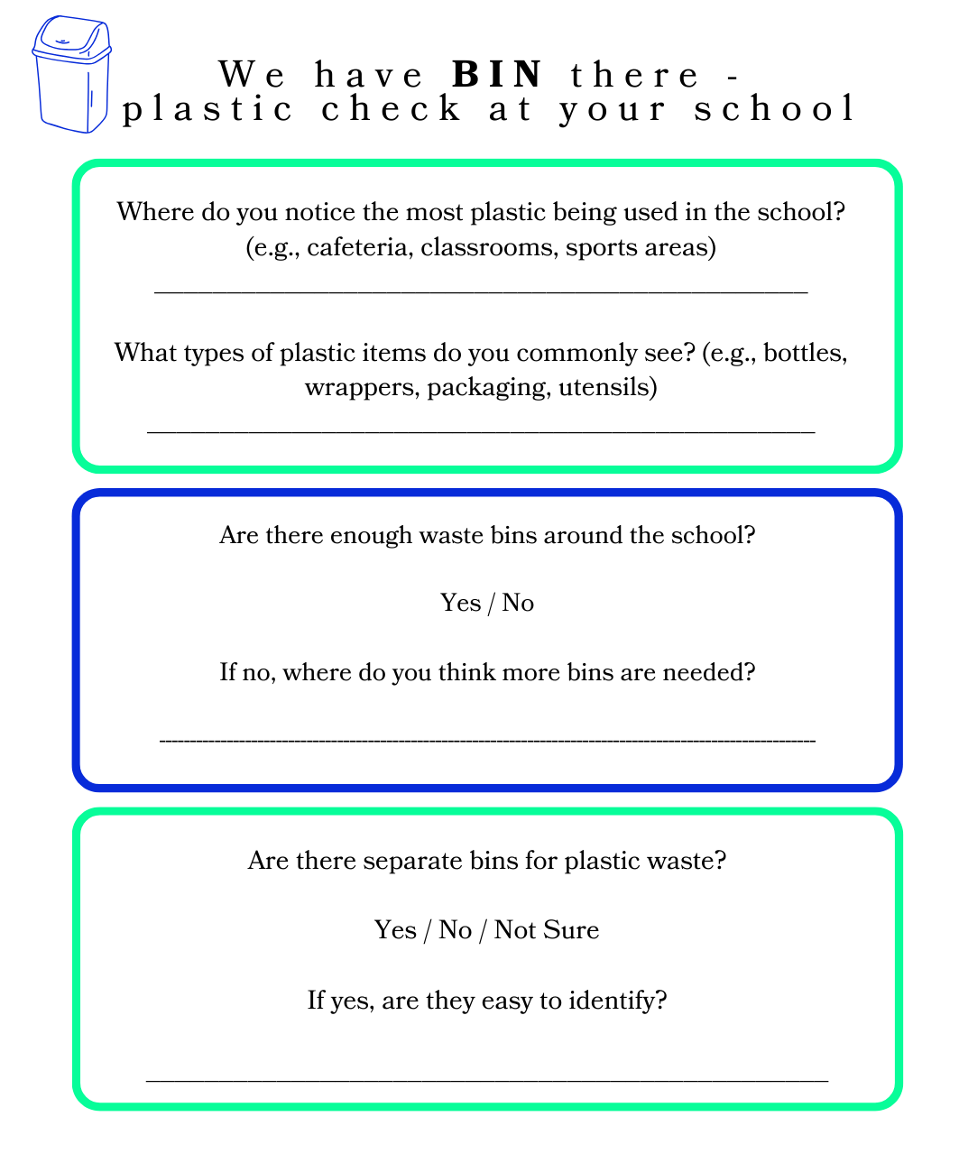
Material 6 – School Check (Worksheet)

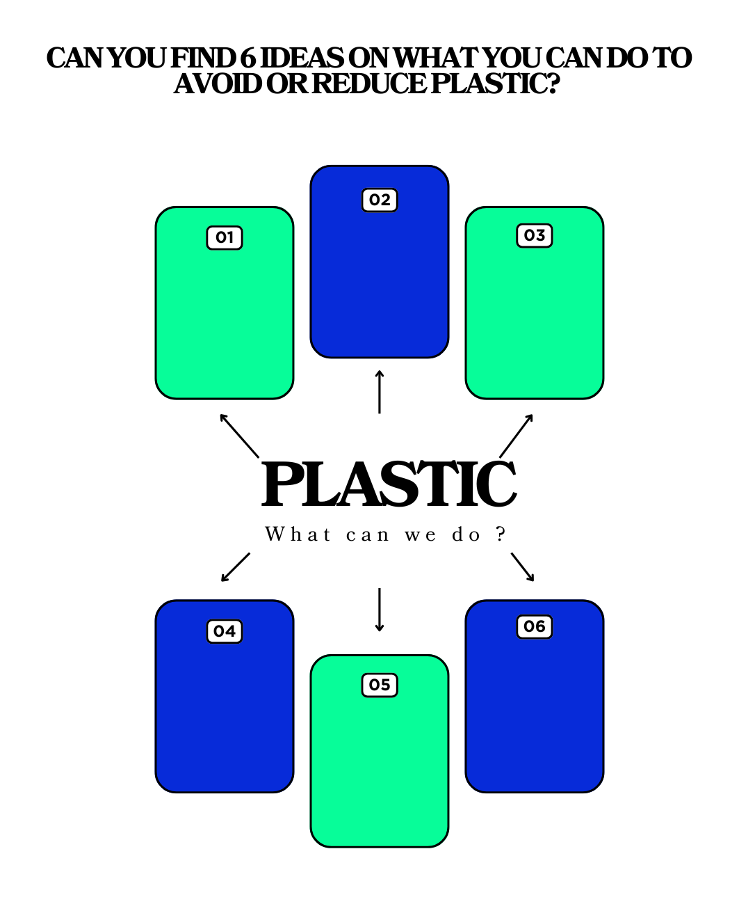
Material 7 – Solutions
Material 8 – Quiz

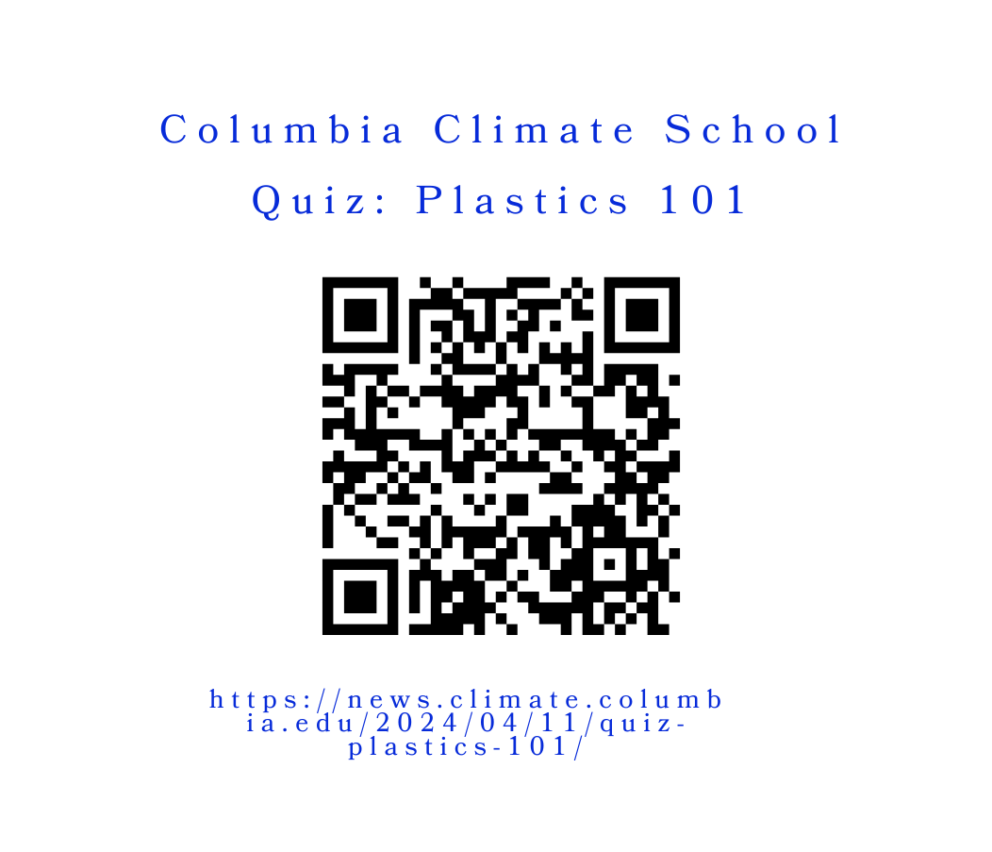

References
BBC.2024. Visualising the great pacific garbage patch. Retrieved December 19, 2024, from https://www.bbc.com/future/article/20240115-visualising-the-great-pacific-garbage-patch
Columbia Climate School. (2024). Quiz: Plastics 101. Retrieved from https://news.climate.columbia.edu/2024/04/11/quiz-plastics-101
OECD. 2022. Plastic pollution is growing relentlessly as waste management and recycling fall short, says OECD. Retrieved from https://www.oecd.org/en/about/news/press-releases/2022/02/plastic-pollution-is-growing-relentlessly-as-waste-management-and-recycling-fall-short.html
Petroleum. Britannica. Retrieved from https://www.britannica.com/science/petroleum
Plastics Crisis: Challenges, Advances, and Relationship with Wastepickers. 2022. Retrieved December 19, 2024, from https://www.no-burn.org/wp-content/uploads/2022/11/Plastics-Crisis-ENG.pdf
Polymerization | Definition, Classes, & Examples. Britannica.
Rubber Ducks at Sea. 2008. Map of possible journeys taken by the bath-tub toys. Retrieved December 19, 2024, from https://seos-project.eu/oceancurrents/oceancurrents-c02-ws01-s.html
Sungai Watch. 2023. Project Report 2023. Retrieved December 19, 2024, from https://www.canva.com/design/DAF6GTqlzhs/RwjfzonUGjswQ2dlU5RV2g/view
The True Size Of. Retrieved December 19, 2024, from https://www.thetruesize.com
Polymerization | Definition, Classes, & Examples. Britannica. Retrieved from https://www.britannica.com/science/polymerization

Annex – Game analysis:

[in the end there should be all analysis – from the Game Analysis Report by UDC – included there with 10pt]

from: https://store.steampowered.com/app/1069360/Plasticity/. [19.12.2024; 15:09].
Hint from testings: in 1,5 hours players could finish around 2-3 times the game with experiencing different endings!

