

Pedagogical Sequences – Quandary
A3.4.

January 2024
Helixconnect Europe

Contents
1. Pedagogical sequences – This war of mine 3
2. Annex – Game analysis 11

1. Pedagogical sequences – quandary
Title: quandary

Quandary is an interactive decision-making game that places players in the role of a leader making ethical decisions for a fictional colony on the planet Braxos. Players are required to analyze multiple perspectives, weigh arguments, and determine the best course of action for their community. The game fosters critical thinking, ethical reasoning, and conflict resolution skills while encouraging students to recognize the complexities of governance and social responsibility.
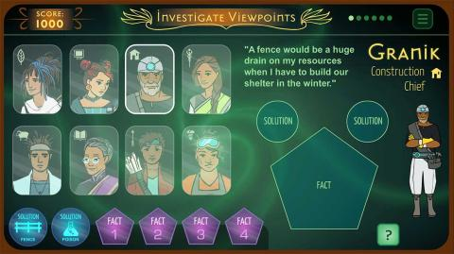

© Quandary Game

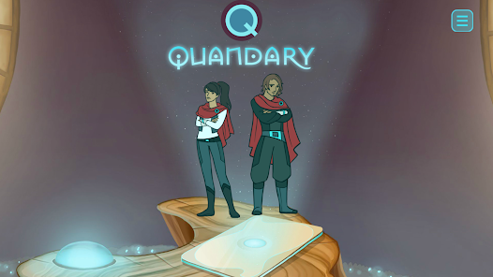
© Quandary Game

Duration: 2 lessons
Subject/s: Civics, Political Science, Social Studies
Topics: Ethical decision-making, leadership, community governance, conflict resolution
SDGs: 16: Peace, Justice, and Strong Institutions; 10: Reduced Inequalities; 4: Quality Education
Dimensions of conflict through the game:
☒ social impact
☒ environmental impact
☒ economic impact
☒ technological impact
Learning objectives:
This sequence aims to help students develop ethical reasoning and decision-making skills by exploring the complexities of leadership and governance. Through in-game dilemmas, students will analyze different viewpoints, evaluate the consequences of their choices, and reflect on how ethical decision-making applies to real-world scenarios.
Interpersonal skills:
- Ethical reasoning and critical thinking
- Conflict resolution and mediation
- Perspective-taking and empathy
- Leadership and decision-making
Technical requirements & material required:
- Computer with internet access
- Speakers and projector (if available)
- YouTube gameplay videos if the game is unavailable for students
- Role-playing materials (character cards, ethical dilemma scenarios)
Further reading/material:
Book: "The Righteous Mind: Why Good People Are Divided by Politics and Religion" by Jonathan Haidt
Official Educational Resources: https://quandarygame.org/resources

Preparation Phase

To introduce the lesson, students will be given an overview of Quandary and its role as an ethical decision-making simulation. Show a short gameplay segment and discuss its mechanics, emphasizing how players must consider different perspectives to make informed choices. Ask students to reflect on decision-making in their own lives: How do you make difficult decisions? What factors influence your choices?

Next, have students download the game before the class (QR codes provided below) and create their characters. Prepare the character sheets beforehand and ask the students to fill-in the information with the characters they created.

Game Phase

Lesson No. | Description in Steps | Social form | Material/technical requirements
1 | Step 1: If devices are available, students will play Quandary in pairs for 15 minutes, making decisions and discussing their thought process. If not, show a recorded gameplay session. | Individual/Small groups | Projector, YouTube video, speakers, Internet connection, Mobile phones
1 | Step 2: Students fill-in character sheets and document dilemmas they faced in the game and justify their decisions based on ethical reasoning. | Individual/Small groups | Character sheets
1 | Step 3: Role-play: Students take on the roles of their characters within the colony and debate their viewpoints through playing the game. | Plenum | Character sheets
1 | Step 4: When the game is finished, have students analyse their choices and compare them to the choices made by their peers. Steer the discussion towards comparing them to real-world ethical dilemmas in leadership and governance. | Plenum | Character sheets
1 | Step 5: Based on the step above, sort students into groups based on the solutions they chose in the game. Create a discussion on how they came to the said solution, and if different circumstances could change their minds. | Small groups | Role-playing
1 | Step 6: Practcal Exercise: Students, divided into groups, can create posters (on a4,3,2 papers) with the ‘Change my mind’ title. Then, have them discuss and appoint one leader per group who will try to persuade the others to join their side. The students who feel persuaded can join the other team. In the end, the team who has the most students win, and has showcased tremendous persuasion skills. | Small groups | Art supplies

Reflection Phase

Lesson No. | Description in Steps | Social form | Material/technical requirements
2 | Step 7: Continuation of the role play: Have students rewind back to the decisions made in-game. Then, assign students the role of a citizen impacted by leadership decisions in the game, requiring them to evaluate leadership effectiveness from multiple perspectives. | Plenum | Role playing,  Writing materials
2 | Step 8: Self-assessment: Have students grade their own leadership choices based on the step 7. Let them explain the reasoning behind the grade. | Indivdual | Character sheets, Journals/Notebooks
2 | Step 9:  Final discussion: How can ethical decision-making in governance create a just and fair society?  Strenghten the discussion by connecting this topic to the subject pupils are currently learning from History, Economics or Civics. | Plenum | Journals/Notebooks

Remember to foster an environment where students feel comfortable discussing moral dilemmas and justifying their choices.

Copy templates:

- QR Codes:

Android phone (Google Play):



IOS (Play Store):



- Character sheet:

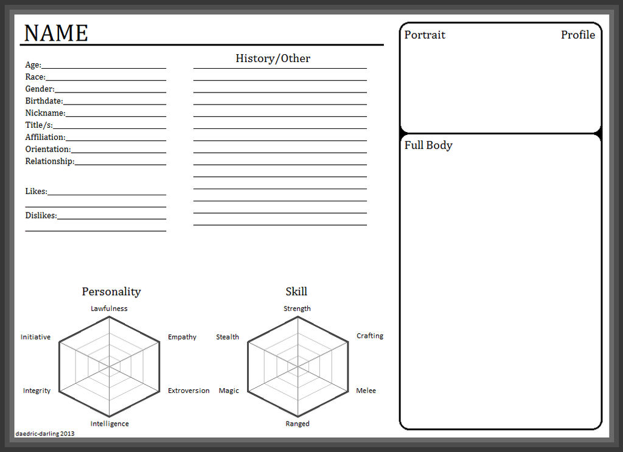
DeviantArt

- Role-playing:

Poster example:



2. Annex – Game analysis
Quandary
In order to facilitate the analysis of the selected video games, a reference table has been prepared, which breaks down the main characteristics to be considered in each of these four categories.

Title
Platform | Windows PC
Language | English
N. º of sessions played | 1
Total time played | 2
Brief Description | You are an acting Captain of Colonial Expansion Program tasked  with resolving conflicts between the population of the colony.

Dimension | Evaluation Criteria
Usability (analysis of technical correctness and ease of use) | - Is the game easy to learn and play?  - Yes it’s quite straight forward.  - Is the user interface (controls and navigation) clear and tailored to the target audience?  - It’s very illustrative and engaging.
 | - Are accessibility options implemented?
 | - The game only requires movement of the mouse with no added
 | time pressure, so I would determine it is quite accessible.
 | - Is the game response accurate and fast?
 | - Fairly fast and accurate.
 | - Are in-game messages accurate?
 | - Yes.
 | - Are there instructions?
 | - Yes, tutorials are in the form of a comic book.
 | - Is it possible to save the game?
 | - It saves automatically.
 | - Are there any bugs?
 | - Not that I’ve encountered.
 | Other relevant usability comments
Gameplay (analysis of the game's play and narrative structures, and how game design produces meaning) | - Were you able to finish the game (yes/no: why)?  Yes I have, there are 4 dilemmas for the player to solve, being able to finish it comfortably in under 2 hours.  - Duration (per level/mission or over the whole game)  - 15-30 minutes per dilemma ,up to 2 hours.  - Degree of interactivity (do the player's decisions play a crucial role in the outcome of the game)?  - Players' decisions play a crucial role, as they take all of the community's opinion into consideration and make the final choice which impacts the results of the mission.  - Is the pace of the game satisfying?  - Quite so, yes.  - Narrative weight (high/medium/low)  - Very high, the game really makes an effort into introducing you to the characters of the colony and fitting you into the role of the captain.  - Presence of a narrator: yes/no  - There are character voice overs and written narrative.  - Presentation and role of the main character (characteristics and qualities of the character/avatar)  - You are the main character, and your decisions or characteristics impact the final outcome.  - Depiction and role of the antagonist (characteristics and qualities)  - There is no real antagonist, but dilemmas without clear right answers.  - Presentation of the setting (world in which the character develops)  - It’s the first human settlement on the planet Braxos, 32 light years away from Earth.  - Dimension/temporality: time period covered by the story and its characteristics (fictional/real, global/local, etc.)  - It’s a sci-fi piece, with undisclosed time period, but we can clearly see an advanced civilisation capable of traveling at the speed of light.  - Mission (what are the essential actions to win/complete the game)  - Find a solution to the colonies conundrum, which may or may not have their best interest in mind.  - What are the implicit/ultimate goals of the game?  - It’s designed to teach players about ethical decision-making, critical thinking, and perspective-taking.  What are the main challenges/obstacles faced by the protagonist?  - The protagonist faces ethical dilemmas and must make tough decisions that balance competing interests within the colony. They also struggle with limited information, conflicting perspectives, and the long-term consequences of their choices on community cohesion.  - Are the game mechanics appropriate to the content and implicit goals?  - Yes  - Do you agree with the reward system (incentives for action)?  - The reward is the outcome itself, getting to see the consequences of your actions.  - How is the feedback system (text, audio or audiovisual comments given to the player for certain actions)?  - There are visual and audio cues that provide the player with feedback regarding their actions.  - Overall story (description of the story of the game as a whole)  - Players assume the role of a colony leader on the distant planet Braxos, where they must navigate various ethical dilemmas that impact the future of the colony. By gathering facts, listening to different viewpoints, and making tough decisions, players shape the development and wellbeing of their community.

Content (analysis of the content of the game and the messages conveyed in relation to the objective) | - What are the themes of the game?  - Quandary include ethical decision-making, leadership, conflict resolution, and understanding diverse perspectives.  - What kind of reflection, knowledge, skills, competences, awareness are developed?  Quandary develops several key skills and competencies, including:
 | - Ethical reasoning: Players learn to analyze moral dilemmas and
 | make informed decisions.
 | - Critical thinking: The game fosters logical analysis, evaluation of
 | evidence, and problem-solving.
 | - Perspective-taking: It enhances empathy and the ability to
 | understand and respect diverse viewpoints.
Conflict resolution: Players practice resolving disputes and balancing competing interests within a community.
- Leadership and responsibility: The game builds awareness of the impact of decisions on others and the importance of community welfare.
- Is there an explicit use of sources of information?
- It explicitly encourages the use of sources of information within the game.
- Do you think the player can get the intended message without external help?
- Yes as the game is designed to guide players through the decision-making process.
- Did you change your beliefs/opinions or learn something new after playing the game?
- I’ve acquired new insights into ethical decision-making and the complexities of leadership.

Didactic resource (analysing the game as a didactic resource) | - 21st century skills included:  - Critical thinking  - Creativity  - Collaboration  - Communication  - Information literacy  - Media literacy  - Technology literacy  - Flexibility  - Leadership  - Initiative  - Productivity  - Social skills  - Dimensions covered:  - Social  - Environmental  - Technological  - Economic  - Link with Intergames subjects:  - Environmental Sciences  - Civic Education  - Arts  - History  - Economics  - Competences (knowledge achieved by the learner)  - Ethical Decision-Making: Understanding how to analyze moral dilemmas and consider the implications of different choices on a community.  - Critical Thinking Skills: Evaluating evidence, identifying biases, and making reasoned judgments based on the information presented.  - Communication Skills: Engaging with various characters and articulating decisions, which enhances understanding of effective dialogue and negotiation.  - Conflict Resolution Skills: Learning to mediate differing opinions and resolve disputes while maintaining group cohesion.  - Empathy and Perspective-Taking: Recognizing and valuing diverse viewpoints, which fosters a greater appreciation for the complexity of social dynamics.  - Problem solving conditions (way of thinking to solve problems: reproductive-memory, productive-creativity)  - Players are encouraged to think creatively about ethical dilemmas, explore multiple perspectives, and devise solutions based on reasoning rather than merely recalling facts.  - Need for prior knowledge (no/yes: detail)  - No, but while the game introduces its concepts clearly, a basic understanding of ethics, decision-making processes, and social dynamics can enhance the player’s experience and understanding.  - Learning curve (learning difficulty: low, medium, high)  - Medium. The game presents challenging dilemmas that require critical thinking and ethical reasoning, which may take time to navigate effectively, especially for younger players or those unfamiliar with such concepts.  - Possibility of group work (no/yes: detail)  - Yes, The game can be played in a group setting where players discuss dilemmas and decisions, facilitating collaborative learning and enhancing the exploration of different viewpoints.  Does it include a teaching guide (information for teachers with tips and examples for implementation in the classroom)?  - Yes. Quandary includes resources for educators, providing tips and examples for implementation in the classroom, helping teachers integrate the game into lessons on ethics, leadership, and critical thinking.  - Possibility of teacher evaluation (no/yes: please specify)  Yes. Teachers can assess students' understanding and skills through discussions, reflections, and observations during gameplay, allowing for evaluation of their ethical reasoning and decision-making processes

