

Pedagogical Sequences – Quandary
A3.4.

January 2025
UDC

Title: QUANDARY
Quandary is a decision-making game that challenges players to navigate complex ethical dilemmas as they lead a colony on a distant planet. The game places players in the role of a leader responsible for resolving conflicts and making tough choices that affect the well-being of the community. Each decision requires balancing different perspectives and considering the potential consequences, emphasizing critical thinking, empathy, and ethical reasoning. Through its interactive narrative, Quandary encourages players to think deeply about the impact of their choices on others, making it both an engaging and educational experience.
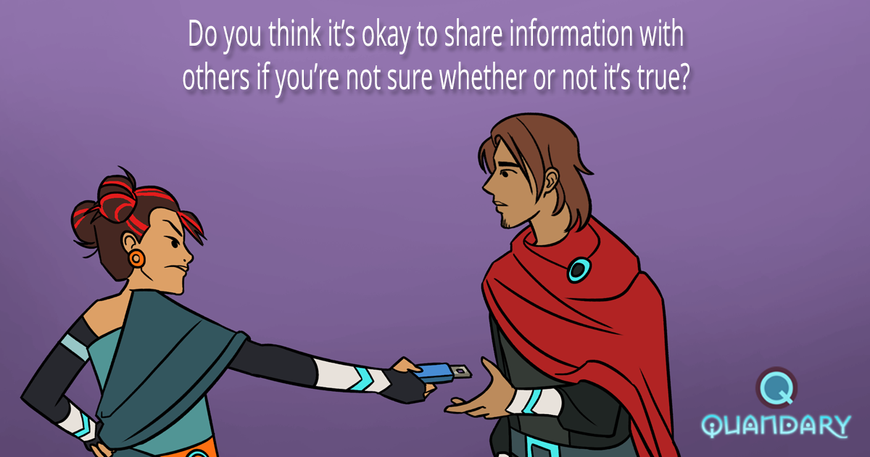
Taken from: Quandary Facebook page [https://www.facebook.com/quandarygame/photos/pb.100063530471307.-2207520000/2138506319620006/?type=3 ]

Duration: 3 lessons
Subject/s: Civic Education, History, Economics.
Topics: ethical decision-making, leadership, community management, and the complexities of balancing diverse perspectives within a society.
SDGs: 9, 11,12, 15, 16
Dimensions of conflict through the game:
X social impact
X environmental impact
X economic impact
X technological impact
Learning objectives: Learners develop competencies such as ethical decision-making, critical thinking, problem-solving, empathy, and social awareness. The game encourages understanding of how individual choices can impact a community and emphasizes the importance of considering multiple perspectives in decision-making.
Interpersonal skills: critical thinking, communication, flexibility, initiative, productivity, social skills
Technical requirements & material required: PC, Headphones, WIFI; materials on the annex.

Further reading/material:
This is a lesson plan using Quandary: https://educators.brainpop.com/lesson-plan/quandary-problem-solving/
Article on strategies to promote critical thinking: https://www.teachhub.com/teaching-strategies/2014/09/teaching-strategies-to-promote-critical-thinking/

Preparation Phase
In terms of preparation, the implementation of Quandary in a lesson relies on a stable Internet connection and adequate technological equipment (e.g. computer, keyboard and mouse). Therefore, teachers need to make sure these devices are working before students arrive in the classroom to avoid possible delays due to hardware malfunction. Although it is not strictly necessary, providing students with headphones can greatly enhance their immersion in the game's sound design, allowing them to engage more deeply without disturbing others. If headphones are not available, we recommend setting the computers on mute to avoid the background noise from the game.
Furthermore, it is important teachers play the videogame and create an avatar so they understand how the game works as well as the score system. Despite the fact that this game is highly intuitive, teachers may want to become acquainted with its software and also pick the episode (each one representing a different conflict) which would be the most beneficial to their students: it must be pointed out that all episodes deal with problem-solving, critical thinking and communicative skills as the basis for the successful completion of the game. This makes this game particularly suitable to work the so-called soft skills and it may be implemented in all subjects, although it is highly recommended for subjects such as Civic Education, History and Economics.
As for possible lack of engagement with the lesson plan and considering the game deals with conflicts in a dystopian future, the teacher may want to propose real-life classroom scenarios so students become more engaged in the task at hand to later redirect them to the lesson plan accordingly.
Game Phase
Lesson No. | Description in Steps | Social form | Material/technical requirements
1 | Step 1: Introduction  Students are shown several pictures to try to guess the location of the game (a new human colony in space). In order to elicit some answers, the teacher may ask the following questions:  - What do you see on these images?  - Could you guess the topic?  - Do you know any movies which deal with this topic? Could you give me an example?  - Why would humans need to leave earth?  - Which problems would be the most worrisome when establishing a new colony? | Plenum | Pictures in A4 format (see Annex 1)
1 | Step 2: Show a short video of the videogame so students know the basic facts of how to play Quandary. | Plenum | Whiteboard, speakers and Internet connection. Link to the video (see Annex 2)
1 | Step 3: Actual gameplay. Students create an avatar for the game and play one of the episodes (the teacher may want to choose which one or allow them to pick for themselves). In the meantime, the teacher moves around the classroom and ask students questions on the decisions they are taking using the ‘5-wh’ questions. | Individual work | Computers, keyboards, headphones (optional) and Internet connection.
1 | Step 4: Reflection on the gameplay. In order to understand possible problems and reflect on the learning outcomes of the game, the teacher should ask the following questions:  - Was the game enjoyable?  - Were there any technical difficulties?  - What was the outcome of the game?  - Did you disagree with any of the solutions to the problem?  - Could you think of a better solution to the problem?  As for the final questions, these should introduce the next lesson, so students should reflect on the following:  - Who made the decisions? And based on what?  - How do you describe the decision-making process?  - Which type of government was present in the game? | Plenum | Whiteboard/blackboard to write down key concepts.
2 | Step 5: Introduction to the second session. The topic of active listening and good leadership (key concepts in the game) are introduced by asking students the following questions using the ‘Think-Pair-Share’ technique:  - Do you know any good leader?  - What makes them good?  After having answered the questions, students watch a Ted Ed video titled “4 things all great listeners know” and answer the questions (see Annex 3). | Plenum and pairwork | Whiteboard, speakers and Internet connection. Link to the video (see Annex 3)
2 | Step 6: Create your own avatar for the new world.  Using the worksheet provided by the teacher, each student creates an avatar for the Quandary world. In the next activity, these avatars are exchanged among students. Teacher should encourage students to provide useful information about their avatar (e.g. personal traits, profession, past experiences, etc.). | Individual | Worksheet (see Annex 4).
2 | Step 7: Role-play.  Students are provided with one of the conflicts in Quandary (see Annex 5). Each student has one of the avatars their classmates created in the previous activity and they have to act like them in the role-play. The purpose of the activity is to reach an agreement on the issue at hand using the active listening techniques they saw on Step 5. | Groups of 4 | Avatar worksheet (done in the previous activity) and screenshot of a Quandary episode (example; see Annex 5).
2 | Step 8: Reflection on the decisions taken during the role-play.  The teacher asks students (group by group) to share the final decision on the conflict they solved. This should be a moment on reflection and understanding different viewpoints, as it is likely the groups made different decisions. Depending on the time left, an informal debate could be carried out on the different solutions to the problem. | Plenum | Whiteboard/blackboard to write down key concepts.

Reflection Phase
Lesson No. | Description in Steps | Social form | Material/technical requirements
3 | Step 9: Kahoot activity.  Students are asked different questions to assess their critical thinking skills by means of a Kahoot game (see link on Annex 6). | Individual | Whiteboard, computers, keyboards, headphones (optional) and Internet connection.  Kahoot link (Annex 6)
3 | Step 10: Types of government in a new colony.  Students read people’s different opinion to the question “If the Earth became a place no one could live and humanity had to move to another planet, which type of government should we establish in the new world?” and answer in pairs some questions (see Annex 7) using the critical thinking skills they worked in the previous activity and throughout the sequence.  In the meantime, the teacher monitors and goes around the classroom asking students to share their answers with them. | Pair work (teacher’s input) | Worksheet (Annex 7).
3 | Step 11: Final reflection.  The last activity of the sequence should gather students’ opinion and also reflect on key concepts, so an informal debate is to be carried out using different prompts such as:  - What did you like about the activities?  - What could have made it better?  - What did you learn?  - Was it difficult to reach an agreement with your classmates? Why?  - Are you aware of your school governing bodies?  - Do you know your school representatives?  - Is there any issue at school which could be solved with active listening and open communication?  This could potentially open up a debate to make students aware of the decision-making system at their school. | Plenum | Ideally, the desks and chairs would form a U-shape to provide an ‘open’ debate area.
 | Extra activity: Fixing our school.  As an extra activity, students may complete a table with school problems they seem, the causes, consequences and possible solutions they may find (see Annex 8).  This could be the starting point to make students’ active participants of the school’s problem-solving and decision-making process. This report could be further expanded (maybe even turned into a project) and submitted to the head of the school. | Groups of 4. | Worksheet (see Annex 8)

Copy templates:
ANNEX 1




Taken from: https://pixabay.com/es/

ANNEX 2
‘Quandary: Game Basics’ video.
Taken from: https://www.youtube.com/watch?v=yuBB0hNuI1c

ANNEX 3
Link to the video and questions: https://ed.ted.com/lessons/4-things-all-great-listeners-know
Questions from the video (screenshots: these could be answered online):
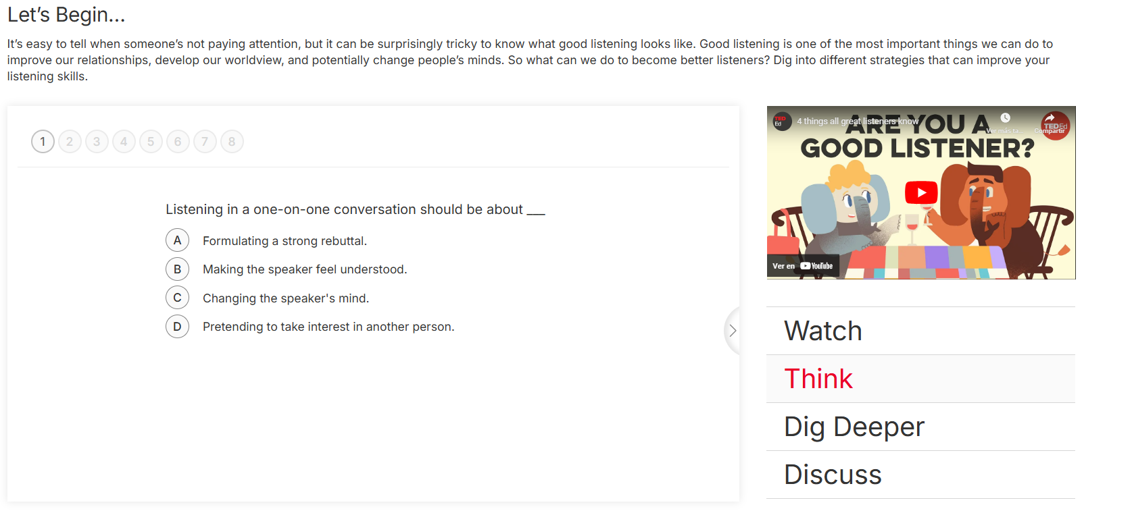
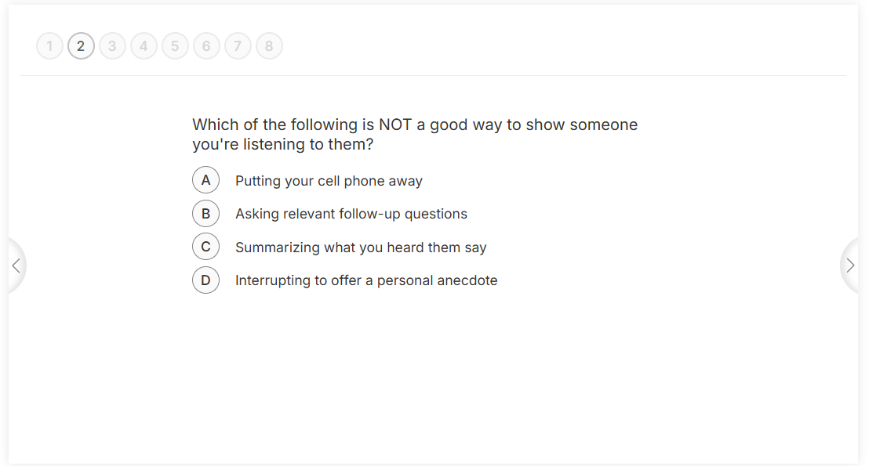
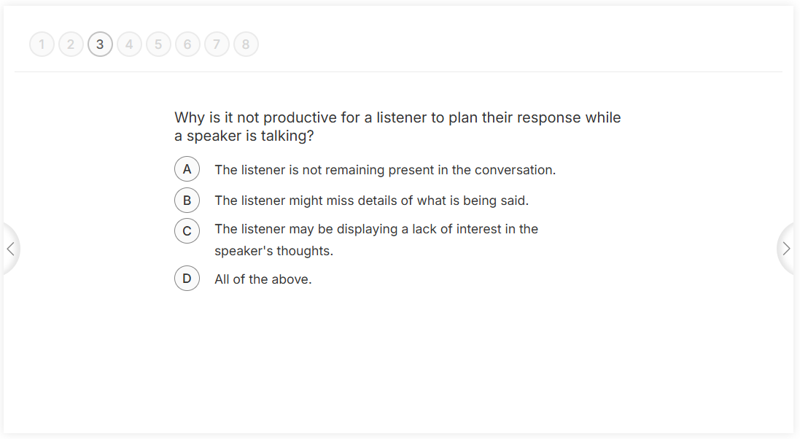
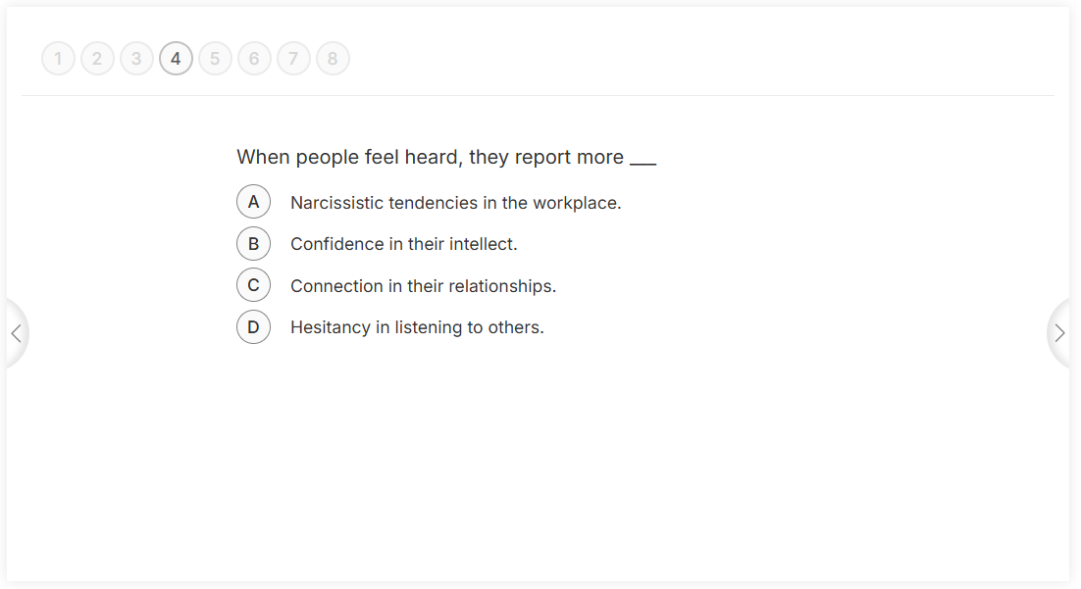
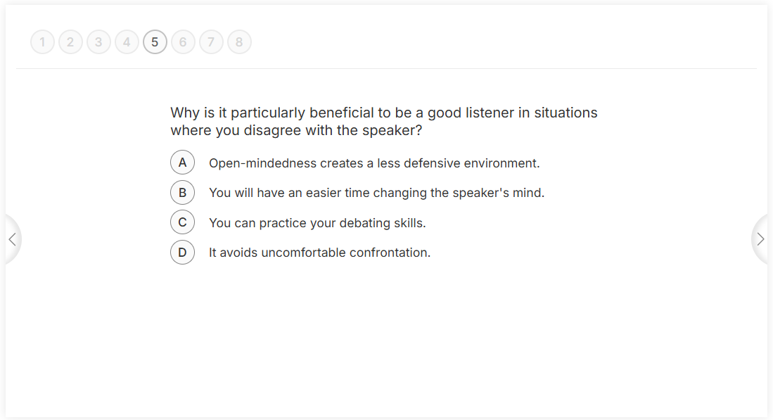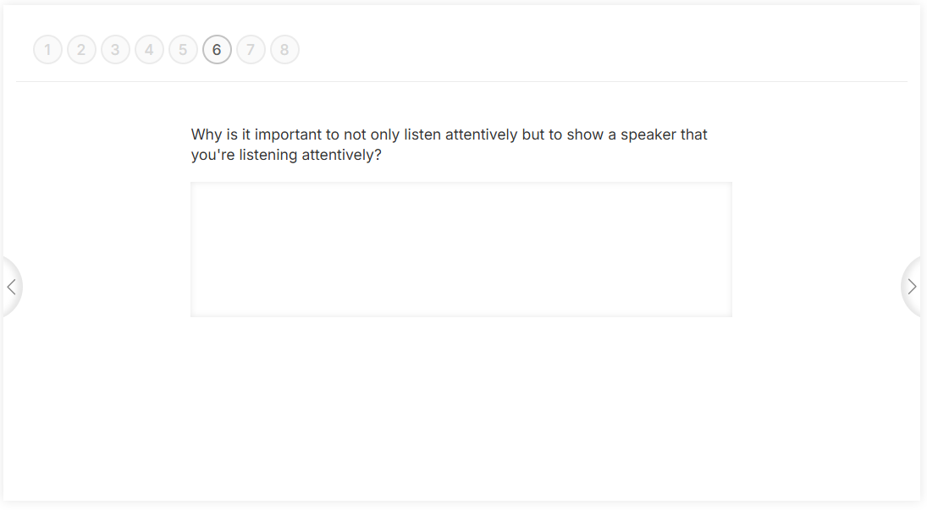
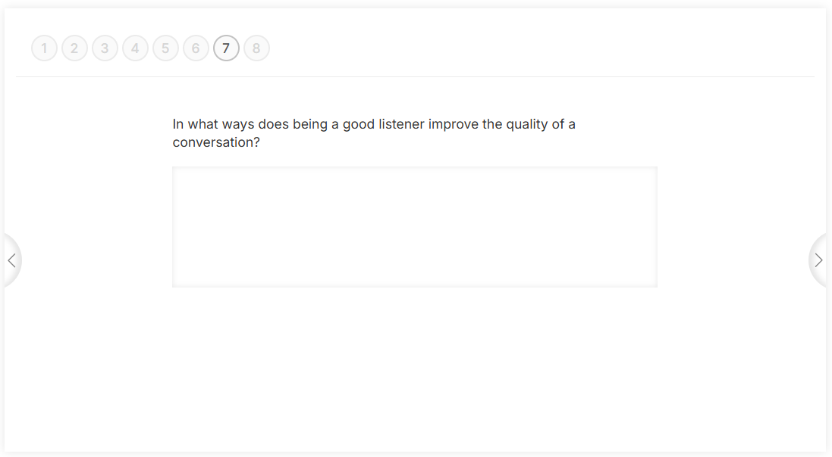
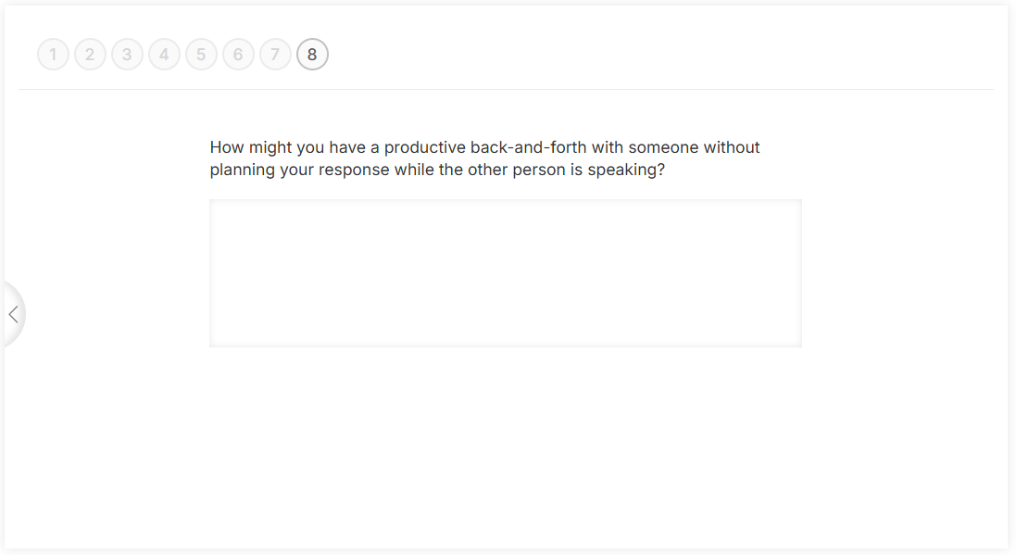

ANNEX 4
Worksheet taken from: https://es.pinterest.com/pin/reading-and-writing-resources-archives-k3-teacher-resources--779545016784970260/
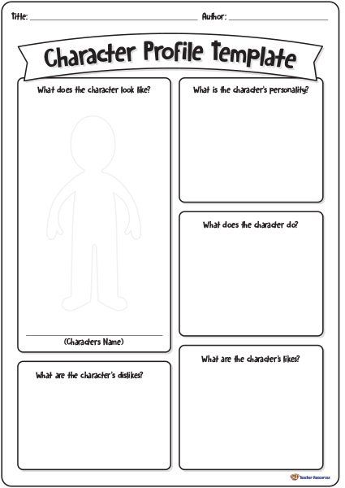
ANNEX 5
Screenshot of ‘Episode 4’ (Quandary)
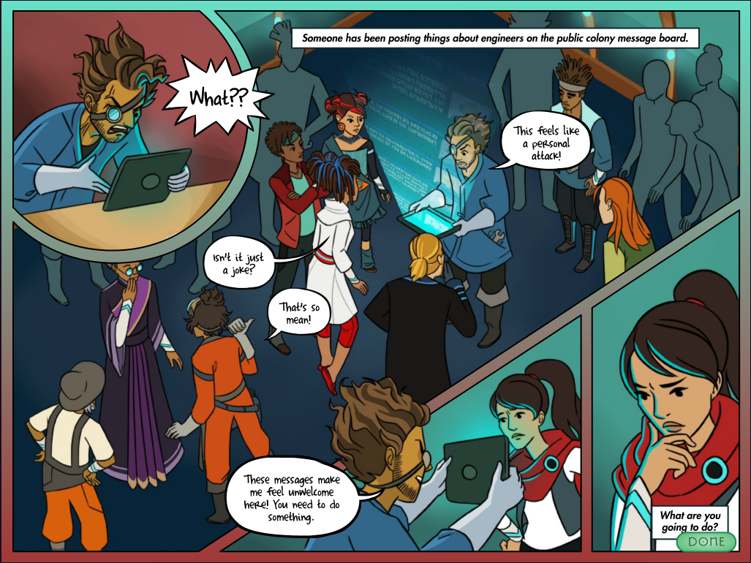

Emergency avatar cards (in case students’ avatars were not created):
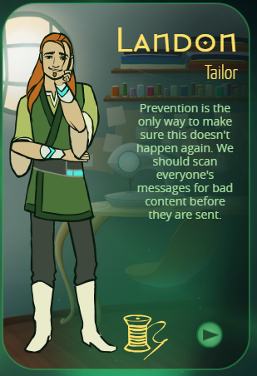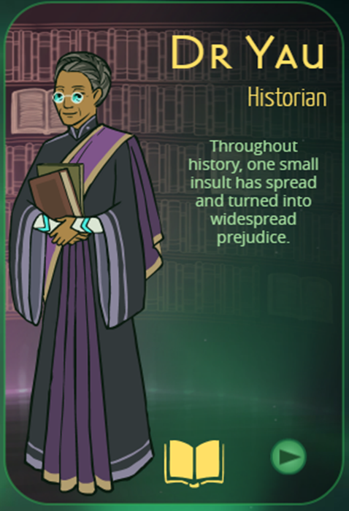
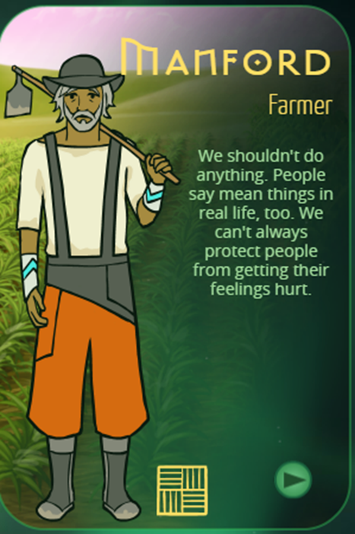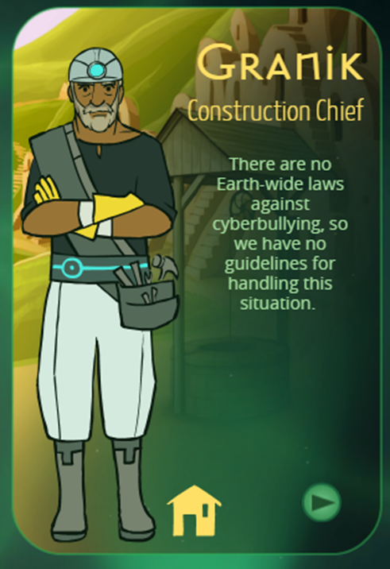
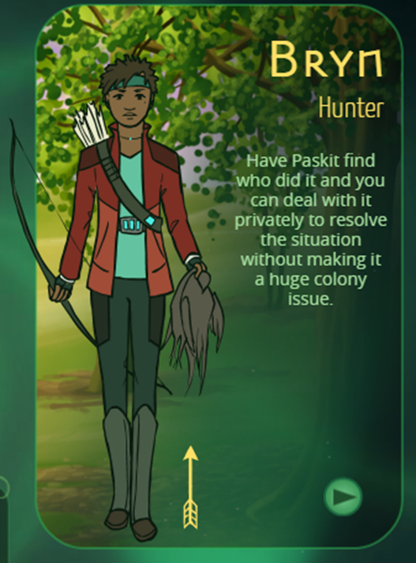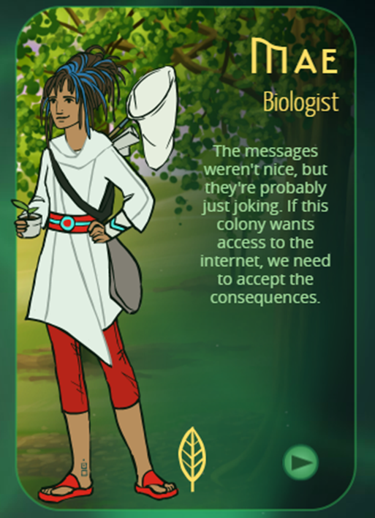
Taken from: https://quandarygame.org/
ANNEX 6
Kahoot link: https://kahoot.it/challenge/006204164
Adapted from: https://create.kahoot.it/details/7664edcc-4a4b-4045-88ff-cd41ba639a81

ANNEX 7
If the Earth became a place no one could live and humanity had to move to another planet, which type of government should we establish in the new world?
Some opinions:
Tom: "Honestly, I think we should just stick with democracy. It's not perfect, but at least we have a say in things. When my mates and I organised that charity event last year, we had to vote on everything from the location to the activities. It felt good to be involved and see everyone's opinion matter."

Sarah: "I reckon we should have a strong leadership, like a benevolent dictatorship. Sometimes people need guidance, especially in tough times like starting anew on a different planet. A few years back, when my old village faced financial issues, it was a firm decision from our town leader that got us all working together again and sorted everything out."

Ben: "I’m really not sure what would be best. On one hand, democracy seems really good because everyone has a voice, but then again, what if people don’t agree? Last week, my group project nearly fell apart because we couldn’t decide on anything, and it gave me a taste of how messy things can get when everyone pushes for their own ideas."

Emily: "Oh, it just breaks my heart to think about leaving Earth! I wish we could fix our problems here instead of starting over elsewhere. When I lost my grandmother, it felt like a piece of me was gone, and I really can't imagine losing the only home I've ever known. No matter where we go, I’ll always cherish the memories we made on this beautiful planet."

Discuss with your classmate and answer the following questions:
1 If you could choose a type of government for a new planet, what would it be and why?
2 How do you think people would adapt to living on another planet?
3 What qualities do you believe are important in a good government?
4 Have you ever thought about how life might be different on another planet?
5 Do you think it's possible for humans to create a better society if we start fresh on a new planet?
6 How important is it for a government to listen to the opinions of its citizens?
7 In your opinion, what challenges would a new government face on another planet?
8 How can we ensure that everyone has a voice in a new government system?
9 What role do you think technology should play in governing a new world?
10 How would you feel about leaving Earth to live on another planet?
Activity created by Twee: https://twee.com/

ANNEX 8
OUR SCHOOL: WHAT CAN WE IMPROVE?
PROBLEM | CAUSES | CONSEQUENCES | HOW DO WE FIX IT?

Annex – Game analysis:
Quandary is a video game that revolves around an engaging narrative experience, gaining meaning through the player's interaction. The game itself functions as a sign, with its meaning shaped by the individual player’s perspective and choices. When studying Quandary, two main hypotheses can be applied:
1. Video Games as a Means of Communication: Quandary serves as a means of communication by conveying important messages about ethical decision-making and the complexities of leadership. The game uses dialogue and situational dilemmas to communicate the challenges of balancing differing perspectives and the consequences of decisions in a community setting.
2. Video Games Contain Values: Quandary embodies significant values such as critical thinking, empathy, and responsibility. The player’s decisions reflect moral and ethical judgments, emphasizing the importance of these values in shaping outcomes within the game's narrative. These decisions influence the well-being of a colony, underlining the weight of ethical considerations in leadership and community management.
Both approaches are grounded in the understanding that Quandary is a production of meaning, carefully crafted by its developers not only to entertain but also to deliver educational content centered on ethical reasoning and social responsibility. The interactivity in Quandary is vital to its impact, as the player’s choices directly affect the narrative and outcomes, making it a powerful tool for fostering ethical awareness and decision-making skills. The game’s interactivity is not merely a feature but a fundamental aspect that enhances its didactic potential.
Quandary is a story-driven game that presents players with a series of moral dilemmas and decisions that shape the fate of a community on a distant planet. The goals and objectives that players pursue are closely tied to their interactions, reflecting the real-world complexity of ethical decision-making and leadership.
Quandary can be analyzed using the following categories:
1. Playability: The playability of Quandary centers on its narrative mechanics, which involve making decisions that influence the story’s progression. The game’s ability to engage players is rooted in its thought-provoking dilemmas and the relatable challenges faced by the characters. The simplicity of its mechanics allows players to focus on the ethical challenges presented by the game.
2. Usability: The game is designed with a clear and intuitive interface, making it easy for players to understand the objectives and mechanics without needing extensive instructions. The clarity of the game’s goals—guiding a community through difficult decisions—ensures that players can quickly engage with the content.
3. Content and Skills Development: As a serious game, Quandary addresses themes such as ethical reasoning, leadership, and the complexities of community management. The game encourages players to develop skills like critical thinking, empathy, and the ability to weigh the consequences of different decisions, which are essential for navigating ethical dilemmas.
4. Didactic Resource: In an educational context, Quandary can be used to cultivate 21st-century skills such as ethical decision-making, critical thinking, and social responsibility. The game’s content aligns with educational dimensions like civic education and ethics, making it a valuable tool for teaching these concepts. It is particularly effective in encouraging players to reflect on their values and the impact of their decisions on others.
To facilitate the analysis of Quandary, a reference table has been prepared, outlining the key characteristics to consider in each of these four categories. This table will serve as a guide for educators and analysts in evaluating the game's potential as both an entertainment medium and an educational resource.
Title
Platform | PC/Mac (online) and Smartphone (Android and iOs)
Language | English, spanish, french and german
N. º of sessions played | 1
Total time played | 1h
Brief Description | Quandary is a decision-making game that challenges players to navigate complex ethical dilemmas as they lead a colony on a distant planet. The game places players in the role of a leader responsible for resolving conflicts and making tough choices that affect the well-being of the community. Each decision requires balancing different perspectives and considering the potential consequences, emphasizing critical thinking, empathy, and ethical reasoning. Through its interactive narrative, Quandary encourages players to think deeply about the impact of their choices on others, making it both an engaging and educational experience.

Dimension | Evaluation Criteria
Usability  (analysis of technical correctness and ease of use) | - Is the game easy to learn and play?  Yes, Quandary is designed to be easy to learn and play. The game’s mechanics involve making decisions and selecting dialogue options, which are straightforward and intuitive. Players can quickly grasp how to interact with the game and navigate its narrative.  - Is the user interface (controls and navigation) clear and tailored to the target audience?  Yes, the user interface is clear and user-friendly. The controls are simple, and the navigation is designed to be intuitive, which is tailored to the game's target audience, including younger players and those new to decision-based games. The interface resembles a messaging app, which helps make the game accessible and engaging.  - Are accessibility options implemented?  Yes, Quandary includes several accessibility options. The game’s text is clear and readable, and there are visual and auditory cues that support players with varying needs. These features make the game more inclusive and ensure that a wider audience can enjoy it.  - Is the game response accurate and fast?  Yes, the game responds accurately and promptly to player inputs. There are no noticeable delays in the game’s response to decisions, and the gameplay remains smooth, contributing to a seamless user experience.  - Are in-game messages accurate?  Yes, in-game messages are accurate and clearly convey the intended information. The text and dialogue are well-written, ensuring that players understand the context and the implications of their choices within the game.  - Are there instructions?  Yes, Quandary provides instructions that are integrated into the gameplay. The game offers guidance on how to make decisions and navigate the narrative, which helps players understand their objectives and how to interact with the game’s mechanics.  - Is it possible to save the game?  Quandary does not have a traditional save system as seen in many other games. Instead, it allows players to progress through different scenarios and decisions, but players cannot manually save and load specific points in the game. The game is designed to be played in one sitting or over multiple sessions, with decisions being recorded as players advance.  - Are there any bugs?  Quandary is generally stable, with no major bugs reported. However, as with any game, players might encounter occasional minor issues. Overall, the game is well-tested and performs reliably.  Other relevant usability comments:  - Quandary is designed to be engaging and educational, and its usability features contribute to its effectiveness as a learning tool. The clear interface, intuitive controls, and accessible design ensure that players can focus on the game's ethical dilemmas and narrative without being hindered by technical issues. The integration of instructions within the gameplay helps players quickly become familiar with the game’s mechanics, enhancing their overall experience.
Gameplay (analysis of the game's play and narrative structures, and how game design produces meaning) | - Were you able to finish the game (yes/no: why)?  Yes. Quandary can be finished. The game is designed to be completed within a reasonable time frame, with each episode providing closure to its respective scenario. The clear objectives and manageable decision-making processes make it accessible to most players.  - Duration (per level/mission or over the whole game)  Each episode in Quandary takes about 20-30 minutes to complete, depending on how much time the player spends considering their decisions. The entire game, consisting of multiple episodes, can be completed in about 2-3 hours.  - Degree of interactivity (do the player's decisions play a crucial role in the outcome of the game)?  High. The player's decisions are central to the game and have a significant impact on the outcome of each scenario. The game emphasizes ethical decision-making, and the consequences of these decisions directly affect the well-being of the colony.  - Is the pace of the game satisfying?  Yes, the pace of Quandary is satisfying. It allows players to thoughtfully consider their decisions without feeling rushed, but it also maintains momentum, keeping the player engaged throughout the narrative.  - Narrative weight (high/medium/low)  High. The narrative is the driving force of the game, with each decision shaping the story and the fate of the characters involved. The game places a strong emphasis on storytelling through player choices.  - Presence of a narrator: yes/no  No. There is no traditional narrator in Quandary. The story unfolds through dialogue, character interactions, and the consequences of the player's decisions.  - Presentation and role of the main character (characteristics and qualities of the character/avatar)  The main character, the colony leader, is characterized by their role as a decision-maker. The leader is portrayed as someone responsible, empathetic, and faced with the tough task of balancing the needs and opinions of the community. The player's choices determine the leader's qualities and the type of leadership they exhibit.  - Depiction and role of the antagonist (characteristics and qualities)  There is no traditional antagonist in Quandary. Instead, the game presents ethical dilemmas and conflicting interests within the community as the main challenges. The "antagonist" is essentially the difficult decisions and the consequences that arise from them.  - Presentation of the setting (world in which the character develops)  The game is set on a distant, fictional planet where a human colony is trying to establish itself. The setting is portrayed as both a place of opportunity and challenge, with the colony's survival depending on the leader’s decisions.  - Dimension/temporality: time period covered by the story and its characteristics (fictional/real, global/local, etc.)  The story is set in a fictional, futuristic time period on an alien planet. The game’s temporality is tied to the colony’s development and the immediate decisions required to ensure its survival and prosperity.  - Mission (what are the essential actions to win/complete the game)  The essential actions involve making thoughtful and ethical decisions that balance the needs and desires of the colonists, resolve conflicts, and ensure the colony’s long-term survival and well-being.  - What are the implicit/ultimate goals of the game?  The ultimate goals are to develop critical thinking, ethical decision-making, and leadership skills. The game encourages players to consider the consequences of their actions and to understand the complexities of managing a community.  - What are the main challenges/obstacles faced by the protagonist?  The main challenges include resolving conflicts among colonists, managing limited resources, and making decisions that affect the colony’s survival and social cohesion. Balancing short-term needs with long-term goals is a recurring challenge.  - Are the game mechanics appropriate to the content and implicit goals?  Yes, the game mechanics—focused on dialogue choices and decision-making—are well-suited to the game’s content and goals. They effectively reinforce the themes of ethical leadership and community management.  - Do you agree with the reward system (incentives for action)?  The reward system is appropriate for the game’s educational focus. Instead of traditional rewards like points or levels, the game provides feedback through the outcomes of the player’s decisions, which encourages reflection on the consequences of their actions.  - How is the feedback system (text, audio or audiovisual comments given to the player for certain actions)?  The feedback system is primarily text-based, with immediate and clear responses to the player’s choices. The consequences of decisions are reflected in the dialogue and the evolving situation within the colony, offering meaningful insights into the impact of the player’s actions.  - Overall story (description of the story of the game as a whole)  The overall story of Quandary revolves around the player’s role as the leader of a human colony on a distant planet. The game presents a series of ethical dilemmas and decision-making scenarios, where the player must navigate conflicts, manage resources, and make choices that affect the entire community. The narrative explores themes of leadership, responsibility, and the complexities of governing a diverse group of people in a challenging environment.  Other relevant gameplay comments  - Quandary is an engaging and thought-provoking game that effectively uses its decision-making mechanics to explore complex ethical issues. The lack of a traditional antagonist and the emphasis on the consequences of player choices make it a unique and valuable educational tool. The game’s pacing, narrative weight, and focus on interactivity contribute to its effectiveness in teaching critical thinking and ethical reasoning.
Content  (analysis of the content of the game and the messages conveyed in relation to the objective) | - What are the themes of the game?  The themes of Quandary include ethical decision-making, leadership, community management, and the complexities of balancing diverse perspectives within a society. The game also explores the consequences of choices, responsibility, and the importance of empathy and critical thinking in resolving conflicts.  - What kind of reflection, knowledge, skills, competences, awareness are developed?  Quandary helps develop several important skills and competencies, including:  - Critical Thinking: Players must analyze situations, consider multiple perspectives, and weigh the consequences of their decisions.  - Ethical Reasoning: The game encourages players to reflect on moral and ethical dilemmas and make decisions that balance fairness, empathy, and responsibility.  - Leadership: Players learn about the challenges of leading a community, including managing conflicting interests and making tough choices.  - Decision-Making: The game hones the ability to make informed and thoughtful decisions under pressure.  - Social Awareness: Through the scenarios presented, players gain a deeper understanding of the complexities of social dynamics and the impact of their actions on others.  - Is there an explicit use of sources of information?  The game doesn’t explicitly cite external sources of information but presents scenarios and dilemmas that are inspired by real-world ethical and social issues. The content is designed to be accessible and understandable without requiring external information, although players are encouraged to think critically about the scenarios presented.  - Do you think the player can get the intended message without external help?  Yes, the game is designed to communicate its intended messages through the scenarios and decisions that players encounter. The narrative and consequences of decisions are clear enough that most players can grasp the ethical and leadership lessons without needing external help. However, discussing the game with others or reflecting on it after playing can enhance understanding.  - Did you change your beliefs/opinions or learn something new after playing the game?  Quandary can prompt players to reflect on their own beliefs and decision-making processes. While the game might not drastically change deeply held beliefs, it is likely to make players more aware of the complexities involved in ethical decision-making and the importance of considering different perspectives. Many players report gaining new insights into leadership and ethical reasoning after playing the game.  Other relevant comments about the content  - Quandary is a well-crafted educational tool that uses gameplay to effectively teach and reinforce important ethical and leadership concepts. Its scenarios are thoughtfully designed to provoke reflection and discussion, making it a valuable resource for both individual players and educational settings. The game’s ability to engage players in meaningful decision-making processes is one of its strongest attributes, offering a unique way to explore complex social and ethical issues.
Didactic resource  (analysing the game as a didactic resource) | - 21st century skills included:  - ☒Critical thinking  - ☐ Creativity  - ☐ Collaboration  - ☒ Communication  - ☐ Information literacy  - ☐ Media literacy  - ☐ Technology literacy  - ☒ Flexibility  - ☐ Leadership  - ☒ Initiative  - ☒ Productivity  - ☒ Social skills  - Dimensions covered:  - ☒ Social  - ☒ Environmental  - ☒ Technological  - ☒ Economic  - Link with InterGames subjects:  - ☐ Environmental Sciences  - ☒ Civic Education  - ☐ Arts  - ☒ History  - ☒ Economics  - Competences (knowledge achieved by the learner)  Learners develop competencies such as ethical decision-making, critical thinking, problem-solving, empathy, and social awareness. The game encourages understanding of how individual choices can impact a community and emphasizes the importance of considering multiple perspectives in decision-making.  - Problem solving conditions (way of thinking to solve problems: reproductive-memory, productive-creativity)  Quandary focuses on productive-creativity. Players must think critically and creatively to solve complex problems, considering the consequences of their decisions rather than relying on rote memory. The game challenges players to generate original solutions to dilemmas presented in the storyline.  - Need for prior knowledge (no/yes: detail)  No prior knowledge is required to play Quandary. The game is designed to be accessible to all players, providing context and background information within the game itself. However, familiarity with basic ethical concepts and social dynamics can enhance the player’s experience.  - Learning curve (learning difficulty: low, medium, high)  Low. The game is straightforward and user-friendly, with intuitive mechanics that allow players to focus on the decision-making process rather than complex gameplay mechanics. This makes it accessible to a wide range of players, including younger audiences.  - Possibility of group work (no/yes: detail)  Yes. Quandary can be used for group work. Although the game is designed for individual play, it can be effectively incorporated into group discussions or classroom settings where students work together to analyze scenarios and make decisions collectively. This fosters collaboration and allows for the exchange of ideas and perspectives.  - Does it include a teaching guide (information for teachers with tips and examples for implementation in the classroom)?  Yes, Quandary includes a teaching guide. The guide provides educators with tips on how to implement the game in the classroom, discussion questions, and examples of how to connect the game’s scenarios to broader educational topics and learning objectives.  - Possibility of teacher evaluation (no/yes: please specify)  Yes. There is the possibility of teacher evaluation. Educators can assess students based on their decision-making processes, participation in discussions, and reflections on the game’s scenarios. The teaching guide may also offer specific criteria or rubrics for evaluation.  Other relevant comments concerning its use as a teaching resource and Interdisciplinary possibilities  - Quandary is an excellent teaching resource for fostering discussions around ethics, social responsibility, and leadership. It has interdisciplinary applications, particularly in subjects like civic education, social studies, history, and even economics. The game’s scenarios are versatile enough to be used in various educational contexts, encouraging students to think critically about real-world issues and the impact of their choices on society. It is especially useful for developing 21st-century skills such as critical thinking, communication, and social awareness.

