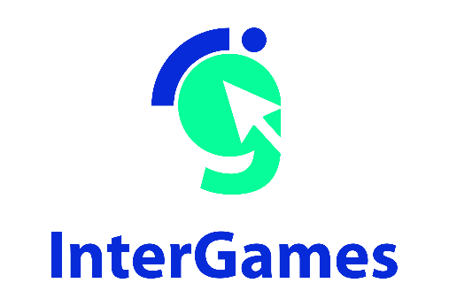

Pedagogical
Sequence

Quandary

By Progettomondo

January

2025

Quandary
Quandary is an educational game that challenges students to resolve conflicts and make ethical decisions for the good of an interstellar community. The Quandary game begins by outlining a problem for the player in the form of a graphic novel. Players can choose to read the graphic novel on the screen and/or listen to the narrative. Reading or listening options are useful for visual and/or auditory learners. The game consists of three different episodes: Lost Sheep, Water Wars, and Fashion Faction.

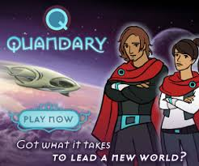

Duration: 3 lessons
Subject/s: civic education, history, social sciences, English, geography
Topics: mediation, decision making, water, war, sustainable economy
SDGs:6, 16
Dimensions of conflict through the game:
X social impact
X environmental impact
X economic impact
X technological impact
Learning objectives: Test the process of decision making and its effect, understand the difference between facts and opinion, understand the power of mediation to take a decision, understand global issues i.e. water supply, war…Promote critical thinking and cultural sensitivity.
Interpersonal skills: Empathy, critical thinking, ability to collaborate, decision- making, prosocial identities
Technical requirements & material required:
Windows PC, Android, or iOS
devices
• Speakers and projector or Interactive Board
• YouTube
• Printed Material 1, 2, 3, 4
• Physical stuff: colours, papers, posters, images
Further reading/material:
https://unstats.un.org/sdgs/dataportal
https://www.youtube.com/watch?v=A0yu7nP50rM
https://worldslargestlesson.globalgoals.org/goal/clean-water-and-sanitation/
https://www.statista.com/chart/27272/water-conflicts/
https://pacinst.org/water-conflicts-continue-to-worsen-worldwide/

Preparation Phase
Ensure that there is a stable Internet connection in the classroom and that all devices are ready to access the game on the platform (https://quandarygame.org/). The game takes time to complete, but you can propose that students test one episode. Have students work in groups of three to experiment with dialogue and shared decision making as they play.
To access the game, registration is not required; you can play by clicking the “Play as guest” button. At this point, the player will need to choose their leader’s profile by clicking on one of the two indicated characters. A comic strip will help set the context in which the missions will take place; invite students to carefully read the story’s opening, and at the end, they will be directed to choose one of the episodes included in the game: “Lost Sheep,” “Water War,” “Fashion Faction,” or “Mixed Message.”
This pedagogical sequence is connected to the episode “Water War.” The game is based on player choices, which require reading instructions and viewpoints available in English. Make sure to allow enough time for translating and analyzing the content while playing the game.
Trigger warning: create the groups in a balanced way, ensuring the presence of students with different characteristics by mixing students with leadership skills with students who have more difficulty exposing themselves, so as to foster dialogue within the group.

Game Phase
Lesson No. | Description in Steps | Social form | Material/technical requirements
1 | Step 1: Introduction (20’)  Ask students to think of a conflict situation they have experienced. It could be with a friend, in the family, with a teacher, or even with themselves. Divide the poster (Material 1) or the board into three parts and asks students to give their opinions on 3 aspects:  1. how would you define a conflict?  2. what factors can contribute to create a conflict?  3. what helps to resolve a conflict?  Collect their contributions in the poster board so that they are visible and make a final summary to return their view of conflict and how it is generated. Then introduce the game they are about to play, explaining that they will be on the planet Braxos, and they will have to help solve some dilemmas, paying attention to the points of view of the various characters. Goal is to help shape the future of a new civilization. | Plenum | Board or poster (Material 1)
1 | Step 2: Gameplay (50’)  Divide the students into groups of 3 according to the recommendations reported in the preparation phase. Invite student to decide some roles within the group: who interacts with the game, who facilitates the translation and summarizes the characters' points of view, who takes notes on the dynamics that are triggered within the group (emotions, critical points, easy decisions...). At this point have each group open their pc and log on to http://quandarygame.org. Communicate that they will have 50' to play the Episode 2 “Water War”. It is not important to get to the end but to follow the dynamics. Give them the instructions detailed in the preparatory phase to help them in using their time in an effective way. During the game give to each group the sheet of Material 1 (used also in the previous activity) asking them to take notes on what arises during the game about what factors create a conflict and what helps to solve the conflict. | Group work | Windows PC,  Android, iOS  Devices, Material 1
1 | Step 3: Debriefing (40’)  Invite the students to sit in a circle to facilitate the exchange among students and promote active listening. Ask the students something about the experience during the game. You can choose questions among these:  - How did you feel during the game?  - What made you choose the solution you chose?  - Did you find it hard to choose? If so, why?  - Are you satisfied about your decision? How would you measure success?  - What is the difference between a fact, an opinion and a solution?  - How were the relations among the group members? Did you have any difficulties and when?  As a summary, ask students to agree on 5 rules that help decision making and conflict resolution even in internal classroom dynamics. Write all the proposal on a poster and at the end invite them to vote the 5 most significant rules for the class. | Work group, plenum | Board or poster to write the rules

Reflection Phase
Lesson No. | Description in Steps | Social form | Material/technical requirements
2 | Step 4: Ice breaking (20’)  Suggest a short activity for students to take up some key concepts that emerged during the game. Explain that this short activity focuses on the importance of active listening, which is an important aspect of managing conflict. Take a ball or, even better, a puppet that can become a class mascot in the listening activities. All participants should take part in this role play. All participants stand together in a circle. It refers to the participants who can speak only when they have the ball in their hands, otherwise they must remain silent and listen to what is being said. When an individual is finished speaking, he or she can pass the ball either to someone who asks for the floor with their hand raised or to someone else (possibly someone they see as not very active during the meeting). Begin the game launching the topic at the center of the discussion and start the discussion based on the rules explained before: what helped me in managing a conflict? | Plenum | Ball, puppet
2 | Step 5: Water and SDGs (20’)  Hang the SDGs in the classroom by printing them from the material that you can find at this link (SDGs Poster and individual goals): https://www.un.org/sustainabledevelopment/news/communications-material/ . Ask the children to look around and explain what the hanging posters are. After gathering their input, briefly explain the 2030 Agenda.  Hang the SDGs in the classroom by printing them from the material 1. Ask the students to look around and explain what the hanging posters are. After gathering their input, briefly explain the 2030 Agenda by pausing in your explanation of the goals.  Then put SDG6 in the center, ask a student to hold the related poster and a ball of yarn.  At this point ask students if they think there might be a connection between SDG6 and the others hanging. The one who finds the connection and motivates him or her stands under the identified SDG and the boy in the center throws the ball of yarn to him or her and then returns it. Continue until connections emerge then summarize and have students observe how the issue of water is linked to other basic human rights | Collective and cooperative work | Material 1, Yarn,
2 | Step 6: Water conflict: from the game to reality (40’)  What is a water conflict? Why the water could be interrelated to conflict? Explain to the students the meaning of these words:  Trigger: Water as a trigger or root cause of conflict, or underlying cause of ongoing tension that is contributing to conflict, where there is a dispute over the control of water or water systems or where economic or physical access to water, or scarcity of water, triggers violence.  Weapon: Water as a weapon of conflict, where water resources, or water systems themselves, are used as a tool or weapon in a violent conflict.  Casualty: Water resources or water systems as a casualty of conflict, where water resources, or water systems, are intentional or incidental casualties or targets of violence.  Show the student the map here: https://www.worldwater.org/conflict/map/ where they can see the amount of water conflict in the world and in the time.  Divide the class into groups of 4-5 students and give each group one of the materials in Material 2. Each group looks at the map or reads the infographic and share the issues that surprises or interests more. The group has 20’ to find more information on the web. Their works are presented to the class.  Each group presents their in-depth study in plenary. | Group work of 4-5 students | Material 1, board
3 | Step 7: What can we do to save the planet? (60’)  Divide the students into groups of 4–5 and invite them to reflect on their relationship with the resource water in their everyday contexts: at school, at home, and in their local area. Encourage them to identify the main problems they observe and possible solutions, using the worksheet provided in Material 3.  At the end of the brainstorming session, each group should identify three key commitments they can adopt to promote responsible behavior regarding water use.  Dedicate the final 20 minutes to a plenary session, during which each group presents the main results of their work  Step 8: A global campaign to save the planet (60’)  Divide the students into groups of 4/5 and tell them that they will now return to the beginning of the game, resuming the initial sentence “At the dawn of a new society how will you decide?”.  What does your ideal society look like in the face of all the challenges we have seen? Print and give the Material 4 and ask students to represent their dreamful society and decide on the claim. | Group work | Material 3 and 4, pens, markers or similar

Material 1
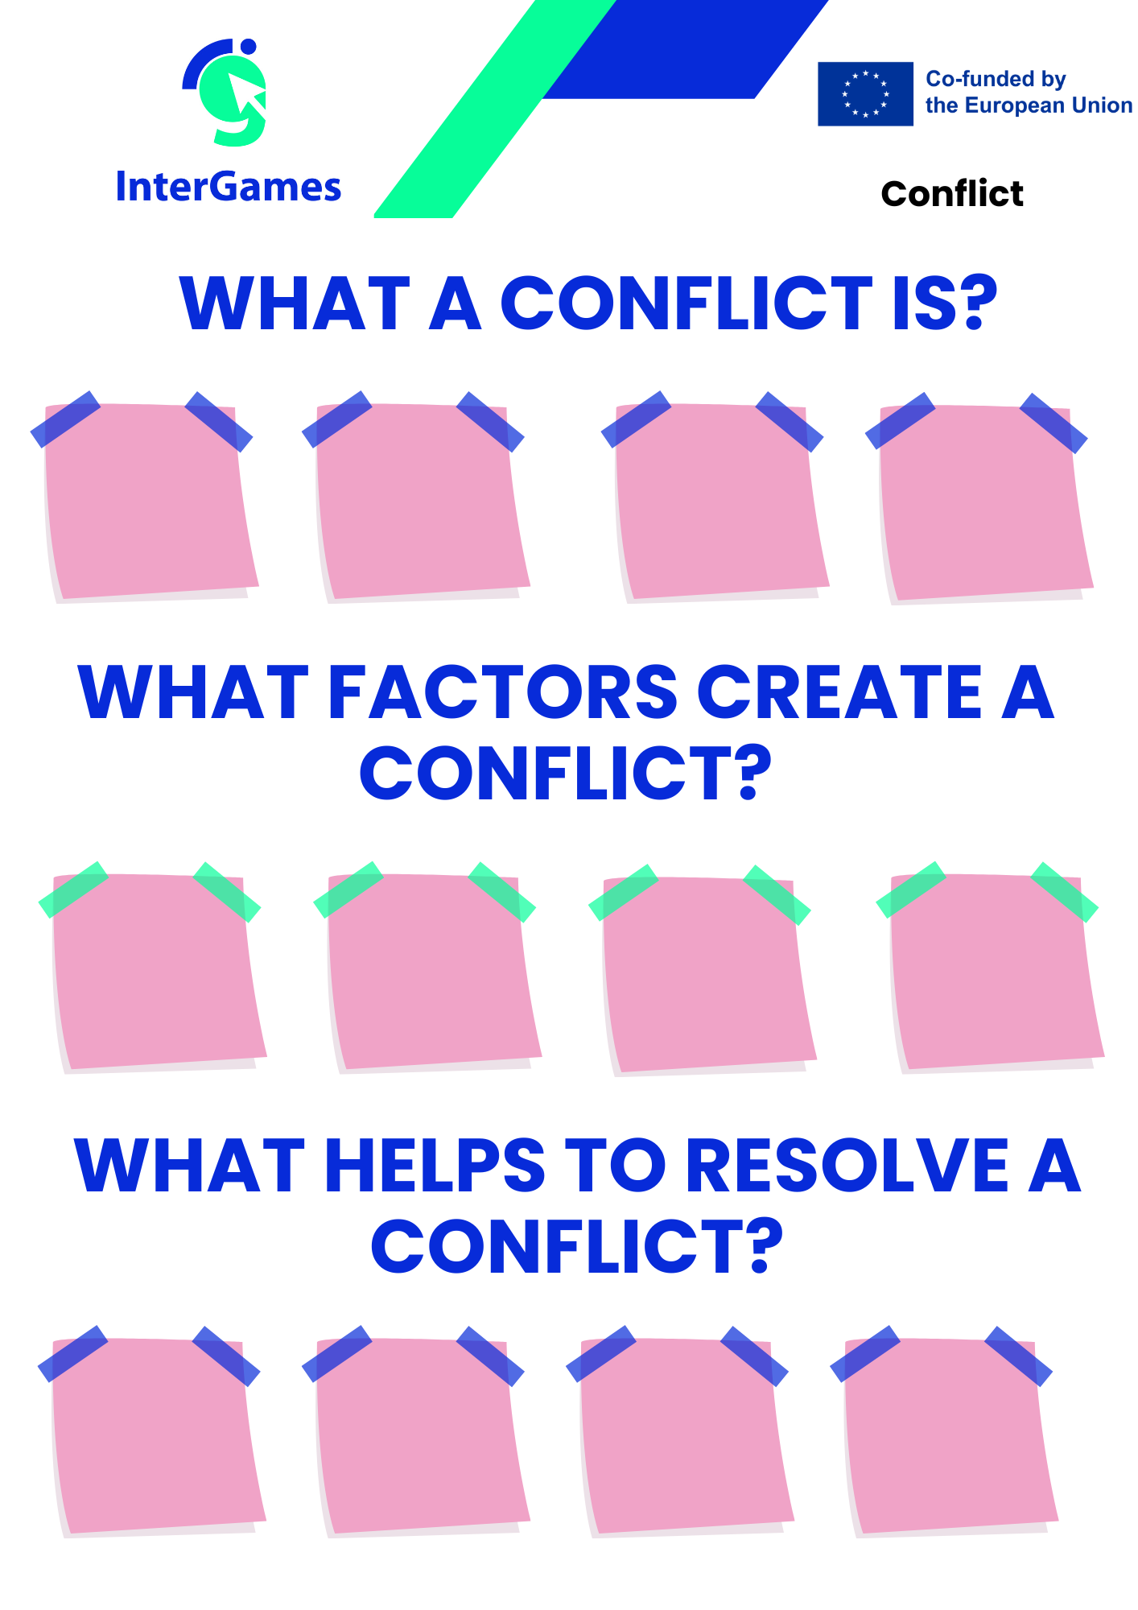

Material 2

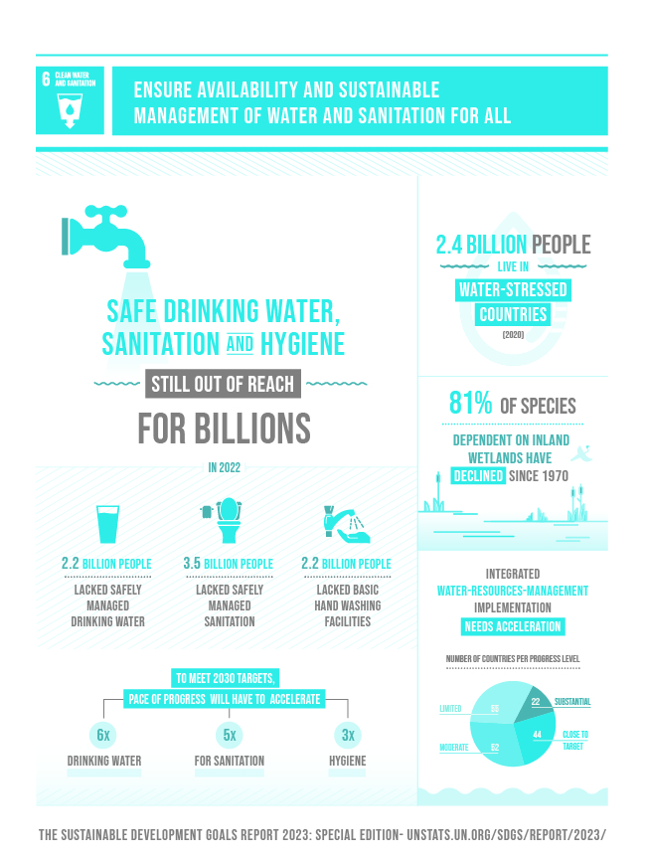

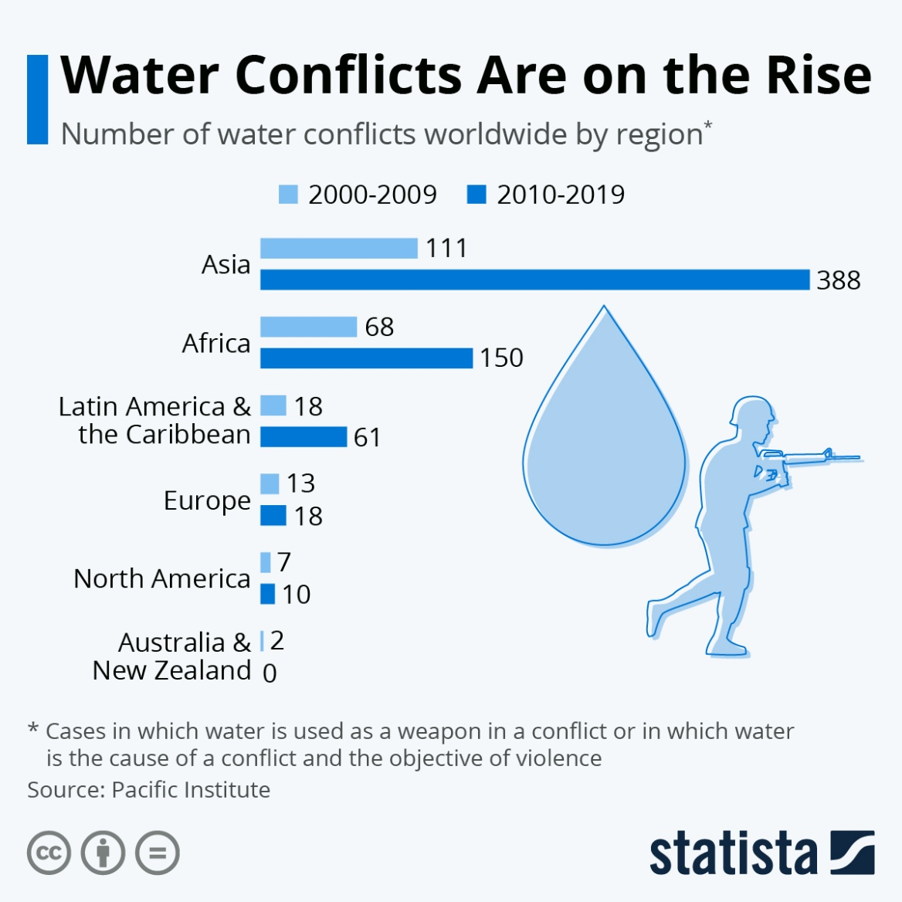

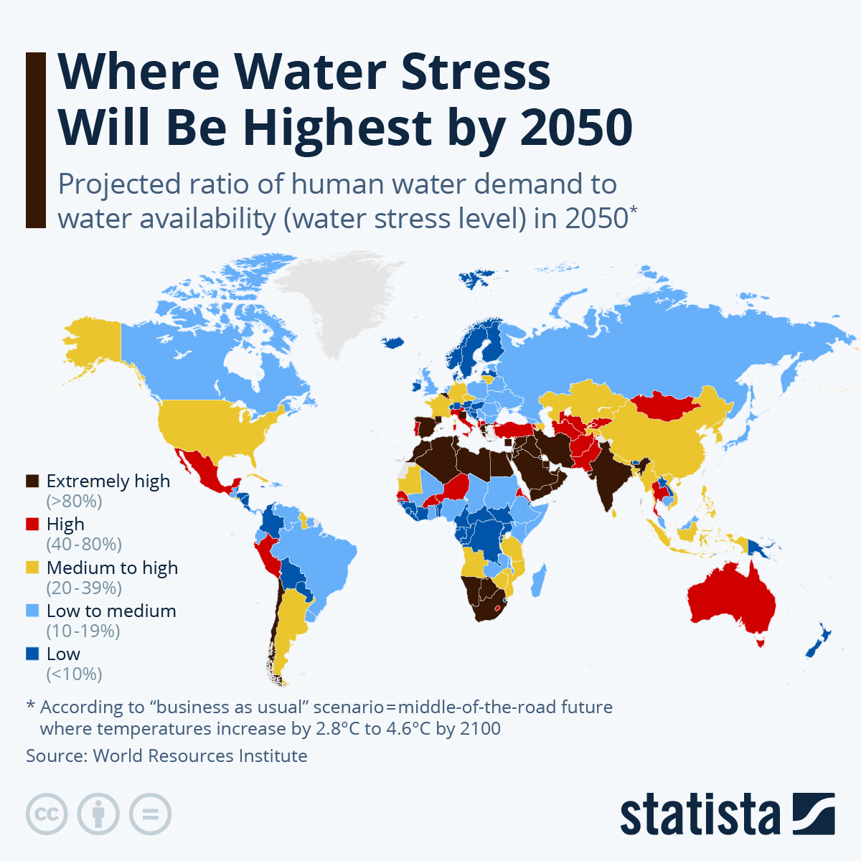

6d Those who lack improved water sources are concentrated largely in Sub-Saharan Africa

Share of population with access to an improved water source, 2015 (%)
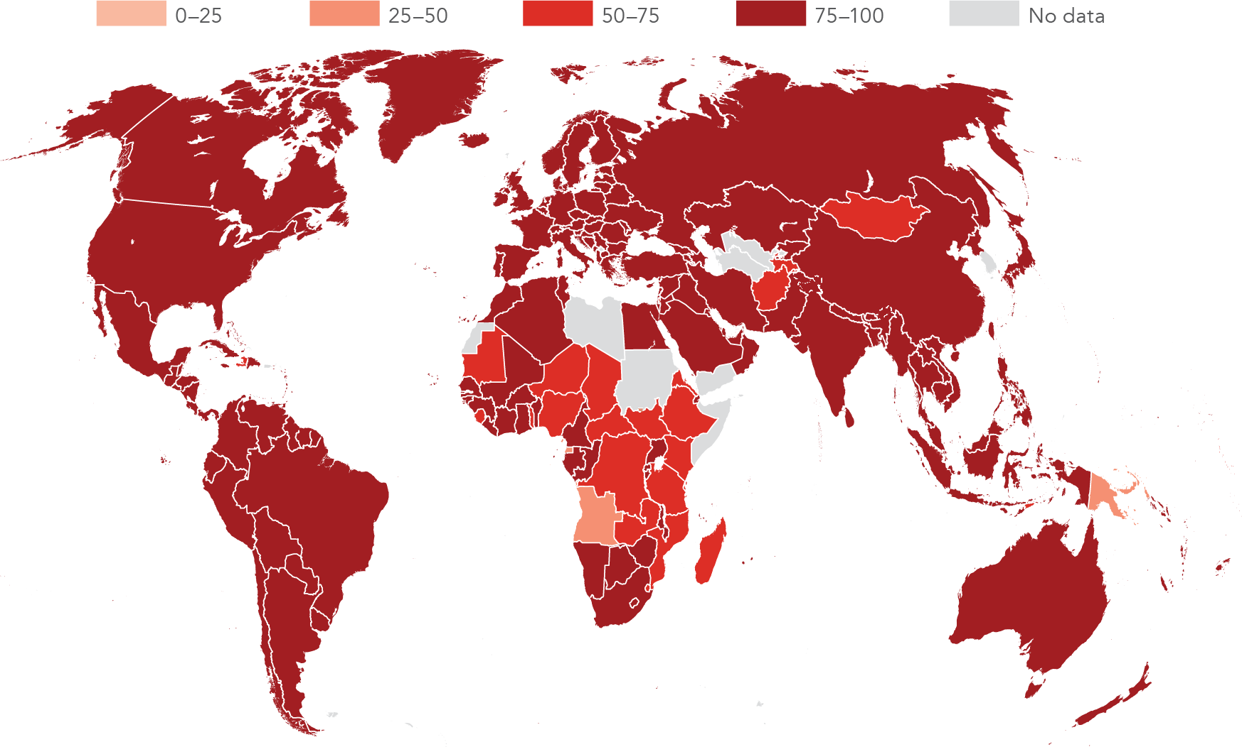

Source: World Health Organization/United Nations Children's Fund Joint Monitoring Programme for Water Supply and Sanitation; WDI (SH.H2O.SAFE.ZS).

Material 3

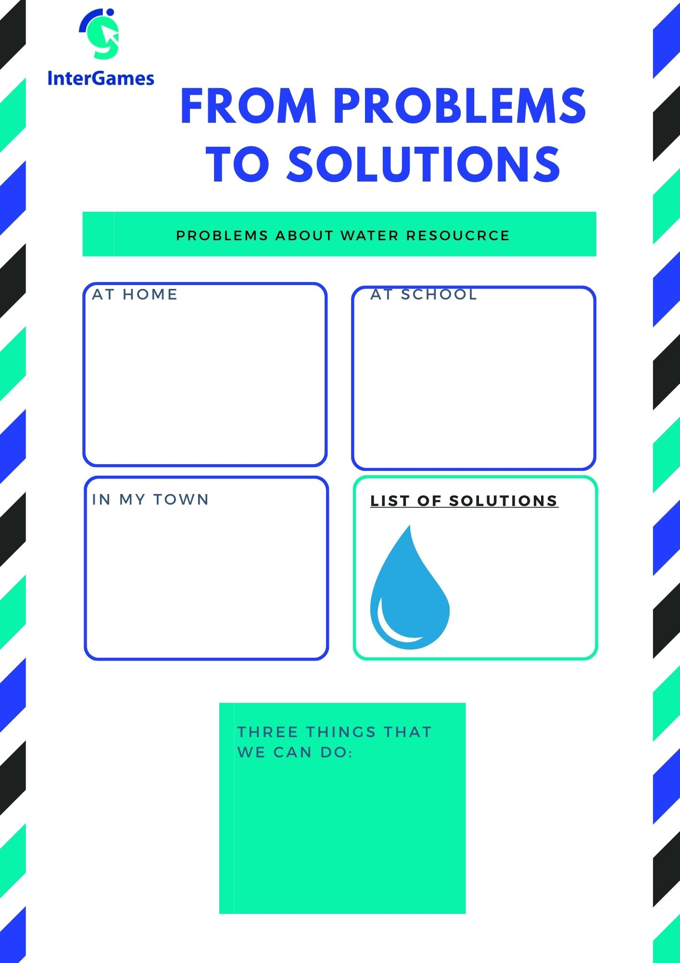

Material 4

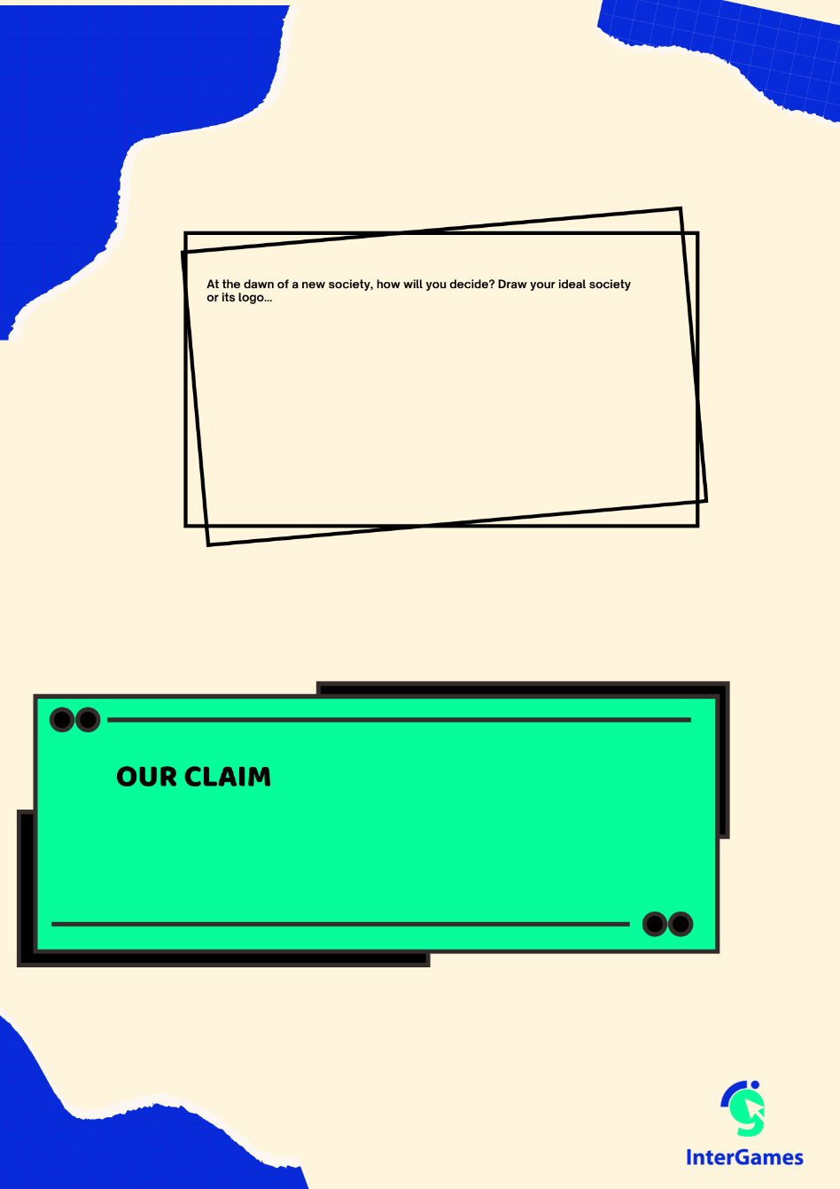

Annex – Game analysis:

