

Pedagogical Sequences – This War of Mine
A3.4.

January 2024
Helixconnect Europe

Contents
1. Pedagogical sequences – This war of mine 3
2. Annex – Game analysis 10

1. Pedagogical sequences – This war of mine
Title: This war of mine

This War of Mine is a survival simulation game that provides an alternative perspective on war, focusing on the struggles of civilians trapped in a besieged city. Unlike traditional war games, it emphasizes resource management, moral dilemmas, and the consequences of survival decisions. The game is inspired by real conflicts, particularly the Siege of Sarajevo.

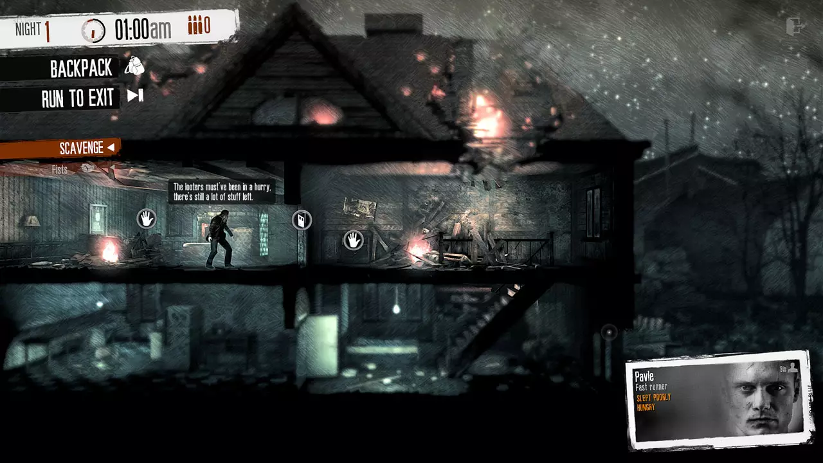
© Gamesplanet

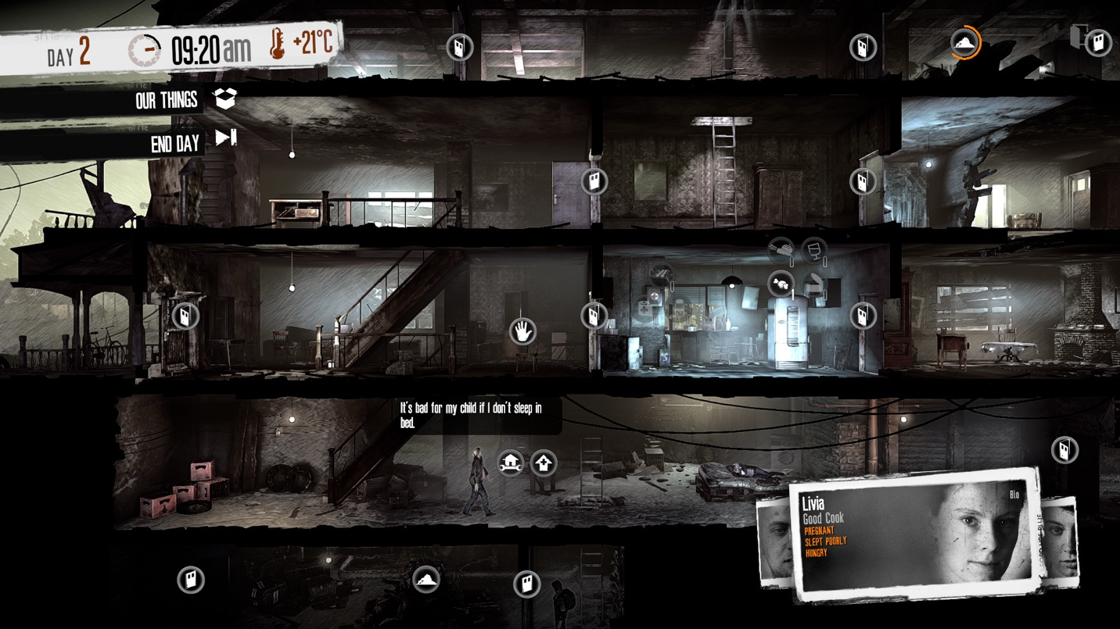
© Steam

Duration: 2 lessons
Subject/s: History, Social Studies, Civics
Topics: Civilian experience in war, moral dilemmas, survival strategies, the impact of war on daily life, human rights violations
SDGs: 16: Peace, Justice, and Strong Institutions; 10: Reduced Inequalities; 1: No Poverty
Dimensions of conflict through the game:
☒ social impact
☒ environmental impact
☒ economic impact
☐ technological impact
Learning objectives:
Students will analyse the ethical and moral dilemmas faced by civilians in war. They will reflect on how war affects non-combatants and compare this to historical and current events.
Students will develop critical thinking and decision-making skills through simulated in-game scenarios and understand the socio-economic impact of war on a population.
Interpersonal skills:
- Empathy and perspective-taking
- Ethical decision-making
- Critical thinking
- Community and leadership skills
Technical requirements & material required:
- Computer with internet access
- Speakers and projector (if available)
- YouTube gameplay videos if the game is unavailable for students
- Printed discussion worksheets & reflection sheets (see Annex)
- Physical activity materials (index cards, role-play prompts, printed case studies) (see Annex)
Further reading/material:
Articles on civilian experiences in war (e.g., Siege of Sarajevo, Syrian Civil War):
- Sarajevo under siege, Ivana Maček, 2009 (Book)
- Long Shot, Azad Cudi (Book)
- More resources:
- https://www.unicef.org/emergencies/syrian-crisis
- https://www.aljazeera.com/features/2021/4/19/how-the-siege-of-sarajevo-changed-journalism

De Smale, S., Kors, M., Sandovar, A., 2017. "The Case of This War of Mine: A Production Studies Perspective on Moral Game Design", Games and Culture. 14. 10.1177/1555412017725996.
Kwiatkowski, K., 2016. "Civilian Casualties: Shifting Perspective in This War of Mine", Zones of Control: Perspectives on Wargaming, Pat Harrigan, Matthew G. Kirschenbaum
Ecenbarger, C., 2016. " In war, not everyone's a soldier." A Review of This War of Mine. Press Start, 3(2), pp.70-73.
Documentary: "The Fog of War" by Errol Morris: https://www.imdb.com/title/tt0317910/

Preparation Phase

Firstly, teachers should get familiar with the game by either viewing a short gameplay ( https://www.youtube.com/watch?v=foroh4lCeAg (20 minutes)), a full gameplay (https://www.youtube.com/watch?v=VOtlLiHJRW8 (5+ hours)), or purchasing and playing the game (https://store.steampowered.com/app/282070/This_War_of_Mine/). When done, they should think about and examine its unique focus on civilians rather than soldiers (and read the game analysis, provided below) to get a grasp on general ideas, topics and aspects of conflict this game covers. With the research done, teachers can proceed with incorporating the lesson plan into their style of teaching.

Game Phase

Lesson No. | Description in Steps | Social form | Material/technical requirements
1 | Step 1: Introduce the game by showing a short gameplay trailer to pupils. | Plenum | Projector, YouTube video, speakers, Internet connection
1 | Step 2:  Ask pupils: What comes to mind when you think of war? Who do you imagine is affected? Write responses on the board. | Plenum | Whiteboard, markers
1 | Step 3:  Distribute short case studies about real-life wartime civilian experiences (e.g., Sarajevo, Aleppo) and discuss the similarities with the game’s setting. | Small groups
  Printed case studies
  (Copy templates 1)
1 | Step 4: Students watch a selected gameplay segment (~10 min), focusing on moral dilemmas (e.g., stealing food, helping others at personal risk). | Plenum | Projector, YouTube video, speakers, Internet connection
1 | Step 5:  Role-playing exercise where students are assigned different characters (e.g., a starving child, an elderly survivor, a wounded civilian). They must argue their choices for survival in a limited-resource scenario. | Small groups | Role-playing scenario cards
1 | Step 6:  Storytelling Exercise: Students can create a short digital narrative (using Canva or Adobe Spark) or  write a physical diary entry from their character’s perspective.  (If not enough time, this can be assigned as a homework activity) | Individual/Pair Work | Computers/tablets  or notebooks

Reflection Phase

Lesson No. | Description in Steps | Social form | Material/technical requirements
2 | Step 7: Discussion on the Role play and Storytelling activities;  Proposed questions:What choices did the player make? What would you have done differently? Why? | Plenum | Materials from step 6.
2 | Step 8:  Debate on Moral Dilemmas: Pose survival dilemmas from the game (e.g., stealing food vs. starvation) and assign students different viewpoints for a structured debate. | Plenum | Debate guidelines, discussion prompts
2 | Step 9:  Students analyze the impact of their role-play decisions and connect them to real-world consequences of war.  (This step can also be paired/adjusted to incorporate current History or Civics lessons) | Plenum | Journals/Notebooks
2 | Step 10: Conclude the lesson with a final discussion encompassing all the topics and activities from above.  Proposed questions:  What lessons can we take from this game about the realities of war? How can we apply these lessons to modern-day conflicts? | Plenum | No material required

Be mindful of students who may have personal or family experiences with war. Provide a space for voluntary participation.

Copy templates:

- Case studies can be downloaded/adapted from this website: https://casebook.icrc.org/case-study/case-study-armed-conflicts-former-yugoslavia; https://casebook.icrc.org/case-study/syria-battle-aleppo
- Case study example with questions: https://study.com/academy/practice/the-syrian-civil-war-quiz-worksheet-for-kids.html

- Role-playing scenario cards template:

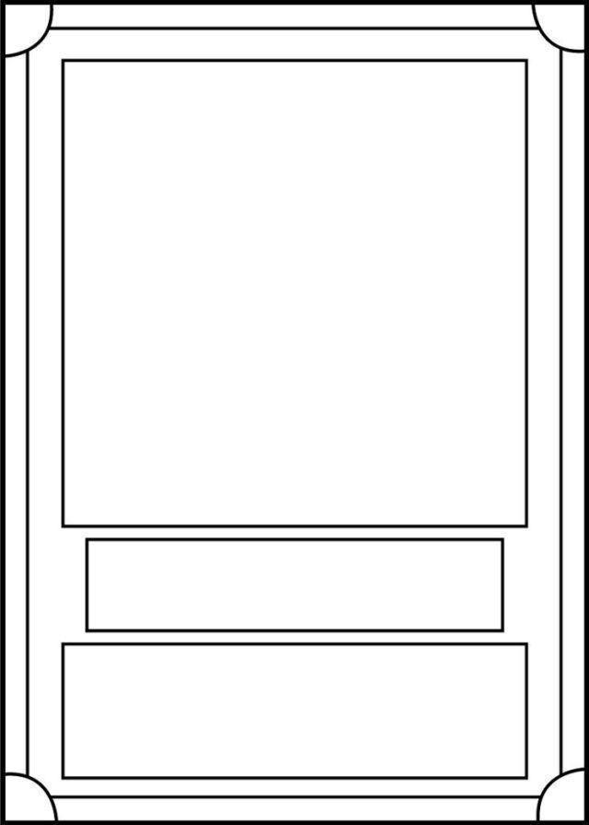
Pinterest: printabletemplateslab.com
- Debate guidelines and discussion prompts:

1) Assign each group a moral dilemma from the game (e.g., stealing food from an elderly couple, allowing a sick group member to die for the survival of others). Each group must prepare arguments for and against their assigned dilemma.
2) One student from each group presents their argument; The opposing side presents their counterargument (2 minutes).
Then, other students can ask questions or challenge statements. After that, allow time for final rebuttals from each side.
3) Your role is to act as a moderator, encouraging students to justify their reasoning with ethical, social, and survival considerations.
4) After all groups have debated, facilitate a whole-class discussion. For example: Did your perspective change after hearing the other side? What real-world parallels can you draw from these dilemmas? How do moral values shift in extreme survival situations?

Discussion prompts:
Stealing for survival:
Should you steal from an elderly couple to feed your starving group? Does the necessity of survival justify theft? Would your answer change if you knew the elderly couple had more resources than they needed?
Helping others at personal risk:
Should you help a wounded stranger if it endangers your group? Is it ever ethical to turn away those in need? Would your choice be different if the person in need was a child?
Leaving a group member behind:
If a group member is sick and using up limited resources, should they be abandoned to save others? Is the “greater good” more important than individual lives? What if they had sacrificed themselves voluntarily?
Trading with criminals:
Would you trade with violent bandits for medicine if it meant helping your group survive? Is there a moral boundary to what should be accepted in a survival situation? How do ethics change when dealing with extreme desperation?
Using violence for protection:
Is it justifiable to harm someone who threatens your survival? Where do you draw the line between self-defense and unnecessary violence? Does desperation turn good people into bad ones?

2. Annex – Game analysis
This War Of Mine
In order to facilitate the analysis of the selected video games, a reference table has been prepared, which breaks down the main characteristics to be considered in each of these four categories.

Title | This War of Mine
Platform | PC
Language | English
N. º of sessions played | 3
Total time played | 6 hours
Brief Description | 2D Platform survival game showcasing harsh realities of war from the perspective of ordinary people.

Dimension | Evaluation Criteria
Usability (analysis of  technical correctness and  ease of  use) | - Is the game easy to learn and play?  - The game has a learning curve, as it involves managing multiple aspects like resources, character needs, and moral decisions. While the basic mechanics are relatively straightforward, mastering the game can be challenging due to its complex and unpredictable nature.  - Is the user interface (controls and navigation) clear and tailored to the target audience?  - Interface is visually pleasing and in tone with the game,  however, it may feel a bit overwhelming initially due to the number of elements players need to manage.  - Are accessibility options implemented?  - There are no real accessibility options regarding this game.  - Is the game response accurate and fast?  - All the game actions are smooth and responsive.  - Are in-game messages accurate?  - Yes, the in-game messages are accurate and provide clear information about the game state, character needs, and the consequences of player decisions. The narrative-driven messages also effectively convey the emotional weight of the game.

- Are there instructions?
- The game is quite intuitive, and the narrative is employed to guide the players through the game leaving them to explore the controls on their own.
- Is it possible to save the game?
- Yes, the game can be saved.
- Are there any bugs?
I have not encountered any bugs while playing the game.
Other relevant usability comments
Gameplay (analysis of the game's play and  narrative structures, and how game design produces meaning) | - Were you able to finish the game (yes/no: why)?  - No, the game in question is a survival-based game, where different decisions lead to different outcomes leaning more to a repeated gameplay rather than a single playthrough.  - Duration (per level/mission or over the whole game)  - It’s player dependent.  - Degree of interactivity (do the player's decisions play a crucial role in the outcome of the game)?  - Game solely relies on the player's decision, so the outcome is completely in the player's hands.  - Is the pace of the game satisfying?  - Yes.  - Narrative weight (high/medium/low)  - High  - Presence of a narrator: yes/no  - No  - Presentation and role of the main character (characteristics and qualities of the character/avatar)  - Depending on the playthrough there can be a main character or a survivor, where you get to relive their war thorn experience.  - Depiction and role of the antagonist (characteristics and qualities)  - War in itself acts as an antagonist, the way war influences  people's decisions and actions and how they can completely flip from everyday life.  - Presentation of the setting (world in which the character develops)

- True to the story, colors are muted and dark, the war devastated setting made me feel as If I was being trapped together with the survivors.
- Dimension/temporality: time period covered by the story and its characteristics (fictional/real, global/local, etc.)
- Inspired by the real-world conflicts, but the game is placed in its own fictional timeline.
- Mission (what are the essential actions to win/complete the game)
- Ensure the survival of your own group.
What are the main challenges/obstacles faced by the protagonist?
Each of the characters has their own set of moral dilemmas
which become plagued by the decisions they have to make to ensure their and the group's survival.
- Are the game mechanics appropriate to the content and implicit goals?
- Yes, ensuring group survival stems from everyday actions of scavenging for food and building up the survival shelter which are the main gameplay mechanics.
- Do you agree with the reward system (incentives for action)?
- It quickly becomes a double-edged sword, as the game rewards you for making morally questionable actions depending on the character at stake, ultimately gaining something, but losing
something as well.
- How is the feedback system (text, audio or audiovisual comments given to the player for certain actions)?
- Game provides immediate feedback response to players depending on the actions they can be all 3 at times.
- Overall story (description of the story of the game as a whole)
- The story unfolds through the daily lives of these civilians, where every choice, whether to steal, help others, or defend your shelter, carries weighty consequences, reflecting the
harshness of war from a civilian's perspective.
Content (analysis  of the  content of the | - What are the themes of the game?  - Survival, morality, costs of war.

game and the  messages conveyed in relation to the objective) | - What kind of reflection, knowledge, skills, competences, awareness are developed?  Deep reflection on the ethical and moral challenges faced during  wartime.  - Is there an explicit use of sources of information?  - The game does not explicitly use real-world sources of information within its narrative, but it is heavily inspired by real- life conflicts and humanitarian crises  - Do you think the player can get the intended message without external help?  - Yes, the player can grasp the intended message of the game without external help.  - Did you change your beliefs/opinions or learn something new after playing the game?  - Yes, it deepened my empathy for those caught in the crossfire of war, having to make tough ethical decisions from their perspective.
Didactic  resource  (analyzing the  game as a didactic resource) | - 21st century skills included:  - Critical thinking  - Creativity  - Collaboration  - Communication  - Information literacy  - Media literacy  - Technology literacy  - Flexibility  - Leadership  - Initiative  - Productivity  - Social skills  - Dimensions covered:  - Social  - Environmental  - Technological  - Economic



- Link with Intergames subjects:
- Environmental Sciences
- Civic Education
- Arts
- History
- Economics

- Competences (knowledge achieved by the learner)
- Players are required to adapt to scarce resources that the game provides which are a great learning tool regarding organizational skills.
- Problem solving conditions (way of thinking to solve problems: reproductive-memory, productive-creativity)
- The moral dilemmas in the game often require players to think outside the box. Deciding whether to help a stranger at the risk of endangering their own group or finding a non-violent way to acquire needed resources are examples where creative problem-solving is essential.
- Need for prior knowledge (no/yes: detail)
- No
- Learning curve (learning difficulty: low, medium, high)
- Medium
- Possibility of group work (no/yes: detail)
- Yes, as making choices regarding morally questionable actions can lead to productive conversations.
- Does it include a teaching guide (information for teachers with tips and examples for implementation in the classroom)?
- No
- Possibility of teacher evaluation (no/yes: please specify)
- No, as the game requires players to make deeply morally questionable decisions regarding war efforts which can be awfully difficult to judge.

This game is not free-to-play. It requires purchase. Currently, its price stands at 1.89€ at a 90% discount on Steam: https://store.steampowered.com/app/282070/This_War_of_Mine/; the price is subject to change. If there is not an option to purchase the game for the lessons, provided gameplay videos can work as well.

