

Pedagogical Sequences –
This war of mine
A3.5.

April 2025
Südwind

Title: THis war OF MINE
Short description of the game
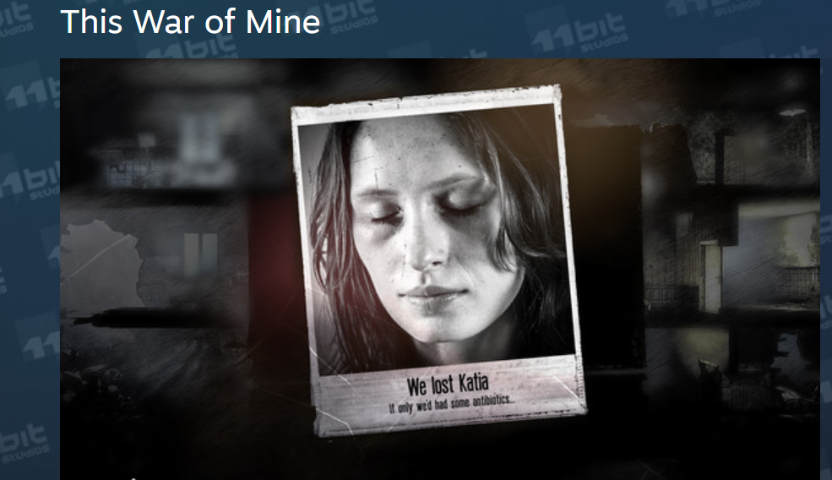
This War of Mine is a survival game where players manage a group of civilians struggling to survive in a war-torn city. Focused on the harsh realities of war, it involves scavenging for resources, managing supplies, and making morally challenging decisions, all while dealing with the physical and emotional toll of conflict.
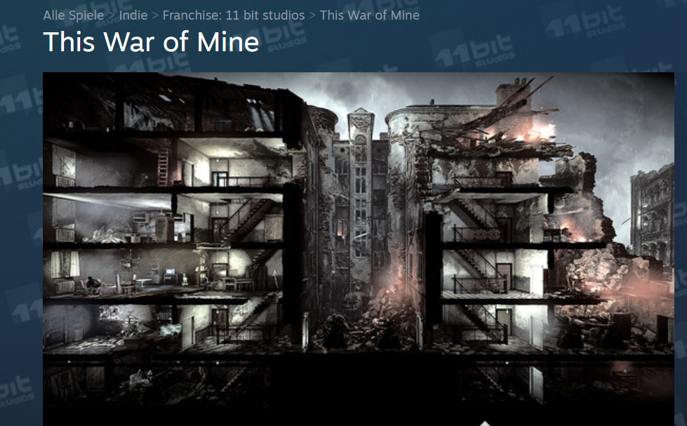
[Picture 1-2, Screenshot ]

Duration: 4 lessons
Subject/s: Civic Education, History
Topics: conflict and
resolution, personal sacrifice, moral ambiguity, power dynamics and personal
responsibility; Themes of identity and agency, strategic use of limited items and goods, worth of some things over others, safety vs. needs

SDGs: 9, 10, 11, 16
Dimensions of conflict through the game:
☒ social impact
☒ environmental impact
☒ economic impact
☒ technological impact
Learning objectives:
Students will simulate war and conflict-situations in the game and learn the cognitive, emotional, environmental, as well as social impact of war and conflict.
Interpersonal skills: critical thinking, ethical reflection, strategic planning, problem solving skills, decision making skills, empathy, self-awareness
Technical requirements & material required: Beamer, PC, PC + Headphones WIFI; QR-Code to URL
Further reading/material: Glasl, Friedrich: Konfliktmanagement. Ein Handbuch für Führungkräfte, Beraterinnen und Berater,
8. aktualisierte und ergänzte Auflage, Paul Haupt Bern Stuttgart Wien, Freies Geistesleben
Stuttgart, 2004, Figur 9.2: Die 9 Stufen der Konflikteskalation: S. 236-237 sowie Kapitel
11: Interventionen der Konfliktbehandlung, S. 313-347 (Auszüge).
McLeod, Saul. (2024). Maslow's Hierarchy of Needs. https://www.researchgate.net/publication/383241976_Maslow's_Hierarchy_of_Needs; [05.02.2025; 11:11].
Circle Forward. 2023. Consnet vs. Consensus – What’s the Difference? https://circleforward.us/consent-vs-consensus-whats-the-difference/; [05.02.2025; 11:09].
Generation Europe Project. 2021.Methode Box.https://generationeurope.org/wp-content/uploads/2023/01/GenE-Methodbox.pdf; [06.02.2025; 11:48].

Preparation Phase
The objective of this lesson is to engage students in thoughtful discussions about the impact of war on civilians and moral dilemmas through a walkthrough of the computer game This War of Mine. The lesson fosters empathy, critical thinking, and ethical reflection.
If you have the resources and time, you can buy the game on different streaming platforms and let the pupils play. For the following lessons YouTube walk-throughs videos are used.
Preparing for the session requires careful attention to content sensitivity. Inform students beforehand that the game contains mature themes, including survival challenges, moral dilemmas, and the civilian experience during war. Offer an opt-out option for any students who may find the content distressing and prepare an alternative activity for these students. Be mindful of students directly affected by conflicts or wars. Provide individual support if necessary and consider consulting with a school counselor.
Ensure technical requirements are met, including a PC with a reliable internet connection, a beamer or projector with speakers, and WLAN access. Materials needed include walkthrough videos of This War of Mine, questionnaires for students to answer while watching, and additional handouts and background materials.
Begin the lesson by introducing the session and providing context for the game. Discuss the concept of "war from a civilian perspective," highlighting that the game portrays the survival struggles of non-combatants. Address content warnings and provide reassurance for students who may need support. During the video walkthrough, play the walkthrough on the projector with clear audio. Distribute questionnaires for students to fill in as they watch. Encourage students to jot down notes on resource management, dangers faced, and moral dilemmas encountered by the characters.
Note & Learning from specific School-testings: It would be beneficial if time and financial resources allowed students to actively play the game. However, most of the gameplay would need to take place at home. Teachers have suggested the possibility of assigning the game as a semester project. This way, both the introduction and the final reflection could occur in a school setting, while the actual gameplay happens at home. The materials developed here rely on playthroughs—an approach that is common and acceptable, particularly for younger gamers. However, this means that students do not take on an active role as players themselves. Nonetheless, social theories and dilemma-based discussions can be explored and analyzed during class time without requiring additional work at home.

Game Phase
Lesson No. | Description in Steps | Social form | Material/technical requirements
1 | Step 1: Explain the Game with a few words. Tell students, that this game has to be bought, that’s why a YouTube- walk through is used for the school-lessons (each video has an approx. duration of 20min).  “In this lesson we will watch two Videos of a possible gameplay of “this war of mine”. We are starting with day 1 and after all will watch day 20 to compare the situation of the characters in the game. Please fill in the questionnaire and your thoughts, make notes, while we are watching the videos.” | Plenum | Beamer, YouTube/internet, link to video, speakers  Material 1 and 2
Step 2: Hand out Material 1 and Material 2 to the students.

(Material 3 shows QR-Codes to the videos, if you want to use them)

Watch the first two videos.

Video 1: Part 1 (The Survivors) https://www.youtube.com/watch?v=9UIfp4V0YnA&list=PLIhNUXJ4tecdFPGFiG-XHJ40H9qsGuMJp&index=1

Video 2: Part 13 (Disaster) https://www.youtube.com/watch?v=E09gZSytj0c&list=PLIhNUXJ4tecdFPGFiG-XHJ40H9qsGuMJp&index=13

1 | Step 3: With the time which is left, discuss with the students their answers and impressions of the game.  You can first make an exchange in pairs (e.g with the sitting neighbours) and than talk in the plenum  After that explain the Homework (Material 2)  Video 3 (Homework) Part 28 (17:26) https://www.youtube.com/watch?v=6rCeqTLSD3A&list=PLIhNUXJ4tecdFPGFiG-XHJ40H9qsGuMJp&index=28  If you have time or don’t want to give it as homework, step 3 can be also done as an individual task. Students can use School PCs or their phones to skip through the videos and watch the ending. | Group work in pairs.  Plenum | Material 3 Printed QR-Code to games

Reflection Phase
Lesson No. | Description in Steps | Social form | Material/technical requirements
2 | Step 4: Compare Homework: How did you answer the questions on your questionnaire? To get back into the topic, you can start with the last question on the homework sheet (Material 2):  “Would you like to play this game?” – “Why/Why not?” | Plenum | Material 2
2 | Step 5: We want to examine two models from social sciences and apply them to our game  Hand out Material 4 (a, b) to each group  - Maslow's pyramid of needs (psychological model) on the basic and hierarchic needs of people  - Friedrich Glasl’s Escalation-Phases-Model  (2004) (social/communication model) about the progressive escalation (9 stages) of conflicts.  (In-depth reading materials can be found at the beginning of the unit)  First discuss Maslow’s pyramid of needs in small groups  Write the discussion questions on the board or flip chart:  1) In general: Do you think it covers all needs? Is the order justified?  2) To what extent can the needs pyramid be applied to the game scenario in “This war of mine”?  3) How does war or peace affect human needs?  Discuss now Glasl’s Escalation-Phases-Model in small groups. Write the discussion questions on the board or flip chart:  1) Does the model make sense to you? Have you perhaps already experienced a gradual deterioration of a conflict yourself?  2) Can one or more of the escalation stages be recognized in our game?  3) Is there a global conflict that could be described using this phase model? Can you think of an example? | Group work of 4-5 pupils | Material 4a  Material 4b  (1 per group)  Board or Flipchart
2 | Step 6: Plenum Discussion  You can discuss each model and the answers separately or per group. Let one student write down keywords on the board, to get an overview. | If you want to make this step 6 more interactive let students give their answers via mentimeter.com, where students can type in their answers with their phone and they will be visible on the screen for everyone. Ist free.
2 | Step 7: 3 Situations – how will you decide?  Hand out 4 examples of situations from the play through video – “This war of mine”  Each group should decide how they would react in the situation. They should put into account the state of the characters (injuries, hunger, etc.) and possible conflict inside the shelter and outside (war).  How would you as a group decide? Take into consideration Maslow’s hierarchy and Glasl’s Escalation-Phases. | Material 5 | Material 5, Phones or computer to rewatch videos, speaker
3 | Step 8: In the last unit we talked about needs and conflicts (brief repetition of the content). In “This war of mine”, a war situation and individual fates are depicted.  Today we want to look to the future.  Think about the game and let's assume that the final stage of escalation (like Friedrich Glasl put it) has been reached - complete annihilation, a lose-lose situation.  Now it is about building a new society and avoiding past mistakes.  Therefore, we need a code that everyone adheres to (Code of Ethics)  We divide the class into two groups. You have 20 minutes to think about the 10 most important rules for a new, functioning society.  - How to govern?  - How are resources distributed?  - Who gets to decide? | 2 groups | A4 Paper, Pens
3 | Step 9: Write your 10 guidelines on an A4 piece of paper | 2 groups | A4 Paper, Pens
3 | Step 10: Let them watch Material 6a and read Material 6b  Video: Consensus Building (by Smith Culp)  https://www.youtube.com/watch?v=9SjUjXkyWBw  There are discussion questions on the Material, which can be used.  Certain words might need clarification, e.g.:  - COP (Conference of Parties)  - Global North/South  - Fossil Fuels | Group work (2 groups) | Material 6a+b
3 | Step 11: Both groups should present now their “code of ethics”  Both groups have the right to comment on each other’s guidelines after the presentation. Let them discover similarities and differences. Some of the ideas and concepts might need helping to find the exact meanings. | Plenum | Board, Flipchart, Pens
3 | Step 12: Round Table  Both groups should now work together to make one catalogue of key-values, write it at the end on a big poster and present it as one.  You can use Material 6 (consensus at COPs) and the Video to explain “consensus” versus consent.  You can agree for example, that only those key-values make it in the final code, which can be agreed upon by consensus. | Plenum | Poster, Markers
4 | Lesson 4 is an optional step and could be done in Ethics, Environmental studies, history or arts, working together in an interdisciplinary manner.  Step 13: Build your sustainable city.  In “This war of mine” survivors have to rebuild their city and society. We made a code of ethics, which shows how to live together, but how can we rebuild a sustainable city?  Students should paint a sustainable city. The code of ethics can be used as guidline to understand connections and important aspects of this city.  You can find a detailed explanation for the Step 8 to 13 in the toolbox from “Generation Europe”, pages 37&54:  https://generationeurope.org/wp-content/uploads/2023/01/GenE-Methodbox.pdf | Plenum,  Small working groups | Link to toolbox
4 | Display your results to your peers, make an exhibition or presentation of your ideas. | Plenum | Plenum,  Small working groups

Copy templates:

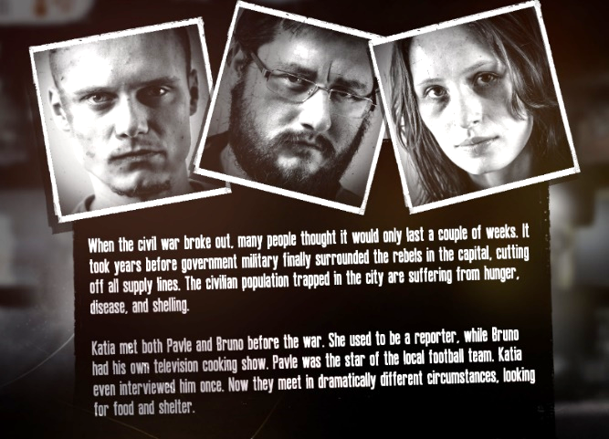
Material 1: Video 1 – This war of mine || Day 1
Game-Characters:
What are the Names of the survivors/characters?
- ____________________________
- ____________________________
- ____________________________
What are their survival- skills?
- ____________________________
- ____________________________ [Picture 3 - Screenshot ]
- ____________________________
What do we know about their life before the war?
- _______________________________________________________________________________________
- _______________________________________________________________________________________
- _______________________________________________________________________________________
Gameplay:
What is the aim of the game and how is it accomplished? ____________________________________________________________________________________________________________________________________________________________________________________________________________________________________________________________________________________________________________________________________________________________________________________________
How would you describe the environment in which the game takes place?
_____________________________________________________________________________________________________________________________________________________________________________________________________________________________________________________________________________________________
What are your thoughts after watching the first video?
____________________________________________________________________________________________________________________________________________________________________________________________________________________________________________________________________________________________________________________________________________________________________________________________
Would you like to play the game yourself?
O YES O NO - Explain why: _______________________________________________________________________
Material 2: Video 2 – This war of mine || Day 20
What has changed since the first day? Write down your observations?
_______________________________________________________________________________________________
_______________________________________________________________________________________________
Kids ask for medicine and help – what would you do in this situation? (Part 13 4:18)
______________________________________________________________________________________________________________________________________________________________________________________________
What do you think about the emotional reaction of the other characters to Markos’s death?
______________________________________________________________________________________________________________________________________________________________________________________________
What do you think about the narrator’s reaction to Markos’s death?
_______________________________________________________________________________________________
_______________________________________________________________________________________________
_______________________________________________________________________________________
Homework
Skip through the rest of the play through videos. Write down some of the things you see or which you find important.
___________________________________________________________________________________________________________________________________________________________________________________________________________________________________________________________________________________________________________________________________________________________________________________________________________________________________________________________________________________________
Watch the Ending of the Game (Part 28; Minute 17:26). What are your thoughts?
_______________________________________________________________________________________________
_______________________________________________________________________________________________
Why do you think is the game called “This war of mine?”
_______________________________________________________________________________________________
_______________________________________________________________________________________________
Would you like to play the game yourself?
O YES O NO Explain why :________________________________________________________________________

Material 3: Video 2 – This war of mine || Day 20
Video 1: Part 1 (The Survivors) https://www.youtube.com/watch?v=9UIfp4V0YnA&list=PLIhNUXJ4tecdFPGFiG-XHJ40H9qsGuMJp&index=1
Video 2: Part 13 (Disaster) https://www.youtube.com/watch?v=E09gZSytj0c&list=PLIhNUXJ4tecdFPGFiG-XHJ40H9qsGuMJp&index=13
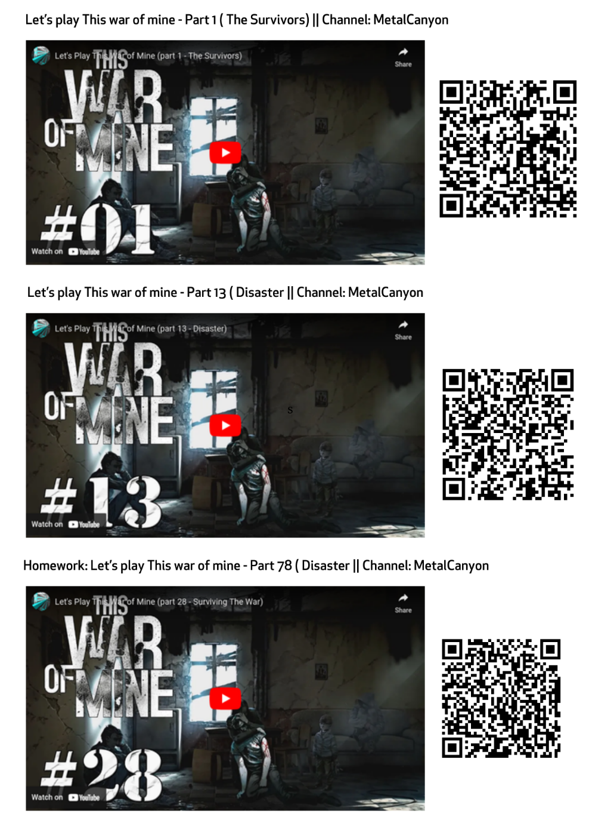
Video 3 (Homework) Part 28 (17:26) https://www.youtube.com/watch?v=6rCeqTLSD3A&list=PLIhNUXJ4tecdFPGFiG-XHJ40H9qsGuMJp&index=28

Material 4a: Maslow’ s Hierarchy of Needs

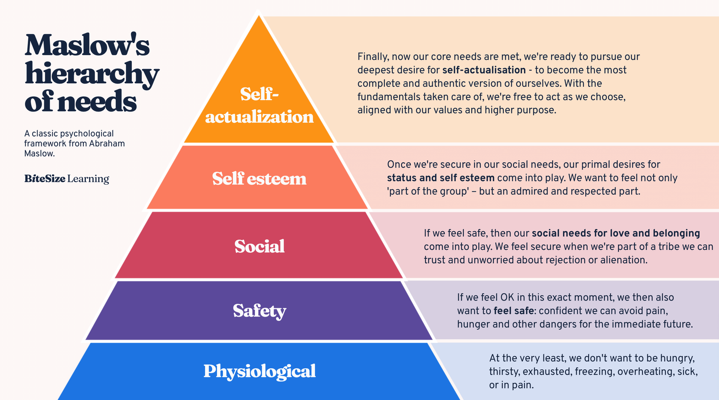

Maslow’s hierarchy of needs, explained. n.d. https://www.bitesizelearning.co.uk/resources/maslows-hierarchy-of-needs-theory [23.01.2025; 11:13]

Material 4b: 9 Escalation Phases by Friedrich Glasl (2004)
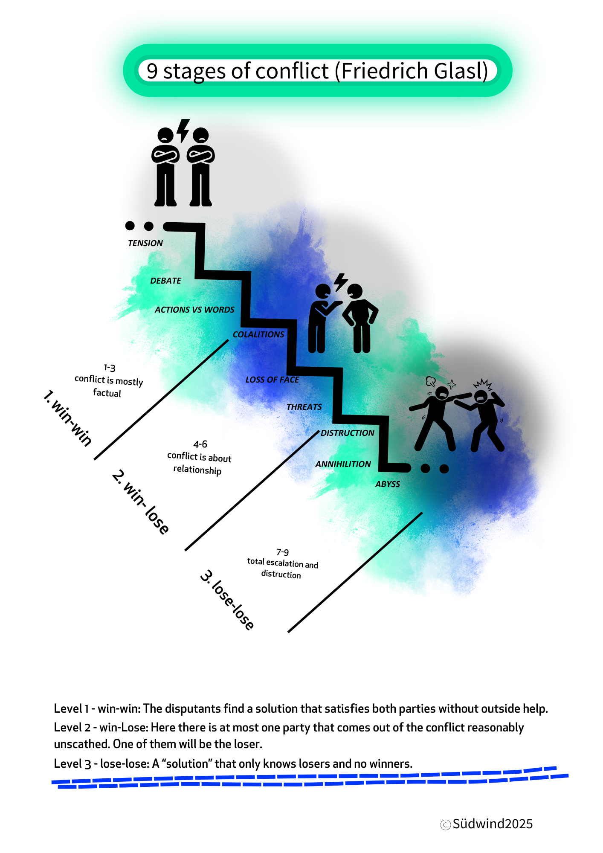

Material 5: 3 situations – how will you decide?
Look at the 3 situations which happened in our example of “This war of mine”. How would you as a group decide? Take into consideration Maslow’s hierarchy of needs and Glasl’s Escalation-Phases. Consider also the state of the characters. Are they ill? Are they hungry? Do they feel cold? When would you act in kindness and under which situations will you look out for yourself or your shelter-mates. Will you use force or weapons?
Write down your decisions.
- Imagine you are the person in the shelter and two kids come and ask for medicine.
Video 2: Part 13 (Disaster) ; 04:25 https://www.youtube.com/watch?v=E09gZSytj0c&list=PLIhNUXJ4tecdFPGFiG-XHJ40H9qsGuMJp&index=13
Your decision: _________________________________________________________________________

- Image you are the person in the shelter and someone breaks into your shelter
Video 2: Part 13 (Disaster) ; 11:14 https://www.youtube.com/watch?v=E09gZSytj0c&list=PLIhNUXJ4tecdFPGFiG-XHJ40H9qsGuMJp&index=13
Your decision: _________________________________________________________________________
- Would you steal to get food, medicine or weapons? If yes, under which circumstances would it be justified?
Video 3: Part 28 (Disaster) ; 07:46
https://www.youtube.com/watch?v=6rCeqTLSD3A&list=PLIhNUXJ4tecdFPGFiG-XHJ40H9qsGuMJp&index=28
Your decision: _________________________________________________________________________

Material 6a: CONSENSUS vs. CONSENT

Consensus | Consent
„agreement or accord“ | „no significant objection“

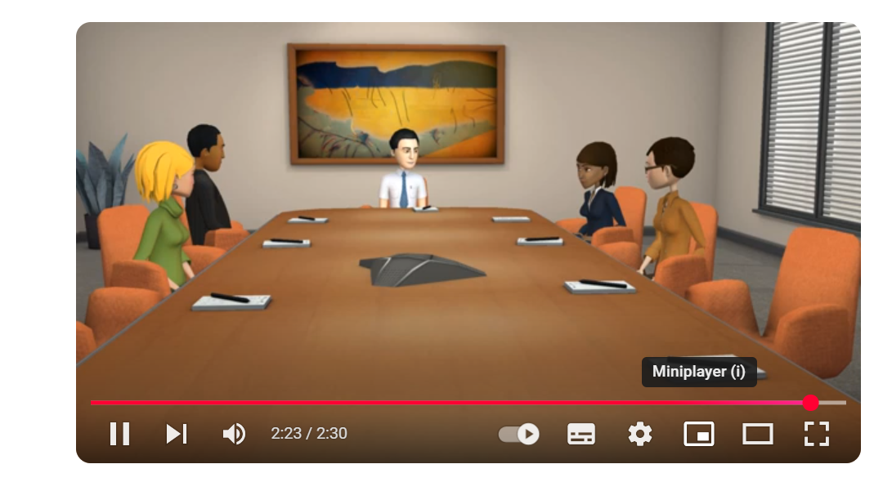

See: Consensus Building: https://www.youtube.com/watch?v=9SjUjXkyWBw

Material 6b: How decisions are made at COP (Conference of Parties) on global climate issues (Summary)
Consensus in Climate Talks:
At international climate meetings like the UN's COP (Conference of Parties), decisions are made by consensus. This means all participating countries must agree, or at least not strongly object.
Why Use Consensus?
- Climate issues affect all nations, so everyone needs to have a voice.
- Consensus ensures small and large countries are heard equally.
- Avoids decisions dominated by just a few powerful nations.
Challenges of Consensus:
- It’s hard to get everyone to agree because countries have different needs and priorities (rich vs. developing nations).
- Negotiations can take a long time and may result in compromises.
- Sometimes, decisions are watered down to get agreement.
Examples from COP History:
- Success: The Paris Agreement in 2015 was a major achievement where consensus led to nations agreeing to limit global warming to well below 2°C.
- Delays: Some meetings go into overtime because consensus is so difficult to achieve.
Takeaway:
Consensus shows how real-world decisions are not just about majority votes but require compromise, patience, and negotiation. In climate talks, this process aims to ensure fairness and long-term cooperation across nations.
Do you think that makes sence? Would you want this type of desicion making for your city/country/state/the European Union? What are pros/cons?

COP CONSENSUS EXAMPLES:

1. Paris Agreement (2015) – A Consensus Success Story
- What Happened: After years of negotiations, 196 countries agreed to a global deal to combat climate change.
- Key Outcome: Countries pledged to limit global warming to below 2°C and pursue efforts to keep it to 1.5°C.
- Consensus Challenge: Countries of the Global South wanted financial help to reduce emissions and adapt to climate change, while nations from the Global North were hesitant at first but eventually agreed to provide funding.
Discussion Question:
- Why do you think it was important to get even small countries involved in this agreement?

2. Copenhagen Accord (2009) – A Consensus Failure
- What Happened: Countries tried to reach a legally binding climate deal but couldn’t reach full agreement.
- Key Issue: Some countries from the Global South, like Bolivia and Venezuela, rejected the draft because they felt it wasn’t fair and lacked strong emission cuts.
- Outcome: The deal was "noted" rather than adopted, showing that without full consensus, progress stalled.
Discussion Question:
- What happens when some countries don’t agree to a climate deal? How does it affect everyone?

3. COP26 Glasgow (2021) – A Difficult Compromise
- What Happened: Countries almost agreed to "phase out" coal use but at the last minute, India and China insisted on changing the wording to "phase down."
- Consensus Challenge: India and China, representing countries from the Global South, argued that their economies still rely heavily on coal and need more time to transition.
- Outcome: Other countries reluctantly agreed to the wording change to maintain consensus.
Discussion Question:
- Why do you think countries made this compromise even if they didn’t fully agree?

4. COP28 Dubai (2023) – Consensus on Fossil Fuels and Climate Goals
- What Happened: The Global Stocktake revealed that countries were not on track to meet the Paris Agreement goals. A consensus emerged to begin the "phasing down" of fossil fuels instead of "phasing out."
- Consensus Challenge:
  - Countries from the Global South argued that they needed more time and financial support to transition away from fossil fuels due to their development needs.
  - Some nations from the Global North wanted a more aggressive "phase-out" commitment.
- Outcome:
  - The agreement softened language to "phase down" rather than "phase out" fossil fuels to maintain consensus.
  - Wealthier nations agreed to increase financial assistance to the Global South for renewable energy projects.
Discussion Question:
- Why do you think countries chose softer language ("phase down" instead of "phase out") to reach consensus?

5. COP29 Baku (2024) – Consensus on Climate Finance
- What Happened: Countries needed to set a new climate finance target beyond the previous USD 100 billion per year goal.
- Consensus Challenge:
  - Countries from the Global South demanded a much higher financial commitment from the Global North to address climate change impacts.
  - Nations from the Global North were initially hesitant due to concerns over their own economic challenges.
- Outcome:
  - After long negotiations, a consensus was reached to triple climate finance to USD 300 billion per year by 2035.
  - A framework for international carbon credit trading was also agreed upon, unlocking new funding mechanisms.
Discussion Question:
- Why is it important for Global North countries to financially support the Global South in addressing climate change?

References:
Circle Forward. 2023. Consnet vs. Consensus – What’s the Difference? https://circleforward.us/consent-vs-consensus-whats-the-difference/; [05.02.2025; 11:09].
Clark, Pipita. 2024. Financial Times: Should a Petrostate Be Allowed to Host a COP?
https://www.ft.com/content/0de38328-13f3-4b59-a6f9-9f9f111f1f62; [06.02.2025; 10:00].
Generation Europe Project. 2021.Methode Box.https://generationeurope.org/wp-content/uploads/2023/01/GenE-Methodbox.pdf; [06.02.2025; 11:48].
Glasl, Friedrich.2004. Konfliktmanagement. Ein Handbuch für Führungkräfte, Beraterinnen und Berater,8. aktualisierte und ergänzte Auflage, Paul Haupt Bern Stuttgart Wien, Freies Geistesleben; Stuttgart, 2004, Figur 9.2: Die 9 Stufen der Konflikteskalation: S. 236-237 sowie Kapitel11: Interventionen der Konfliktbehandlung, S. 313-347 (Auszüge).
Khan, Yusuf. 2024. Wall Street Journal: U.N. Negotiators Take Key Step Toward Global Carbon Dealhttps://www.wsj.com/articles/u-n-negotiators-take-key-step-to-global-carbon-deal-1e23433e [06.02.2025; 10:25].
Massai, Leonardo. 2018. Dealing with “Consensus” at the UN Climate talks. http://www.climalia.eu/dealing-consensus-un-climate-talks/; [06.02.2025; 10:22].
McLeod, Saul. (2024). Maslow's Hierarchy of Needs. https://www.researchgate.net/publication/383241976_Maslow's_Hierarchy_of_Needs ; [05.02.2025; 11:11].
Ramirez, Rachel. 2023. What is COP28? The UN climate summit, explained. https://edition.cnn.com/2023/11/20/climate/cop28-dubai-climate-summit-explained/index.html; [06.02.2025; 12:19].
Skills Succsession. n.d. Glasl’s Model. Different Stages of conflict. https://image.isu.pub/190625102909-95f9a35262cc50ba0acf6854ca8f847d/jpg/page_1.jpg; [06.02.2025; 12:27].
Wall-skills.2025. Glasl’s Stages of Conflict Escalation. https://wall-skills.com/2017/glasls-stages-of-conflict-escalation/; [06.02.2025; 12:04]
World Economic Forum.2023. COP28 — What Did It Accomplish and What’s Next?https://www.weforum.org/stories/2023/12/cop28-what-did-it-accomplish-and-whats-next; [06.02.2025; 10:20].

Annex – Game analysis:

From: steam https://store.steampowered.com/app/282070/This_War_of_Mine/?l=german; [14.01.2025; 15:00].
From steam: https://store.steampowered.com/app/282070/This_War_of_Mine/?l=german; [15.01.2025;12:03]
From Youtube : https://www.youtube.com/watch?v=9SjUjXkyWBw; [06.02.2025; 12:00]

