

Aguamod – Pedagogical Sequences
By UDC

December
2024

Contents
1. Pedagogical sequences – template 2
2. Example 6

pedagogical sequences – template

Safe it according to this example: “AGUAMOD_Spain”

If ready, share the pedagogical sequence with your partner organisation that creates a pedagogical sequence for the same game and incorporate the feedback afterwards. The feedback follows no specific structure and can be written via E-Mail (please insert in all the feedback E-Mails always Olivia and Luz as Leader and Quality Leader).

Please safe the first version (with the incorporated partners feedback) here: https://nextcloud.suedwind.at/index.php/s/7miNHpceogMtibL

AGUAMOD
Short description of the game: Aguamod is a serious game developed as part of the EU-funded SUDOE Interreg project, which focuses on water resource management across Southwest Europe. The game aims to educate users on sustainable water management practices by simulating various water-related scenarios, especially during low-water or drought periods. Through the game, players make decisions impacting water distribution for drinking, agriculture, and environmental needs, helping illustrate the complexities of managing shared water resources under different climate scenarios and governance models.
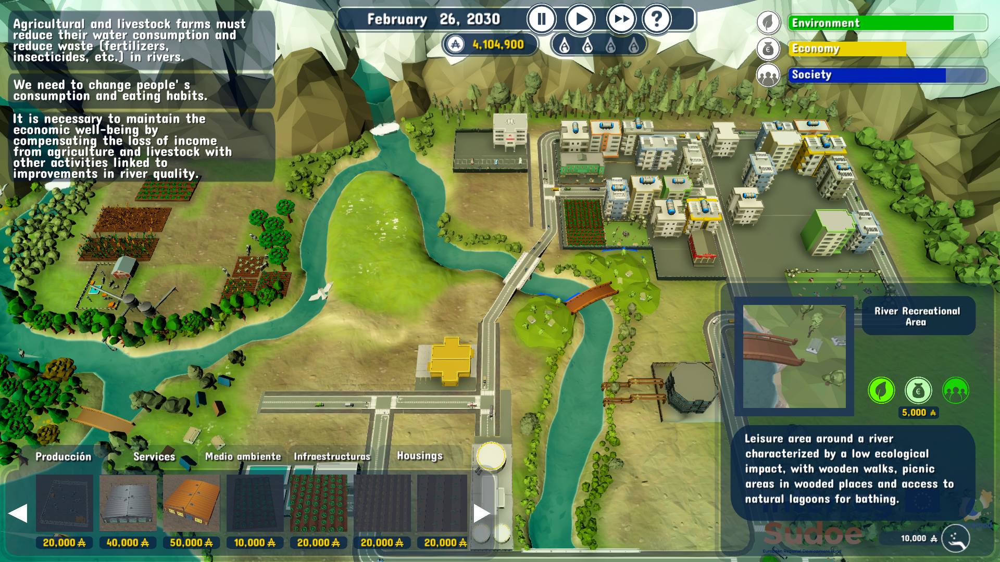

Duration: 4 lessons
Subject/s: Environmental science, Civic
Education, Economics
Topics: Sustainability, resource management, environmental stewardship, and community collaboration.
SDGs: 11, 12, 13

Dimensions of conflict through the game:
☒ social impact
☒ environmental impact
☒ economic impact
☐ technological impact
Learning objectives: Aguamod's pedagogical sequence seeks to promote Understanding the interconnected and inter- and eco-dependent nature of human activities, through the identification and analysis of relevant eco-social problems, to promote habits and attitudes ethically committed to achieving sustainable ways of life. Through environmental challenges and interactive scenario-based play, it promotes understanding and empathy towards real-world water management issues. Collaborative learning is fostered through discussion of sustainability, economics and public policy. Players develop strategic thinking, decision-making skills and awareness of water resource challenges and climate impacts. The main objective is to promote understanding of sustainable water management, resource allocation and environmental impact.
Interpersonal skills: Critical thinking, Creativity, Information literacy, Technology literacy, Initiative.
Technical requirements & material required: PC; mouse for each student; WIFI; downloaded videogame
Further reading/material:
INTERREG SUDOE AGUAMOD: http://www.aguamod-sudoe.eu/videojuego/
Teaching guide: http://www.aguamod- sudoe.eu/handbook/content/pdf/principal/ficha_juegointeractiv o_en.pdf
Introductory video: https://www.youtube.com/watch?v=ACP3Sd-yChY&t=27s

http://www.aguamod-sudoe.eu/handbook/content/pdf/seriousgame/index.html

Preparation Phase
Careful planning is essential to introduce and prepare the learning environment for using Aguamod in the classroom. The first step is to ensure that all students have access to a suitable device, such as a PC, tablet or smartphone. The game should be installed and running smoothly. A stable internet connection is important for uninterrupted gameplay, as the game relies on real-time feedback and updates based on player decisions. If available, providing students with headphones can greatly enhance their immersion in the game's sound design, allowing them to engage more deeply without disturbing others.
Before presenting Aguamod to the class, it is important for the teacher to play the game independently. This hands-on experience allows the teacher to understand the mechanics, game structure and educational themes of the game, so that he/she can anticipate any difficulties the students may encounter and provide effective guidance during the session. When introducing the game, the teacher should provide an engaging context that highlights the environmental challenges that are explored in Aguamod, such as the management of climate and resources under the pressure of climate change. However, in order to preserve the element of discovery for pupils, care should be taken not to reveal specific details of the game.
The gameplay itself encourages students to make decisions that balance environmental, social and financial considerations, and to reflect on their values and the wider consequences of their choices. The teacher should be prepared to facilitate discussions about sustainability, the complexities of climate change and the impact of political decisions at both local and global levels. It is equally important to create a supportive environment where students feel comfortable expressing any frustrations or ethical dilemmas that may arise as they grapple with the challenges presented by the game. Providing students with introductory material on environmental, social and economic issues, climate change and sustainable practices can help them to engage more deeply with Aguamod's themes. For those with a particular interest or background in environmental science, the teacher can encourage them to share their insights, enriching the learning experience for the whole class.
The aim of the game is to restore and achieve a sustainable balance between the environment, society and the economy through the player's actions and choices. We must ensure that we maintain the quality and quantity of water resources for a sustainable society in the long term. To achieve this, the user has several typical elements that can be added or removed from the scenario to overcome the challenges (Aguamod didactic guide, n.d.). By carefully preparing both the technical and emotional aspects of the learning environment, the teacher can ensure that Aguamod becomes a powerful educational tool for exploring critical issues of sustainability and environmental responsibility.

Game Phase
Lesson No. | Description in Steps | Social form | Material/technical requirements
1 | Step 1: Introduction to the game and topic  It would be good if the teacher could provide relevant environmental information to justify the activity. The aim is to create cohesion and serve as an introduction to the subsequent understanding of the game.  The teacher should explain that the game is designed to simulate the consequences of decisions on the distribution of drinking water, agriculture and environmental needs. The aim is to achieve a balance between economic growth, social stability and environmental sustainability in the SUDOE territory, it will be essential to use the introductory video: https://www.youtube.com/watch?v=ACP3Sd-yChY&t=27s. | Plenum | Laptop and projector  for demonstrating  gameplay overview, link to video
1 | Step 2: Practice game mechanics  Afterwards, a discussion may be a good idea to reflect on the topic to be discussed and possible alternatives. It is recommended to look for materials or, in the case of students who do not usually participate, to provide different resources such as: https://ed.ted.com/lessons/can-the-economy-grow-forever.  The dynamic starts with an essential question to be discussed in small groups, with a spokesperson presenting the conclusions, for example Is drinking water a common good? or What are the challenges, problems and situations to be faced in the future with regard to the management of natural resources, especially water? What is the impact of water consumption on the economic system? The debate will take up the first half of the session. | Plenum and group work in groups of 4 or 5 | Laptop and projector  for demonstrating  gameplay overview, link to video or resource to think about the topic
1-2 | Step 3: Practice game mechanics  Pupils open a browser and enters the game and klick on the button “New Game” as well as on the big “play” sign that appears;  After the game has finished the page with the score appears pairs shall stop at that point to compare in classroom, if wanted.  After the first pair test, the teacher will guide the students through an introductory scenario to ensure that everyone understands how to interact with, read and interpret the game.  If learners face language barriers (as the game may not be in their native language but can be used in English), it is essential to use translation tools or provide basic vocabulary of key concepts beforehand. | Group work in pairs
2 | Step 4: Actual game play  Once the students understand the mechanics of the game, they will start playing in pairs to improve their teamwork and communication skills as they will have to consult on decisions. Each will open the game on the device (smartphone, tablet or PC).  Pupils will play through the early stages of the game, making decisions that will have an impact on resource allocation, environmental protection and overall development. The development of a team matrix (Material 1) will facilitate understanding of the importance of balancing environmental, financial and social factors. Pupils should be encouraged to explore different ways of making decisions and to consider the long-term consequences of their choices. Teachers can provide guidance if needed, especially if students have difficulty understanding the consequences of their choices. | Group work in pairs | Material 1

Reflection Phase
Lesson No. | Description in Steps | Social form | Material/technical requirements
2-3 | Step 5: Reflection on the game and class discussion  Once the students have finished their game, the teacher will lead a reflection session on the experiences and results. The game has three phases with three challenges associated with each of them, with each phase taking approximately 20 minutes on average to complete. To take into account the time of all pupils, half a lesson is enough to play the game. Students who finish the game will be able to compare their matrix and draw conclusions in class for the next session. They will use the team matrix and in groups of two to three pairs, they will discuss the following questions (there are indicative and can be modified by the teacher). Initial reflection questions could be:  - What was the most difficult decision in the game - why?  - How did your decisions affect the water resources?  - What strategies did you use to balance economic growth, environmental sustainability and economic sustainability?  - How did the game make you think about water resources and reality?  - Were there times when there were tensions between economic, environmental and social issues? What was the priority in those moments? | Group work of 4-6 ppls | Material 1
3 | Step 6: Reflect in groups about the findings of Material 1  In this phase you will look at the choices made by the majority, but also at the alternatives that were less chosen.  Pupils should share their experiences and discuss how their game strategies can deal with real-life issues. To do this, each group will have a spokesperson who will present the results of the questions and then pupils who wish to do so will be able to intervene. | Plenum
3-4 | Step 7: My own reflection “Water foot print”  The aim of the following activity is to analyse the impact of certain actions on the environment and health, in order to promote and adopt habits that avoid or minimise negative environmental impacts, are compatible with sustainable development and make it possible to maintain and improve individual and collective health, in this case through water consumption. For that purpose, the 'waterfootprint game' will reinforce the previous work done through the Matrix, but in their own lives.  Water is essential for everyday activities such as drinking, cooking and washing, but much more is needed to manufacture everyday products such as food, paper and cotton. The **water footprint** measures the total amount of water used throughout a product's production chain.  In an active game, participants learn about their water footprint by ‘shopping’ for a meal in a supermarket, focusing not on the price but on the cost of water to produce the meal. The aim is to choose the food with the smallest water footprint.  In the groups they have previously played with, they will be tasked with selecting a meal and a dessert from a recipe book that lists the ingredients. While looking for a tasty option, they have to prioritise the reduction of the total water footprint. The ‘shop’ shows the water footprint (in litres) of all products.  Once a group has collected their food in a basket they have to calculate the total water footprint of the selected ingredients. The group with the lowest total wins the game, demonstrating the importance of water-saving choices. It is also important that they value the conflicts that the choices they make generate for them. For the activity, all data on the water footprint of ingredients, meals and desserts are provided.  More resources: https://www.youtube.com/watch?v=b1f-G6v3voA  One of the group members will write down any dilemmas, doubts, problems, questions or disagreements that arise during the voting.  The aim of this activity is to be a reflection booster for those groups that have already completed the previous steps. Therefore, it will be a reinforcing activity for the final conclusions. The aim is to go deeper, with the aim of proposing and adopting sustainable habits, critically analysing one's own and other people's activities on the basis of one's own reasoning, the knowledge acquired and the information available, in this case the "water footprint". In this sense, it will also develop the ability to address challenges related to the efficient, equitable and sustainable use of water in different contexts, whether real or simulated, using the necessary economic and financial knowledge. This includes a critical appreciation of the economic problem of resource scarcity and the need for choice, as well as an understanding of the principles of social interaction from an economic perspective. By integrating these skills, the ability to calculate and interpret the water footprint will be strengthened, promoting sustainable decision-making in the face of environmental and resource management challenges. | Group work of 4-6 ppls | Material 2
4 | Step 8: Conclusion  Wrap up the last two lessons with What new things have you learned after playing Aguamod and doing the water footprint? From the conclusions drawn, there will be one person who will take notes and present the conclusions to the group. | Plenum | Class presentation in working groups
4 | Step 9: ‘Less water footprint, more future: Take the challenge!  In working groups, they will make an infographic for the improvement of water management in the school context. The five most successful infographics will be projected in the school, in the way the school considers and will be proposed as challenges for the school. The idea is to set small challenges that can be implemented in daily life.

Copy templates:
Material 1 – Team matrix
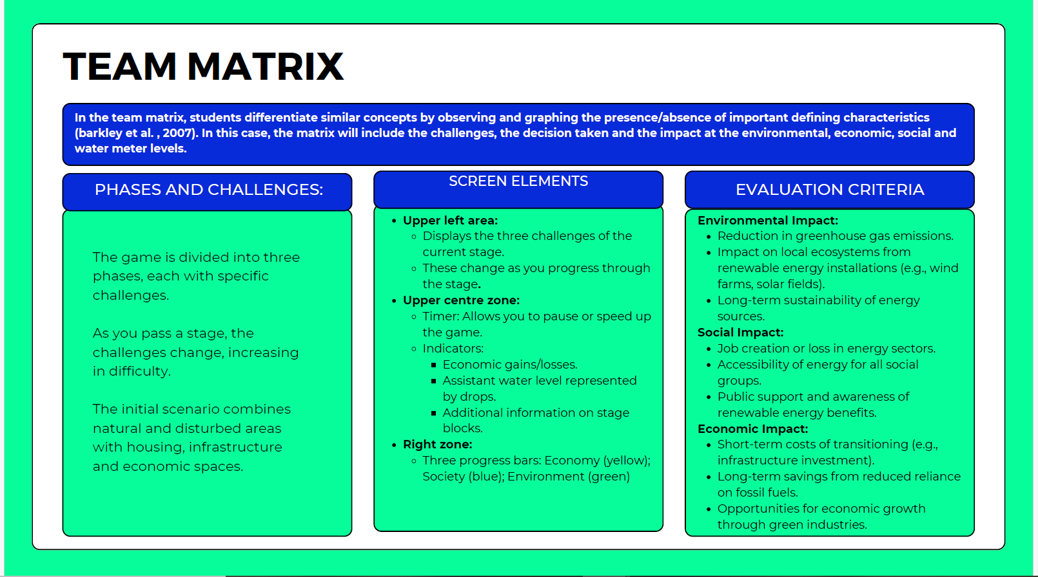
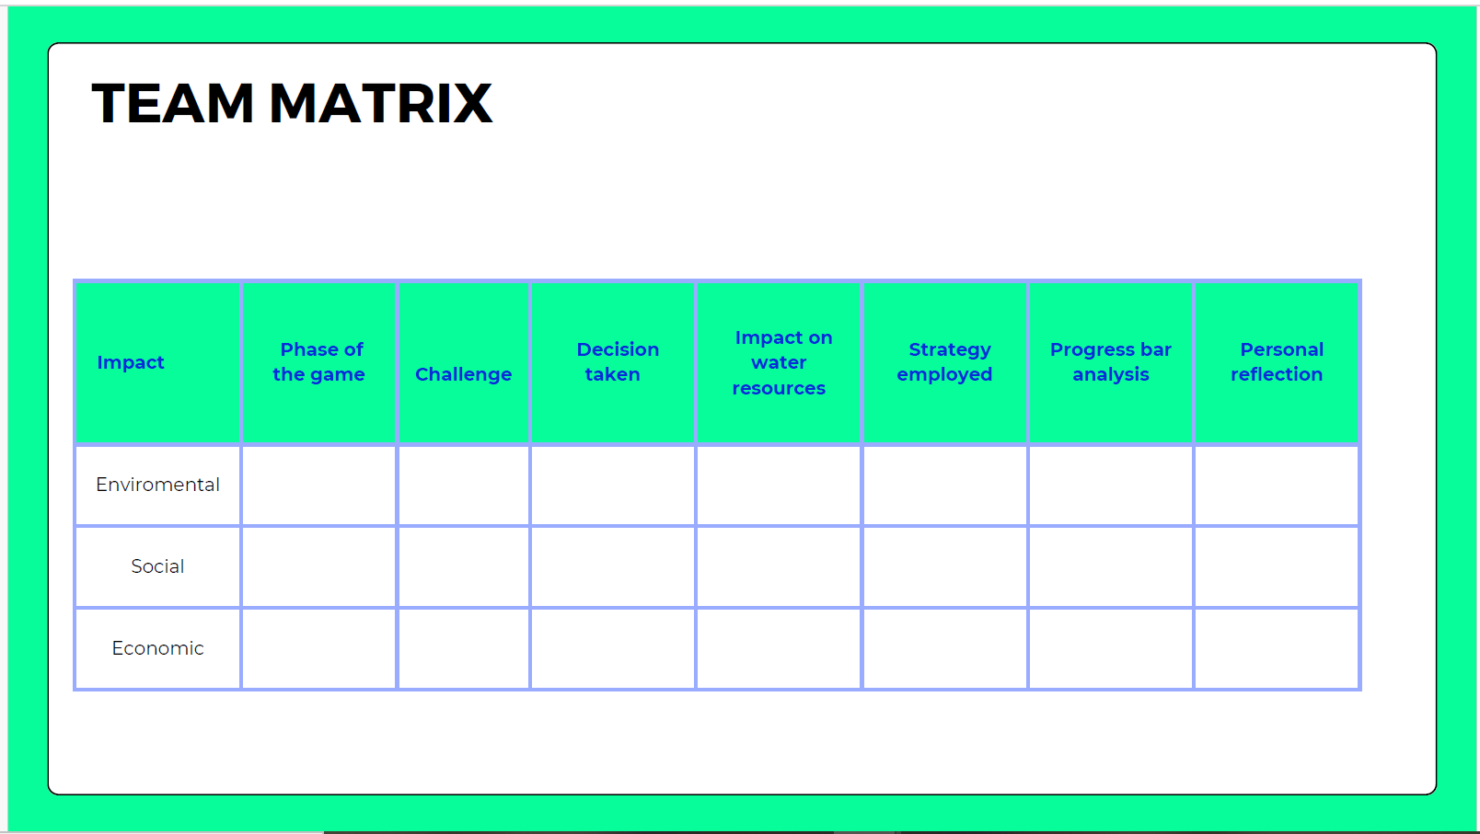

Canva presentation: https://www.canva.com/design/DAGbtPTctpY/4a-eV-IsAi-ZqewDUjntbA/edit?utm_content=DAGbtPTctpY&utm_campaign=designshare&utm_medium=link2&utm_source=sharebutton

Material 2_ Water footprint game for school children
Steps for the game:
1. Keeping with the group division already done above, each group must ‘buy’ a meal and a dessert from a recipe book.
Condition: Choose something delicious, but optimise the total water footprint of the ingredients.
2. Tour of the ‘shop’: The products needed for the recipes will be available in the shop. Each product will have a label indicating its water footprint in litres (amount of water used during production).
3. Purchase of products: The groups select the necessary ingredients and place them in their ‘basket’.
4. Passing through the box: Each group passes through the ‘box’ (represented by the instructor).
The instructor adds up the water footprint of the chosen ingredients and gives them the total.
5. Winner: The group with the meal (including dessert) with the lowest total water footprint is the winner.

Taking to: https://www.waterfootprint.org/resources-explained/school-resources/
For more information and material resources:
The explanation of the game for teacher: English Deutsch Nederlands
The game requires this list of products: English Deutsch Nederlands
The game requires this recipe book: English Deutsch Nederlands

Annex – Game analysis:
Aguamod is a serious game developed as part of the EU-funded SUDOE Interreg project, which focuses on water resource management across Southwest Europe. The game aims to educate users on sustainable water management practices by simulating various water-related scenarios, especially during low-water or drought periods. Through the game, players make decisions impacting water distribution for drinking, agriculture, and environmental needs, helping illustrate the complexities of managing shared water resources under different climate scenarios and governance models.
Video Games as a Means of Communication
Aguamod functions effectively as a communication tool by translating complex, data-driven water management issues into interactive and relatable scenarios. Its game format appeals to diverse audiences, fostering engagement with environmental issues while encouraging exploration of the trade-offs and priorities in water resource management. By combining climate data and real-life water usage contexts, it simplifies technical concepts and fosters discussions on resource sustainability. The game’s participatory design—engaging players in decision-making processes—promotes a broader understanding of governance challenges, making it an effective medium for both education and stakeholder dialogue.
Video Games Contain Values
Aguamod conveys several core values through its gameplay:
- Sustainability: The game emphasizes responsible water use and conservation, promoting long-term ecological health over short-term gains.
- Collaboration: It highlights the importance of cooperation among stakeholders, such as policymakers, communities, and industries, to achieve balanced water resource management.
- Adaptability: Aguamod encourages players to adapt strategies based on fluctuating resources and climate changes, underscoring resilience in environmental management.
- Informed Decision-Making: By making players face realistic consequences, it values evidence-based choices, urging players to consider environmental and societal impacts equally.
These values align Aguamod as an educational and communicative tool aimed at fostering a sustainable, cooperative, and informed approach to natural resource management.

Aguamod can be analyzed using the following categories:
1. Playability
Aguamod is a serious game, with gameplay centered on strategic decision-making around water management. Players simulate real-world scenarios, managing resources in drought conditions and balancing ecological and social needs.
2. Usability
Simulation game interfaces tend to be complex. The Aguamod’s interface is designed to be intuitive, with visual aids and straightforward controls. This makes it accessible to both novices and those familiar with water management topics, supporting smooth learning progression.

3. Content and Skills Development
Aguamod educates users on sustainable practices, emphasizing the trade-offs in water management decisions for agriculture, industry, and ecosystem health. Scenarios reflect real-life water scarcity issues, helping players grasp the social, economic, and environmental factors. The game integrates climate change impacts on water resources, reinforcing the importance of sustainable practices.
Title
Platform | PC (Windows)
Language | English, Spanish, French and Portuguese
N. º of sessions played | 2
Total time played | 60 minutes
Brief Description | Interactive serious game that challenges players to manage water resources sustainably during periods of scarcity, balancing social, economic, and ecological needs.

Dimension | Evaluation Criteria
Usability  (analysis of technical correctness and ease of use) | - Is the game easy to learn and play?  Yes, Aguamod is designed to be accessible, making complex water management concepts easy to grasp through guided, interactive gameplay.<  - Is the user interface (controls and navigation) clear and tailored to the target audience?  The interface is generally intuitive, with visual aids that cater to both novices and professionals in environmental sciences. It should be noted that simulators usually require a large amount of data to be visible to the user. Therefore, the interface tends to be complex.  - Are accessibility options implemented?  No, but it has a user-friendly design  - Is the game response accurate and fast?  Yes, the game is responsive, allowing players to make quick decisions and see immediate effects of their actions.  - Are in-game messages accurate?  In-game messages are precise and informative, aligning well with Aguamod’s educational goals.  - Are there instructions?  Yes, the game includes instructions to guide players through scenarios and controls effectively.  - Is it possible to save the game?  Yes, the game has an autosave system and you can pick up where you left off.  - Are there any bugs?  No.  Other relevant usability comments:  Aguamod’s usability is enhanced by its realistic scenarios, making it an engaging and informative tool for understanding water management challenges and strategies.
Gameplay (analysis of the game's play and narrative structures, and how game design produces meaning) | - Were you able to finish the game (yes/no: why)?  Yes, as it’s designed to be completable, offering clear goals and an educational endpoint.  - Duration (per level/mission or over the whole game)  Each mission is around 10-20 minutes, with the total game time varying based on user engagement.  - Degree of interactivity (do the player's decisions play a crucial role in the outcome of the game)?  Player decisions critically impact resource management outcomes.  - Is the pace of the game satisfying?  Yes, with a balanced pace that allows thoughtful decision-making without dragging.  - Narrative weight (high/medium/low)  Medium; focused more on decision-making than storytelling.  - Presence of a narrator: yes/no  No; guidance is embedded within gameplay and instructions.  - Presentation and role of the main character (characteristics and qualities of the character/avatar)  The player acts as a resource manager, embodying the traits of responsibility and adaptability.  - Depiction and role of the antagonist (characteristics and qualities)  No direct antagonist; challenges arise from environmental and resource constraints.  - Presentation of the setting (world in which the character develops)  A realistic, regional environment based on Southwest European water resource issues.  - Dimension/temporality: time period covered by the story and its characteristics (fictional/real, global/local, etc.)  Real and regional, set in present-day Southwest Europe.  - Mission (the essential actions to win/complete the game)  To allocate water resources effectively, balancing diverse needs and sustainability.  - What are the implicit/ultimate goals of the game?  To promote sustainable water management and awareness of resource challenges.  - What are the main challenges/obstacles faced by the protagonist?  Limited resources, fluctuating climate impacts, and stakeholder demands.  - Are the game mechanics appropriate to the content and implicit goals?  Yes, mechanics align with resource allocation, encouraging thoughtful environmental stewardship.  - Do you agree with the reward system (incentives for action)?  Yes, as rewards reflect improved water sustainability and ecosystem balance.  - How is the feedback system (text, audio or audiovisual comments given to the player for certain actions)?  Mainly text-based feedback highlights the consequences of actions for learning purposes  - Overall story (description of the story of the game as a whole)  Players manage water in a resource-limited region, making decisions that reflect real-world sustainability challenges in water management.  Other relevant gameplay comments
Content  (analysis of the content of the game and the messages conveyed in relation to the objective) | - What are the themes of the game?  Sustainability, resource management, environmental stewardship, and community collaboration.  - What kind of reflection, knowledge, skills, competences, awareness are developed?  Players develop strategic thinking, decision-making skills, and awareness of water resource challenges and climate impacts.  - Is there an explicit use of sources of information?  Yes, real-world climate and environmental data are embedded in scenarios.  - Do you think the player can get the intended message without external help?  Yes, the game is designed to convey its messages independently through scenarios and feedback.  - Did you change your beliefs/opinions or learn something new after playing the game?  Yes, players typically gain insight into sustainable resource management and the complex trade-offs involved.  Other relevant comments about the content:  Aguamod effectively translates real-world resource issues into an accessible, educational format that promotes ecological awareness and sustainable thinking.
Didactic resource  (analysing the game as a didactic resource) | - 21st century skills included:  - ☐Critical thinking  - ☒ Creativity  - ☐ Collaboration  - ☐ Communication  - ☒ Information literacy  - ☐ Media literacy  - ☒ Technology literacy  - ☐ Flexibility  - ☐ Leadership  - ☒ Initiative  - ☐ Productivity  - ☐ Social skills  - Dimensions covered:  - ☐ Social  - ☒ Environmental  - ☐ Technological  - ☐ Economic  - Link with InterGames subjects:  - ☒ Environmental Sciences  - ☒ Civic Education  - ☒ Arts  - ☒ History  - ☒ Economics  - Competences (knowledge achieved by the learner)  Understanding sustainable water management, resource allocation, and ecological impacts.  - Problem solving conditions (way of thinking to solve problems: reproductive-memory, productive-creativity)  Encourages productive, creative problem-solving to balance competing needs under resource constraints.  - Need for prior knowledge (no/yes: detail)  Minimal; general awareness of environmental issues may help but isn’t required.  - Learning curve (learning difficulty: low, medium, high)  Medium; concepts are accessible but require strategic thinking.  - Possibility of group work (no/yes: detail)  Yes, could be adapted for collaborative decision-making in teams or classroom discussions.  - Does it include a teaching guide (information for teachers with tips and examples for implementation in the classroom)?  Yes. http://www.aguamod- sudoe.eu/handbook/content/pdf/principal/ficha_juegointeractiv o_en.pdf  - Possibility of teacher evaluation (no/yes: please specify)  Yes, teachers can evaluate based on decision outcomes, reflection, and engagement in discussion.  Other relevant comments concerning its use as a teaching resource and Interdisciplinary possibilities.  Aguamod is valuable for interdisciplinary lessons in environmental science, geography, and social studies, fostering collaboration and systems thinking. It promotes discussions on sustainability, economics, and public policy, making it ideal for both individual learning and group projects.

