

Burry Me,
My Love
–

Pedagogical

Sequence

By C.I.P.

December

2024

BURRY ME, MY LOVE
Short description of the game: Bury Me, My Love is a narrative-driven game that tells the story of a Syrian refugee, Nour, and her husband, Majd, who stays behind. Players guide Nour’s journey to safety by making decisions through text message exchanges, with each choice shaping her path and the game’s unpredictable outcomes. This emotionally powerful game fosters empathy and understanding of the refugee experience.
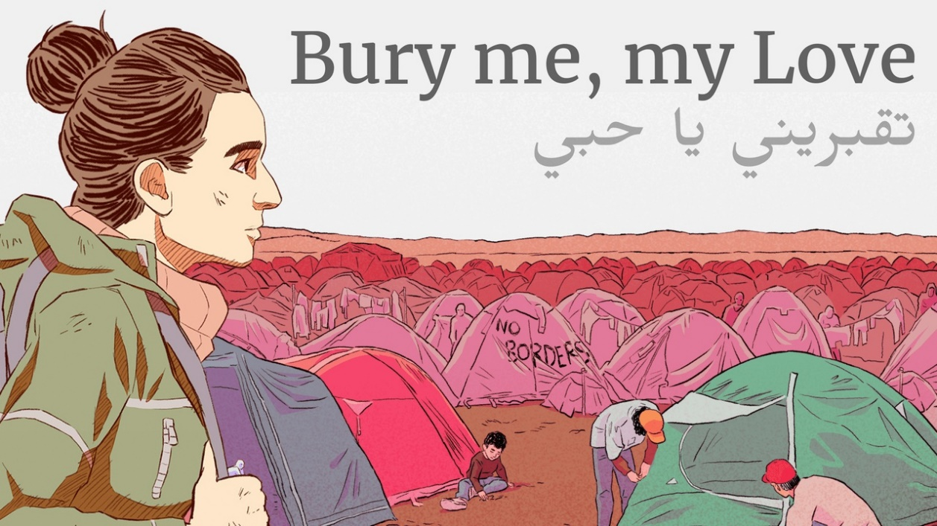

Duration: 4 lessons
Subject/s: Civic Education, History, Economics
Topics: Human rights, migration, conflicts and global crises, ethics, economic impacts
SDGs: 1, 10, 16
Dimensions of conflict through the game:
☐ social impact
☐ environmental impact
☐ economic impact
☐ technological impact

Learning objectives: Students will understand more about the causes and consequences of forced migration, particularly in the context of the Syrian Civil War, which saw recent changes recently, and the challenges faced by refugees, including legal, economic, and cultural barriers; will understand the complexities of moral and ethical decision-making in situations of crises, the socio-economic and geopolitical factors driving migration, and the emotional and personal dimensions of the refugee experience. Finally, they will be able to reflect critically on their choices in the game, develop empathy for displaced populations, and consider the broader implications of migration in global contexts.
Interpersonal skills: Empathy, Critical thinking, Ethical reasoning, social responsibility and communication skills
Technical requirements & material required: PC/Tablet/Smartphone + Headphones + mouse for each student; WIFI; The game purchased
Further reading/material: https://burymemylove.arte.tv/
Syrian Refugee Crisis and Foreign Policy Decision-Making in Jordan, Lebanon, and Turkey | Journal of Global Security Studies | Oxford Academic

Preparation Phase
In the preparation phase, it is essential to ensure that each student has access to a device (PC, tablet, or smartphone) with the game Bury Me, My Love installed and functioning properly. A strong internet connection must be available to ensure smooth gameplay. Each student should also have access to headphones to immerse themselves in the game’s audio and narrative fully and not disturb others. This is a game that can be played during students’ free time therefore ensuring access on their phones can foster engagement and enhance the game-play experience.
Before the class starts, the teachers should play through the game themselves to understand its mechanics, themes, emotional impact and the overall gaming experience. This will help the teacher guide students through the experience effectively and anticipate potential challenges. Even though it is a relatively easy game to play it is an essential step to take. To introduce the game without spoiling the narrative, the teacher can present an overview of the game’s context (focusing on the Syrian refugee experience and to some of the moral dilemmas the players will face) without giving away key plot points. There is no need for the teacher to introduce the game and showcase it playing since it is very simple.
Finally, the teacher should also prepare the class for the sensitive topics that will be raised in the game, discussing the themes of migration, refugee crises, and moral decision-making. The teacher may also provide students with background reading materials or a brief discussion on the context of the Syrian conflict to ensure they understand the real-world implications of the narrative. Also since most European classrooms are multicultural, and there might be refugees themselves, and also Syrian, it is important to discuss it privately with them in that case to combat any sensitive issues or personalizations that may arise.

Game Phase

Lesson No. | Description in Steps | Social form | Material/technical requirements
1 | Step 1: Introduce the students to the topic:  Begin the lesson by introducing the topic of forced migration, specifically focusing on the Syrian refugee crisis. Engage students with questions such as, “What do you know about the challenges refugees face?” and “What are some factors that drive people to leave their homes and seek refuge in other countries?”.  This will set the context for the game and allow students to activate prior knowledge, thoughts and reflections and be more prepared to absorb the correct messages while playing the game. The teacher at this point there is no need to provide any information regarding the refugee crisis or any overview of the Syrian conflict. This step is just to open the curiosity of the students, write down their perspectives before encountering the game in order to make the comparison before and after playing the game on their knowledge and approach on the topic and when approaching the refugee experience. | Plenum | Whiteboard + markers or projector for key points (Make sure these points are saved for later reflection and comparison)
1 | Step 2: Introduce the students to the game  Inform students that they will be playing Bury Me, My Love, a narrative-driven game that explores the journey of a Syrian refugee. Emphasize that the game is not about entertainment, but about understanding the emotional, moral and physical challenges refugees face. Explain that the game is played through text-based interactions (similar to a texting app), where they will make decisions that influence the outcome of the story. Highlight that their choices will directly impact the fate of the protagonist, a woman (Nour) seeking refuge.  Encourage the students to focus on the decision-making process and consider the ethical implications of their choices as they play. | Plenum | Laptop and projector
1 | Step 3: Practice the Mechanics  Before starting, the teacher should demonstrate the basic mechanics of the game. Open the game and walk through the process of selecting options in the text message interface, explaining how their choices will guide the story. Since the game involves reading and making decisions based on text, the teacher should ensure that students understand the flow of the game and how to interpret the messages and make decisions. Is not necessary for the teacher to show a short segment of the game or to explain its structure since is easy to follow.  A barrier which may arise is that since the game is available only in English, French, Italian, German and Spanish, will be in the case that there are students who do not speak these languages. | Plenum | Laptop and projector
1-2 | Step 4: Actual Gameplay (this session will last half of lesson 1 and half of lesson 2 plus during their own time)  Each student should open the game on their device (smartphone, tablet, or PC). The students will play individually, making decisions through text messages that guide the main character's journey. Ensure that all students have access to the game and are able to engage with the narrative.  The teacher should monitor the students as they play, ensuring that they are following the instructions and making thoughtful choices. The game play can continue when at home since it might take a couple of hours to finish or even days. The game is designed for multiple playthroughs, so students should be encouraged to replay the game if time allows to explore different decision paths and outcomes. | Individual/Single Player | 1 PC/tablet/smartphone per student,  1 headphone per pupil  1 paper and pen to write down thoughts and experiences
2 | Step 6: Reflection on Game Play  After the gameplay, the teacher should lead a class discussion to reflect on the experience. This is a crucial part of the game phase, where students can begin processing their decisions, emotions, and learning. Questions for reflection may include:  - What did you find most challenging about the game and the decisions you had to make?  - What was the ending of your game session? (since for each player there is a different ending)  - Did any of the decisions affect you emotionally? If yes how?  - What do you think the game tells us about the refugee experience?  - Were there any points in the game where you felt conflicted or regret about the choices you made?  - How can the issues in the game relate to real-world refugee crises?  The goal of this step is to guide students to connect the game’s narrative to real-world contexts and their own moral reflections. This discussion should be open, with the teacher moderating and encouraging students to share their thoughts and feelings about the game. This will be the introductory phase where it will make students begin thinking and brainstorming around the concepts of the game and better prepare them and introduce them to the reflection phase that will follow. | Plenum | Whiteboard/Interactive board

Reflection Phase

Lesson No. | Description in Steps | Social form | Material/technical requirements
3 | Step 7: Reality check  Now that the gameplay is finished, the teacher should further guide the students to reflect on the experiences and choices they made during the game, and explore how those choices connect to real-world refugee issues. To begin, encourage students to consider whether they think that the scenarios presented in the game align with the real challenges faced by refugees, particularly those fleeing from Syria. To do that it is suggested to ask some guiding questions like:  - Do you think the game portrayed the challenges realistically?  - Were there moments in the game that surprised you in terms of the choices you had to make for the character?  - In the end of the game, now that you know the outcome did you regret for any of the decisions you have taken?  This will help students bridge the gap between the fictional narrative and the actual refugee crisis.  To deepen the reflection, the teacher the will present a brief fact sheet/infographic (e.g. Material 1) that outlines key statistics or facts about the Syrian refugee crisis, such as the number of refugees, the countries they flee to, and the political or social barriers they face. This will provide factual context for students to reflect on the game’s portrayal of migration compared to these realities. Students can then discuss in groups whether they feel the game was too simplified or overly dramatic in its representation of these issues. | Plenum | Material 1
3 | Step 8: Exploring the emotional impact  A critical part of the reflection phase of this game is addressing the emotional response that students had to the game’s narrative. This step will help students process their feelings and gain insights into the emotional complexity of refugee experiences. Ask open-ended questions such as:  - How did the game make you feel about the protagonist’s journey?  - Were there any decisions that you found especially difficult and not being able to cope? Why?  - Did the game make you reconsider your views on refugees and migrants and the refugee crisis in general?  And have students write a short personal reflection (essay form) on how the game affected them emotionally. Provide further prompts such as, “Reflect on a moment from the game that challenged your perceptions”, “What decision in the game made you feel conflicted?”. This written reflection can then be shared in a larger classroom discussion. Also since this might be emotional or personal give the option to students to keep it for themselves if they want to.  Alternatively, instead of writing an essay, you can introduce a concept called “empathy mapping” (Material 2) where students create a visual map on a piece of paper showing what the protagonist might have been thinking, feeling, saying, and doing at different points in the game. This will encourage students to step into the character’s shoes and engage with the emotional complexities of the refugee experience. | Individual work (written reflection), followed by group discussion | Reflection prompts, empathy mapping worksheet (Material 2)
3 | Step 9: Explore Real-Life Applications  At this point, the teacher can help students link their gameplay experience to real-world issues of refugees and the broader implications of migration. To do this, ask students to think critically about how the decisions they made in the game might have consequences in real-life refugee scenarios. In case tyou find challenges in initiating discussion, prompt the class with questions like:  - What could we learn from the game that applies to real-life refugee journeys? And how do you position yourself in the real-life of refugees?  - How can we as individuals or communities support refugees in real life?  - What kind of policies or support systems do you think could help refugees more effectively?  Ask from students to research organizations that provide support for refugees or to look into current events, frameworks and actions regarding migration and refugee policy. This can be done through homework assignments or as an in-class activity if there is enough time. For example, students can research NGOs in their communities, their countries and internationally that assist refugees, and share their findings with the class in a short presentation or group discussion. Some examples of such organizations to be shared as examples for further exploration could be these:  https://www.amnesty.org/en/  https://www.unhcr.org/  https://www.cyrefugeecouncil.org/  (Partners include 1 each from their country)  This step can also include a brief discussion about the portrayal of refugees in the media, and how the media often shapes public opinion. Use news articles or videos (Material 3) about a current refugee crisis and discuss how the narrative around refugees is presented. This will allow students to critically analyze how stories are framed and what actions can be taken to advocate for refugees in their real lives. | Homework and plenum | News article/video on refugees (Material 3)
4 | Step 10: Role-playing Exercise – Decision Making in Crisis  To further develop empathy and understanding, organize a role-playing activity where students take on the roles of different stakeholders involved in the refugee crisis (refugees, governments, aid organizations, local citizens, etc.). In small groups, students will act out a scenario where a refugee is trying to cross a border or gain access to aid, and other students will take on roles that either support or hinder the refugee’s journey. This exercise will highlight the complex decision-making processes and the obstacles refugees face in real-life situations.  After the role-playing exercise, hold a debriefing session with the whole class, asking questions like:  - What was it like to be in the shoes of a refugee or someone who has the power to help them?  - How did the obstacles or support you faced influence your decisions?  - What can we do as individuals to make the refugee experience more humane?  This hands-on exercise can help reinforce the empathy students developed in the game while providing a platform for discussing practical solutions to real-world issues. | Small-groups | Role play cards (Material 4)
4 | Step 11: Wrap-Up and Call to Action  Conclude the reflection phase with a wrap-up discussion that ties the lessons from the game and the activities to broader societal issues. Ask students to share one thing they learned or one insight they gained from playing the game. Emphasize the importance of continued reflection and action. To leave students feeling empowered, discuss ways they can engage with the issue of refugees beyond the classroom, such as volunteering, donating to refugee organizations, or raising awareness through social media campaigns.  End the session by encouraging students to take small but meaningful actions in their own lives to support refugees and marginalized groups. The teacher can also suggest that students reflect further through a final homework assignment, such as writing a letter to a policymaker advocating for refugee rights, or creating a social media post that educates others on the realities of the refugee experience. | Plenum | Social media campaign template  (Material 5)

Copy templates:

Material 1 - Infographics:
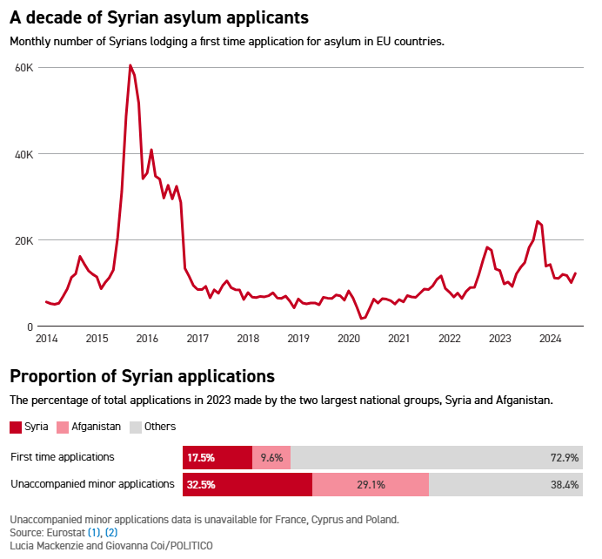
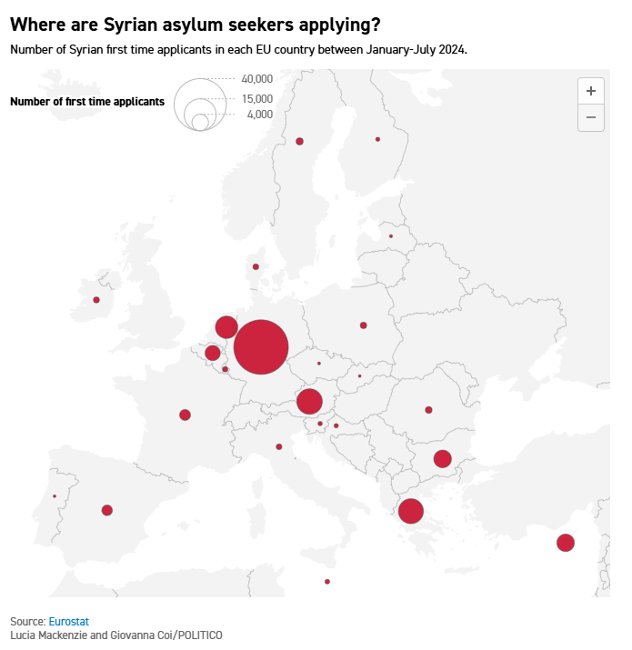

Material 2 – Empathy Map

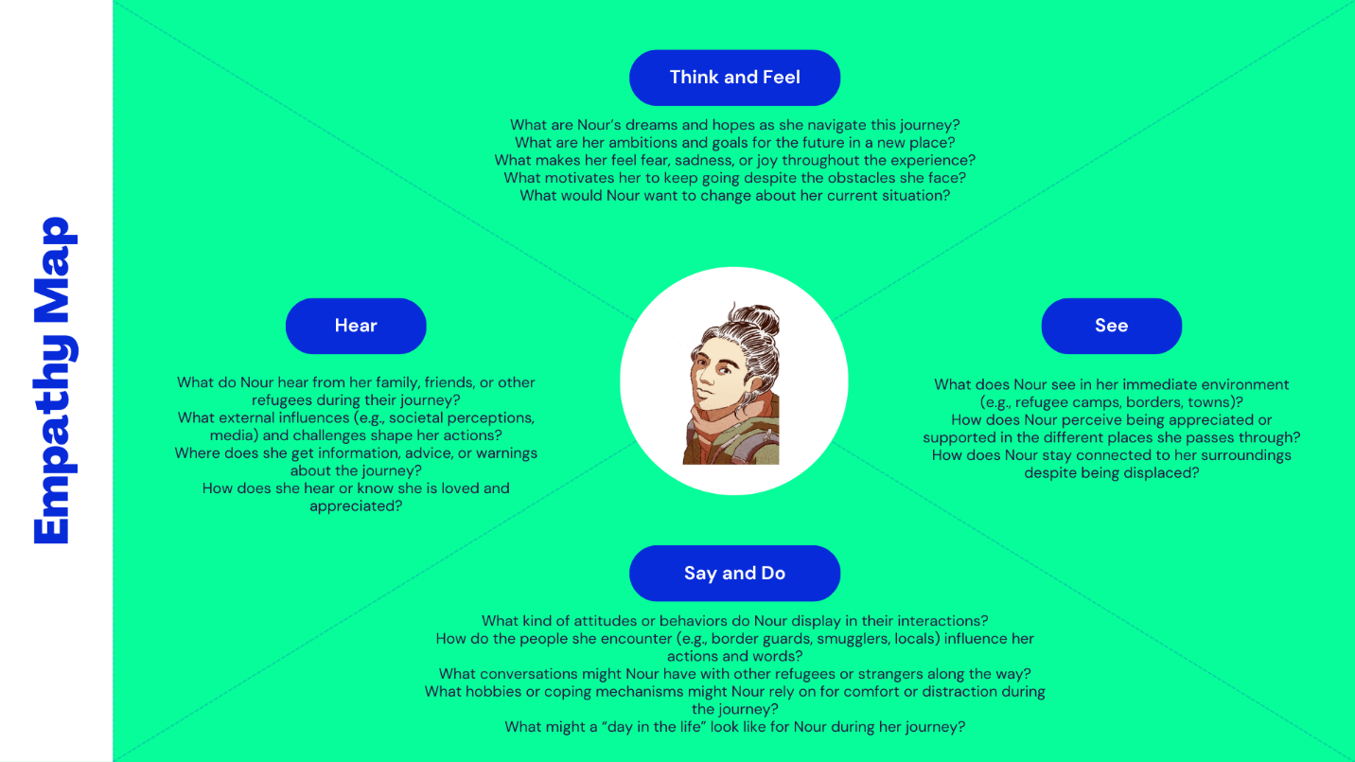

Material 3 – Refugee coverage by the media:

https://www.sigmalive.com/news/local/1162846/sxedon-to-50-ton-mathiton-sti-lefkosia-einai-allodapoi-analytika-ta-stoixeia
- The November 2023 Sigmalive article, titled "Almost 50% of Nicosia students are foreigners," is misleading. Official data from the Ministry of Education contradicts this, indicating around 20%, not 50%, of students are foreigners. The article, relying on a survey by the Nicosia school tax office, misrepresents the situation by focusing on specific schools with higher percentages, distorting the overall student population in Nicosia. This misinformation, based on a misinterpretation of survey results, has generated negative reactions against immigrants in Cyprus.
https://www.france24.com/en/live-news/20230912-cyprus-migrants-face-wave-of-attacks-as-hostility-brews
- Tragically, disinformation's consequences extend beyond misconceptions, fueling violence and instability. Recent attacks on migrants in Cyprus illustrate the real-world impact of xenophobia rooted in misinformation. Escalating violence, including attacks on migrant-owned businesses, calls for comprehensive measures. The normalization of hate speech, even by mainstream parties spreading fake news and racist rhetoric, contributes to an overall atmosphere of xenophobia.

https://www.theguardian.com/us-news/2024/sep/13/trump-repeats-lies-haitian-immigrants

(In here it will be good for all partners to add 1-2 local articles in their local languages)

Material 4:
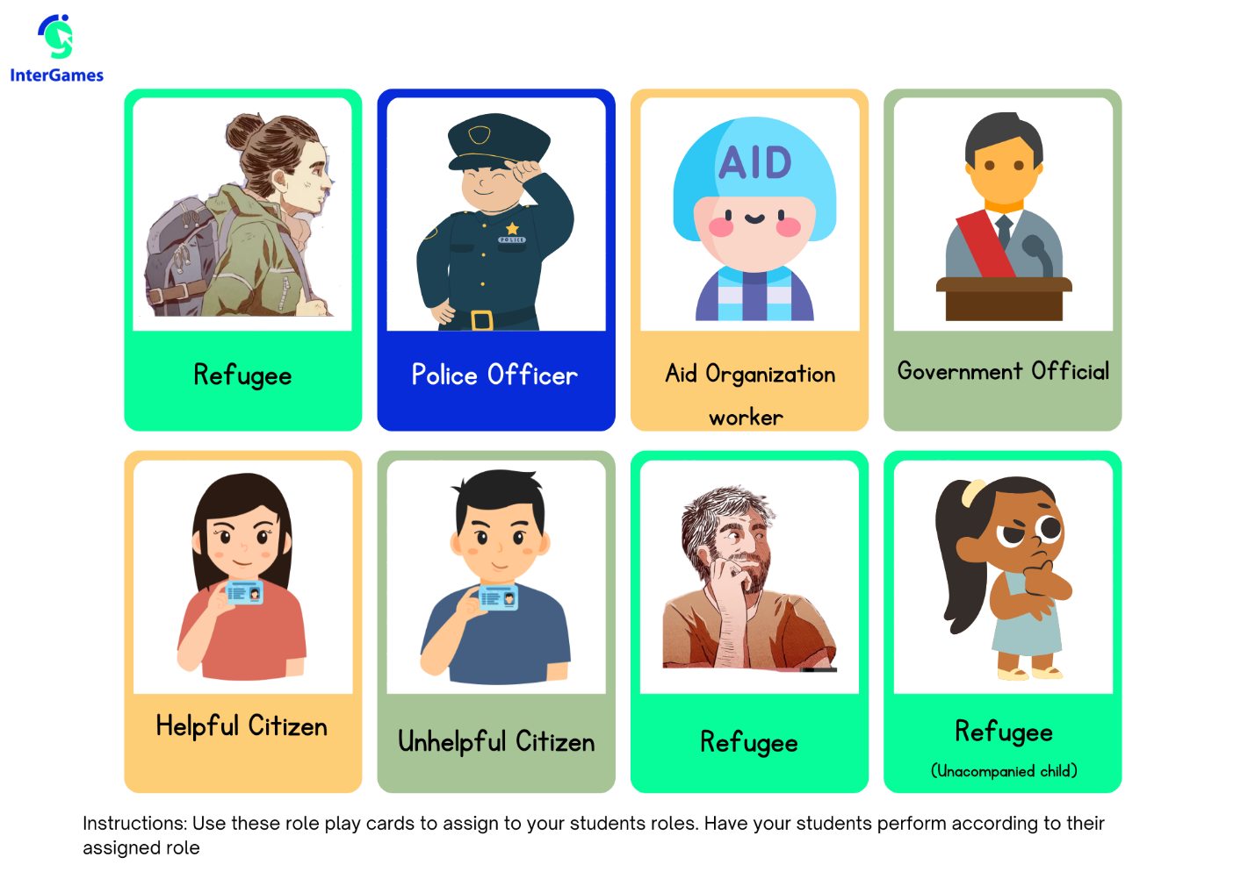
Material 5:

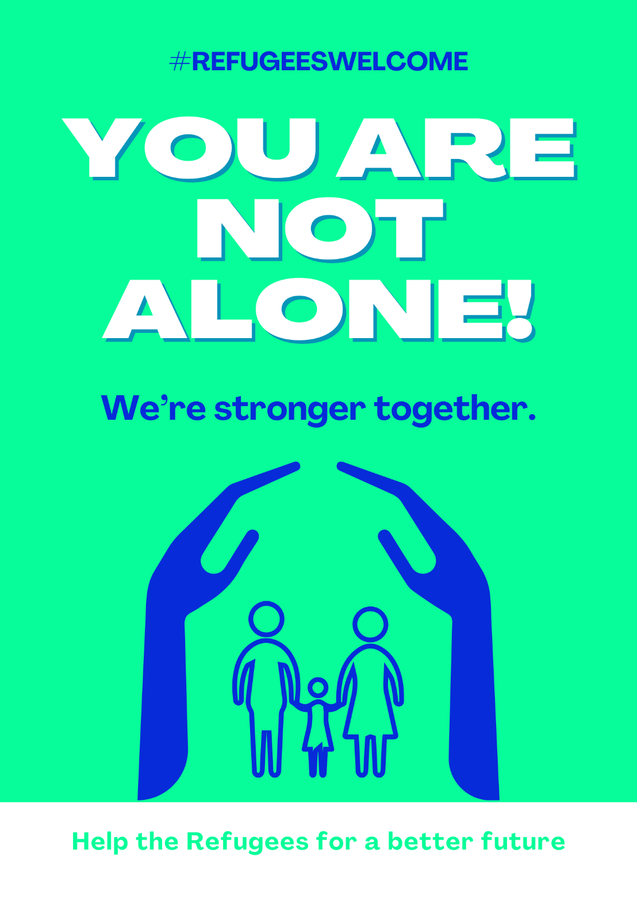

Annex – Game analysis:

