

Pedagogical Sequences – Bury Me, My Love
A3.5.

April 2025
Südwind

Title: Bury me, my love
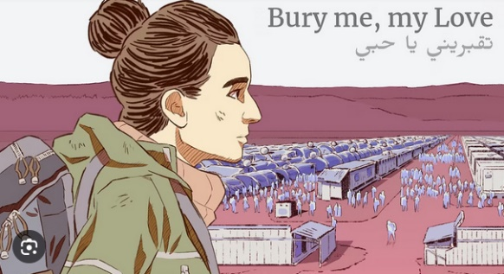
Bury Me, My Love is a video game that revolves around a powerful narrative experience, which gains meaning through the interaction between the player and the game. Bury Me, My Love is an interactive narrative game that tells the story of Nour, a young Syrian woman who decides to flee her war-torn country in search of safety in Europe. The player takes on the role of her husband, Majd, who remains in Syria and stays in touch with her through text messages. As Nour makes her perilous journey, the player helps guide her by making decisions that impact her route, choices, and ultimately, her fate. The game is a poignant exploration of the refugee experience, highlighting the challenges, dangers, and emotional toll of seeking asylum.

Duration: 4 lessons
Subject/s: History: Contemporary conflicts and migration. Civic Education: Human rights and refugee crises. Economics: Resource analysis and risk management in conflict situations. Arts: Home & Identity
Topics: War, refugees, migration, gender, survival, crisis decision-making
SDGs: main topic 16 but also related to 4, 8, 10, 17
Dimensions of conflict through the game:
☒ social impact
☐ environmental impact
☒ economic impact
☐ technological impact
Learning objectives: Critical thinking, Collaboration, Communication, Technology literacy, Initiative
Interpersonal skills: Empathy, decision-making, understanding of refugee experiences, strategic and critical thinking, cultural awareness, emotional intelligence
Technical requirements & material required: Cell-Phone or PC/Tablet; “Bury me my love”-APP or via Steam; or Switch (Euro 2,99 /purchase)
Further reading/material: https://burymemylove.arte.tv/
https://www.kiocs.org/
https://www.framerspace.com/course/bmml?cid=5d271a859c51fc5a157c0b8f
https://games-im-unterricht.de/unterrichtskonzepte/begrabe-mich-mein-schatz

Preparation Phase
Before you can use this text-based game in your lessons, you need to be aware of the different options and choose one of them. Bury me, my love is a paid game (2025: € 2,99/app download) - the budget must be financed in advance.
- In the first option, pupils need to bring their own device to the lessons, will download the app in their app-store and play it in the mobile-phone version.
- If the students have school tablets, they could register with Steam in advance (it's free) and buy the game via their personal accounts.
In both options above, the budget must be clarified and agreed on in advance (from the parents' association, school fees, other funding bodies). It cannot be expected that all pupils can or/and want to pay the approx. three euros.
- Alternatively, it could be purchased by educators via their Steam accounts and played on PCs – working in pairs – this would mean that more educators need to be registered via Steam, purchase the game and download the game beforehand on the PC that is used for the teamwork.
In the descripted lesson plan below, the first option was chosen: Each pupil buys the game via their app store and gets the money refunded by the InterGames project.

It is essential that the teachers have played the game to understand the mechanics and story lines. It is not necessary that the teachers experience has been successful – also failure is a valuable experience!

Some words on the background of the game:
‘Bury me, My Love’ was explicitly developed to trace the experiences of Syrian refugees. Interviews, reports and articles have been incorporated into the story. This allows the developers to create a realistic narrative full of human moments.
The narrative of the game is based on true stories — most prominently the story of Dana, featured in a piece by Le Monde journalist Lucie Soullier, “The journey of a Syrian migrant through her Whatsapp thread.”
The partner of Nour will stay at home and the player will step in his shoes: The choice of his answers influences the relationship between the two and thus Nour's will to persevere.
The journey ends in nineteen possible ways, not always happily!
Therefore, the background of the target group should be taken into consideration! Young people who have experienced flight, war or trauma can have strong emotional reactions to the game, as it incorporates real-life experiences.

Game Phase
Lesson No. | Description in Steps | Social form | Material/technical requirements
1 | Step 1: Introduce the game with a short video  Dear Villagers (2019), 1:28’  LINK: https://www.youtube.com/watch?v=GWl2tiOnbSw&t=85s | Plenum | Beamer, youtube/internet, link to video, speakers
1 | Step 2: Facilitation of the game-play itself  Hand out a worksheet (Material 1) to help the students write down their gaming experience in a structured manner. One part is about the places/stops on her journey, the second part focusses on the people Nour meets along the way and the last part is about the fate of Nour in students playing experience.  Ask the students to fill in these sheets while they are playing the game, so they can also record their thoughts. This will help the pupils to understand the game better and make informed decisions for Nour. | Plenum | Material 1
1 & 2 | Step 3: Actual Game-Play  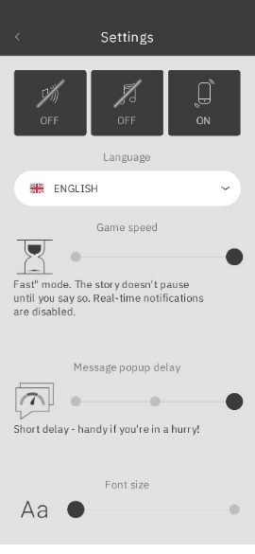  Although the immersion in the game would be much better if the ‘real-time mode’ was switched on, we recommend setting the game speed to ‘fast mode’ for the school setting (see screenshot below). This deactivates the real-time notifications, but the game can be easily embedded in lessons. Also, the tempo of the messages can be speed up (Message pop up delay – see screenshot).  à Tell your pupils to go in the settings and change accordingly. If pupils have a headset with them, they can also play the game with tone.  Now the time is hard to estimate. Some pupils might take “bad” decisions at a very early stage and their unsuccessful journey ends very fast. Some pupils might play until the end of lesson 2 and make it to Europe and others might need additional time to play at home to finish the journey. The game progress is saved automatically.  You could provide students who complete Lesson 2 early with Material 2, allowing them to begin the reflection process. sooner.  We recommend to give pupils time until the end of lesson 2 maximum. In case some need more time, they need to play it as homework and get additional credits for that effort. | Individ. work  A tip from the actual tests: As it is a very ‘reading-heavy game’, teachers advise choosing the ‘real-time mode’ and turning the game into a term project. The completed materials are then used for joint reflection at the end of the semester. | App, Smartphones
3 | Step 4: Create personal involvement  Before moving on to the important reflection and debriefing phase, a video can be shown in the plenary that is personally very moving.  ⚠️ TRIGGER WARNING ⚠️ The media below contains emotionally distressing material to survivors of violence. The subject matter may be upsetting to someone who views it. Everybody is advised to watch it at their own discretion!  The video is therefore only recommended if you know your students well and know that there are no recent or personal experiences of flight in the classroom.  Save The Children (2014) – 1:33’  LINK: https://youtu.be/RBQ-IoHfimQ | Plenum | PC, Beamer, Internet, Speakers, Youtube

Reflection Phase
Lesson No. | Description in Steps | Social form | Material/technical requirements
3 & 4 | Step 5: Reflection of the individual game experience, migration-facts and home/belonging  Take Material 2 with ten questions and distribute it to the pupils. They shall answer individually and think of their own game experience, their feelings, perceptions and knowledge. | Individ. work | Material 2, pen
3 & 4 | Optional game: Prejudices & Facts  To the topic of migration, you can also play a short game with the pupils in your group. Take Material 5, print it and cut out the cards. There are 8 prejudices and 8 corresponding facts – in case your group is bigger, put them in pairs for the facts.  Distribute it randomly amongst the pupils and give them some time to read it. They shall ask beforehand if they do not understand certain words.  One pupil starts to read out lout a prejudice. Now one pair of pupils would need to read the corresponding fact.  For example: “Austria is overrun by Asylum Seekers” (prejudice)  “Asylum Seekers make up 0,29 % of the population of Austria” (fact) | Plenum | Material 5 (would need to be cut out into smaller cards)
3 & 4 | Step 6: Reflection of what are essential items  Material 3 is an easy material that could also function as a “filler” for the pupils who are faster in their journey/game experience. It is a reflection on what is important to pupils and why so many refugees have a Smart-Phone. | Individ. work | Material 3, pen
3 & 4 | Step 7: Reflection of “identity”  Material 4 is an optional material that might as well function as “filler” for the pupils who are faster in their journey/game experience. It is a reflection on identity and what creates “me”. | Individ. work | Material 4, pen
4 | Step 8: Discussion some of the questions  In the end, the answers to questions about all the materials used need to be recorded. This can be done in various ways, such as in group work where only certain interesting discussions are brought to the plenary, or by addressing the entire group from the start.  Some of the background-info and -material for educators might be useful for the “resolution”. | Plenum (or group work) | Material 1, 2,3,4
This question could also be approached from a more creative perspective (e.g., in the Arts).

Material 1 – While playing
Mapping Nour’s journey
Date/Day | Country | City/Refugee Camp | Distance from home | What let Nour there?

Mapping Nour’s interaction with people
Place | Who all did Nour meet? | Emotions felt | What perceptions Nour had about them?

Nour’s fate
Nour's fate is determined by the actions you took while playing the game and the path generated. In total there are 19 different endings possible – not all of them have a happy ending.

- Where was Nour at the end of your game?

- Did she successfully enter Europe?

- Based on Nour's fate in your gameplay, try to imagine what is life like in her new location?

- What do you think will happen to you/Majd in the ending of your gameplay?

Material 2 – After your game experience

- What are your thoughts of the game? Did you like it? Why yes or why not?

- What do you think is the purpose of this game?

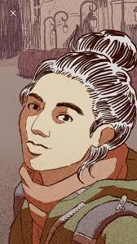
- How would you describe Nour’s state of mind when she was on the run? Pick max. 4 or/and find your own words.

☐ On high alert
☐ Panicky
☐ Relaxed
☐ Adventurous
☐ Happy
☐ Peaceful
☐ Fearful
☐ Hopeful
☐ Sad
☐ ________________________________

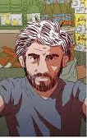
- When you were responding as Majd, what words best describe your feelings? Pick max. 4 or/and find your own words.

☐ Concerned
☐ Scared
☐ Terrified
☐ Sad
☐ Happy
☐ Peaceful
☐ Angry
☐ Anxious
☐ Curious
☐ _______________________________

- Where was Nour’s home?

- Who was left behind? What did Nour have to leave behind?

- What do you think was Nour’s reason for fleeing her home, Syria? Do you think she had a choice in the matter? Why yes or why not?

- Think about the word “home”.
  - What is the image that comes to your mind?
  - Describe what “home” means to you.
  - Use your five senses (touch, taste, smell, hear, sight) to describe what is special about your home.

- In your understanding of “migration” and “refugee” – would you call Nour a migrant or a refugee? Please explain your answer briefly.

- Please write down what you think is an “internally displaced person”?

Material 3 – Pack your most essential items
Imagine that you have to leave your home for another country.

    - What is that one object of importance or value you would bring with yourself?

    - And now imagine you can pack one small bag for your unknown journey. Are there some items that you would bring along? Pick a maximum number of items that you can imagine can fit inside one small back-pack.

    - “A real refugee seeking shelter and assistance would not possess the luxury of a smartphone."
What do you say to this sentence? Would you agree or disagree? Please give an explanation to your choice.
Think of Nour’s journey – was the phone essential for her or luxury that she could have left at home?

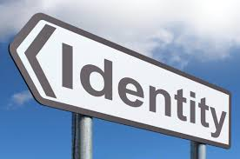
Material 4 – Identity Puzzle
Identity can be defined as the qualities, characteristics or beliefs that make a person who they are. Often it is associated with the question ‘Who am I?’
There can be multiple factors influencing one’s identity, such as, our gender, nationality, religion, age, language, along with other factors such as where we live, where we go to school or work, our interests and beliefs.
© CC BY-SA 3.0

- What do you think are or might be some characteristics essential to Nour's identity? You can select as many as you like and you can also put some more characteristics in play.

☐ Syrian national
☐ Woman
☐ Refugee
☐ Asylum seeker
☐ Control freak
☐ Humorous
☐ Opinionated
☐ Married
☐ Good swimmer
☐ Brave
☐ Naive
☐ Nurse
☐ ____________________________
☐ ____________________________
☐ ____________________________

- Do you think Nour will identify herself differently after migrating out of Syria or after becoming a refugee? Will there be a difference in how she is as a person before and after the crisis?

- Make your own “identity chart” as the example is shown here:
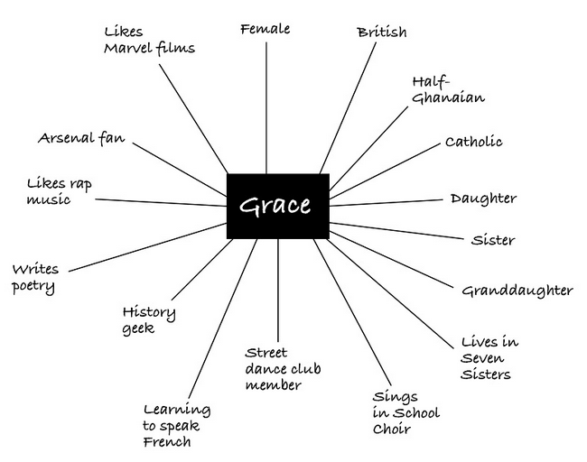

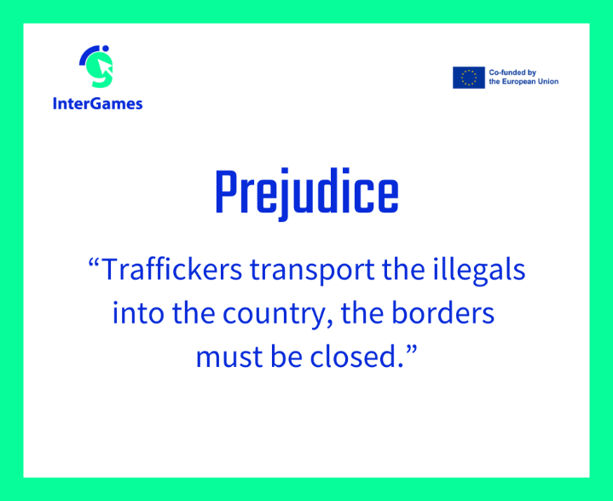
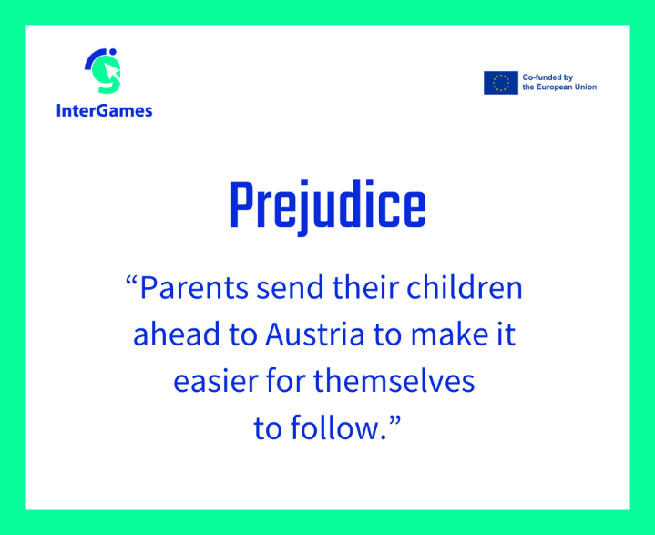
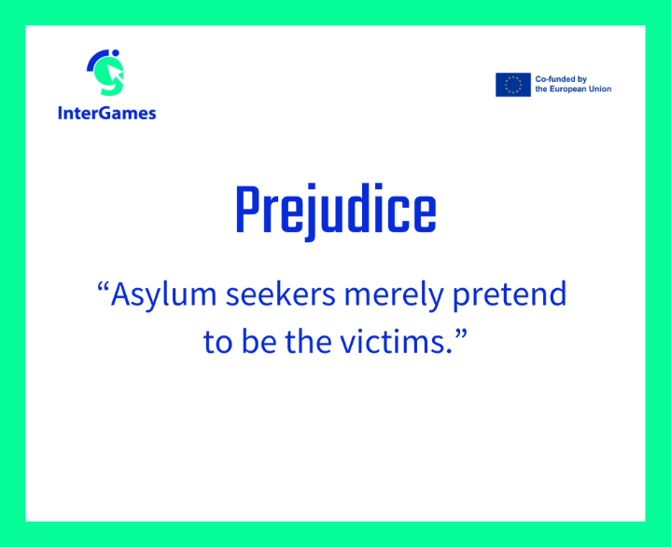
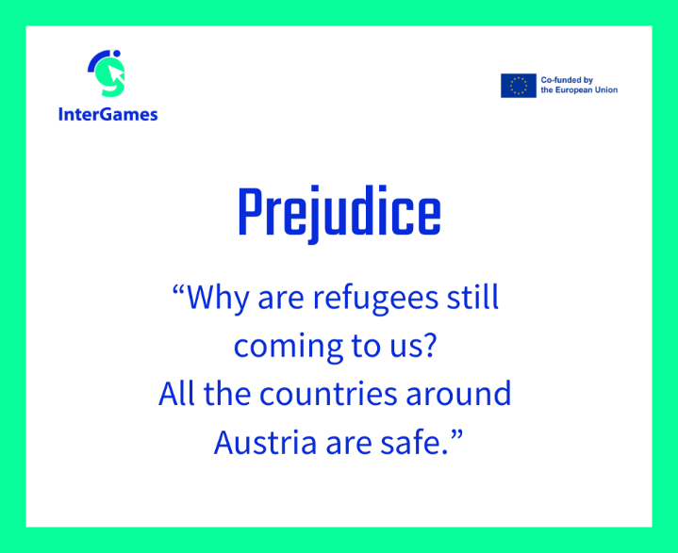
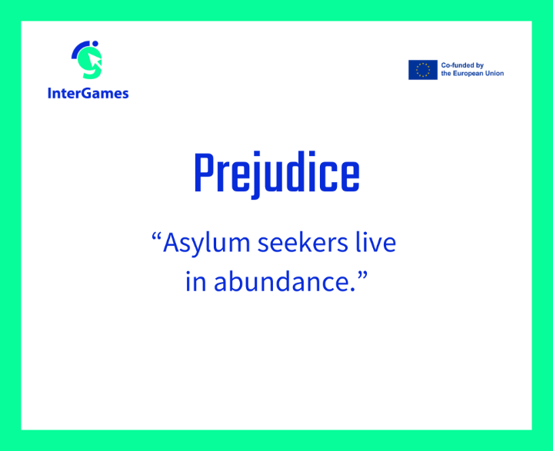
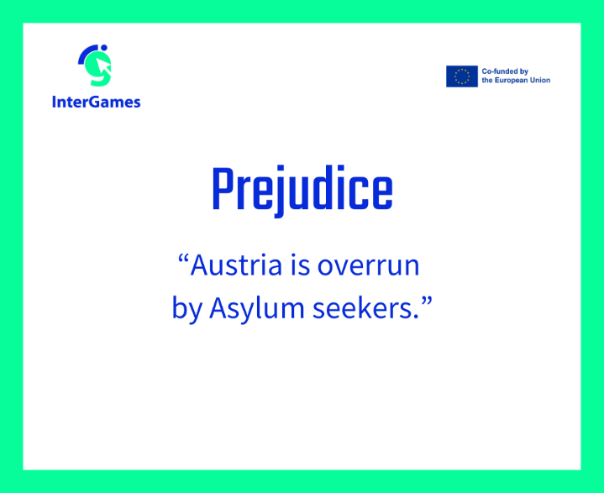
Material 5 – Prejudice Memory

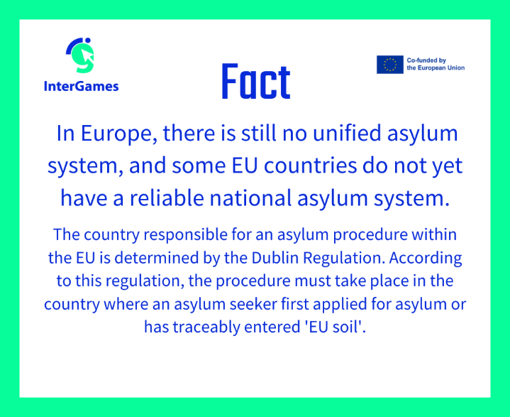
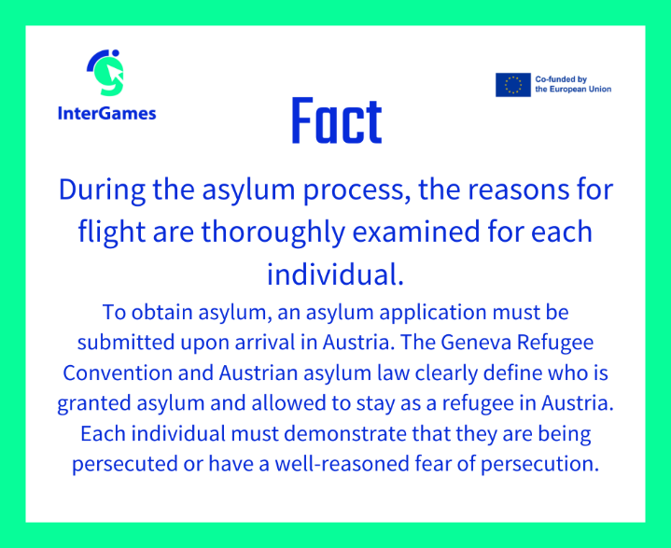
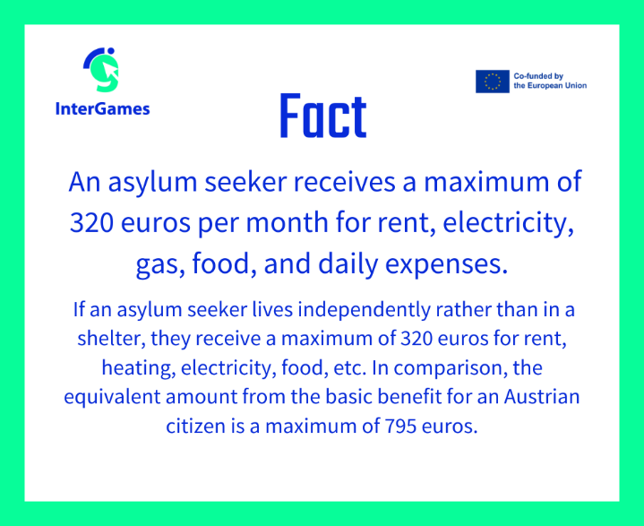
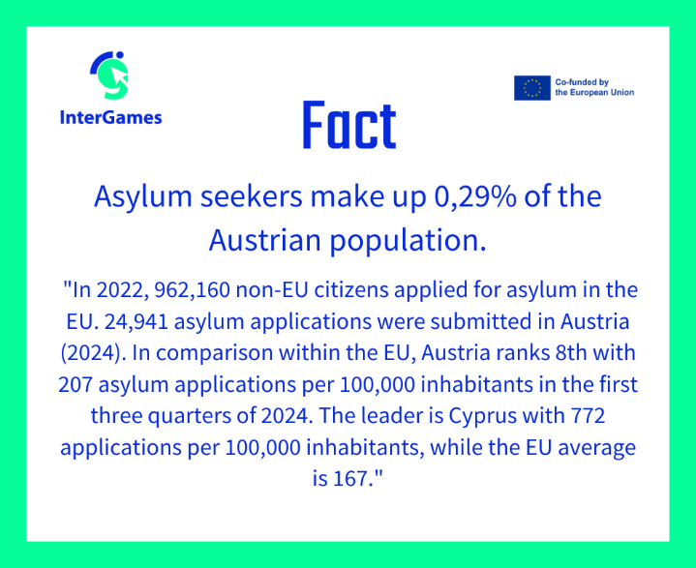
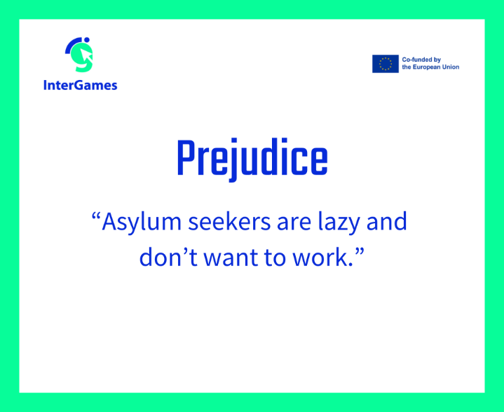
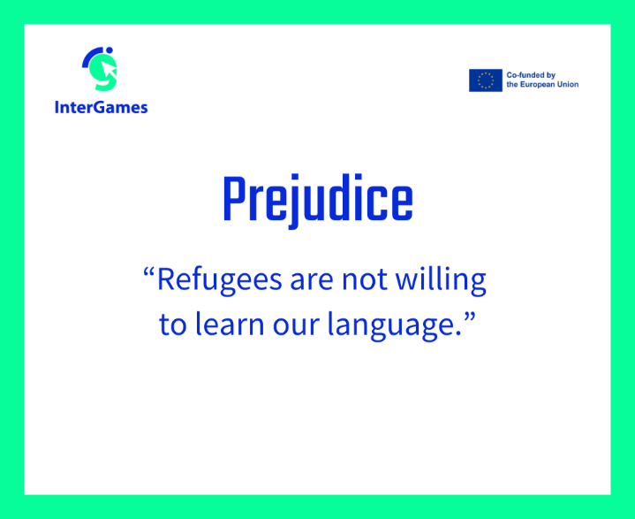

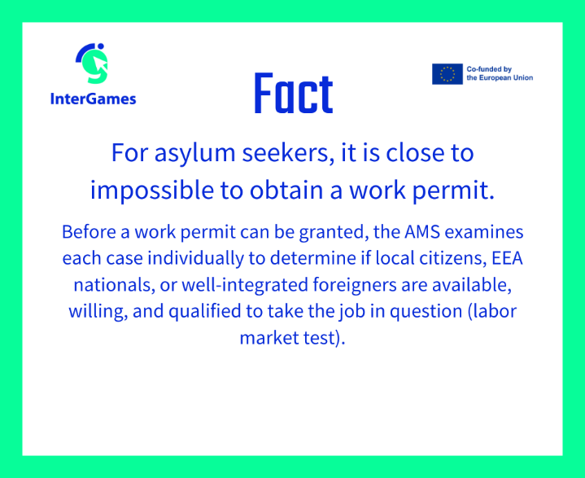
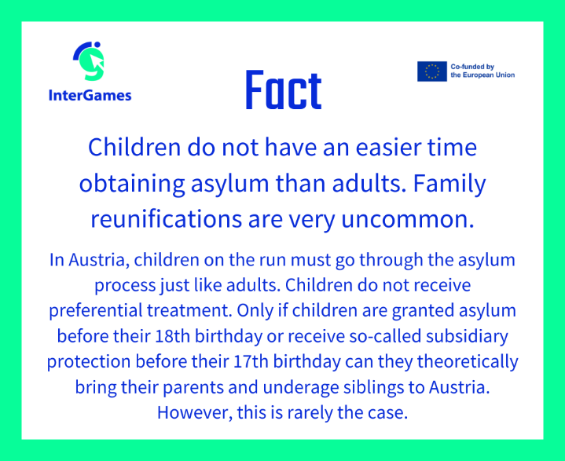
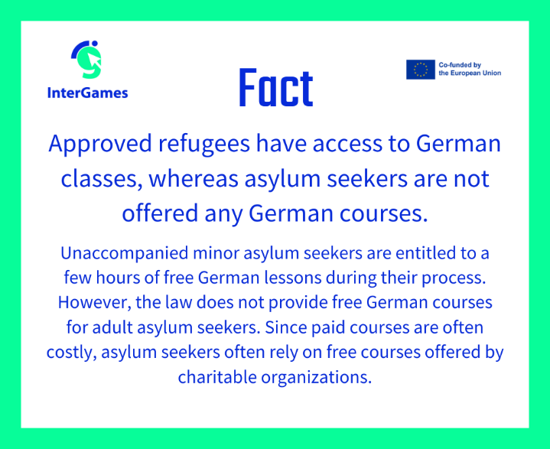
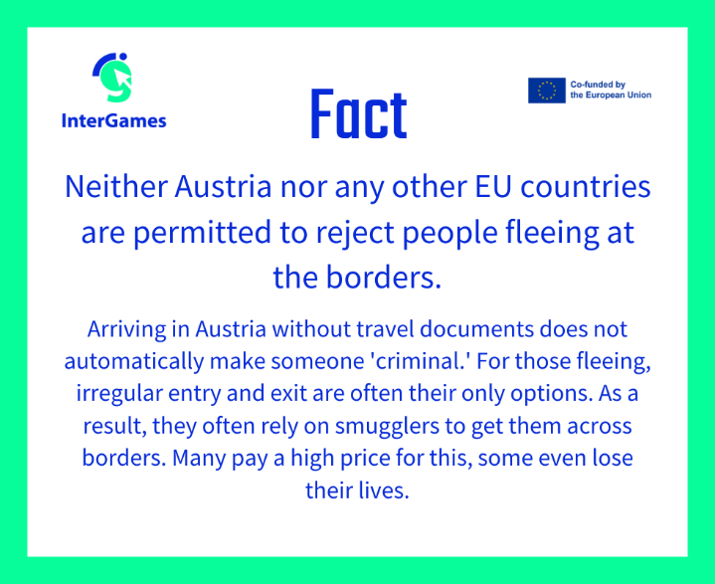

Background info for educators

Migrant: A person who is moving or has moved across an international border or within a home country regardless of whether the move is voluntary or involuntary (e.g., due to work-related issues) and regardless of the length of stay.
The UN Migration Agency (IOM) defines a migrant as any person who is moving or has moved across an international border or within a State away from his/her habitual place of residence, regardless of (1) the person’s legal status; (2) whether the movement is voluntary or involuntary; (3) what the causes for the movement are; or (4) what the length of the stay is.
According to UNHCR, migrants choose to move not because of a direct threat of persecution or death, but mainly to improve their lives by finding work, or in some cases for education, family reunion, or other reasons. Unlike refugees who cannot safely return home, migrants face no such impediment to return.

Refugee: A person who lives outside the country of nationality and is unable to return because of persecution or fear of persecution based on race, religion, nationality, membership of a particular social group or political opinion.
The text of the Refugee Convention defines a refugee in 51 words as a person who “owing to a well-founded fear of being persecuted for reasons of race, religion, nationality, membership of a particular social group, or political opinion, is outside the country of his nationality, and is unable to or, owing to such fear, is unwilling to avail himself of the protection of that country”.
145 countries have agreed to follow the Refugee Convention, a legal promise that those who need safety will be given it.
According to UNHCR, refugees are persons fleeing armed conflict or persecution.

Asylum seeker: A person who seeks refuge in a country to which they have fled because of persecution.

Internally displaced persons: People who fled their homes – but not their countries – because of armed conflict, violence, disaster or a violation of human rights. Internally displaced persons make up a large part of the global refugee population, as many people have to stay in crisis areas within their own country instead of crossing the border to another country.

Push and pull factors:
Push factors and pull factors are terms used to describe the reasons why people migrate from one place to another. In short, push factors drive people away from their current location, while pull factors draw them to a new place.

@Push factors refer to the conditions or circumstances in the place where someone lives that make them want to leave. These are often negative factors that "push" people away from their home country or region. Examples include:
- Economic hardship (e.g., high unemployment or poverty)
- Political instability (e.g., war, violence, or oppressive governments)
- Environmental disasters (e.g., earthquakes, floods, or droughts)
- Lack of opportunities (e.g., limited access to education or healthcare)

@Pull factors are the positive aspects of a new place that attract people to migrate there. These factors "pull" people toward a new destination. Examples include:
- Better economic opportunities (e.g., higher-paying jobs or more job availability)
- Political stability (e.g., safety, freedom, or democratic governance)
- Better living conditions (e.g., better healthcare, education, or infrastructure)
- Social connections (e.g., the presence of family, friends, or communities from similar cultural backgrounds)

Background material – Poster refugee or migrant
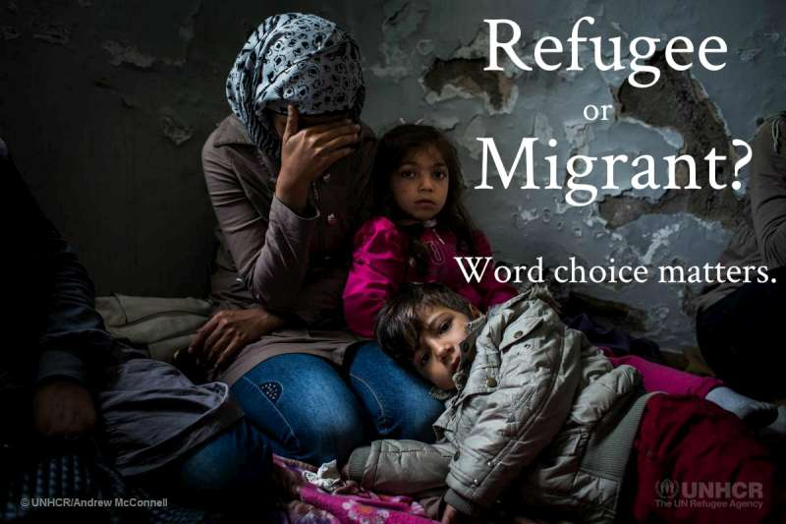

©UNHCR

Background material – Important items for refugees/personal stories
Let's take a look at a few of the most important things that Syrian refugees brought with them while fleeing home:
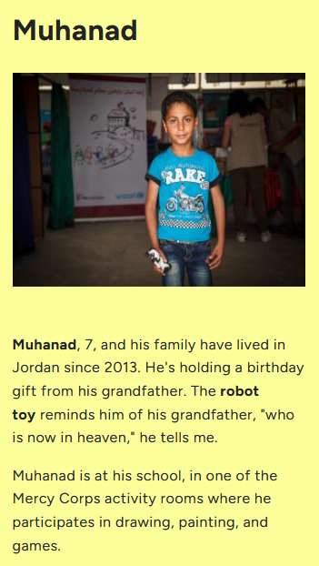
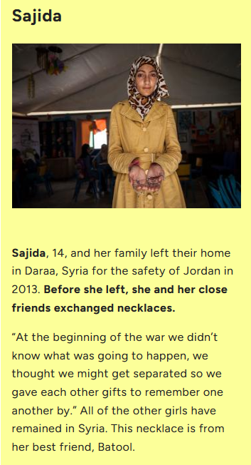

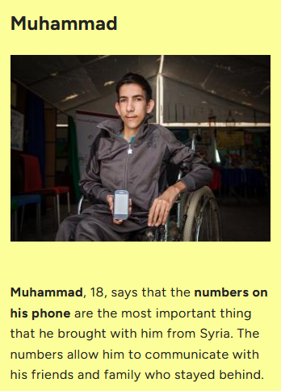
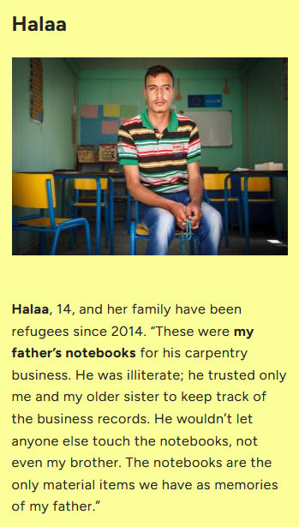
Annex – Game analysis:

[I will not put all analysis in here but in the end, they shall form the attachment in a smaller font – 10pt]

In case you decide to let pupils play in ‘real-time-mode’, only 2 lessons are needed for intro & reflection!
For Austria, the Erasmus⁺ project ‘InterGames’ can still cover the costs until the end of 2025. For further info, please contact olivia.tischler@suedwind.at.
See: https://www.lemonde.fr/international/visuel/2015/12/18/dans-le-telephone-d-une-migrante-syrienne_4834834_3210.html Last opening 12.2.25.
Some ideas and the structure of the reflection phase are based on an online-course produced by UNESCO MGIEP (mahatma Gandhi Institute of Education for Peace and Sustainable Development) (oJ), generated on “framerspace”. See: https://www.framerspace.com/course/bmml?cid=5d271a859c51fc5a157c0b8f. Last opening 18.02.2025
Idea to this game derived from: UNHCR (2014): Aufbrechen, Ankommen, Bleiben. Bildungsmaterial zu Flucht und Asyl. Ab 12 Jahren. Vienna. pp 76 – 79 (English: Leaving, arriving, staying. Educational material on flight and asylum. From 12 years)
See more: https://www.unhcr.org/news/latest/2016/7/55df0e556/unhcr-viewpoint-refugee-migrant-right.html. Last opened: 18.02.2025
See more: https://www.unhcr.org/sites/default/files/legacy-pdf/4ca34be29.pdf. Last opened: 18.02.2025
From: https://www.framerspace.com/course/bmml/SJzPhcFZr?cid=5d271a859c51fc5a157c0b8f&mid=5d2c1c599c51fc5a157c0bbc. Last opening 18.2.2025
See MercyCorps (oJ): https://www.framerspace.com/course/bmml/HJX9T5tZH?cid=5d271a859c51fc5a157c0b8f&mid=5d2c1d8a9c51fc5a157c0bbd). Last opening on 18.02.2025

