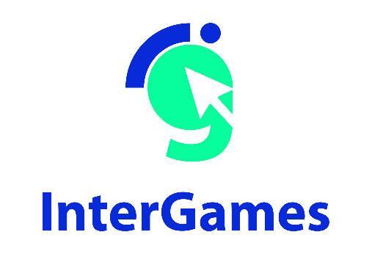

Pedagogical Sequences –
Freedom Bridge
A3.4.

January 2025
University of A Coruña

Contents
1. Pedagogical sequences – Freedom Bridge 2

Title: Freedom bridge
Freedom Bridge: A Minimalist Exploration of the Korean Divide
Freedom Bridge by Jordan Magnuson is a brief yet deeply emotional "notgame" that highlights the stark realities of the Korean border. Through its minimalist design, it offers a simple yet powerful interaction with the environment, immersing players in the emotional weight of crossing the divide between North and South Korea.
Freedom Bridge uses minimalistic gameplay to deliver a poignant message about the harsh realities of the Korean divide. By focusing on the human experience rather than complex mechanics, it invites players to empathize with those affected by geopolitical tensions. This approach turns the game into a tool for raising awareness, sparking conversations about conflict, division, and human rights.
The game embodies values of empathy, highlighting the emotional toll of political conflict and the human cost of separation. It explores themes such as family division, the peril of border crossings, and the broader struggles within politically charged landscapes. By presenting these issues in a stark, emotional manner, Freedom Bridge fosters reflection on freedom, separation, and hope, urging players to consider the real-life consequences of the Korean divide.

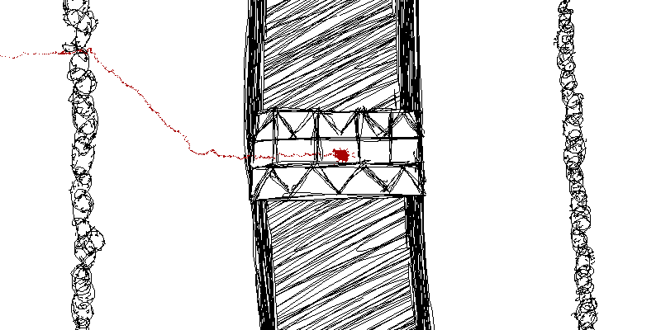
Taken from: https://playindiegames.wordpress.com/tag/freedom-bridge/]

Duration: 3 lessons
Subject/s: History and Civic Education
Topics: geopolitical division, human rights, freedom, and the emotional impact of separation, particularly focusing on the Korean conflict and the challenges faced by those affected by it
SDGs: 16, 10
Dimensions of conflict through the game:
☒ social impact
☐ environmental impact
☐ economic impact
☐ technological impact
Learning objectives: Learners develop competences such as empathy, critical thinking, and awareness of global political issues, particularly border conflicts and the human cost of division.
Interpersonal skills: critical thinking, communication, social skills

.

Technical requirements & material required: PC, WIFI
Further reading/material: https://www.britannica.com/place/demilitarized-zone-Korean-peninsula

Preparation Phase
Technology Setup: Ensure a stable Internet connection and adequate technological equipment (computers/tablets, keyboards, and mice). Headphones are highly recommended to enhance immersion.
Game Familiarization: Teachers should play Freedom Bridge to understand the gameplay, objectives, and themes. The game explores the divide between North and South Korea, focusing on personal stories, critical thinking, and decision-making.
Relevance Connection: To engage students, the teacher might present real-world connections:
- Discussing the Korean War and its impact on families.
- Introducing current relations between North and South Korea.
Engagement Strategy: Teachers may use real-life examples of divided communities or historical conflicts (e.g., Berlin Wall, Spanish Civil War) to establish relevance.

Game Phase
Lesson No. | Description in Steps | Social form | Material/technical requirements
1 | Step 1: Step 1: Visual Brainstorm  Show images or maps of Korea, highlighting the Demilitarized Zone (DMZ).  Ask:  What do you observe?  Why might these areas be significant?  Have you heard about the division of Korea?  Watch the CNN video: https://youtu.be/Y2KE2fNWs9k?si=qS_M7jnP0vcbYHsA explaining what the DMZ is. | plenum | Maps, historical photos (Annex 1). Video projector
1 | Step 2: Reading “demilitarized zone: Korean peninsula” (https://www.britannica.com/place/demilitarized-zone-Korean-peninsula)  In pairs students read this short text about the DMZ and answer the following questions:  What is the DMZ, and why was it created?  What is the significance of the 38th parallel in the context of the DMZ?  What role did the “truce village” of Panmunjom play during the Korean War?  Describe the events of the "tree-trimming murders" and how they escalated tensions along the DMZ.  What natural features and ecosystems can be found within the DMZ, and why are they significant?  What challenges do land mines and unexploded ordnance present to the wildlife in the DMZ? | In pairs | PC and internet connection
1 | Step 3: Teacher and students review answers. | Plenum | Whiteboard for notes.
1 | Step 4: Students play the game individually, focusing on choices and consequences in the lives of characters attempting to cross the DMZ. The teacher circulates, asking questions such as:  What motivated your decisions?  How did you prioritize your actions?  What risks did you consider? | Group work in pairs | Computers, and game access

Lesson No. | Description in Steps | Social form | Material/technical requirements
1 | Step 5: Reflection on Gameplay  Discuss students' experiences with the game:  What challenges did you face?  Did your decisions have unexpected consequences?  How did you feel about the outcomes? | Plenum | Whiteboard for notes.
2 | Step 6: Role-Play Preparation  Students are divided into groups. Each group receives a role-play scenario based on a family attempting to cross the DMZ (Annex 2). Groups develop a plan to address their character's challenges. | Group work of 4-5 ppls | Role-play worksheets and game screenshots. Annex 2
2 | Step 7: Role-Play Activity  Students act out their scenarios, using strategies such as empathy and negotiation to resolve conflicts. Teachers encourage active listening and creative solutions. | Groups | Prepared scenarios and props (optional).

Reflection Phase
Lesson No. | Description in Steps | Social form | Material/technical requirements
3 | Step 8: AI Analysis preparation  Students use an AI tool (e.g., ChatGPT or similar) to analyze real-life scenarios related to divisions in society, such as the Korean Peninsula or other historical conflicts.  Setup:  Each group of students is provided with a different historical or contemporary scenario involving societal division (e.g., Spanish Civil War, Berlin Wall, segregation in the USA, Brexit).  The teacher shares a pre-selected AI tool that students can use to interact with and analyze these scenarios. | Plenum | Whiteboard, computers, keyboards, headphones (optional) and Internet
3 | Step 9: AI analyisis  Students describe the scenario to the AI and ask questions such as:  What are the key causes of this division?  What challenges might arise when attempting reconciliation?  What strategies have been successful in other divided societies?  Alternative: They can also simulate decision-making by asking the AI for possible outcomes of actions related to reconciliation. | Group work of 4-5 ppls | Whiteboard, computers, keyboards, headphones (optional) and Internet
3 | Step 10: AI analysis output  Students summarize the AI's responses, critically evaluating the suggestions and reflecting on their applicability to the Freedom Bridge context. | Group work of 4-5 ppls | PC
3 | Step 11: AI analysis Discussion.  Each group presents their findings, comparing how AI insights relate to their own thoughts on societal division and reconciliation. | Plenum | Whiteboard for notes.
 | Extra Activity: "Bridging Divides in Our Community"  Objective: Students explore ways to address and solve divisions in their local or European context, drawing parallels to the Korean divide.The goal of this activity is to help students relate the concept of overcoming divides to their everyday lives, fostering empathy and problem-solving skills.  Activity Steps  Step 1: Introduction  The teacher introduces the idea of "divides" by discussing examples closer to the students' reality, such as:  - Local community disagreements (e.g., school rules, neighborhood issues).  - European challenges like cultural integration or political differences between EU member states.  Students can also suggest other examples of “divides” they are familiar with.  By grounding the activity in their immediate context, students can better understand and apply the lessons of reconciliation and bridge-building.  Step 2: Group Work  Students are divided into small groups and given a specific local or European challenge to solve. Examples:  Integrating newcomers into a school.  Finding solutions for disagreements between classmates or teams.  Proposing ways to celebrate diverse cultures in their community.  Each group brainstorms ideas for building "bridges" and solving their assigned challenge.  Step 3: Presentation  Groups present their ideas briefly to the class.  The teacher facilitates a discussion on the similarities between resolving these local issues and larger-scale conflicts like the Korean divide.  Step 4: Reflection  Students reflect on the importance of understanding, empathy, and communication in solving problems, both locally and globally.  Optionally, they write a short statement: “One way I can build a bridge in my community is...” | Group Work and Class Discussion | Paper or digital tools for brainstorming and presenting ideas.

Annex 1
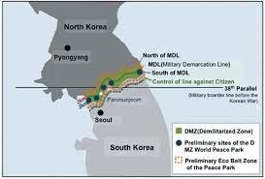

Source: https://www.researchgate.net/figure/Map-of-Korean-DMZ-and-the-proposed-DMZ-Peace-Park-area-cited-from-Mjelde-et-al-2017_fig1_330505082
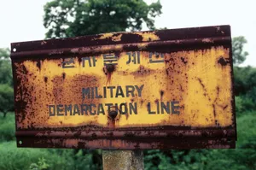
Demilitarized zone Sign indicating the military demarcation line in the woods near Panmunjom, in the demilitarized zone (DMZ) separating North and South Korea.
Source: https://www.britannica.com/place/demilitarized-zone-Korean-peninsula

Annex 2– Role Play

