

Pedagogical
Sequences

Liyla and the shadow of war

By Progettomondo

January

2025

Liyla and the Shadow of War
Liyla and the Shadows of War is a narrative video game that allows players to experience the difficulties and dilemmas of a family trapped in armed conflict. The protagonist is Liyla, a Palestinian girl who finds herself fleeing the drama of war with her family. The game is based on real events and aims to stimulate empathy and reflection on the human consequences of war, especially on the children life.

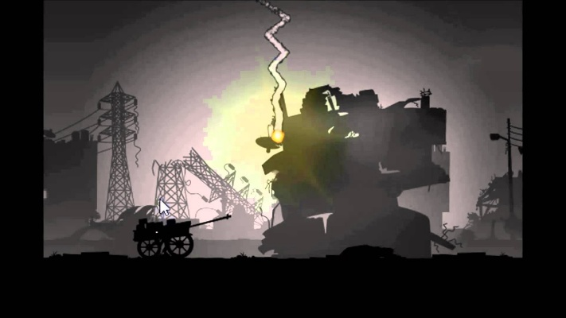

Duration: 3 lessons
Subject/s: civic education, history, technology, art, english
Topics: war conflict and its consequences, human and children’s rights, refugees’ flows
SDGs: 1, 5, 10, 16
Dimensions of conflict through the game:
X social impact
X environmental impact
☐ economic impact
☐ technological impact
Learning objectives: Understand the human and psychological effects of war and reflect on the importance of human rights and the protection of the civilians, especially children. Promote critical thinking and cultural sensitivity.
Interpersonal skills: Empathy, critical thinking, ability to work in a team
Technical requirements & material required:
Windows PC, Android, or iOS
devices
• Speakers and projector (if available)
• YouTube
• Printed sheets (Material 1, 2, 3, 4)
• Physical stuff: colours, papers, posters, images, newspapers…
Further reading/material: https://www.un.org/unispal/history/
https://acleddata.com/mid-year-metrics-2024-infographics/

Preparation Phase
In the preparation phase, it must be ensured that there is a strong WLAN in the room and that Internet is available for each PC or tablet. Also, it must be ensured that each student has a device and headset.
As this game needs to be downloaded, it must be ensured that all students do it on their devices before the beginning of the workshop or if they are using the multimedia classroom, that the game is downloaded on each PC.
Trigger alert: this pedagogical sequence shall help integrating war and conflict issues through games into the classroom. It is important to always keep the well-being of the pupils in mind. This game deals with theme that might trigger students who have experienced similar situations or whose families have fled conflicts. Students must be made aware of the content of the workshop in advance and they must be aware of the possibility to opt-out of the activity to protect themselves if the experience of the game is too triggering.

Game Phase
Lesson No. | Description in Steps | Social form | Material/technical requirements
1 | Step 1: Introduction  Spend 5 minutes for a group brainstorming session. Write the word ‘war’ in the middle of a board and collect words and thoughts that this word provokes in the students.  After having collected all the contribution, group words according to subject area (some may be related to consequences, others to causes, others to emotions or rights...) This work helps the students visualise a sort of mental map of the class from which they deduce the complexity of the theme that will be addressed | Plenum | Board
1 | Step 2: War in the world  Ask the students to list the armed wars they know are currently active in the world and note them down on the blackboard or on a poster board. Then show the map of wars (see link) without pausing to analyse them but only to visually show how many people are in a state of war at the moment:  https://www.cfr.org/global-conflict-tracker  https://www.thenewhumanitarian.org/maps-and-graphics/2017/04/04/updated-mapped-world-war | Plenum | Board, video projector, internet
1 | Step 3: Introduction to the game  “Before we look into this issue a bit more into detail, you are going to play a short browser game on the topic.”  The teacher projects his/her browser and shows them to get to the game. Each pupil opens his/her browser and enters the URL (https://play.google.com/store/apps/details?id=org.liyla.war&hl=en).The game should be already downloaded on their device. After download the game, put the icon on a tablet/pc desktop and prepare to be ready for the game! | Plenum | Windows PC,  Android, iOS  devices, or  YouTube  gameplay video
1 | Step 4: Gameplay  Each student opens a game and click on the button Play  After the game has finished a page with real life data is shown → pupils shall have the time to read through data  Each game might need around 20 min (depending on the skills of the player) – each player should have the possibility to play the game until the end (especially if he/she dropped out quickly). | Individual | Windows PC,  Android, iOS  devices
1 | Step 5: Debriefing  Divide the class in groups of 4 or 5 students. Each groups discuss following these questions. Start from the emotive part:  How did you feel during the game? Ask the students to choose their emotions using the “flower of emotions” where they can find different shades of emotions.  How do you feel now?  “What did you surprise most about the game? Why?”  “Were there any parts of the game that frustrated you? How did you handle them?”  “What decisions did you find most difficult? Why?”  “Did the game suggest some open questions that you would like to go deeper?”  Leave the students enough time to share the answers (20’). At the end of the time each group share with the class the main issues raised. The teacher helps the students with active listening supporting them in saying that he/she knows that the theme of the game is very raw and there will be room to deepen. The teacher takes note of the open questions to be answered in the next lesson | Work group, plenum | Material 1  Board

Reflection Phase
Lesson No. | Description in Steps | Social form | Material/technical requirements
2 | Step 6: Let’s explore the issue of war  The lesson begins with a briefing from the previous lesson and sharing of new thoughts from the students.  The first activity begins in the classroom, to focus the children's attention on how many conflicts are present in the world today, so how many populations are experiencing these situations.  Go back on the map and navigate an overview of the conflict:  https://www.cfr.org/global-conflict-tracker  https://www.thenewhumanitarian.org/maps-and-graphics/2017/04/04/updated-mapped-world-war  Ask to the students what conflicts did they know and what didn’t they imagine | Plenum
2 | Step 7: From the numbers to the people  Divide the class into groups of 4-5 students. Print and give each group the Material 2. Explain that they find some sentences to which they have to associate one of the numbers below. The aim is to associate the correct numbers next to the sentences. Some facts about the war and its consequences will emerge. At the end, share the answers in plenary and give the correct answers (Material 3). Ask the students:  - Are there any data that surprise you?  -What would you like to know in addition to this? Ask to the students to find these data as homework. | Group work of 4-5 students; plenum | Material 2 Material 3
2 | Step 8: Liyla in the war  Divide the class into groups of 4-5 students and give each one the map of Material 4.  Each group should go through Liyla's challenges in the game and identify for each stage:  -what happened?  -what the main theme was at that stage?  -what consequences does the war have in relation to the identified theme?  This work helps teacher to let students see how many effect and consequences the war has on the life of the people and especially of the children.  In the final step of the lesson the teacher asks to the students: “what are the violation of human rights that Liyla and his family suffer? The teacher takes note on the board | Group work of 4-5 students | Material 4, board
3 | Step 9: War and Global Goals  The lesson begins with a briefing from the previous lesson and sharing of new thoughts from the students.  Do you remember the story of Lyila and the human rights violation.  Do you know the Agenda 2030 and its goals? The teacher summarise the main goals https://sdgs.un.org/goals  The teacher launches these videos related to refugee children (UNICEF), asking the students to take note while they are watching them, about the link they find with SDGs: https://www.youtube.com/watch?v=7QVmXX62_H0&t=1s  https://www.youtube.com/watch?v=xpG3jLGGkvc&t=44s  After having watched the videos, the teacher asks the student to express themselves about “This story has the link with SDGs ….Because…” | Individual, plenum, | Youtube videos, projector or interactive board
3 | Step 10: Take action  The teacher ask the student:  “Give me a word of peace for you, that is, a word that makes you feel good in your relationship with the other either when you use it or when you receive it. Think of common, everyday expressions such as asking how are you? is everything OK? can I help you? or similar expressions”  Using mentimeter (www.menti.com) the teacher creates the word cloud of the class.  Dividing the class in small groups, the teacher asks the students to choose one of their expression/word of peace to be represented in an artistic product. They can use images, or draw or whatever.  Give them at least 40’ to finish their work and at the end collect them and prepare an exposition in the classroom.  Dedicate 10’ in the final step to share their thoughts. Probbaly they feel that they can’t do nothing to solve the wars in the world but we can start in creating peaceful relations among people around us… | Plenum, work groups | Mentimeter, old newspapers, images, colours, posters

Material 1

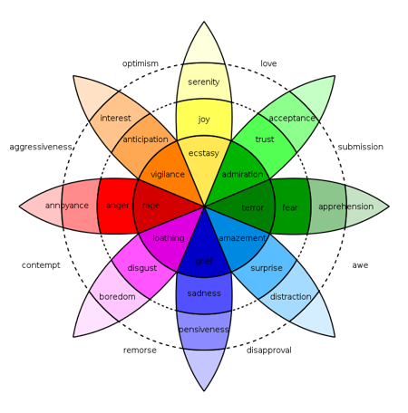

Material 2

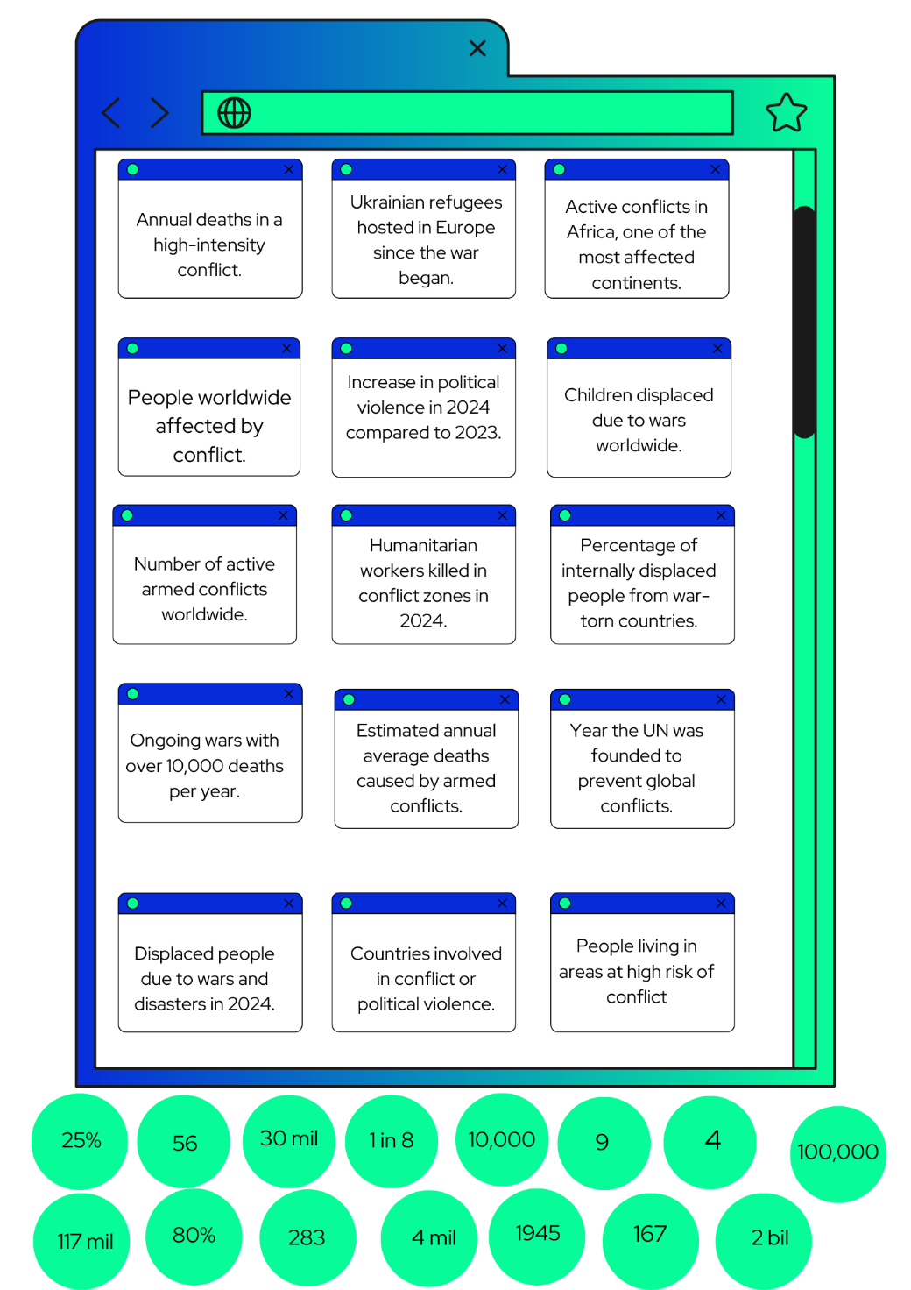

Material 3

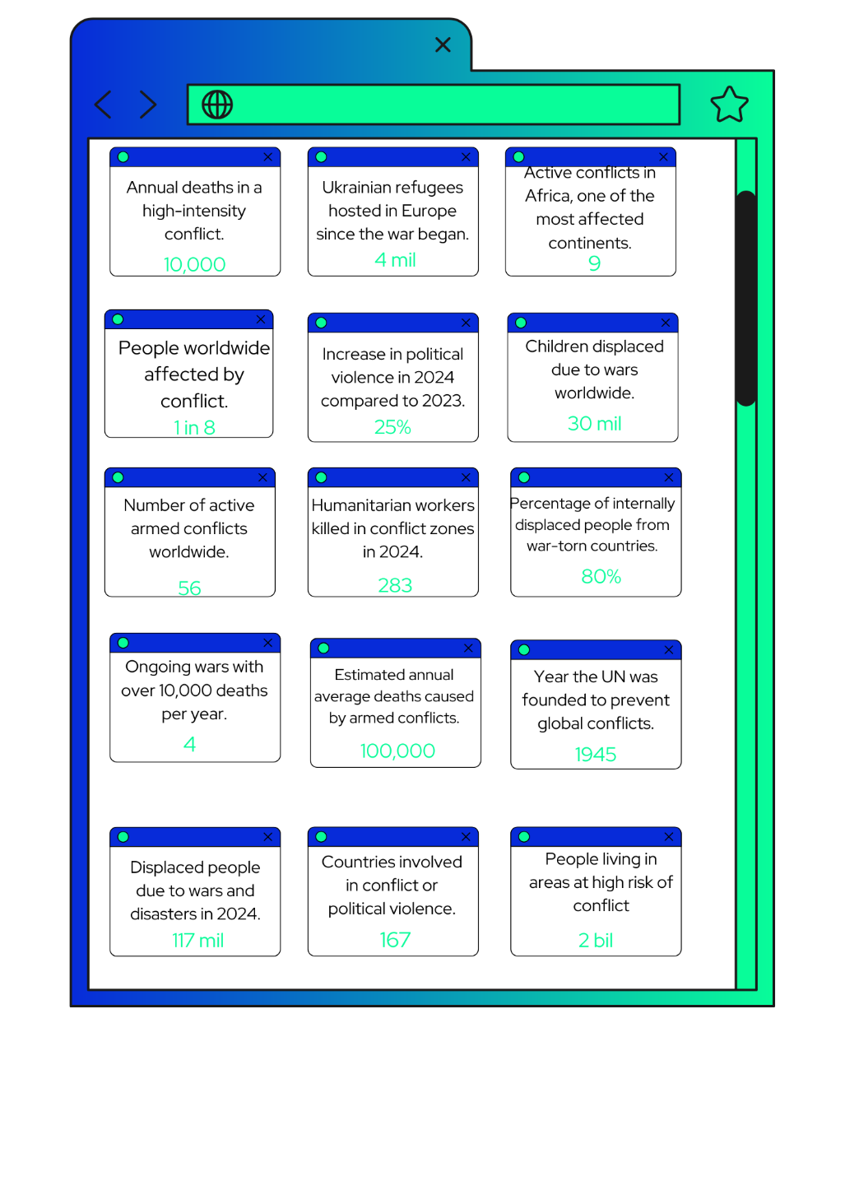

Material 4

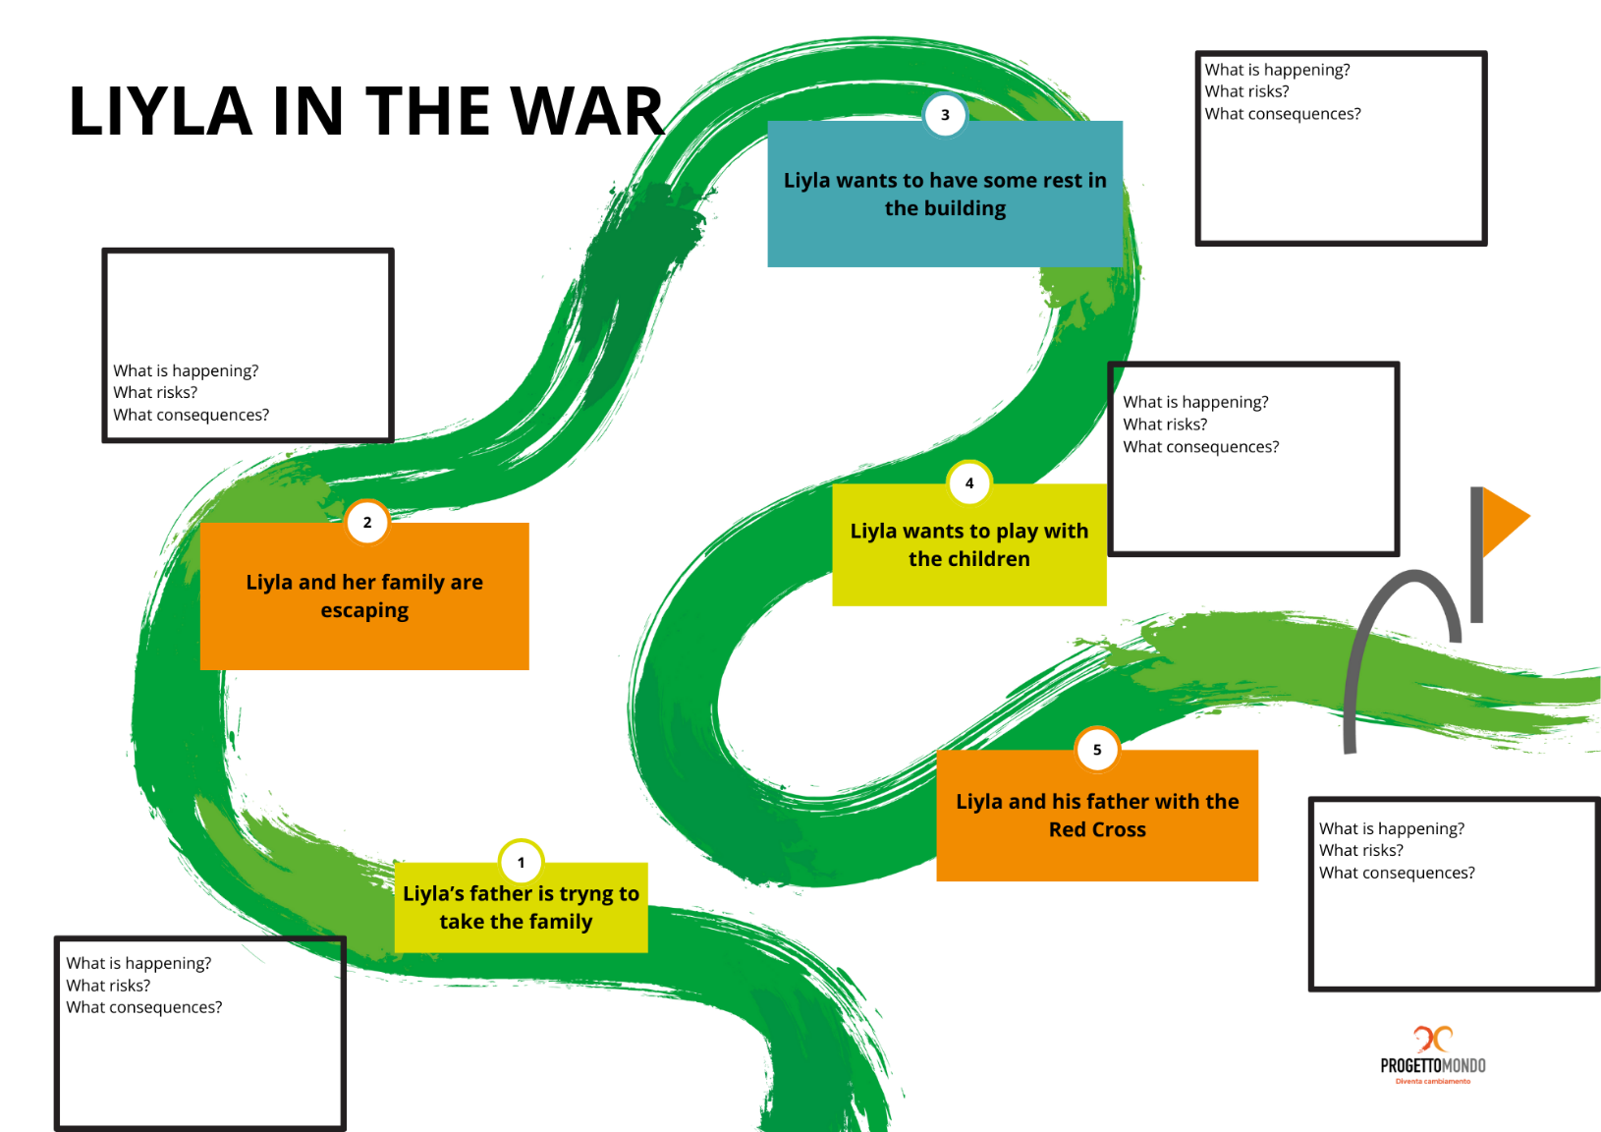

Annex – Game analysis:

