

Phone
Story
–

Pedagogical

Sequence

By C.I.P

December

2024

PHONE-STORY
Short description of the game: Phone Story is a thought-provoking mobile game that critically examines the global impact of the smartphone industry. Through a series of simple interactive mini-games, users explore different stages of the smartphone supply chain, beginning with resource extraction, then to factory conditions, e-waste, and consumer culture. Rather than focusing on traditional gameplay, Phone Story uses its narrative to highlight labor exploitation, environmental degradation, and the ethical challenges tied to technology production in the capitalist system. By presenting these complex issues in an accessible and interactive format, the game encourages players to reflect on their role as consumers in a global system, promoting awareness of ethical consumption and social responsibility.

Duration: 2 lessons
Subject/s: Economics, Civic Education and Environmental Education
Topics: Human rights, migration, conflicts and global crises, ethics, economic impacts
SDGs: 8, 12, 13
Dimensions of conflict through the game:
☐ social impact
☐ environmental impact
☐ economic impact
☐ technological impact

Learning objectives: This pedagogical sequence aims to develop critical awareness of the ethical and social challenges in the smartphone industry in capitalism. Students will explore the supply chain, labor rights, and environmental impacts of electronics, fostering an understanding of corporate social responsibility (CSR) and consumer responsibility. Additionally, learners will critically analyze overconsumption and the systemic effects of capitalistic structures on global sustainability.
Interpersonal skills: Critical thinking, social responsibility, communication, collaboration, global awareness, information literacy
Technical requirements & material required: PC/smartphone/tablet + Headphones + mouse for each student; WIFI; QR-Code to game URL
Further reading/material: https://www.phonestory.org https://electronicswatch.org/en
Redefining scope: the true environmental impact of smartphones? | The International Journal of Life Cycle Assessment
Can an ethical smartphone change the world? - BBC News

Preparation Phase
In the preparation phase, it is essential to ensure that each student has access to a device (PC, tablet, or smartphone). A stable internet connection should be available for smooth gameplay. Students will also benefit from headphones to focus on the game’s audio-visual elements without distractions, therefore it is important to provide headphones for a better gaming experience.
Before the class begins, the teacher should play through the game multiple times to familiarize themselves with its mechanics, themes, the game play experience and the provocative content it addresses. This will enable the teacher to guide discussions effectively and address potential questions or challenges students may encounter during gameplay.
To introduce the game without spoiling its impact, the teacher can provide a brief overview of the themes (e.g., global supply chains, labor exploitation, environmental impact, and consumer responsibility) while maintaining curiosity about the specific scenarios in the game. A discussion about the role of technology in daily life and the hidden costs behind its production can serve as an attractive entry point.
Finally, the teacher should prepare the class for the sensitive topics the game explores, such as exploitative labor practices and environmental degradation, emphasizing the importance of engaging with these issues critically and respectfully. Supplementary materials or a brief presentation on real-world case studies related to the electronics industry may be provided to contextualize the game’s narrative.

Game Phase
Lesson No. | Description in Steps | Social form | Material/technical requirements
1 | Step 1: Introduction to the topic  Start the session by provoking discussion in order to introduce the production cycle of smartphones in capitalism, to bring to the fora the hidden environmental and social costs associated with their creation. This can be done without the teacher giving information but just by provoking engaging questions like to trigger curiosity and fascilitate constructive discussion:  Have you ever wondered where the materials for your phone come from?  What happens to your old phone when you replace it with a new one?  Who do you think produces your smartphones and in what working conditions is this taking place?  Encourage students to share their knowledge and assumptions about the smartphone supply chain, covering stages such as raw material extraction, manufacturing, distribution, and disposal.  As a transition, explain that they will explore these issues and try to get answers through a short and impactful game. Introduce the concept of using games as tools for learning about serious topics, explaining that the goal is to raise awareness about the ethics and responsibilities tied to consumer electronics.  (THE ANSWERS THAT WILL BE GIVEN AND THE IMPORTANT POINTS THAT WILL ARISE FROM THE DISCUSSION, SAVE THEM AND WILL EVALUATE THEM AT THE END COMPARED TO THEIR NEW ONES AFTER THEY PLAY THE GAME AND PASS BY THE REFLECTION PHASE) | Plenum (teacher-led discussion) | Whiteboard or interactive digital board for brainstorming and projector for supporting visuals.
1 | Step 2: Introduction to the game  State that students will be playing Phone Story, a game that highlights ethical issues in the smartphone supply chain through a series of mini-games. Emphasize that while the game is playful in nature, it carries serious messages about labor exploitation, environmental harm, overconsumption, and corporate accountability.  Provide a quick walkthrough of the game structure, mentioning that each mini-game represents a stage in the lifecycle of a smartphone. Discuss briefly how the game uses its mechanics to provoke thought, for example:  Extracting rare minerals in harsh conditions.  Working in unsafe manufacturing environments.  Encouraging overconsumption and e-waste.  End with a motivating statement: “As you play, think about how your actions in the game mirror real-world practices. Be ready to share your thoughts afterward”. | Plenum | Projector  PC with game opened in browser
1 | Step 3: Practice the Mechanics  To ensure all students are comfortable with the gameplay, the teacher demonstrates the basic mechanics by playing online through the computer connected to a big screen the story mode. Highlight the actions required and their significance (e.g., tapping to mine minerals or dragging to assemble phones). Emphasize the time pressure and repetitive nature of the tasks, relating this to real-life labor conditions.  If students express confusion about controls, provide clarifications, but avoid solving the challenges for them. For classes with language barriers, clarify key terms or symbols that might appear during gameplay. After the demonstration, confirm that students are ready to start their own playthroughs. It is important to showcase it silently since is better for students to go through it on their own | Plenum | Projector, laptop for playing the game connected to the projector
1 | Step 4: Actual Individual Gameplay  Students access the game individually on their devices (via phonestory.org or provide them with a QR code to be scanned) and start playing through games at their own pace.  The teacher circulates the room to observe, offer support, and ask thought-provoking questions to deepen curiosity and reflection, such as:  - How does it feel to experience this level of urgency or repetition?  - What do you think the game is trying to make you realize?  Since the gameplay is relatively fast, encourage them to replay the stages multiple times and then reflect on their experience. This ensures everyone has a meaningful engagement with the material. | Individual Work | 1 device per student (laptop, smartphone, tablet) and 1 pair of headphones per student
1 | Step 5: Discussion and sharing experiences  Once gameplay is complete, initiate a class-wide discussion to reflect on their experiences. Start with open-ended questions to allow students to share their thoughts:  - Which part of the game stood out to you the most? Why?  - How did you feel during the mini-games? Did any of the tasks frustrate or surprise you?  - How does this game relate to what we discussed earlier about the smartphone supply chain?  Encourage students to connect their gameplay experience to real-world issues. Highlight key takeaways from the discussion on the board, such as exploitation in mining, unsafe labor practices, consumer responsibility, and e-waste challenges. | Plenum | Whiteboard/digital bord to summarize key points
1 | Step 6: Preparation for the transition to the reflection phase  Wrap up the game phase by posing a final reflective question to transition into the next session/lesson: “Now that we have experienced the challenges behind our smartphones, what can we do as individuals and as a society to address these issues?”  Preview the upcoming reflection phase, where students will delve deeper into the ethical dilemmas and systemic structures the game exposes. Reassure them that no answer is too small or insignificant, emphasizing the value of critical thinking and incremental change. End the session and the day after will begin the reflection phase. | Plenum | None

Reflection Phase

Lesson No. | Description in Steps | Social form | Material/technical requirements
2 | Step 7: Connecting the game to real life  Begin by revisiting the he environmental impact of smartphones throughout their lifecycle. Display this on the board or a slide using infographic (Material 1), and ask students to recall specific scenes from the game that correspond to it. Facilitate a discussion around the central question: How accurately do you think the game represents real-world practices? Are these scenarios exaggerated or realistic?  Follow up with a brief presentation to provide factual context for each stage. Highlight current issues such as exploitative labor, environmental destruction, and e-waste. Ensure students understand the broader systems at play, including the economic and social drivers of these problems.  https://www.youtube.com/watch?v=qhGCuYW0xeg | Plenum | Material 1
2 | Step 8: Visualizing the Problem – Systems thinking exercise  Switch gears to a systems thinking approach. Introduce a “cause-and-effect map” activity where students collectively map out the interconnected issues presented in the game. Use the board or a digital tool (like Miro or Jamboard) to create a flowchart starting with a smartphone. Students brainstorm and add elements branching out from its production, such as:  - Raw materials extraction → conflict zones, environmental damage.  - Factory conditions → poor labor rights, exploitation.  - Consumer demand → overproduction, unsustainable practices.  - End of life → e-waste, improper disposal.  Encourage them to draw connections between these elements, illustrating how one part of the system impacts the others.  Interactive Element: Allow students to highlight points where intervention (corporate, governmental, or consumer-level) could improve the system, marking these with green circles. | Group work | Large paper sheets and markers
2 | Step 9: Unpacking Truth from Satire – Research-Based Investigation  Assign each group a theme from the game (e.g., mining, labor rights, environmental impact, consumerism) and task them with finding factual evidence about how it manifests in the real world. Provide them with guiding questions:  - What does the game exaggerate for satirical effect?  - What real-world evidence supports the game’s message?  Each group of students create a short presentation or poster summarizing their findings, including visuals such as graphs, photos, or statistics. They can use sources like:  - Articles from publications or news reports.  - NGO reports (e.g., Amnesty International’s report on cobalt mining).  - Videos such as Conflict Minerals 101.  Extra step: Host a “gallery of evidence” where students showcase their work to the rest of the school. | Group work | Laptop, power-point or canva, printer, poster papers,  Internet
3 | Step 10: Taking Action – personal and collective responsibility  Now that the causes and the problem has been analysed and discussed, shift the focus to solutions, asking students to brainstorm realistic actions they can take as individuals and collectively as a class. Facilitate a discussion using prompts like:  - How can you, as a consumer, make more ethical choices?  - What collective actions could influence change at a larger scale?  Each student writes down one personal action they commit to (e.g., buying second-hand phones, reducing e-waste, or spreading awareness) and one collective action idea. Examples of projects might include:  - Creating an awareness campaign on ethical tech use.  - Organizing a community e-waste recycling drive.  - Writing an open letter to tech companies advocating for better practices. | Plenum  or  Working groups 4-5 students | Material 5  Material 6

Material 1:
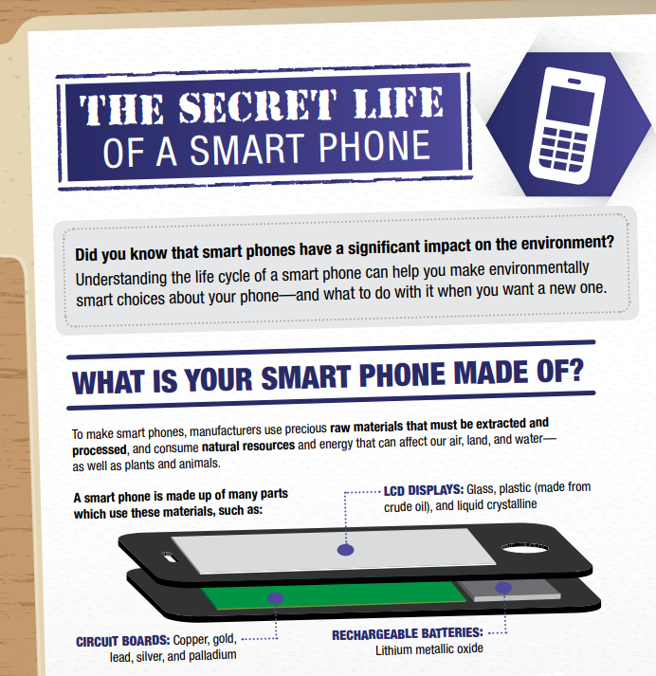
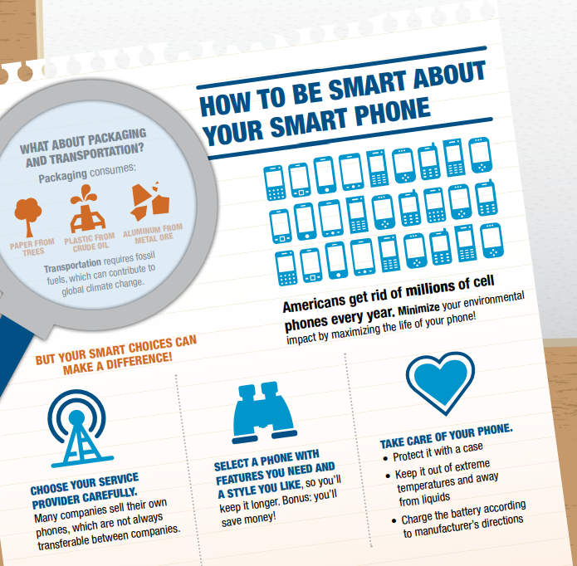

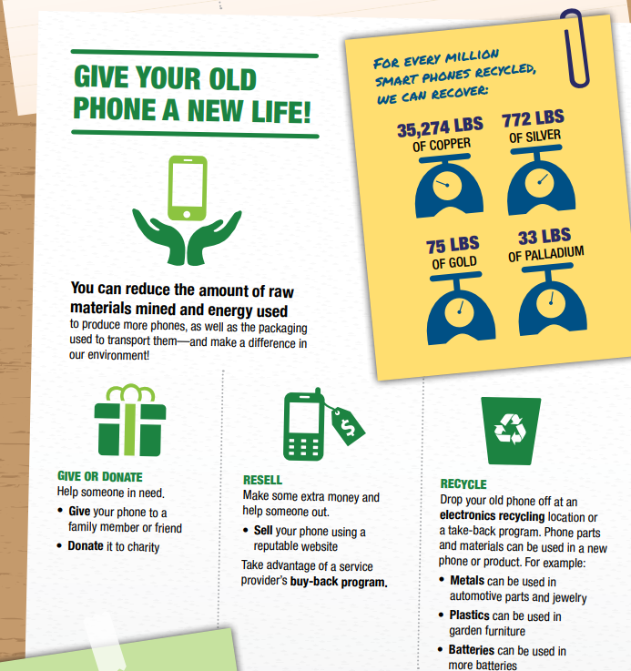
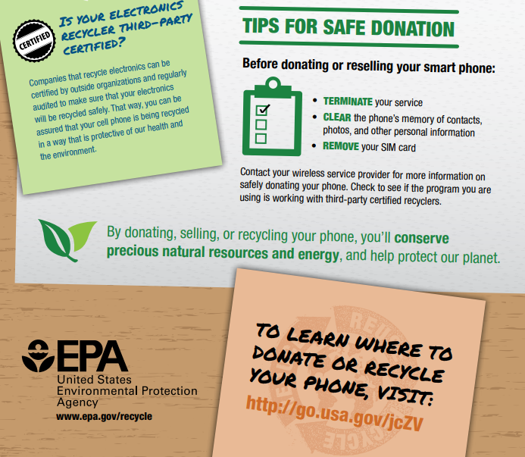

Annex – Game analysis:

